Government House
Canberra ACT 2600

23 May 2022

His Excellency the Governor-General directs it to be notified, for general information, that he has accepted the resignation of the Honourable Scott Morrison MP as Prime Minister.

By His Excellency’s Command

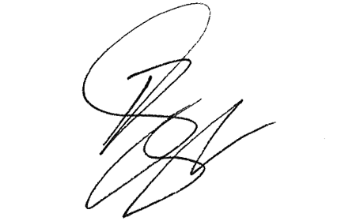
Paul Singer MVO
Official Secretary to the Governor-General

