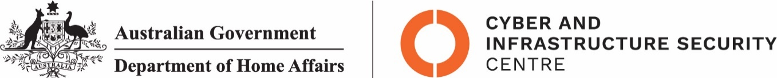

NTC-23517

***Aviation Transport Security Act 2004***

**NTC-23517 - DECLARATION OF SECURITY CONTROLLED AIRPORT AND ESTABLISHMENT OF AIRSIDE AREA - BENDIGO AIRPORT**

I am a Delegate of the Secretary of the Department of Home Affairs (Secretary). Under subsection 28(2) of the *Aviation Transport Security Act 2004* (the Act), I:

**REVOKE** notice NTC-15828 which declared Bendigo Airport as a security controlled airport as published in the *Gazette (C2019G00259 on 19 March 2019)*; and

**DECLARE** Bendigo Airport is a security controlled airport, the boundaries of Bendigo Airport are shown on the attached map which forms part of this notice; and

**ESTABLISH,** in accordance with section 29 of the Act, an airside area for Bendigo Airport being that area indicated as the airside area on the attached map which forms part of this notice.

This Notice commences upon publication in the *Gazette*.

Karen Peevor

Assistant Director, Regulatory Compliance

Cyber and Infrastructure Security Operations

Delegate of the Secretary of the

Department of Home Affairs

16 September 2022

Note:

1. *Gazette* means the *Commonwealth of Australia Gazette*
2. This Notice remains in force until otherwise revoked in writing and upon subsequent publication in the *Gazette*

This map shows the boundaries of the security controlled airport and airside area for the purpose of the Aviation Transport Security Act 2004 and the Aviation Transport Security Regulations 2005 only. The map should not be used for air navigation purposes. Further information can be obtained from the Department of Home Affairs. Canberra ACT 2601, or phone the Guidance Centre on 1300 791 581
