Government House

CANBERRA ACT 2600

15 September 2022

ORDER OF AUSTRALIA

It is notified for general information that the Governor-General of the Commonwealth of Australia has terminated the appointment as a Member of the Order of Australia and cancelled the award of the Medal of the Order of Australia made to:

Mr Simon Paul Poidevin

By His Excellency’s Command

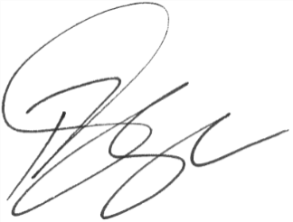

Paul Singer MVO
Official Secretary to the Governor-General
Secretary of the Order of Australia

