Aboriginal and Torres Strait Islander Heritage Protection Act 1984 (Cth)
Notice of an application for the protection of a specified area, being parts of the area known as Murujuga (or the Burrup Peninsula and Dampier Archipelago), Western Australia
Invitation to make representations
I, Alison Stone, hereby give notice as follows:
The Minister for the Environment (Minister), responsible for the Aboriginal and Torres Strait Islander Heritage Protection Act 1984 (Cth) (Act), has received an application made under section 10 of the Act. The application is seeking long term preservation and protection of the area known as Murujuga, or the Burrup Peninsula and the Dampier Archipelago, near Karratha in Western Australia. The Minister has appointed me to provide a report to the Minister under paragraph 10(1)(c) of the Act.

The Applicants
The application is made by Raelene Cooper, from the Mardudhunera language group, and Josie Alec, from the Kuruma/Mardudhunera language group (Applicants).

The purpose of the application
The application seeks the long-term preservation or protection of the area specified in the application. This specified area (specified area) is depicted in Figure 1 below. Section 10 of the Act confers power on the Minister to make a declaration to preserve and protect an area where the Minister is satisfied that it is a ‘significant Aboriginal area’ under threat of injury or desecration. A ‘significant Aboriginal area’ is defined by section 3 of the Act as an area of land or waters that is ‘of particular significance to Aboriginals in accordance with Aboriginal tradition’. ‘Aboriginal tradition’ is defined as the ‘body of traditions, observances, customs and beliefs of Aboriginals generally or of a particular community or group of Aboriginals, and includes any such traditions, observances, customs or beliefs relating to particular persons, areas, objects or relationships’.

Matters the report is required to deal with
The Minister must consider my report pursuant to section 10 of the Act in relation to the specified area before deciding whether to make a declaration under section 10 of the Act. Under subsection 10(4) of the Act, the report is required to deal with the following matters:
- the particular significance of the area to Aboriginals;
- the nature and extent of the threat of injury to, or desecration of, the area;
- the extent of the area that should be protected;
- the prohibitions and restrictions to be made with respect to the area;
- the effects the making of a declaration may have on the proprietary or pecuniary interests of persons other than the Aboriginal or Aboriginals who made the application, or on whose behalf the application is made;
- the duration of any declaration;
- the extent to which the area is or may be protected by or under a law of the State or Territory, and the effectiveness of any remedies available under any such law; and
- such other matters (if any) as prescribed.
In making her decision on the section 10 application, the Minister will consider my report and any representations attached to the report, as outlined in subsection 10(1)(c). It is important to note that my report is but one input to the Minister’s decision, and that in making her decision she will also consider any other material she thinks relevant, as outlined in subsection 10(1)(d).

The specified area
The specified area comprises parts of the Burrup Peninsula and the Dampier Archipelago in Western Australia, which are already or may in future be subject to industrial development under the terms of the Burrup and Maitland Industrial Estates Agreement (BMIEA). The specified area is depicted in the map at Figure 1 below.
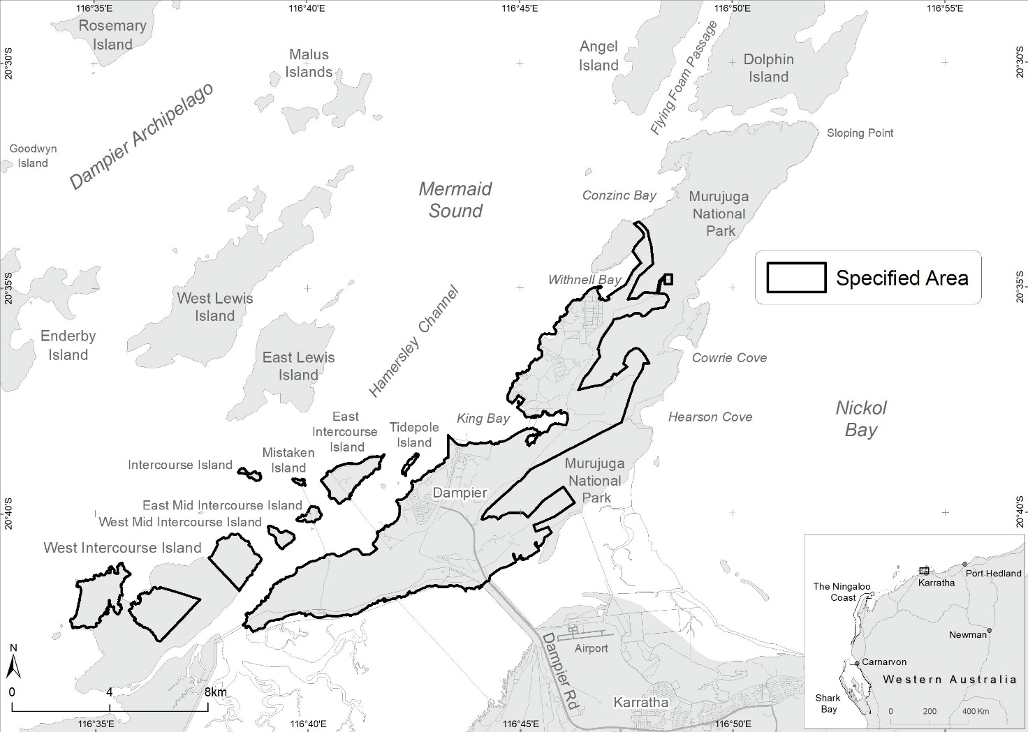
Figure 1 Map showing the specified area, Murujuga, Burrup Peninsula

Claims in relation to ‘significant Aboriginal area’
The Applicants claim the specified area is of particular significance in accordance with Aboriginal tradition for the following reasons:
- Murujuga is sacred, it is a place where everything is connected, through the ancestral creator beings – the land, sky, sea, plants, animals, the Lore and the spiritual world. This belief system underlies life on Murujuga today.
- For the Aboriginal people of the Pilbara region, the petroglyphs are the work of the Marrga, the ancestral creator beings, who are a permanent reminder of Traditional Lore and who retain their spiritual power.
- The songs and mythologies for many of the images, such as Minyuburru (Seven Sisters), the fruit bat and Archaic Face, have important meaning across the whole of the Pilbara region and are central to the applicants’ culture.
- With more than one million images in an area of more the 37,000 hectares, Murujuga is home to one of the most significant and diverse collections of petroglyphs in the world. These petroglyphs allow for the teaching and continuation of culture.
- Murujuga is currently listed on the National Heritage List and the UNESCO Tentative World Heritage List. There is ‘extensive scholarly literature’ on Murujuga’s ‘globally significant’ rock art.
- Murujuga holds over two thousand registered sites and ‘Other Heritage Places’ under section 5 of the Aboriginal Heritage Act 1972 (WA), which are listed on the Aboriginal Heritage Inquiry System maintained by the WA Department of Planning, Lands and Heritage.
Claimed threat of injury or desecration
The Applicants claim that the specified area is under threat from the following proposed projects:
- The Scarborough Liquefied Natural Gas (LNG) project by Woodside Energy Group Ltd.;
- The Perdaman Urea Project by Perdaman Chemicals and Fertilisers Pty Ltd.;
- The Yara Pilbara Hydrogen Plant by Yara Australia Pty Ltd; and
- The proposed extension on the life of the Karratha Northwest Shelf Gas Plant until 2070 by Woodside Energy Group Ltd.
- Woodside’s proposed Browse Basin project.
The Applicants also claim that the specified area is under threat from ongoing industrial activity from the following projects:
- The Yara Pilbara Fertilisers plant and the Yara Pilbara Nitrates Technical Ammonium Nitrate (TAN) plant by Yara Australia Pty Ltd.; and
- The Pluto Liquefied Natural Gas (LNG) plant and the Karratha Gas Plant by Woodside Energy Group Ltd.
The claimed threat is primarily attributed to the degradation and destruction of many sacred sites and ancient rock carvings of Murujuga claimed to be caused by:
- ‘inappropriate’ location of existing industrial facilities;
- ‘inappropriate’ location of proposed industrial facilities;
- current and forecasted gas emissions, chemical discharge, and acid rain from the above projects, specifically NOx, Sox and ammonia in relation to a) and b) above;
- ‘visual desecration’ by Yara Pilbara, caused by proposed solar panels for the Yara Pilbara Hydrogen Plant. The applicants claim that this ‘visual desecration’ is adjacent to the culturally and archaeologically significant Nganjarli (Deep Gorge area);
- indirect impacts on cultural heritage values including visual amenity, landscape impacts, light, noise, and other related impacts from the North West Shelf plant and the Pluto LNG plant by Woodside Energy Group Ltd.;
- direct and indirect impacts from the proposed Perdaman Urea Project on a range of individual sites (including the removal of at least one secret/sacred petroglyph) and compromising culturally significant sites nearby such as the fish thalu (increase site) and yatha (bough shed) adjacent to the project footprint;
- potential construction of new facilities on West Intercourse Island which may impact Aboriginal sites; and
- the above threats hindering the ability of Traditional Owners to continue practising and passing on cultural knowledge on the Burrup.
The claimed threat also includes:
- lack of access, and degradation of amenity, for Traditional Owners to important sites through fencing and positioning of plant facilities near important sites;
- lack of effective regulation of industrial pollution and other impacts to Murujuga rock art by the Western Australian Government;
- poor administration of the Burrup emissions monitoring programs by the WA Government, including allowing inappropriate industry influence on research and a delay in the availability of data on rock art impacts by industrial emissions until 2025 at the earliest;
- lack of best practice technology to control emissions from industrial facilities run by Woodside Energy Group Ltd. and Yara Australia Pty. Ltd.;
- the WA Government promoting the construction of new industrial facilities on Murujuga instead of the Maitland Industrial Estate as the appropriate agreed location for industry;
- restrictions on Traditional Owners, including clause 4.8 of the BMIEA, precluding Traditional Owners (including the Murujuga Aboriginal Corporation) from voicing their objections to threats to their cultural heritage;
- impacts to National Heritage and tentative World Heritage values, including compromising the World Heritage nomination of the Murujuga Cultural Landscape by reducing the scope, geographical extent, and values that are recognised and protected by such a listing; and
- unsatisfactory protection under Western Australian legislation, including:
  - inadequate and racially discriminatory provisions of the Aboriginal Heritage Act 1972 (WA) (the AHA);
  - lack of state approval under section 18 of the AHA for indirect impacts to rock art from acid gas emissions, and inappropriate reliance by Woodside on decades-old section 18 heritage approvals;
  - ongoing use of section 18 of the AHA to provide inappropriate approvals to impact sites against the wishes of Traditional Owners, including for the proposed Perdaman Urea Project.; and
  - failure of the State Government and industry to provide for the free, prior and informed consent of Traditional Owners for industrial developments which impact cultural heritage, as required under the United Nations Declaration on the Rights of Indigenous Peoples;
- threats to cultural heritage values arising from, and being accelerated by, Woodside Energy's operations and related industry on the Burrup which include Australia's largest source of carbon pollution; and
- loss of long-term sustainable economic value associated with the protection and preservation of cultural heritage on the Burrup, and related tourism, knowledge and cultural enterprises.

Invitation to make representations
Interested parties are invited to furnish representations in connection with my report to:
Ms Alison Stone
Murujuga Section 10 Reporter
PO Box 1810
NEWCASTLE NSW 2300
Mob: 0419 546 435
murujuga.reporter@gmail.com
Interested parties are urged to contact me as soon as possible to be provided with further information about the submission process, including the provision of the Application, making representations in response to the Application, and making final comments in response to representations received.
Representations must be made in writing by 5pm AWST on 16 November 2022 or within such further period as may be allowed. Do not send your representations directly to the Minister.
Representations made by, or on behalf of, more than person should be signed by each of those persons.

Representations received by the due date may subsequently be provided to the Applicant and other interested parties for their review and comment in order to meet procedural fairness requirements. If representations are circulated to the Applicant and/or other interested parties for comment, an additional period will be allowed for those parties to make any final comments in writing. Representations will only be circulated to the Applicant and/or other interested parties where the representation may adversely affect the interests of that particular interested party. Please contact me should you have any questions about this.

Claiming confidentiality
If you wish to claim confidentiality over any part of your representation, please identify why you are claiming confidentiality and how you wish confidentiality to apply. Representations will be provided to the Minister and the Department of Climate Change, Energy, the Environment and Water (department), along with the section 10 report. Representations, even those subject to confidentiality, may be disclosed where it is authorised or required by law, to meet procedural fairness requirements, and in response to a request by a House or Committee of the Parliament of the Commonwealth.
Privacy notice
What is personal information and sensitive information?
As defined by the Privacy Act 1988 (Cth) (the Privacy Act), personal information means information or an opinion about an identified individual, or an individual who is reasonably identifiable.
Sensitive information is a subset of personal information and includes any information or opinion about an individual's racial or ethnic origin, political opinion or association, religious beliefs or affiliations, philosophical beliefs, sexual preferences or practices, trade or professional associations and memberships, union membership, criminal record, health or genetic information and biometric information or templates.
Collection of personal information
By submitting a representation in response to this Notice, you consent to the collection of all personal information, including sensitive information, contained in your representation. Your personal information will be used and stored in accordance with the Australian Privacy Principles set out in Schedule 1 of the Privacy Act.
I, Alison Stone, collect your personal information contained in your representation for the purposes of consideration in drafting a report for the Minister under section 10 of the ATSIHP Act in relation to the specified area. If you do not provide some or all of any relevant personal information in your representation(s), I may be unable to fully and comprehensively consider your representation in the drafting of the report. Your representation, including any personal information it contains, may also be used by other persons engaged to assist me to prepare the report.
The department collects your personal information for the purposes of the Minister’s consideration of the application described in this notice. If you do not provide some or all of any relevant personal information in your representation(s), the Minister may be unable to fully and comprehensively consider your representation in deciding whether to make a declaration under section 10 of the Act in relation to the specified area.
The department may disclose your personal information to the Minister, parties that may be affected by a decision of the Minister under section 10 of the Act (to meet procedural fairness requirements), and other Australian government agencies, persons or organisations where necessary for the above purposes, provided the disclosure is consistent with relevant laws, in particular the Privacy Act. By submitting a representation, you consent to the disclosure of all personal information contained in your representation to:
- the Minister;
- parties that may be affected by the decision of the Minister under section 10 of the Act, should this be required to meet procedural fairness requirements; and
- other Australian government agencies, persons or organisations where necessary for the purposes of preparing the report and consideration of that report by the Minister, provided the disclosure is consistent with relevant laws, including the Privacy Act.
If a representation contains the personal information of another person, you are responsible for ensuring that the other person has agreed to their personal information being collected, used and disclosed for the purposes set out in this notice. This includes providing a copy of the Gazette Notice and this Privacy Notice to them.
See the department's Privacy Policy to learn more about accessing or correcting personal information or making a complaint. Alternatively, email the department at privacy@dcceew.gov.au

