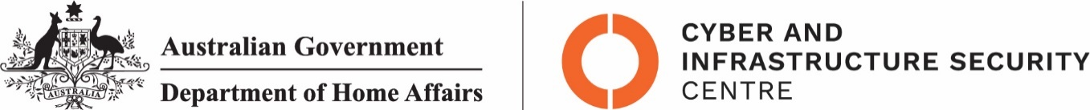

NTC-23731

***Aviation Transport Security Act 2004***

**NTC-23731 - DECLARATION OF SECURITY CONTROLLED AIRPORT AND ESTABLISHMENT OF AIRSIDE AREA - GLADSTONE AIRPORT**

I am a Delegate of the Secretary of the Department of Home Affairs. Under subsection 28(2) of the *Aviation Transport Security Act 2004* (the Act), I:

**REVOKE** notice NTC-14627 which declared Gladstone Airport as a security controlled airport as published in the *Gazette (C2018G00346 10 May 2018)*; and

**DECLARE** Gladstone Airport is a security controlled airport, the boundaries of Gladstone Airport are shown on the attached maps which form part of this notice; and

**ESTABLISH,** in accordance with section 29 of the Act, an airside area for Gladstone Airport being that area indicated as the airside area on the attached maps which form part of this notice.

This Notice commences upon publication in the *Gazette*.

Jaran Blethyn

Assistant Director, Regulatory Compliance

Cyber and Infrastructure Security Operations

Delegate of the Secretary of the

Department of Home Affairs

27 October 2022

Note:

1. *Gazette* means the *Commonwealth of Australia Gazette*
2. This Notice remains in force until otherwise revoked in writing and upon subsequent publication in the *Gazette*

This is map 1 of 2 of Gladstone Airport, which has been declared a security controlled airport. The map establishes airport boundaries and airside areas for the purposes of section 28 and section 29 of the Aviation Transport Security Act 2004.
 