# 

**Government House**

**CANBERRA ACT 2600**

**19 October 2022**

**Honorary Appointment – Military Division – February 2023**

**The Governor-General is pleased to announce the following appointment in the Order of Australia:**

**HONORARY OFFICER (AO) IN THE MILITARY DIVISION**

**Major General Kelvin KHONG Boon Leong,** Republic of Singapore

For distinguished service in fostering the military relationship between the Republic of Singapore and Australia through strategic vision, outstanding personal commitment and exceptional leadership, and in recognition of his role in supporting Australia during times of great need.

By His Excellency’s command

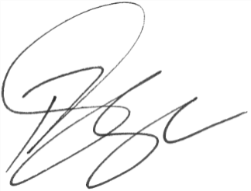

### **Paul Singer MVO**

Official Secretary to the Governor-General