# 

**Government House**

**CANBERRA ACT 2600**

**21 November 2022**

**Honorary Awards - General Division - February 2023**

**The Governor-General is pleased to announce the following awards in the Order of Australia:**

**HONORARY MEDAL (OAM) IN THE GENERAL DIVISION**

**Ms Jennifer Jean MACAULAY,** Portalington, Victoria

For service to the community of Portarlington, Victoria, particularly through educational and cultural initiatives.

**Mr Pierre SEILLIER,** La Bassee, France

For service to commemorating Australia's military service, particularly during World War I at the Western Front at Fromelles, France.

By His Excellency’s command

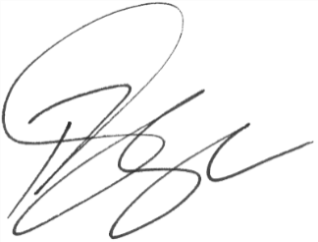

### **Paul Singer MVO**

Official Secretary to the Governor-General