# 

**Government House**

**CANBERRA ACT 2600**

**21 February 2023**

**Honorary Appointment – General Division - March 2023**

**The Governor-General is pleased to announce the following appointment in the Order of Australia:**

**HONORARY OFFICER (AO) IN THE GENERAL DIVISION**

**Mr Ratan TATA,** Mumbai, India

For distinguished service to the Australia-India bilateral relationship, particularly to trade, investment and philanthropy.

By His Excellency’s command

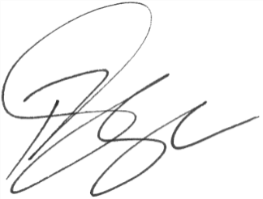

### **Paul Singer MVO**

Official Secretary to the Governor-General