

Government House

Canberra ACT 2600

20 March 2023

The Governor-General directs it to be notified, for general information, that His Majesty The King has been pleased to approve that Mr Michael Gunner be granted the title “Honourable” for life.

By His Excellency’s Command

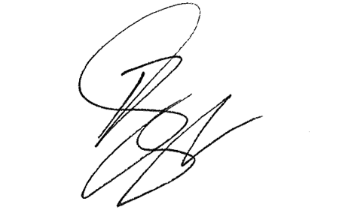

**Paul Singer MVO**

Official Secretary to the Governor-General