Government House

CANBERRA ACT 2600

19 October 2022

Honorary Appointment - Military Division - March 2023

The Governor-General is pleased to announce the following appointment:

HONORARY OFFICER (AO) IN THE MILITARY DIVISION

Lieutenant General Scott David BERRIER, Washington, United States of America
For distinguished service to strengthening the defence intelligence relationship between Australia and the United States of America through leadership, dedication and strategic foresight as Director Defense Intelligence Agency.

By His Excellency’s command
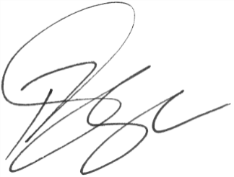

Paul Singer MVO
Official Secretary to the Governor-General

