Aboriginal and Torres Strait Islander Heritage Protection Act 1984 (Cth)
Notice of an application for the protection of a specified area, being the area known as the Mount Pleasant Operation mine and The Pocket, near Muswellbrook, New South Wales
Invitation to make representations
I, Ruth Elvin, hereby give notice as follows:
The Minister for the Environment and Water (minister), responsible for the Aboriginal and Torres Strait Islander Heritage Protection Act 1984 (Cth) (Act), has received an application made under section 10 of the Act. The application is seeking long term preservation and protection of a significant Aboriginal area being the areas known as the Mount Pleasant Operation mine and The Pocket, near Muswellbrook in New South Wales. The minister has appointed me to provide a report to the minister under paragraph 10(1)(c) of the Act.

The Applicants
The application is made by Robert Lester and Scott Franks on behalf of the Plains Clans of the Wonnarua People (Applicants).

The purpose of the application
The application seeks the long-term preservation or protection of the area specified in the application (the specified area). This area is depicted in Figure 1. Section 10 of the Act confers power on the minister to make a declaration to preserve and protect an area where the minister is satisfied that it is a ‘significant Aboriginal area’ under threat of injury or desecration. A ‘significant Aboriginal area’ is an area of land or water in Australia that is ‘of particular significance to Aboriginals in accordance with Aboriginal tradition.’ ‘Aboriginal tradition’ is the ‘body of traditions, observances, customs and beliefs of Aboriginals generally or of a particular community or group of Aboriginals, and includes any such traditions, observances, customs or beliefs relating to particular persons, areas, objects or relationships.’

Matters the report is required to deal with
The minister must consider my report pursuant to section 10 of the Act in relation to the specified area before deciding whether to make a declaration under section 10 of the Act. Under subsection 10(4) of the Act, the report is required to deal with the following matters:
- the particular significance of the area to Aboriginals;
- the nature and extent of the threat of injury to, or desecration of, the area;
- the extent of the area that should be protected;
- the prohibitions and restrictions to be made with respect to the area;
- the effects the making of a declaration may have on the proprietary or pecuniary interests of persons other than the Aboriginal or Aboriginals who made the application, or on whose behalf the application is made;
- the duration of any declaration;
- the extent to which the area is or may be protected by or under a law of a State or Territory, and the effectiveness of any remedies available under any such law; and
- such other matters (if any) as prescribed.

The specified area
Figure 1 depicts the area for which preservation and protection is sought. This specified area includes: the Mount Pleasant Operation coal mine operated by MACH Energy and surrounding land within the area of the Mount Pleasant Optimisation Project State Significant Development Application (SSD-10418); the area known as The Pocket, within the Mount Arthur coal mine operated by BHP; and adjacent areas including a section of the Hunter River.
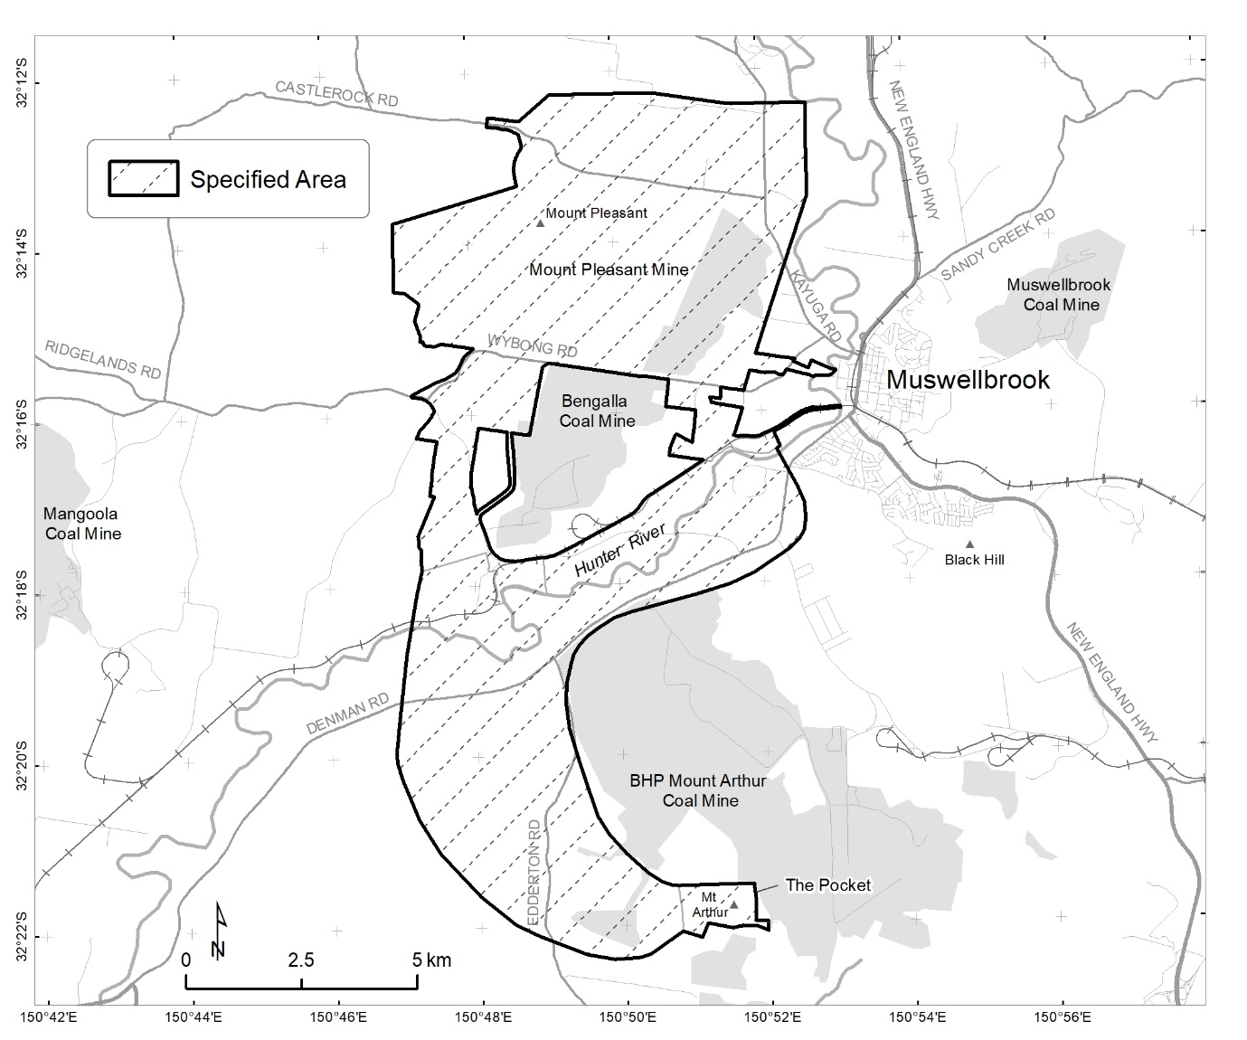
Figure 1 Map showing the specified area near Muswellbrook, NSW

Claims in relation to ‘significant Aboriginal area’
The Applicant claims the specified area is of particular significance in accordance with Aboriginal tradition for the following reasons:
- the specified area contains a high concentration of Aboriginal sites, registered with Heritage NSW, including an important site associated with a significant women’s story and a song line; and
- the area known as The Pocket is associated with a men’s site, and the massacre of Wonnaru people.

Claimed threat of injury or desecration
The Applicant claims that the specified area is under threat from:
- the operation and extension of the Mount Pleasant Operation mine, including the Mount Pleasant Optimisation Project by MACH Energy, which the Applicants state ‘will remove the surface of the area and destroy the subject land’; and
- rehabilitation work being undertaken at the Mount Arthur Coal mine by BHP.

Invitation to make representations
Interested parties are invited to furnish representations in connection with my report to:
Ms Ruth Elvin
Mount Pleasant / The Pocket Section 10 Reporter
RE1 Consulting
PO Box 252
Waverley NSW 2024
0432 102 927
elvinruth7@gmail.com
Interested parties are urged to contact me as soon as possible to be provided with further information about the submission process, including the provision of the Application, the making of representations in response to the Application, and the making of final comments in response to representations received.
Representations must be made in writing by 5pm AEST on 26 April 2022 or within such further period as may be allowed. Do not send your representations directly to the minister.
Representations made by, or on behalf of, more than person should be signed by each of those persons.
Representations received by the due date may subsequently be provided to the Applicant and other interested parties for their review and comment in order to meet procedural fairness requirements. If representations are circulated to the Applicant and/or other interested parties for comment, an additional period will be allowed for those parties to make any final comments in writing. Representations will only be circulated to the Applicant and/or other interested parties where the representation may adversely affect the interests of that particular interested party. Please contact me should you have any questions about this.

Claiming confidentiality
If you wish to claim confidentiality over any part of your representation, please identify why you are claiming confidentiality and how you wish confidentiality to apply. Representations will be provided to the minister and the Department of Climate Change, Energy, the Environment and Water (department), along with the section 10 report. Representations, even those subject to confidentiality, may be disclosed where it is authorised or required by law, to meet procedural fairness requirements, and in response to a request by a House or Committee of the Parliament of the Commonwealth.
Privacy notice
The Privacy Act 1988 (Cth) (the Privacy Act) sets out how I and the department can collect, use and disclose the personal and sensitive information of individuals.
Personal information contained in any representations, submissions, correspondence and/or supporting material submitted will be collected by me, Ruth Elvin, and the department. By submitting a representation, you consent to the collection, use and disclosure of all personal information, including sensitive information (as defined in the Privacy Act 1988), contained in your representation, in accordance with this Privacy Notice. By submitting a representation, you agree that you have read and understood this Privacy Notice.
If a representation that you submit contains the personal information of another person, you are responsible for ensuring that the other person has agreed to their personal information being collected, used and disclosed for the purposes set out in this notice.
What is personal information and sensitive information?
‘Personal information’ is any information or opinion about an identified individual, or an individual who is reasonably identifiable (whether true or not).
‘Sensitive information’ is a subset of personal information and includes any information or opinion about an individual's racial or ethnic origin, political opinion or association, religious beliefs or affiliations, philosophical beliefs, sexual orientation or practices, trade or professional associations and memberships, union membership, criminal record, health or genetic information and biometric information or templates.
Your personal information will be used and stored in accordance with the Australian Privacy Principles set out in Schedule 1 of the Privacy Act.
Collection and use of personal information
By submitting a representation in response to the ‘Notice of an application for the preservation and protection of a specified area, being the areas known as the Mount Pleasant Operation mine and The Pocket’ you consent to the collection of all personal information (including sensitive information) contained in your representation, by myself as the section 10 reporter and by the department. By submitting a representation, you agree that you have read and understood this Privacy Notice.
I, Ruth Elvin, collect your personal information contained in your representation for the purposes of consideration in drafting a report under section 10 of the ATSIHP Act in relation to the specified area and related purposes. I will disclose your personal information to the department for the purpose of providing a section 10 report.
The department collects your personal information contained in your representation, and any subsequent correspondence in relation to your representation, for the purposes of the minister’s consideration in deciding whether to make a declaration under section 10 of the Act in relation to the specified area and related purposes.

Disclosure of personal information
I and/or the department may disclose your personal information to the minister, parties that may be affected by a decision of the minister under section 10 of the Act (to meet procedural fairness requirements), other Commonwealth agencies, State or Territory agencies, and other Australian government agencies, persons or organisations where necessary for the above purposes, provided the disclosure is consistent with relevant laws, in particular the Privacy Act. Your personal information will be used and stored in accordance with the Australian Privacy Principles set out in Schedule 1 of the Privacy Act.
By submitting a representation, you consent to the disclosure of all personal information contained in your representation to:
- the department;
- the minister;
- parties that may be affected by the decision of the minister under section 10 of the Act, should this be required to meet procedural fairness requirements; and
- other Australian government agencies, persons or organisations where necessary for the purposes of preparing the report and consideration of that report by the minister, provided the disclosure is consistent with relevant laws.
Your personal information will not be disclosed to overseas recipients unless such disclosure is necessary to consider an application made under section 10 of the ATSHIP Act or for related purposes.
Anonymous representations
You can choose to make an anonymous representation and/or to not disclose relevant personal information in your representation. However, this may mean your representation cannot be fully considered under the Act in relation to the specified area.
Personal and sensitive information of other individuals
If your representation contains the personal information of another person, you are responsible for ensuring that the other person has agreed to their personal information being collected, used and disclosed for the purposes set out in this notice. This includes giving them a copy of the Gazette Notice and this Privacy Notice.
Privacy Policy
The department's Privacy Policy is available at https://www.dcceew.gov.au/about/commitment/privacy. It contains more information about how personal information is handled, how to access or correct your personal information, and how to make a complaint.

