# 

**Government House**

**CANBERRA ACT 2600**

**16 August 2022**

**Honorary Award - General Division - April 2023**

**The Governor-General is pleased to announce the following award in the Order of Australia:**

**HONORARY MEDAL (OAM) IN THE GENERAL DIVISION**

**Mr THAM Yau Kong,** Sabah, Malaysia

For service to commemorating the sacrifice of Australian prisoners of war in Malaysia, particularly along the Sandakan-Ranau death march (1942-1945).

By His Excellency’s command

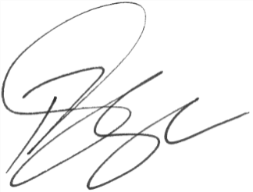

### **Paul Singer MVO**

Official Secretary to the Governor-General