Government House

CANBERRA ACT 2600

19 October 2022

Honorary Appointment - Military Division - April 2023

The Governor-General is pleased to announce the following appointment in the Order of Australia:

HONORARY OFFICER (OA) IN THE MILITARY DIVISION

General AFFENDI bin Buang, Kuala Lumpur, Malaysia
For distinguished service to strengthening the defence relationship between Australia and Malaysia through commitment, leadership and strategic foresight as the Malaysian Chief of Defence Force.

By His Excellency’s command
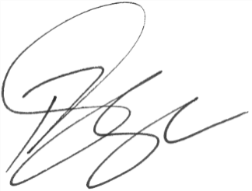

Paul Singer MVO
Official Secretary to the Governor-General

