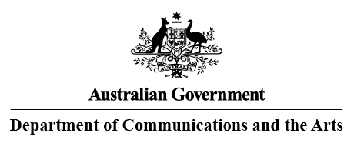

**Notification under section 124 of the *Copyright Regulations 2017,* Number 1, 2023**

***Use of copyright material for the services of the Commonwealth under section 183 of the Copyright Act 1968***

***Use of copyright material by the Commonwealth and the acts to which the notice relates:***

The Commonwealth of Australia as represented by the Classification Branch of the Department of Communications and the Arts (“**the Classification Branch**”) will be communicating short clips from a number of films for community standards research.

The Classification Branch will be providing research on community standards relating to classifiable elements and consumer advice.

In accordance with section 183(4) of the *Copyright Act 1968*, the purpose of this notice is to inform the owners of copyright in the film clips of the copyright acts undertaken by the Commonwealth as represented by the Classification Branch.

***Title/details of the copyright material*:**

|  |  |  |  |  |
| --- | --- | --- | --- | --- |
| **TITLE OF FILM** | **PRODUCER(S)** | **DIRECTOR/S** | **PRODUCTION COMPANY** | **DURATION (seconds)** |
| **Beatles: Get Back** | JONATHAN CLYDE / OLIVIA HARRISON / PAUL MCCARTNEY / CLARE OLSSEN / RINGO STARR / YOKO ONO LENNON / PETER JACKSON | PETER JACKSON | WALT DISNEY PICTURES | 10 |
| **Harry and Meghan: Escaping the Palace** | JOYCE SAWA / SHAWN WILLIAMSON / JAMIE GOEHRING | MENHAJ HUDA | LIGHTHOUSE PICTURES | 10 |