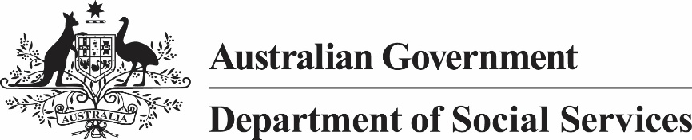

***Child Support (Assessment) Act 1989***

**Child Support (Assessment) (Average Weekly Earnings amount) Notice 2023**

I, Ray Griggs AO CSC, Secretary of the Department of Social Services, give notice under subsection 155(2A) of the *Child Support (Assessment) Act 1989* that the Average Weekly Earnings amount (within the meaning of subsection 58AA(1) of that Act) for the quarter ending on 31 December 2022 is $1,376.60.

Ray Griggs AO CSC

Secretary

10 May 2023