# 

**Government House**

**CANBERRA ACT 2600**

**13 April 2023**

**The Governor-General is pleased to announce the following award:**

**MEDAL FOR GALLANTRY (MG)**

*Australian Army*

**Mr (then Private) Alan James PARR OAM**

For acts of gallantry in action in hazardous circumstances as the radio operator in the 1st Battalion, the Royal Australian Regiment's mortar line during the Battle for Fire Support Base Coral in Vietnam on 13 May 1968.

**By His Excellency’s command**

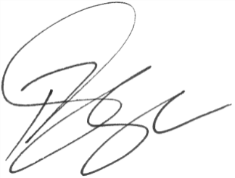

### **Paul Singer MVO**

Official Secretary to the Governor-General