|  |  |  |
| --- | --- | --- |
| Commonwealth Coat of Arms of Australia | **Commonwealth of Australia** | **Gazette** |
| Published by the Commonwealth of Australia | | **GOVERNMENT NOTICES** |

***Aboriginal and Torres Strait Islander Heritage Protection Act 1984* (Cth)**

**Notice of an application for the protection of a specified area, being the area known as Morrison Bore and an area of a radius of 6 kilometres around Morrison Bore, in the Aṉangu Pitjantjatjara Yankunytjatjara Lands, South Australia**

**Invitation to make representations**

I, Richard Mackay, hereby give notice as follows:

The Minister for the Environment and Water (**minister**), responsible for the *Aboriginal and Torres Strait Islander Heritage Protection Act 1984* (Cth)(**Act**), has received an application made under section 10 of the Act. The application is seeking long term preservation and protection of a significant Aboriginal area being the area known as the whole of Morrison Bore and an area of a radius of 6 kilometres around Morrison Bore, located approximately 17 kilometres northeast of Kaltjiti (Fregon) in the Aṉangu Pitjantjatjara Yankunytjatjara Lands of South Australia (APY Lands). The minister has appointed me to provide a report to the minister under paragraph 10(1)(c) of the Act.

### The Applicant

The application is made by Gerry Bowen, Solicitor, Adelaide Capital Lawyers on behalf of Anangu senior lore man Murray George (**Applicant**).

### The purpose of the application

The application seeks the long-term preservation or protection of the area specified in the application (the **specified area**). This area is depicted in Figure 1. Section 10 of the Act confers power on the minister to make a declaration to preserve and protect an area where the minister is satisfied that it is a ‘significant Aboriginal area’ under threat of injury or desecration. A ‘significant Aboriginal area’ is an area of land or water in Australia that is ‘of particular significance to Aboriginals in accordance with Aboriginal tradition’. ‘Aboriginal tradition’ is the ‘body of traditions, observances, customs and beliefs of Aboriginals generally or of a particular community or group of Aboriginals, and includes any such traditions, observances, customs or beliefs relating to particular persons, areas, objects or relationships’.

### Matters the report is required to deal with

The minister must consider my report pursuant to section 10 of the Act in relation to the specified area before deciding whether to make a declaration under section 10 of the Act. Under subsection 10(4) of the Act, the report is required to deal with the following matters:

1. the particular significance of the area to Aboriginals;
2. the nature and extent of the threat of injury to, or desecration of, the area;
3. the extent of the area that should be protected;
4. the prohibitions and restrictions to be made with respect to the area;
5. the effects the making of a declaration may have on the proprietary or pecuniary interests of persons other than the Aboriginal or Aboriginals who made the application, or on whose behalf the application is made;
6. the duration of any declaration;
7. the extent to which the area is or may be protected by or under a law of a State or Territory, and the effectiveness of any remedies available under any such law; and
8. such other matters (if any) as prescribed.

### The specified area

Figure 1 depicts the area for which preservation and protection is sought. This specified area is described as the whole of Morrison Bore and an area of a radius of 6 kilometres around Morrison Bore, it is located approximately 17 kilometres northeast of Kaltjiti (Fregon) in the Aṉangu Pitjantjatjara Yankunytjatjara Lands of South Australia.

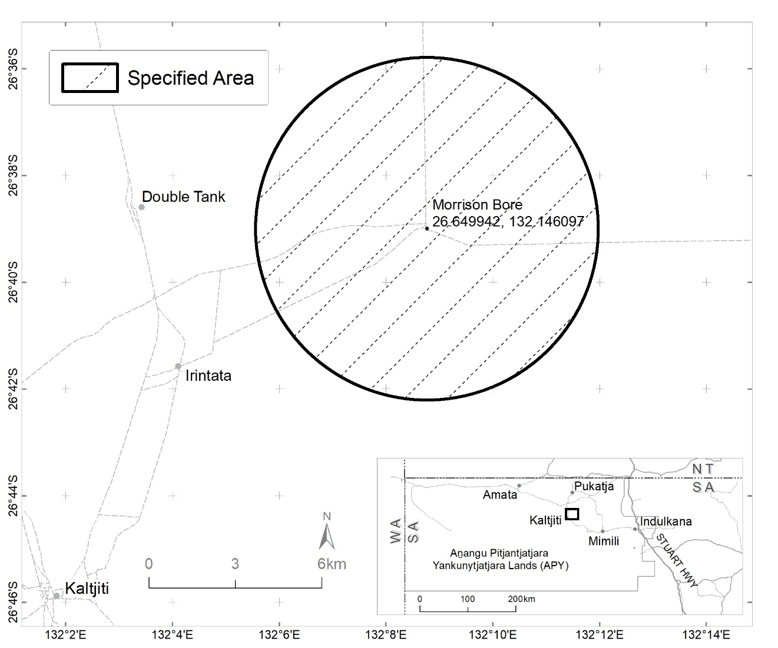

Figure 1 Map showing the specified area in the Aṉangu Pitjantjatjara Yankunytjatjara Lands of South Australia

### Claims in relation to ‘significant Aboriginal area’

The Applicant claims the specified area is of particular significance in accordance with Anangu Aboriginal tradition for the following reasons:

* It is the deliberately chosen birthplace of an Aboriginal child (the daughter of the Applicant) and holds extreme spiritual and cultural significance. The subsequent death of the Applicant’s daughter has instilled Morrison Bore with further cultural and spiritual significance as the country of, and spiritual connection to her.
* Morrison Bore provides a physical location for the Applicant and his entire family and community to connect with the memory and spirit of their daughter, and to care for and engage with the land ensuring the protection of current, and emerging, traditional Anangu stories that will be passed down to future generations, maintaining respect, care and connection to ancestors, culture and country.

### Claimed threat of injury or desecration

The Applicant claims that the specified area is under threat from:

* Unauthorised occupants and the unauthorised rearing / grazing of their cattle.
* The claim of ownership by another person.

It is asserted that this causes:

* A real and likely threat that cattle will destroy a fence line installed to keep animals out of Morrison Bore, and this will in turn allow further injury to the area.
* A tangible threat from the cattle of soil erosion, trampling and destruction of the native and culturally significant vegetation, in turn threatening the prosperity of the physical connection to culture and tradition.
* A threat to desecrate the significant area and the ability for the Applicant and his family to observe traditional and cultural Anangu practices.
* Rearing of livestock by people who do not have the required knowledge to rear livestock in a manner that is compatible with, and respectful to Anangu tradition and culture, resulting in disrespect of culturally significant areas though littering, damage to the land and vegetation; and a loss of connection to country, of traditional songlines and stories through a lack of knowledge and protection of them.

### Invitation to make representations

Interested parties are invited to furnish representations in connection with my report to:

Prof Richard Mackay, AM  
Mackay Strategic  
PO Box 479 Lindfield  
NSW 2070  
0412673548   
Richard@mackaystrategic.com.au

Interested parties are urged to **contact me** as soon as possible to request further information about the submission process, including the provision of the Application, the making of representations in response to the Application, and the making of final comments in response to representations received.

Representations must be made in writing by 5pm AEST on **Friday 30 June** or within such further period as may be allowed. **Do not send your representations directly to the minister.**

Representations made by, or on behalf of, more than person should be signed by each of those persons.

### Representations received by the due date may subsequently be provided to the Applicant and other interested parties for their review and comment in order to meet procedural fairness requirements. If representations are circulated to the Applicant and/or other interested parties for comment, an additional period will be allowed for those parties to make any final comments in writing. Representations will only be circulated to the Applicant and/or other interested parties where the representation may adversely affect the interests of that particular interested party. Please contact me should you have any questions about this.

### Claiming confidentiality

If you wish to claim confidentiality over any part of your representation, please identify why you are claiming confidentiality and how you wish confidentiality to apply. Representations will be provided to the minister for the Environment and the Department of Climate Change, Energy, the Environment and Water (**department**), along with the section 10 report. Representations, even those subject to confidentiality, may be disclosed where it is authorised or required by law, to meet procedural fairness requirements, and in response to a request by a House or Committee of the Parliament of the Commonwealth.

**Privacy**

Your personal information is protected by law, including the [Privacy Act 1988 (Cth)](https://www.legislation.gov.au/Details/C2022C00135).

Please read this notice carefully before submitting a representation about the application.

Collection and use of your personal information

Your representation may contain your personal information, such as your name, contact details, your identity as an Aboriginal or Torres Strait Islander person, and your opinions about the application.

By submitting a representation, you consent to your personal information being collected by me for the purpose of:

* Contacting you about your representation, including for verification or clarification purposes;
* Preparing my report and briefing the minister;
* The minister making a decision in relation to the application,

and for related purposes. You also consent to your personal information being collected by the Department of Climate Change, Energy, the Environment and Water for these same purposes.

Disclosure of your personal information

I may need to disclose your personal information to the department and the minister for the purposes listed above. I may also need to disclose your personal information to:

* Third parties that may be affected by the minister’s decision, where necessary to meet procedural fairness requirements;
* Commonwealth, State or Territory entities and/or persons or organisations, where necessary to prepare my report and/or for the minister to make a decision about the application.

Your personal information will not be disclosed to overseas recipients unless necessary for the above purposes.

Anonymous representations

You can make an anonymous representation or use a pseudonym. However, this may mean I cannot verify information provided in your representation and/or take your representation into account.

Representations containing other people’s personal information

If your representation contains the personal information of another person, you must ensure they have agreed to their personal information being collected, used and disclosed in accordance with this privacy notice. This includes giving them a copy of this public notice and the privacy notice.

Privacy Policy

The department's [Privacy Policy](https://www.dcceew.gov.au/about/commitment/privacy) is available at <https://www.dcceew.gov.au/about/commitment/privacy> and explains how personal information is handled by the department, how to access or correct your personal information, and how to make a complaint.