Aboriginal and Torres Strait Islander Heritage Protection Act 1984 (Cth)
Notice of an application for the protection of a specified area, being the area known as Direl (Lake Tyrrell), near Sea Lake, Victoria
Invitation for interested persons to make representations
I, Terry Bailey, hereby give notice as follows:
The Minister for the Environment and Water (Minister), responsible for the Aboriginal and Torres Strait Islander Heritage Protection Act 1984 (Cth) (ATSIHP Act), has received applications made under sections 10 and 12 of the ATSIHP Act. The applications are seeking the preservation and protection of a specified area known as Direl (Lake Tyrrell), near Sea Lake, Victoria, and objects relating to this area. The Minister has nominated me to provide a report to the Minister under paragraph 10(1)(c) of the Act.

The applicants
The applications have been made on behalf of five Aboriginal people from Wergaia, Wamba Wamba, and Nyeri Nyeri Traditional Owners (applicants).

The purpose of the application
The applications seek the long-term preservation or protection of the area specified in the application (specified area) and objects relating to this area. The specified area is depicted within the solid bold line in Figure 1. Section 10 of the Act confers power on the Minister to make a declaration to preserve and protect an area where the Minister is satisfied that it is a ‘significant Aboriginal area’ under threat of injury or desecration. A ‘significant Aboriginal area’ is an area of land or water in Australia that is ‘of particular significance to Aboriginals in accordance with Aboriginal tradition.’ ‘Aboriginal tradition’ is the ‘body of traditions, observances, customs and beliefs of Aboriginals generally or of a particular community or group of Aboriginals, and includes any such traditions, observances, customs or beliefs relating to particular persons, areas, objects or relationships.’

Matters the report is required to deal with
The Minister must consider my report pursuant to section 10 of the ATSIHP Act in relation to the specified area before deciding whether to make a declaration under section 10 of the ATSIHP Act. Under subsection 10(4) of the ATSIHP Act, the report is required to deal with the following matters:
- the particular significance of the area to Aboriginals;
- the nature and extent of the threat of injury to, or desecration of, the area;
- the extent of the area that should be protected;
- the prohibitions and restrictions to be made with respect to the area;
- the effects the making of a declaration may have on the proprietary or pecuniary interests of persons other than the Aboriginal or Aboriginals who made the application, or on whose behalf the application is made;
- the duration of any declaration;
- the extent to which the area is or may be protected by or under a law of a State or Territory, and the effectiveness of any remedies available under any such law; and
- such other matters (if any) as prescribed.
The report will also deal with objects in the application made under section 12 of the ATSIHP Act.

The specified area
The area within the solid bold line in Figure 1 depicts the area for which preservation and protection is sought (the specified area).
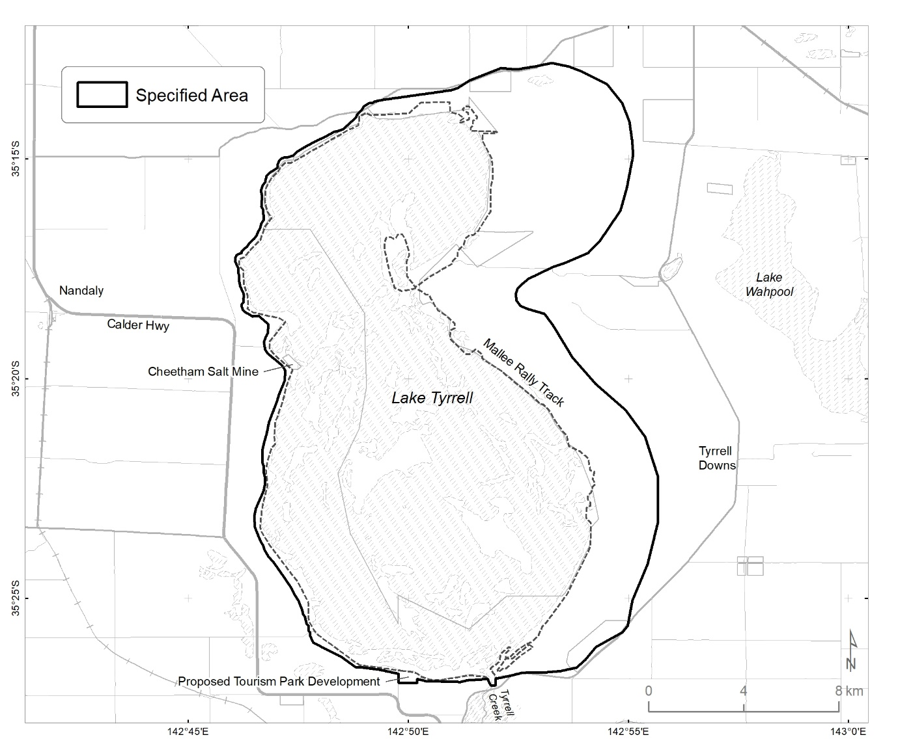
Figure 1 – Map showing the specified area, Direl (depicted within the solid bold line) (Lake Tyrrell), near Sea Lake, Victoria

Claims in relation to ‘significant Aboriginal area’
The applicants claim the specified area is of particular significance in accordance with Aboriginal tradition as it forms a cultural landscape of high cultural significance, containing burials, archaeological and cultural sites, including as a:
- well-known resting place for the sacred remains of Ancestors;
- gallery for the observation of the stars, other celestial objects and other astronomical phenomena, their movements and their interconnectedness;
- special and valued place dedicated to the intellectual, cultural, astronomy, and aesthetic life of individuals and their societies, providing a visual representation of many of the Creation Stories and other cultural accounts passed down orally from generation to generation;
- meeting place for the negotiation and settling of inter-clan/tribal business, for ceremonies and celebrations of events significant to the various clans and tribes; and
- resource for tracking of the seasons and availability of resources, including water, food, and medicine.

Claimed threats of injury or desecration
The applicants claim that the specified area is under threat from:
- the potential return of the Mallee Motorised Dune Buggy Rally.
- ongoing industry works, including salt mining operations and associated asbestos pollution of the lake and water table.
- a new tourist park development on private land near the edge of the lake; and
- planning and development activities encroaching on the tangible and intangible cultural heritage values of Direl without proper negotiation with First Peoples and their free, prior and informed consent.
- the failure of the State and Shire of Buloke to undertake a full Cultural Heritage Management Plan pursuant to the Aboriginal Heritage Act 2006 (Vic) aimed at identifying the substantive cultural values and physical cultural heritage of Direl.

Specified objects
The specified objects include the following:
- Sacred and culturally significant objects and artefacts including Burial Sites and Ancestral Remains, mounds, middens, and artefact scatters; and
- An Etched Bark from Direl depicting, among other things, ceremonies, emus, plus other artefacts held in the Museum of Victoria.

Invitation to make representations
Interested parties are invited to furnish representations in connection with my report to:
Mr Terry Bailey
O&G – Rosedale Pty Ltd
PO Box 445
Sandy Bay Tas 7005
T: 0409 313 381
E: Terry.oandg@gmail.com
Interested parties are invited to contact me as soon as possible to be provided with further information about the submission process, including the provision of the application, the making of representations in response to the application, and the making of final comments in response to representations received.
Representations must be made in writing by 5pm AEST on 1 September 2023 or within such further period as may be allowed. Do not send your representations directly to the Minister.
Representations made by, or on behalf of, more than one person should be signed by each of those persons.

Representations received by the due date may subsequently be provided to the applicants and other interested parties for their review and comment in order to meet procedural fairness requirements. If representations are circulated to the applicants and/or other interested parties for comment, an additional period will be allowed for those parties to make any final comments in writing. Representations will only be circulated to the applicants and/or other interested parties where the representation may adversely affect the interests of that particular interested party. Please contact me should you have any questions about this.

Claiming confidentiality

If you wish to claim confidentiality over any part of your representation, please identify why you are claiming confidentiality and how you wish confidentiality to apply. Representations will be provided to the Minister and the Department of Climate Change, Energy, the Environment and Water (department), along with the section 10 report. Representations, even those subject to confidentiality, may be disclosed where it is authorised or required by law, to meet procedural fairness requirements, and in response to a request by a House or Committee of the Parliament of the Commonwealth.
Privacy
Your personal information is protected by law, including the Privacy Act 1988 (Cth).
Please read this notice carefully before submitting a representation about the application.
Collection and use of your personal information
Your representation may contain your personal information, such as your name, contact details, your identity as an Aboriginal or Torres Strait Islander person, and your opinions about the application.
By submitting a representation, you consent to your personal information being collected by me for the purpose of:
• Contacting you about your representation, including for verification or clarification purposes;
• Preparing my report and briefing the Minister;
• The Minister making a decision in relation to the application
and for related purposes. You also consent to your personal information being collected by the Department of Climate Change, Energy, the Environment and Water for these same purposes.
Disclosure of your personal information
I may need to disclose your personal information to the department and the Minister for the purposes listed above. I may also need to disclose your personal information to:
• Third parties that may be affected by the Minister’s decision, where necessary to meet procedural fairness requirements;
• Commonwealth, State or Territory entities and/or persons or organisations, where necessary to prepare my report and/or for the Minister to make a decision about the application.
Your personal information will not be disclosed to overseas recipients unless necessary for the above purposes.
Anonymous representations
You can make an anonymous representation or use a pseudonym. However, this may mean I cannot verify information provided in your representation and/or take your representation into account.
Representations containing other people’s personal information
If your representation contains the personal information of another person, you must ensure they have agreed to their personal information being collected, used and disclosed in accordance with this privacy notice. This includes giving them a copy of this public notice and the privacy notice.
Privacy Policy
The department's privacy policy is available at: https://www.dcceew.gov.au/about/commitment/privacy and explains how personal information is handled by the department, how to access or correct your personal information, and how to make a complaint.

