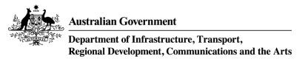

**NOTICE OF DECISION TO GRANT AN AUTHORISATION WITH CONDITIONS**

**UNDER THE AIRPORTS (ENVIRONMENT PROTECTION) REGULATIONS 1997**

Pursuant to Part 5 of the Airports (Environment Protection) Regulations 1997, notice is given that on 20 July 2023 a decision was made by the Airport Environment Officer for Western Sydney International (Nancy-Bird Walton) Airport (WSI), to grant authorisation with conditions to CPB Contractors Ghella Joint Venture to discharge treated construction water into Badgerys Creek via a pipeline running adjacent to stormwater detention basin number 3 on the Airport Site. The construction water is the result of tunnelling activities on the airport site for the Sydney Metro – WSA rail link running from St Mary’s to the Western Sydney Aerotropolis. The authorisation is valid until 31 October 2024.

A copy of the decision can be inspected at the offices of the WSI Airport Lessee Company, WSA Co Limited, Level 3, 45 Scott Street, Liverpool NSW 2170 or viewed online at:

[Airport environmental management | Department of Infrastructure, Transport, Regional Development, Communications and the Arts](https://www.infrastructure.gov.au/infrastructure-transport-vehicles/aviation/airports/airport-planning-regulation/airport-environmental-management)