Aboriginal and Torres Strait Islander Heritage Protection Act 1984 (Cth)
Notice of an application for the protection of a specified area, being an area at Binybara (Lee Point), Northern Territory
Invitation to make representations
I, Andrew Preston, hereby give notice as follows:
The Minister for the Environment and Water (minister), responsible for the Aboriginal and Torres Strait Islander Heritage Protection Act 1984 (Cth) (ATSIHP Act), has received an application made under section 10 of the ATSIHP Act. The application is seeking long term preservation and protection of a significant Aboriginal area at Binybara (Lee Point), in the Northern Territory. The minister has appointed me to provide a report to the minister under paragraph 10(1)(c) of the ATSIHP Act.

The Applicant
The application is made by Mr Kevin “Tibby” Quall. Mr Quall on behalf of the Batcho Family of the Kulumbirigin Danggalaba clan (the applicant).

The purpose of the application
The application seeks the long-term preservation or protection of the area specified in the application (the specified area). This area is depicted in Figure 1. Section 10 of the ATSIHP Act confers power on the minister to make a declaration to preserve and protect an area where the minister is satisfied that it is a ‘significant Aboriginal area’ under threat of injury or desecration. A ‘significant Aboriginal area’ is an area of land or water in Australia that is ‘of particular significance to Aboriginals in accordance with Aboriginal tradition’. ‘Aboriginal tradition’ is the ‘body of traditions, observances, customs and beliefs of Aboriginals generally or of a particular community or group of Aboriginals, and includes any such traditions, observances, customs or beliefs relating to particular persons, areas, objects or relationships’.

Matters the report is required to deal with
The minister must consider my report pursuant to section 10 of the ATSIHP Act in relation to the specified area before deciding whether to make a declaration under section 10 of the ATSIHP Act. Under subsection 10(4) of the ATSIHP Act, the report is required to deal with the following matters:
- the particular significance of the area to Aboriginals;
- the nature and extent of the threat of injury to, or desecration of, the area;
- the extent of the area that should be protected;
- the prohibitions and restrictions to be made with respect to the area;
- the effects the making of a declaration may have on the proprietary or pecuniary interests of persons other than the Aboriginal or Aboriginals who made the application, or on whose behalf the application is made;
- the duration of any declaration;
- the extent to which the area is or may be protected by or under a law of a State or Territory, and the effectiveness of any remedies available under any such law; and
- such other matters (if any) as are prescribed.

The specified area
Figure 1 depicts the area for which preservation and protection is sought. This specified area is described as Lots 4873 and 9370, at Binybara (Lee Point), north of Darwin, in the Northern Territory.
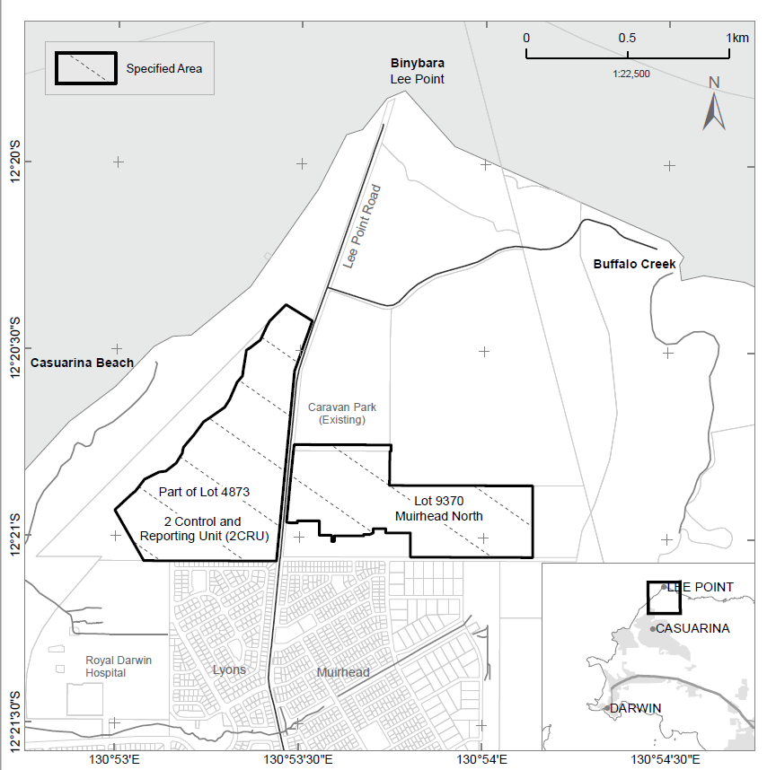
Figure 1 Map showing the specified area at Binybara (Lee Point), Darwin NT.

Claims in relation to ‘significant Aboriginal area’
The applicant claims the specified area is of particular significance in accordance with Aboriginal tradition for the following reasons:
- The specified area is part of a cultural landscape, connected to the registered sacred sites at the tip of Lee Point and Darriba Nungalinya (Old Man Rock), located offshore from Lee Point.
  - Binybara is the name of the sacred site at Lee Point and is also used by traditional owners to describe the broader cultural landscape.
  - Binybara, is the wife of Darriba Nungalinya.
- It contains Dreamings.
  - This includes the significant Kenbi (alligator) Dreaming track; the frog Dreaming places; and Darriba Nungalinya.
- It contains burial sites, stone scatters, camping places and the remains of the prehistoric dolphin.
- The applicant also claims that the areas near the top of the peninsula were used by the clan as ceremonial places for cleansing ceremonies when people passed away, as part of the burial process. The application claims the specified area has also been used for camping and hunting activities.

Claimed threat of injury or desecration
The applicant claims that the specified area is under threat from development by Defence Housing Australia (DHA) (the proponent) which includes residential housing, commercial and public infrastructure, and community facilities.

Invitation to make representations
Interested parties are invited to furnish representations in connection with my report to:
Andrew Preston
Binybara (Lee Point)
35/32 Turbot Street
Brisbane QLD 4000
Mob: 0487 090 597 or 1800 571 242
leepoint.submission@gmail.com
Interested parties are urged to contact me as soon as possible to be provided with further information about the submission process, including the provision of the application, the making of representations in response to the application, and the making of final comments in response to representations received.
Representations must be made in writing by 5pm ACST on 24 November 2023 or within such further period as may be allowed. Do not send your representations directly to the minister.
Representations made by, or on behalf of, more than one person should be signed by each of those persons.

Representations received by the due date may subsequently be provided to the applicant and other interested parties for their review and comment in order to meet procedural fairness requirements. If representations are circulated to the applicant and/or other interested parties for comment, an additional period will be allowed for those parties to make any final comments in writing. Representations will only be circulated to the applicant and/or other interested parties where the representation may adversely affect the interests of that particular interested party. Please contact me should you have any questions about this.

Claiming confidentiality
If you wish to claim confidentiality over any part of your representation, please identify why you are claiming confidentiality and how you wish confidentiality to apply. Representations will be provided to the Minister for the Environment and Water and the Department of Climate Change, Energy, the Environment and Water (department), along with the section 10 report. Representations, even those subject to confidentiality, may be disclosed where it is authorised or required by law, to meet procedural fairness requirements, and in response to a request by a House or Committee of the Parliament of the Commonwealth.
Privacy
Your personal information is protected by law, including the Privacy Act 1988 (Cth).
Please read this notice carefully before submitting a representation about the application.
Collection and use of your personal information
Your representation may contain your personal information, such as your name, contact details, your identity as an Aboriginal and/or Torres Strait Islander person, and your opinions about the application.
By submitting a representation, you consent to your personal information being collected by me for the purpose of:
- Contacting you about your representation, including for verification or clarification purposes;
- Preparing my report and briefing the minister;
- The minister making a decision in relation to the application,
and for related purposes You also consent to your personal information being collected by the department for these same purposes.
Disclosure of your personal information
I may need to disclose your personal information to the department and the minister for the purposes listed above. I may also need to disclose your personal information to:
- Third parties that may be affected by the minister’s decision, where necessary to meet procedural fairness requirements;
- Commonwealth, State or Territory entities and/or persons or organisations, where necessary to prepare my report and/or for the minister to make a decision about the application.
Your personal information will not be disclosed to overseas recipients unless necessary for the above purposes.
Anonymous representations
You can make an anonymous representation or use a pseudonym. However, this may mean I cannot verify information provided in your representation and/or take your representation into account.
Representations containing other people’s personal information
If your representation contains the personal information of another person, you must ensure they have agreed to their personal information being collected, used and disclosed in accordance with this privacy notice. This includes giving them a copy of this public notice and the privacy notice.
Privacy Policy
The department's Privacy Policy is available at https://www.dcceew.gov.au/about/commitment/privacy and explains how personal information is handled by the department, how to access or correct your personal information, and how to make a complaint.

