# 

**Government House**

**CANBERRA ACT 2600**

**16 August 2023**

**Honorary Appointment - General Division - December 2023**

**The Governor-General is pleased to announce the following appointment in the   
Order of Australia:**

**HONORARY MEMBER (AM) IN THE GENERAL DIVISION**

**General Elrick IRASTORZA (Retd),** Castries, France

For significant service to the relationship between Australia and France, during the ANZAC Centenary Commemorative period in France (2014-2018).

By His Excellency’s command

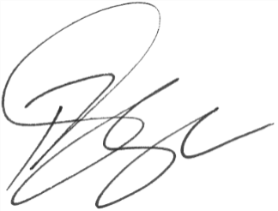

### **Paul Singer MVO**

Official Secretary to the Governor-General