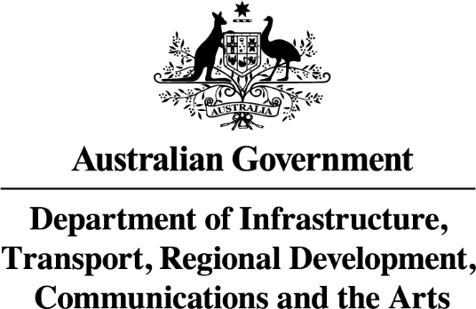

AIRPORTS (PROTECTION OF AIRSPACE) REGULATIONS 1996

Notice of Declaration of Prescribed Airspace
for Perth Airport 2023

NOTICE is hereby given that on 19 December 2023, the Department of Infrastructure, Transport, Regional Development, Communications and the Arts, pursuant to subregulation 5(1) of the Airports (Protection of Airspace) Regulations 1996, declared prescribed airspace for Perth Airport.

Charts of the prescribed airspace for Perth Airport are available for inspection or purchase from:

Airfield Planning,
Perth Airport Pty Ltd
2 George Wiencke Drive
Perth Airport WA 6105

