Government House

CANBERRA ACT 2600

8 December 2023

ORDER OF AUSTRALIA

It is notified for general information that the Governor-General of the Commonwealth of Australia has accepted the resignation as a member of the Order of Australia in the General Division with effect from 8 December 2023 of:

Mr Michael Joseph Keelty APM

To cease to be appointed an Officer of the Order of Australia

By His Excellency’s Command

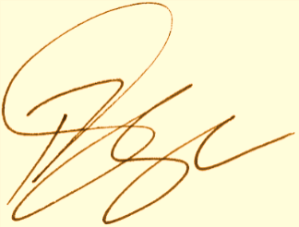

Paul Singer MVO
Official Secretary to the Governor-General
Secretary of the Order of Australia

