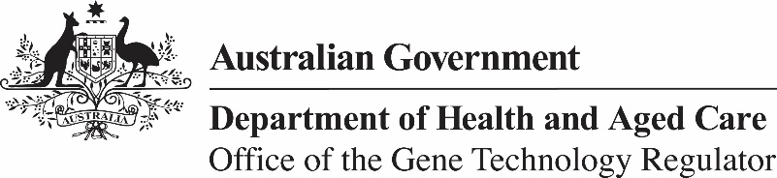
31 January 2024

Invitation to comment on a field trial of genetically modified wheat and barley (DIR 201)
The Gene Technology Regulator is assessing an application from The University of Adelaide to conduct a field trial of wheat and barley genetically modified for yield enhancement. The trial is proposed to take place between May 2024 and January 2029, on one site with a maximum of 2 hectares per year. The trial site is located in Light Regional Council in South Australia. The GM wheat and barley grown in this field trial would not be used for human food or animal feed.
The Regulator has prepared a Risk Assessment and Risk Management Plan (RARMP) for this application and welcomes written submissions relating to the protection of human health and safety and the environment prior to making a decision on whether to issue the licence. The consultation RARMP and related information can be obtained via our website (search for DIR 201), or from the contacts below. Submissions should reference DIR 201 and be received by 12 March 2024.
Office of the Gene Technology Regulator
MDP 54 GPO Box 9848 CANBERRA ACT 2601
Telephone: 1800 181 030 Website: www.ogtr.gov.au
E-mail: ogtr@health.gov.au

