|  |  |  |  |  |
| --- | --- | --- | --- | --- |
| Commonwealth Coast of Arms of Australia | **Commonwealth**  **of Australia** | **Gazette** | | |
| Published by the Commonwealth of Australia | | | **GOVERNMENT NOTICES** |
|  | | |

***Customs Act 1901***

**Notice under paragraph 15(2)(b) and subsection 15(3)   
Boarding Station Revocation and Appointment (No. 24/01)**

I, Phil Emerson, delegate of the Comptroller-General of Customs, under paragraph 15(2)(b) and subsection 15(3) of the *Customs Act 1901* (***the Act***):

1. REVOKE the Boarding Station Appointment No. (2602)

(GN No.C2017G00706) published in the *Commonwealth of Australia Gazette* on 27th June 2017, appointing Super Yacht Berths SY1-SY5 and adjacent gangway at South Port Yacht Club Marina within the Port of Brisbane as a boarding station and limiting the purpose in the South Port Yacht Club; and

1. APPOINT the area, within the red boundary line as indicated in **Attachment A,** of the Super Yacht Berths SY1 – SY5, gangway adjacent to SY1 – SY5, and Mega Yacht Berths MY01 to MY03, in the Port of Brisbane in the State of Queensland, as a boarding station; and
2. LIMIT the purpose of the boarding station covered by paragraph (b) to the clearance of a ship (within the meaning of the Act) to which both of the following apply:
3. the ship is 100 metres or less in length; and
4. cargo is not unloaded from or loaded on the ship.

This notice commences on 2nd February 2024.

Dated the 25th day of January 2024.

Phil Emerson

Director Ports Policy

Traveller Policy and Industry Engagement

Industry and Border Systems Division

Australian Border Force

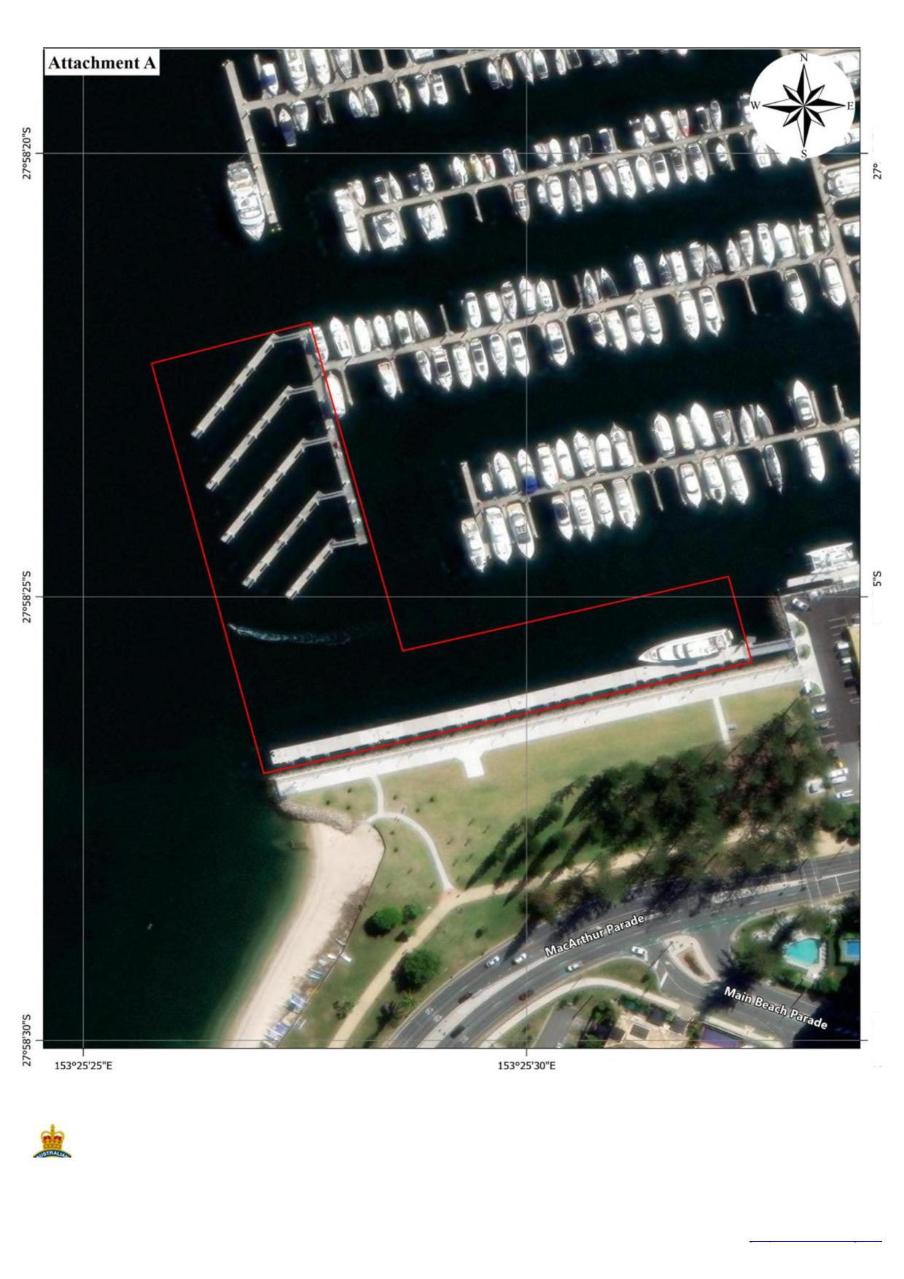

153°25'25"E 153°25'30"E

vi U-,

N co

N N

(r)

O co m Lri

0

N N

**South Port Yacht Club Marina**

Limits of the **Boarding — Station** appointed under s15(2)(b) of the *Customs Act 1901*

**Section 15 of the** *Customs Act 1901* **(Cth)   
Appointment of South Port Yacht Club Marina   
in the Port of Brisbane, Queensland**

Imagery Source:

ESRI Imagery Basemap 18AUG2022

**Australian**

**BORDER FORCE**

Photo Scale = 1:1,500

*Date produced: 25/01/2024 Map produced by Geospatial Intelligence Unit Department of Home Affairs* [*geospatial@homeaffairs.gov.au*](mailto:geospatial@homeaffairs.gov.au)