***Customs Act 1901***

**Notice under Subsection 234AA(3)**

**Revocation and Specification of areas to which section 234AA applies (No. 24/02) – Adelaide International Airport**

I, Phil Emerson, delegate of the Comptroller-General of Customs, under subsection 234AA(3) of the *Customs Act 1901* (***the Act***):

1. REVOKE the notice titled ‘NOTICE UNDER SECTION 234AA OF THE CUSTOMS ACT 1901 AIRPORT RESTRICTED AREAS’, published in the Commonwealth of Australia Gazette No.18 on 9 May 2007, specifying areas in the international terminal of Adelaide International Airport as areas to which section 234AA of the Act applies; and
2. SPECIFY the areas within the red boundary lines as indicated in **Attachment A**, **Attachment B** and **Attachment C** to this notice, at the international terminal of Adelaide International Airport in the state of South Australia, as areas to which section 234AA of the Act applies.

This notice commences on 13th of February 2024.

Dated the 13th day of February 2024.

Phil Emerson

Director Ports Policy

Traveller Policy and Industry Engagement Branch

Industry and Border Systems Group

Australian Border Force

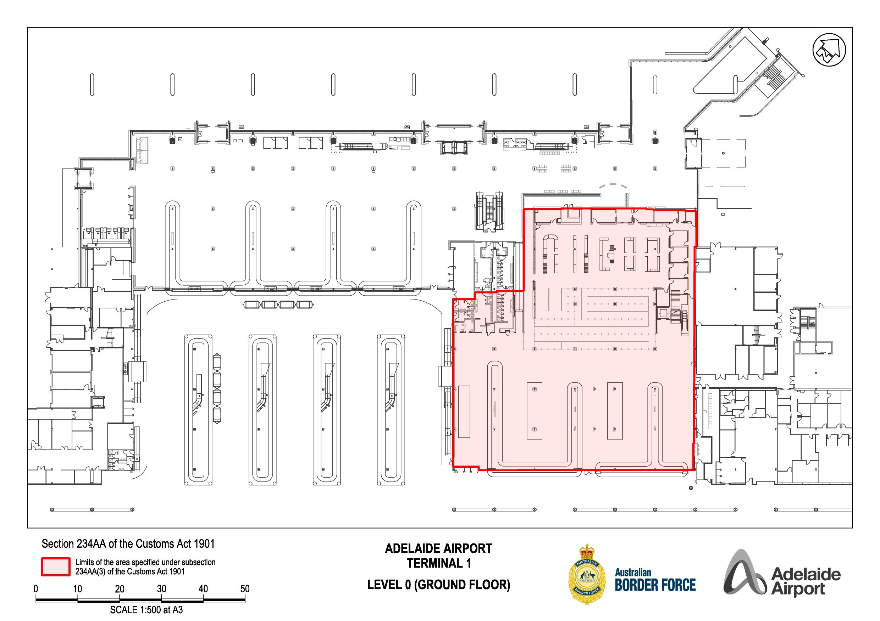

Attachment A

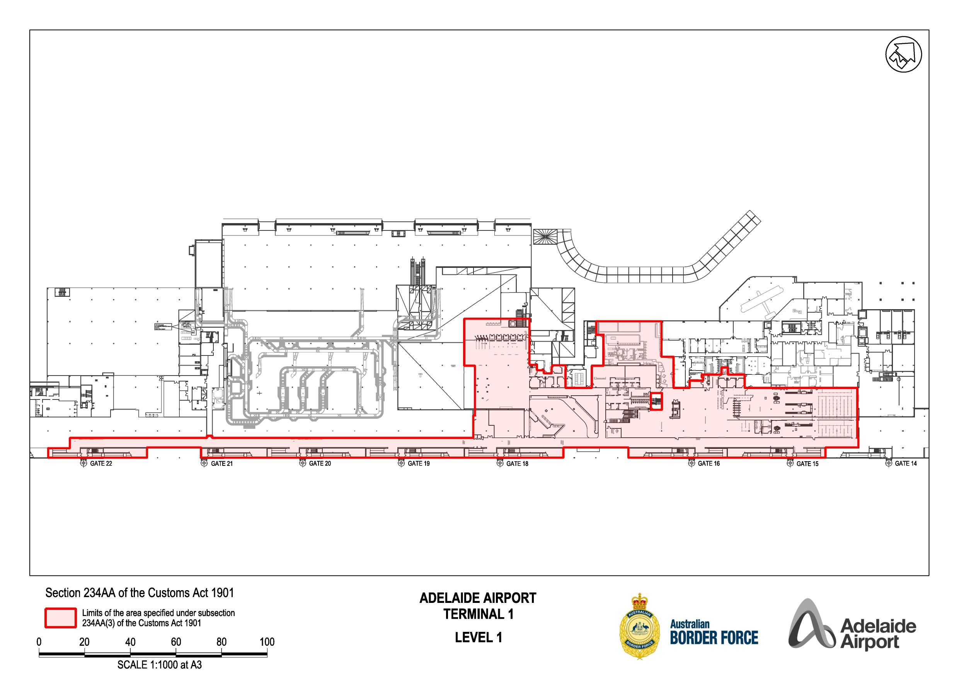

Attachment B

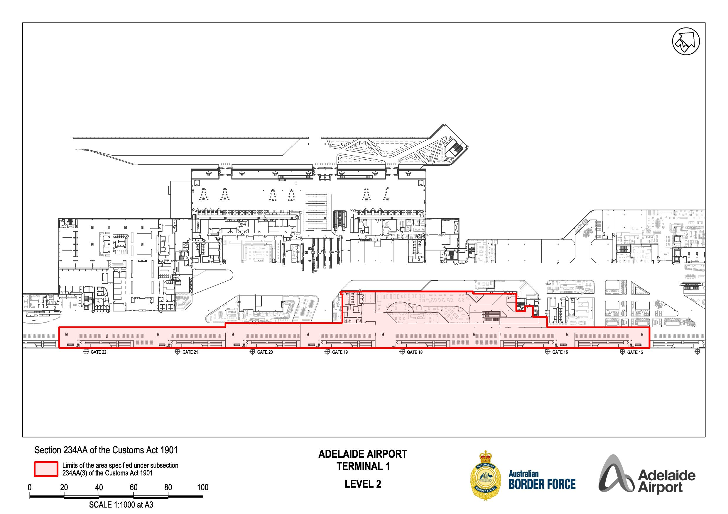

Attachment C