*Excise Tariff Act 1921*

**NOTICE OF SUBSTITUTED RATES OF EXCISE DUTY**

NOTICE No. 2 (2024)

I, Tony Poulakis, delegate of the Commissioner of Taxation, in accordance with subsections 6AA(11) and 6AAB(9) of the *Excise Tariff Act 1921* (the Tariff Act), give notice that, on and from 1 March 2024, the substituted rate of excise duty for goods classified to each item of the Schedule to the Tariff Act set out in Column 1 of the following table is the rate set out in Column 2 opposite each item.

In this notice, “item” means item and subitem.

**THE TABLE**

|  |  |
| --- | --- |
| Column 1 | Column 2 |
|  |  |
| Excise tariff item | Substituted rate of duty |
|  |  |
| 5.1 | $1.27816 per stick |
| 5.5 | $1893.57 per kilogram of tobacco content |
| 5.8 | The amount of duty worked out under section 6AAC |
|  |  |

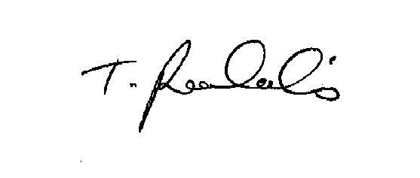

Dated this 22nd day of February 2024.

Tony Poulakis

Delegate of the Commissioner of Taxation