# 

**Government House**

**CANBERRA ACT 2600**

**26 October 2023**

**The Governor-General is pleased to announce the following award:**

**COMMENDATION FOR DISTINGUISHED SERVICE**

*Australian Army*

**Lieutenant Colonel Conrad Hayden WALSH**

For outstanding achievement in the performance of duty as the Public Affairs and Information Operations Advisor to the Kabul Garrison Command on warlike operations from 11 October 2016 to 15 June 2017.

**By His Excellency’s command**

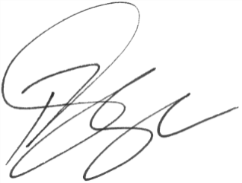

### **Paul Singer MVO**

Official Secretary to the Governor-General