Government House

CANBERRA ACT 2600

25 October 2023

Gallantry Decorations

The Governor-General is pleased to announce the following Gallantry Decorations:

MEDAL FOR GALLANTRY (GM)

Pilot Officer Warran Frank COWAN
For acts of gallantry in action in hazardous circumstances on 22 July 1942 as the plane captain of Lockheed Hudson A16-201.
Sergeant Russell Bradburn POLLACK
For acts of gallantry in action in hazardous circumstances on 22 July 1942 as the plane navigator of Lockheed Hudson A16-201.
Sergeant Laurie Edwin SHEARD
For acts of gallantry in action in hazardous circumstances on 22 July 1942 as the aircraft gunner of Lockheed Hudson A16-201.
Pilot Officer David Reid TAYLOR
For acts of gallantry in action in hazardous circumstances on 22 July 1942 as the plane wireless operator of Lockheed Hudson A16-201.

COMMENDATION FOR GALLANTRY

For acts of gallantry in action over two tours of operational service with Number 464 Squadron.

Warrant Officer William Albert KINLOCH
Pilot Officer Justin Reginald MULLIGAN

By His Excellency’s command
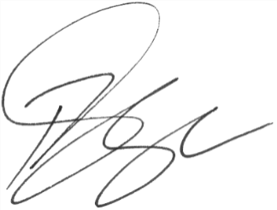

Paul Singer MVO
Official Secretary to the Governor-General

