**COMPETITION AND CONSUMER ACT 2010**

**Extension of the declaration expiry date under section s152ALA(4) – Local carriage service – 2024**

1. Pursuant to section 152ALA(4) of the *Competition and Consumer Act 2010* (the Act), the Australian Competition and Consumer Commission extends the expiry date for the Local Carriage Service (LCS) declaration to 30 June 2029.

Note: the previous expiry date was 30 June 2024.

1. The LCS is described in Annexure 1 to this instrument.

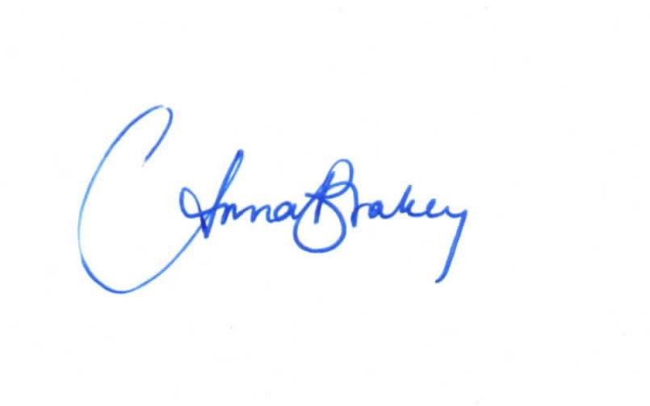

………………………………………….

Anna Brakey

Commission

Australian Competition and Consumer Commission

Dated: 26 March 2024

**Annexure 1: Service description for the LCS**

The Local Carriage Service is a service for the carriage of telephone calls from customer equipment at an end-user’s premises to separately located customer equipment of an end-user in the same standard zone, however, the local carriage service does not include services where the connectivity between the end-user and the carrier or carriage service provider’s network is provided in whole or in part by means of a Layer 2 bitstream service that is supplied by an NBN corporation.

**Definitions**

Where words or phrases used in this declaration are defined in the Act or the Telecommunications Act 1997, they have the same meaning given in the relevant Act.

In this Appendix:

**Layer 2 bitstream service** has the same meaning as in the Telecommunications Act 1997;

**NBN corporation** has the same meaning as in the National Broadband Network Companies Act 2011;

**public switched telephone network** is a telephone network accessible by the public providing switching and transmission facilities utilising analogue and digital technologies;

**standard zone** has the same meaning as in Part 4 of the Telecommunications (Consumer Protection and Service Standards) Act 1999;

**telephone calls** are calls for the carriage of communications at 3.1kHz bandwidth solely by means of a public switched telephone network.