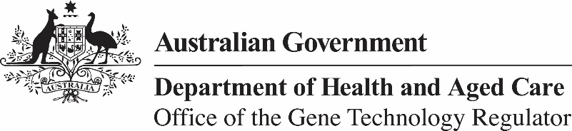

2 May 2024

Invitation to comment on the commercial release
of a live attenuated vaccine containing canine distemper virus and a genetically modified canine parvovirus (Nobivac Puppy DP Plus) for dogs
The Gene Technology Regulator is assessing an application from Intervet Australia Pty Ltd for the commercial supply of a live attenuated vaccine containing canine distemper virus and a genetically modified (GM) canine parvovirus (Nobivac Puppy DP Plus) for dogs. The vaccine would be used as a prescription only vaccine for dogs.
As a veterinary product, the vaccine requires Intervet Australia Pty Ltd to seek approval from both the OGTR and the Australian Pesticides and Veterinary Medicines Authority (APVMA) before it is able to be used in Australia.
The Regulator has prepared a Risk Assessment and Risk Management Plan (RARMP) for this application and welcomes written submissions on any risks to human or animal health and the environment posed by the import, transport, storage and disposal of this vaccine and is seeking comment on the assessment prior to making a decision on whether to issue the licence.
The consultation RARMP and related information can be obtained via our website (search for DIR 202), or from the contacts below. Submissions should reference DIR 202 and be received by 19 June 2024.
Office of the Gene Technology Regulator
MDP 54 GPO Box 9848 CANBERRA ACT 2601
Telephone: 1800 181 030 Website: www.ogtr.gov.au
E-mail: ogtr@health.gov.au

