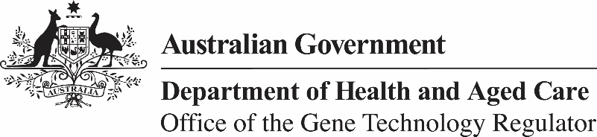

5 June 2024

**Invitation to comment on a field trial of genetically modified** **wheat (DIR 204)**

The Gene Technology Regulator is assessing an application from Trigall Australia Pty Ltd to conduct a field trial of wheat genetically modified for increased tolerance to environmental stress. The trial is proposed to take place at 10 sites with a total area of 20 ha per year over 5 years. Sites will be in NSW, Vic, WA and SA. The plants grown in this field trial would not be used for human food or animal feed.

The Regulator has prepared a Risk Assessment and Risk Management Plan (RARMP) for this application and welcomes written submissions relating to the protection of human health and safety and the environment prior to making a decision on whether to issue the licence. The consultation RARMP and related information can be obtained via our website (search for DIR 204), or from the contacts below. Submissions should reference DIR 204 and be received by **16 July 2024**.

**Office of the Gene Technology Regulator  
MDP 54 GPO Box 9848 CANBERRA ACT 2601**

**Telephone: 1800 181 030 Website:** [**www.ogtr.gov.au**](https://www.ogtr.gov.au/)

**E-mail:** [**ogtr****@health.gov.au**](mailto:ogtr@health.gov.au)