# 

**Government House**

**CANBERRA ACT 2600**

**18 June 2024**

**Honorary Appointment - Military Division - July 2024**

**The Governor-General is pleased to announce the following appointment in the   
Order of Australia:**

**HONORARY OFFICER (AO) IN THE MILITARY DIVISION**

**General Charles Anthony FLYNN,** Hawaii, United States of America

For distinguished service in fostering and deepening the military relationship between Australia and the United States of America.

By Her Excellency’s command

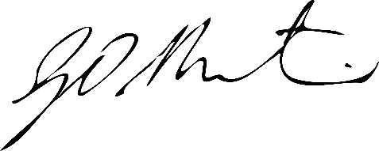

**Gerard Martin PSM**

Official Secretary to the Governor-General