# 

**Government House**

**CANBERRA ACT 2600**

**15 April 2024**

**Honorary Appointment - Military Division - September 2024**

**The Governor-General is pleased to announce the following appointment in the   
Order of Australia:**

**HONORARY MEMBER (AM) IN THE MILITARY DIVISION**

**Major General Mubarak Ali Abdullah AL NEYADI,** Abu Dhabi, United Arab Emirates  
For exceptional service in fostering the military relationship between Australia and the United Arab Emirates.

By Her Excellency’s command

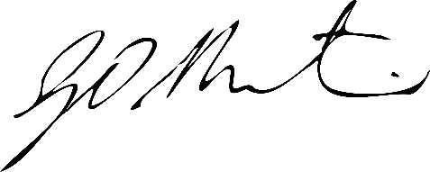

### **Gerard Martin PSM**

Official Secretary to the Governor-General