

Government House

CANBERRA ACT 2600

26 September 2024

ORDER OF AUSTRALIA

It is notified for general information that the Governor-General of the Commonwealth of Australia has terminated the appointment as an Officer of the Order of Australia made to:

Mr Michael Pezzullo

By Her Excellency’s Command

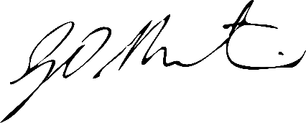

Gerard Martin PSM
Official Secretary to the Governor-General
Secretary of the Order of Australia

