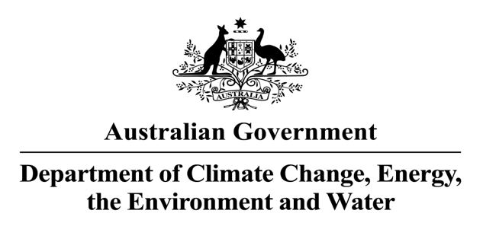  
***ENVIRONMENT PROTECTION (SEA DUMPING) ACT 1981*   
MATTERS TO BE PUBLISHED IN THE GAZETTE FOR THE PERIOD:   
1 July 2024 to 30 September 2024**

Pursuant to section 25 of the *Environment Protection (Sea Dumping) Act 1981* (the Act), notice is given that:

***Applications for permits received under section 18 of the Act***

* An application (SD2024-4064) was received on 9 July 2024 from OceanR Pty Ltd, trading as Offshore Biotechnologies, Level 3, 28 Kay Street, Traralgon, Victoria 3844 (ACN: 656 378 862) and Director of Parks Australia (ACN: 051 694 963) for the placement of an artificial reef for research purposes. The reef comprises purpose-built structures consisting of 64 concrete mats, 36 limestone aggregate reefs and 8 recycled bivalve shell reefs, located offshore approximately 12 kilometres south of Cape Otway, Victoria, in the northwest corner of Apollo Marine Park.
* An application (SD2024-4065) was received on 27 August 2024 from WA Recreational and Sportfishing Council (Inc.), trading as Recfishwest, Suite 3, 45 Northside Drive, Hillarys, Western Australia, 6025 (ABN: 77 922 817 608) and the Department of Primary Industries and Regional Development, 1 Nash Street, Perth, Western Australia, 6000 (ABN: 18 951 343 745) for the placement of an artificial reef for recreational fishing purposes. The reef comprises up to 48 purpose-built concrete modules, located offshore approximately 29 kilometres north north-west of Dampier, Western Australia.
* An application (SD2024-4066) was received on 16 September 2024 from Tasmanian Ports Corporation Pty Ltd, trading as TasPorts, 90-110 Willis Street, Launceston, Tasmania 7250 (ABN: 82 114 161 938) for a 10-year permit to load for the purposes of dumping, and to dump up to 1,974,000 cubic metres (in-situ) of dredged material derived from the maintenance dredging of the entrance channel and bend and the inner harbour at the Port of Devonport, Devonport, Tasmania.
* An application (SD2024-4067) was received on 20 September 2024 from the City of Cockburn,   
  9 Coleville Crescent, Spearwood, Western Australia 6163 (ABN: 27 471 341 209), for the placement of an artificial reef for human recreational purposes. The reef comprises of a repurposed 2 tonne iron anchor, located offshore approximately 0.3 km south south-west of the marina breakwaters at North Coogee, Western Australia.
* An application (SD2024-4068) was received on 18 September 2024 from LINX Port Services Pty Ltd (trading as CKI Port), Rumah Baru Road, West Island, Cocos (Keeling) Islands, Western Australia 6799 (ACN: 44 007427652), for a permit to load for the purposes of dumping, and to dump up to 1 steel unmotorised barge vessel (James Capstan; UVI 455674), located offshore approximately 1.4 km west-north-west of Direction Island, Cocos (Keeling) Islands, Western Australia.

***Applications received for permit variations under section 23 of the Act***

* An application for a variation to a permit (SD2016-3462) was received on 18 July 2024 from Pilbara Iron Pty Ltd, Level 22 Central Park, 152-158 Georges Terrace, Perth, Western Australia 6000   
  (ACN: 107 216 535). The variation sought to extend the permit period by 6 months.
* An application for a variation to a permit (SD2018-3942) was received on 11 September 2024 from the Port of Townsville Limited, Engineering Building, Benwell Road, Townsville, Queensland 4810   
  (ACN: 130 077 673). The variation sought to vary the approved maintenance dredging footprint at the Port of Townsville, Queensland. The variation proposed to encompass the widened channel footprint created from the Port of Townsville’s Channel Upgrade project into the maintenance dredging footprint.

***P******ermit variations granted under sections 21 and 23 of the Act***

* A variation (No.1) to a permit (SD2016-3462) was granted on 6 September 2024 to Pilbara Iron Pty Ltd, Level 22 Central Park, 152-158 Georges Terrace, Perth, Western Australia, 6000 (ACN: 107 216 535). The variation extended the existing permit period by 6 months from 31 January 2025 to 31 July 2025. The permit is for the loading for the purposes of dumping, and to dump up to 1,113,116 cubic metres of dredged material (in-situ; remaining from the original total of 1,225,000 cubic metres), derived from the maintenance dredging of areas within the berths, swing basins and departure channels associated with the East Intercourse Island and Parker Point port facilities at the Port of Dampier in Dampier, Western Australia. This permit is valid until 31 July 2025.
* A variation (No.2) to a permit (SD2018-3942) was granted on 30 September 2024 to the Port of Townsville Limited, Engineering Building, Benwell Road, Townsville, Queensland 4810   
  (ACN: 130 077 673) to vary the approved maintenance dredging footprint to encompass the widened channel footprint created from the Port of Townsville’s Channel Upgrade project. The permit is to load for the purposes of dumping, and to dump up to 1,618,327 of dredged material (in-situ; remaining from the original total of 4,050,000 cubic metres), derived from maintenance dredging of the inner and outer harbour areas, swing basins and in the Platypus and Sea Channels at the Port of Townsville, Queensland. This permit is valid until 31 May 2025.

The Minister/delegate did not require either of the variations to the permits to undergo an assessment in accordance with section 160 of the *Environment Protection and Biodiversity Conservation Act 1999* (EPBC Act).

Copies of a decision by the Minister/delegate under the Act may be obtained, upon request, from the Director, Sea Dumping Section, Department of Climate Change, Energy, the Environment and Water, GPO Box 3090, CANBERRA, ACT 2601.

Heather Agnew

Director

Sea Dumping Section

23 October 2024