

**Government House CANBERRA ACT 2600**

19 March 2025

**Australian Bravery Decorations March 2025**

BRAVERY MEDAL (BM)

*(For acts of bravery in hazardous circumstances)*

Mr Jordan Heath ANDERSON

Mr Stephen Shane EDWARDS

QLD

The late Senior Constable Kelly Ann FOSTER

New South Wales Police Force

Mr Luke Aidan GIUDICATTI

Ingham QLD 4850

Ms Gabrielle Rebecca KELLY

North Ipswich QLD 4305

`

COMMENDATION FOR BRAVE CONDUCT

*(For acts of bravery worthy of recognition)*

Mr Liam Connor BRIAN

Charmhaven NSW 2263

Mr Jason Andrew GIBBS

Mr Luke Alex GORECKI

NSW

Mr Clifford George HAGART

Sunset Beach Geraldton WA 6530

Mr Cameron Jack ONEILL

Coomera QLD 4209

Detective Senior Constable Travis Mark PETERSEN

Western Australia Police Force

Mr Peter ZMUDA

Northcote VIC 3070

GROUP BRAVERY CITATION

*(For a collective act of bravery, by a group of persons in extraordinary circumstances, that is considered worthy of recognition)*

*The recipients are recognised with the award of the Group Bravery Citation for their actions in intervening and apprehending a man armed with a knife in Sydney, NSW on 13 August 2019.*

Mr Mitchell John BENNETTS

Mermaid Waters QLD 4217

Mr Bennett Lea GARDINER

NSW

Mr Gonzalo Alejandro HERRERA

Liberty Grove NSW 2138

Mr Jamie INGRAM

NSW

Mr Jase SHORE

SA

By Her Excellency’s command

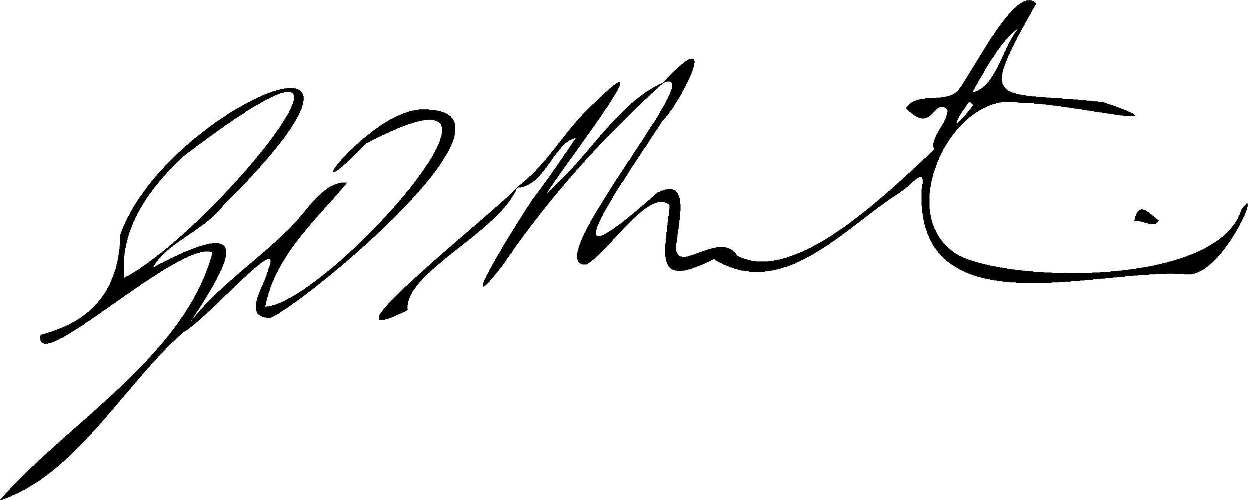

Gerard Martin PSM

Official Secretary to the Governor-General