# A black and white image of a crown and wattle - logo of the Office of the Governor-General

**Government House**

**CANBERRA ACT 2600**

**9 March 2025**

**National Medal (Approved Voluntary Organisations) Determination 2025**

It is notified for general information that the Governor-General has approved the extension of eligibility for the National Medal to volunteer members of the Royal Life Saving Clubs of Queensland Inc.

A copy of the Determination will be made available on the Governor-General’s website at www.gg.gov.au

By Her Excellency’s Command

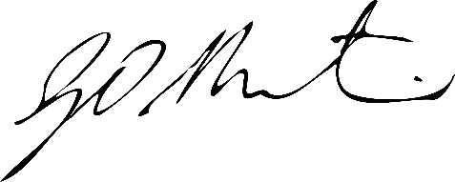

### **Gerard Martin PSM**

Official Secretary to the Governor-General