A black and white image of a crown and wattle - logo of the Official Office of the Governor-General


**Government House**

**CANBERRA ACT 2600**

##### 7 March 2025

**ORDER OF AUSTRALIA**

It is notified for general information that the Governor-General of the Commonwealth of Australia has cancelled the Medal of the Order of Award awarded to:

**Mr George Wadih Ghossayn**

# By Her Excellency’s Command

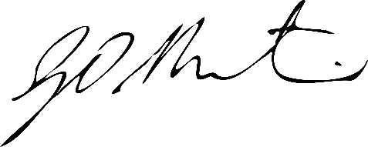

#### Gerard Martin PSM

Official Secretary to the Governor-General

Secretary of the Order of Australia