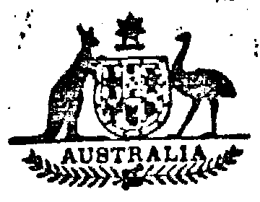
Statutory Rules
1976 No. 146
REGULATIONS UNDER THE HEALTH INSURANCE COMMISSION ACT 1973.*
I, THE GOVERNOR-GENERAL of the Commonwealth of Australia, acting with the advice of the Federal Executive Council, hereby make the following Regulations under the Health Insurance Commission Act 1973.
Dated this twenty-second day of July, 1976.
John R. Kerr
Governor-General.
By His Excellency’s Command,
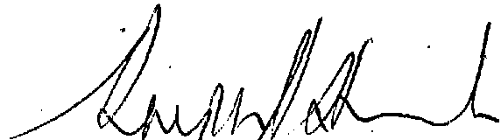
Minister of State for Health.
Amendments of the Health Insurance Commission Regulations†
1. After regulation 2 of the Health Insurance Commission Regulations, the following regulation is inserted:—
Definitions.
“ 2a. In these Regulations—
‘ officer ’ means an officer or employee of the Commission;
‘ registered organization ’ means an organization that was, immediately before the commencement of the Act, a registered medical benefits organization or a registered hospital benefits organization within the meaning of the National Health Act 1953;
‘ the Act ’ means the Health Insurance Commission Act 1973.”.
Previous employment to be taken into account.
2. After regulation 5 of the Health Insurance Commission Regulations the following regulation and Schedules are added:—
“ 6. (1) Sub-regulation (2) applies to an officer who—
(a) became an officer before 8 August 1975;
(b) ceased to be employed by a registered organization specified in Schedule 1 on or after 1 July 1975 and before 1 July 1978 and became an officer within 12 months after so ceasing to be employed by that organization; or
(c) ceased to be employed by a registered organization specified in column 1 of Schedule 2 on or after 1 July 1975 and before the date specified in relation to that organization in column 2 of Schedule 2 and became an officer within 12 months after so ceasing to be employed by that organization.
*Notified in the Australian Government Gazette on 22 July 1976.
† Statutory-Rules 1975. No. 27, as amended by Statutory Rules 1976, No. 21.
16148/75—Recommended retail price 10c 10/5.7.1976
“ (2) The previous employment of an officer to whom, this sub-regulation applies in the service of a registered organization, being employment in the service of that organization that would, immediately before he ceased to be employed in the service of that organization, have been taken into account for the purposes of determining his entitlement to long service leave under the terms of his employment in the service of that organization, shall be taken into account for the purposes of section 6 of the Commonwealth Employees’ Furlough Act 1943 as if that previous employment were employment in the service of an authority of the Commonwealth.”.
SCHEDULE 1 Regulation 6 (1)
Army Health Benefits Society
Associated Pulp and Paper Makers’ Council Medical Benefits Fund
Australian Catholic Guild Friendly Society
Coals Patons Employees’ Mutual Benefit Society and Hospital and Medical Benefit Association
Commonwealth Bank Health Society
Electrolytic Zinc Employees’ Medical Union
E. R. & S. Hospital and Medical Club
Goldfields Medical Fund (Incorporated)
Hibernian Australasian Catholic Benefit Society of New South Wales
Independent Order of Odd Fellows of the State of New South Wales
Independent Order of Odd Fellows of Victoria
Latrobe Valley Hospitals and Health Services Association
Local Government Employees’ Medical and Hospital Club
Naval Health Benefits Society
Newcastle Industrial Benefits Limited
New South Wales District, No. 85, Independent Order of Rechabites, Salford Unity, Friendly Society
New South Wales Teachers’ Federation Health Society
Northern District Miners’ Medical Fund
Pemberton Medical Accident and Hospital Fund
Queensland Teachers’ Union Health Society
Queenstown Medical Union Ancillary Medical Benefits Fund
Reserve Bank Health Society
Rosebery Hospital & Medical Benefits Society
Tasmanian Government Insurance Office Medical Benefits Plan
The Hunter Medical Benefit Fund Limited
The Lysaght Hospital & Medical Club
The Manchester Unity Independent Order of Oddfellows Friendly Society in Queensland
The Mildura’ District Hospital & Medical Fund
The Phoenix Welfare Association Limited
The Store Hospital and Medical Fund
The Victorian District Independent Order of Rechabites Friendly Society
Tramways Benefit Society
Western District Medical Benefits Fund
SCHEDULE 2 Regulation 6 (1)
Column 1 | Column 2
Name of organization | Date
Post Office Mutual Benefit Society of N.S.W……………………………………….. | 17 December 1975
Printed by Authority by the Government Printer of Australia.

