STATUTORY RULES.
1952. No. 60.
–––––––––
REGULATIONS UNDER THE DEFENCE ACT 1903-1951.*
I, THE GOVERNOR-GENERAL in and over the Commonwealth of Australia, acting with the advice of the Federal Executive Council, hereby make the following Regulations under the Defence Act 1903-1951.
Dated this fourth day of August, 1952.
Governor-General.
By His Excellency’s Command,
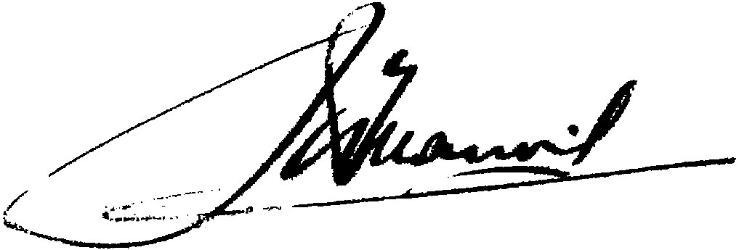
Minister of State for the Army.
–––––––
Amendments of the Australian Military Regulations.†
Order of precedence.
1. Regulation 65 of the Australian Military Regulations is amended by omitting from paragraph (c) of sub-regulation (1) the words “A lance-sergeant or acting lance-sergeant shall take precedence of all corporals, and a lance-bombardier,” and inserting in their stead the words “A lance-bombardier,”
2. Regulation 75 of the Australian Military Regulations is repealed and the following regulation inserted in its stead:—
Eligibility to compete for examinations for promotion to commissioned rank.
“75. A member of a unit of the Citizen Forces who is a warrant officer, or a non-commissioned officer of the rank of, or a higher rank than the rank of, corporal or bombardier may present himself for examination for promotion to the rank of lieutenant—
(a) in the unit to which he belongs;
(b) if his unit is a unit maintained at an educational establishment—in a unit of the battalion area in which he resides, or, with the approval of the formation, &c., commanders concerned, in another unit of the Citizen Forces; or
(c) in a unit of the Citizen Forces of the Royal Australian Engineers or of the Royal Australian Corps of Signals in the military district in which he is serving.”.
Promotions to commissioned ranks in Citizen Forces.
3. Regulation 76 of the Australian Military Regulations is amended—
(a) by omitting from sub-regulation (1) the words “Senior Cadets” and inserting in their stead the words “Australian Cadet Corps”; and

* Notified in the Commonwealth Gazette on , 1952.
† Statutory Rules 1927, No. 149, as amended to date. For previous amendments of the Australian Military Regulations see Statutory Rules 1952, No. 8 and see also Statutory Rules 1952, Nos.
2080.—Price 3d. 10/5.6.1952.
(b) by omitting from the proviso to that sub-regulation the words “Royal Australian Engineers (Militia) or of the Australian Corps of Signals” and inserting in then stead the words “Royal Australian Engineers or of the Royal Australian Corps of Signals”.
Eligibility for examination for promotion in Citizen Forces.
4. Regulation 88 of the Australian Military Regulations is amended by omitting sub-regulation (3) and inserting in its stead the following sub-regulation:—
“(3) Sub-regulation (1) of this regulation does not apply to officers of the Royal Australian Army Medical Corps or the Royal Australian Army Dental Corps.”.
Appointment.
5. Regulation 97 of the Australian Military Regulations is amended by omitting from sub-regulation (1) the words “Australian Army Medical Corps” and inserting in their stead the words “Royal Australian Army Medical Corps”.
Ages for retirement.
6. Regulation 124 of the Australian Military Regulations is amended by inserting in paragraph (b) of sub-regulation (1), after the words “The Australian Army Printing and Stationery Services,”, the words “The Australian Army Canteens Service,”.
Extra Departmental employment.
7. Regulation 211 of the Australian Military Regulations is amended—
(a) by inserting in sub-regulation (1), after the words “Permanent Forces”, the words “employed on continuous full-time duty”;
(b) by omitting paragraph (e) of sub-regulation (1) and inserting in its stead the following paragraph:—
“(c) accept, engage, or continue in, paid employment otherwise than in connexion with his duties as an officer or soldier of the Permanent Forces on continuous full-time duty; or”;
(c) by inserting in sub-regulation (2), after the words “Permanent Forces” (wherever occurring), the words “employed on continuous full-time duty”; and
(d) by inserting in sub-regulation (3), after the words “Permanent Forces”, the words “employed on continuous full-time duty”.
Obligatory attendance at training.
8. Regulation 489 of the Australian Military Regulations is amended by omitting sub-regulation (2.) and inserting in its stead the following sub-regulation:—
“(2.) A member of the Citizen Forces called up for service under the National Service Act who fails to attend any training referred to in the last preceding sub-regulation, shall attend, at the place, and for the period, appointed by his commanding officer, a parade or a camp of continuous training of a duration equal to the duration of the training that he has failed to attend.”.
Guard of honour 100 rank and file.
9. Regulation 696 of the Australian Military Regulations is amended by omitting from sub-regulation (1.) the words “usually of 50 rank and file” and inserting in their stead the words “not exceeding 100 rank and file”.

Guard of honour—50 rank and file.
10. Regulation 697 of the Australian Military Regulations is amended by omitting from sub-regulation (1) the words “usually of 30 rank and file” and inserting in their stead the words “not exceeding 50 rank and file”.
Flag stations.
11. Regulation 708 of the Australian Military Regulations is amended by omitting from the table in sub-regulation (1) the words “Fort Largs” and inserting in their stead the words “Torrens Training Depot”.
Saluting stations.
12. Regulation 709 of the Australian Military Regulations is amended by omitting from the table in sub-regulation (1) the words “South Head” and inserting in their stead the words “George’s Heights”.
Artillery salutes
13. Regulation 710 of the Australian Military Regulations is amended by omitting from sub-regulation (5) the figures “19” and inserting in their stead the figures “21”.
Rules for messes.
14. Regulation 783 of the Australian Military Regulations is amended by omitting sub-regulation (3) and inserting in its stead the following sub-regulation:—
“(3) The ownership of the funds and property of a mess shall be vested in the members for the time being of that mess as joint owners.”.
Assessment of claims.
15. Regulation 816 of the Australian Military Regulations is amended—
(a) by omitting from sub-regulation (1) the words “district base commandant” and inserting in their stead the words “Commander of the Command”;
(b) by omitting from sub-regulation (2) the letters “D.F.O.” and inserting in their stead the words “Command Paymaster.”;
(c) by omitting from sub-regulation (3) the letters “D.F.O.” and inserting in their stead the words “Command Paymaster.”;
(d) by omitting sub-regulation (4) and inserting in its stead the following sub-regulations:—
“(4) Where the compensation assessed by the board in respect of a claim or claims by a person, does not exceed Two hundred pounds and that person agrees to accept the amount so assessed in full settlement of his claim or claims, the amount agreed upon may be paid—
(a) by the Command Paymaster if the amount agreed upon does not exceed Fifty pounds; or
(b) by the Command Paymaster, with the approval of the Commander of the Command, if the amount agreed upon exceeds Fifty pounds but does not exceed Two hundred pounds.
“(4a) Where the compensation assessed by the board in respect of a claim or claims by a person, exceeds Two hundred pounds or in any case where the claimant does not agree to accept the amount of compensation assessed by the board, the Commander of the Command shall, as

soon as practicable, forward the claim or claims to the Military Board for determination with a full statement of the case and his recommendation as to the amount of compensation payable.”; and
(e) by omitting from sub-regulation (5) the letters “D.F.O.” and inserting in their stead the words “Command Paymaster.”.
Exercises and Bivouacs.
16. Regulation 817 of the Australian Military Regulations is amended—
(a) by omitting from sub-regulation (3) the letters “D.F.O.” (wherever occurring) and inserting in their stead the words “Command Paymaster”; and
(b) by omitting from that sub-regulation the word “twenty” (wherever occurring) and inserting in its stead the word “Fifty”.
Surveys.
17. Regulation 818 of the Australian Military Regulations is amended—
(a) by omitting from sub-regulation (1) the letters “D.F.O.” and inserting in their stead the words “Command Paymaster”;
(b) by omitting from sub-regulation (2) the letters “D.F.O.” (wherever occurring) and inserting in their stead the words “Command Paymaster”;
(c) by omitting from sub-regulation (3) the letters “D.F.O.” and inserting in their stead the words “Command Paymaster”;
(d) by omitting from Sub-regulation (3) the words “military district” and inserting in their stead the word “Command”;
(e) by omitting sub-regulation (4) and inserting in its stead the following sub-regulation:—
“(4) Where an officer appointed by the Command Paymaster to inquire into a claim made under this regulation certifies that—
(a) the damage or loss was caused by a member of a Survey Section or a person employed in connexion with the survey;
(b) an amount assessed by him and specified in his certificate is reasonable compensation for the damage or loss sustained; and
(c) the person making the claim agrees to accept the amount so assessed,
that amount may be paid—
(d) by the Command Paymaster if that amount does not exceed Fifty pounds; or
(e) by the Command Paymaster with the approval of the Commander of the Command if that amount exceeds Fifty pounds but does not exceed Two hundred pounds.”; and
(f) by omitting from sub-regulation (5) the words “twenty pounds” and inserting in their stead the words “Two hundred pounds”.
–––––––––––––––––
By Authority: L. F. Johnston, Commonwealth Government Printer, Canberra.

