
Statutory Rules
1974 No.
REGULATION UNDER THE COURTS-MARTIAL APPEALS ACT 1955-1973.*
I, THE GOVERNOR-GENERAL of Australia, acting with the advice of the Executive Council, hereby make the fallowing Regulation under the Courts-Martial Appeals Act 1955-1973.
Dated this tenth day of October, 1974.
John R. Kerr
Governor-General.
By His Excellency’s Command,
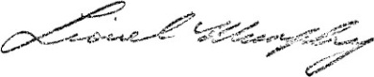
Attorney-General.

Amendment of the Courts-Martial Appeals Regulations†
Payment of Registrar's expenses.
Regulation 20 of the Courts-Martial Appeals Regulations is repealed.

* Notified in the Australian Government Gazette on 15 October 1974.
† Statutory Rules 1957, No. 20, as amended by Statutory Rules 1967, No. 48; and 1969, No. 214.
Printed by Authority by the Government Printer of Australia
13391/74—Price 5c 9/13.5.1974

