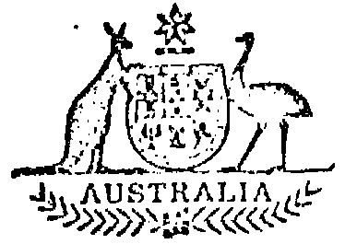

Statutory Rules
1978 No. 27
REGULATION UNDER the WAR PRECAUTIONS ACT REPEAL ACT 1920*
I, the GOVERNOR-GENERAL of the Commonwealth of Australia, acting with the advice of the Federal Executive Council, hereby make the following Regulation under the War Precautions Act Repeal Act 1920.

Dated this twenty-third day of February 1978.
ZELMAN COWEN
Governor-General

By His Excellency’s Command,

Minister of State for Productivity
–––––––––
AMENDMENTS OF the PROTECTION OF WORD “ ANZAC ” REGULATIONS†

Table of amendments
The Protection of Word “ Anzac ” Regulations are amended as set out in the following table:
Provision amended | Amendment
Sub-regulation 2 (1) | Omit “ Attorney-General ”, substitute “ Minister ”.
Paragraph 2 (3) (b) | Omit “ Attorney-General ”, substitute “ Minister ”.
Paragraph 2 (4) (b) | Omit “ Attorney-General ”, substitute “ Minister ”.
Sub-regulation 3 (1) | Omit “ Attorney-General ”, substitute “ Minister ”.
* Notified in the Commonwealth of Australia Gazette on 28 February 1978.
† Statutory Rules 1921, No. 2 as amended by Statutory Rules 1921, No. 216; 1959, No. 29; and 1962, No. 79.

Printed by Authority by the Commonwealth Government Printer
10071/78 Cat. No. —Recommended retail price 10c 10/12.1.1978

