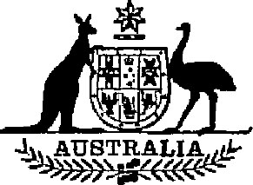

Statutory Rules 1985 No. 335¹
–––––––––––––––––
Wheat Marketing (Liability to Taxation) Regulations
I, THE GOVERNOR-GENERAL of the Commonwealth of Australia, acting with the advice of the Federal Executive Council, hereby make the following Regulations under the Wheat Marketing Act 1984.
Dated 5 December 1985.
N. M. STEPHEN
Governor-General
By His Excellency’s Command,
JOHN KERIN
Minister of State for Primary Industry
–––––––––
Citation
1. These Regulations may be cited as the Wheat Marketing (Liability to Taxation) Regulations.
Commencement
2. These Regulations shall be deemed to have come into operation on 25 October 1984.
Liability to pay-roll tax
3. Sub-section 54 (2) of the Wheat Marketing Act 1984 does not apply in relation to taxation under any of the following laws:
(a) the Pay-roll Tax Act, 1971 of the State of New South Wales;
(b) the Pay-roll Tax Act 1971 of the State of Victoria;
(c) the Pay-roll Tax Act 1971 of the State of Queensland;
(d) the Pay-roll Tax Act, 1971 of the State of Western Australia;
(e) the Pay-roll Tax Act, 1971 of the State of South Australia;
(f) the Pay-roll Tax Act 1971 of the State of Tasmania;
(g) the Pay-roll Tax Act of the Northern Territory.

NOTE
1. Notified in the Commonwealth of Australia Gazette on 12 December 1985.

