Federal Magistrates Court Rules 2001
Statutory Rules 2001 No. 195¹
WE, Federal Magistrates, make the following Rules of Court under the Federal Magistrates Act 1999.
Dated 10 July 2001
BRYANT CFM
BAUMANN FM
BREWSTER FM
COKER FM
CONNOLLY FM
DONALD FM
DRIVER FM
HARTNETT FM
McINNIS FM
MEAD FM
PHIPPS FM
RAPHAEL FM
RIMMER FM
ROBERTS FM
RYAN FM
SCARLETT FM
Federal Magistrates

PETER MAY
Chief Executive Officer

Contents
Page
Chapter 1 All proceedings
Part 1 Introduction
1.01 Name of Rules 17
1.02 Commencement 17
1.03 Objects 17
1.04 Dictionary 18
1.05 Application 18
1.06 Court may dispense with rules 19
Part 2 Documents
Division 2.1 General
2.01 Requirements for documents 20
2.02 Document must have distinctive number 20
2.03 Document to be signed 20
2.04 Forms 21
Division 2.2 Filing documents
2.05 How documents may be filed 21
2.06 Registrar may refuse to accept document 21
2.07 Filing by fax or e-mail 22
Division 2.3 Searching records
2.08 Searching records 23
Part 3 Sittings, registry hours and time
Division 3.1 Sittings, holidays and registry hours
3.01 Sittings 25
3.02 Registry hours 25
Division 3.2 Time
3.03 Meaning of month 25
3.04 Calculating time 25
3.05 Extension or shortening of time fixed 26
Part 4 Starting proceedings
4.01 Application 27
4.02 Content of application 27
4.03 Response to application 27
4.04 Content of response 27
4.05 Affidavit to be filed with application or response 28
4.06 Information sheet to be filed with certain applications 28
4.07 Reply in certain circumstances 29
Part 5 Urgent applications
5.01 Urgent application 30
5.02 Form of application 30
5.03 Evidence 30
Part 6 Service
Division 6.1 General
6.01 Address for service 32
6.02 Change of address for service 32
6.03 Service of documents 32
6.04 Court’s discretion in relation to service 33
6.05 Affidavit of service 33
Division 6.2 Service by hand in particular cases
6.06 When is service by hand required 33
6.07 Service by hand 33
6.08 Service by hand on a corporation, unincorporated association or organisation 34
6.09 Service of application on unregistered business 34
6.10 Service of application on partnership 35
Division 6.3 Ordinary service
6.11 Service other than by hand 35
6.12 When service is effected by post 36
6.13 Special requirements for service by fax 36
Division 6.4 Substituted service
6.14 Substituted service 37
6.15 Matters to be taken into account 37
6.16 Failure to comply with condition 38
Division 6.5 Time for service
6.17 General time limit 38
6.18 Time for service of subpoena 38
Part 7 Amendment
Division 7.1 General
7.01 Power to amend 39
7.02 Who may be required to make amendment 39
Division 7.2 General federal law proceedings
7.03 Amendment after limitation period 39
Part 8 Transfer of proceedings
8.01 Change of venue 41
8.02 Transfer to Federal Court or Family Court 41
8.03 Proceeding transferred to Federal Court or Family Court 42
8.04 Proceeding transferred from Federal Court or Family Court 42
8.05 Proceeding transferred from Federal Court or Family Court 43
Part 9 Lawyers
9.01 Change between acting in person and by lawyer 44
9.02 Change of lawyer 44
9.03 Withdrawal as lawyer 44
9.04 Corporation must be represented 45
Part 10 How to conduct proceedings
Division 10.1 First court date
10.01 Directions and orders 46
10.02 Adjournment of first court date 47
10.03 Fixing date for final hearing 47
Division 10.2 Primary dispute resolution
10.04 Agreement reached by primary dispute resolution 47
10.05 Conciliation conference 48
Division 10.3 Notice of constitutional matter
10.06 Party to file notice of constitutional matter 49
Part 11 Parties and litigation guardians
Division 11.1 Parties
11.01 Necessary parties 50
11.02 Party may include another person as a party 50
11.03 Person may apply to be included 51
11.04 Party may apply to be removed 51
11.05 Court may order notice to be given 51
11.06 Intervention by Attorney-General 52
11.07 Child to whom state welfare law applies 52
Division 11.2 Litigation guardian
11.08 Person who needs a litigation guardian 52
11.09 Starting, continuing, defending or inclusion in proceeding 52
11.10 Who may be a litigation guardian 53
11.11 Appointment of litigation guardian 53
11.12 Authorised persons 53
11.13 Notice of becoming litigation guardian 54
11.14 Costs and expenses of litigation guardian 54
11.15 Service 54
Part 12 Referral by Court for legal assistance
12.01 Object of Part 55
12.02 Pro bono panel 55
12.03 Referral to a lawyer 55
12.04 Kind of assistance 56
12.05 Provision of assistance by lawyer 56
12.06 Application for leave 56
12.07 Professional fees and disbursements 57
Part 13 Ending a proceeding early
Division 13.1 Discontinuance and default
13.01 Discontinuance 58
13.02 Costs 58
13.03 Default 59
Division 13.2 Consent orders
13.04 Application for order by consent 59
13.05 Additional information 59
Division 13.3 Summary disposal and stay
13.06 Application 60
13.07 Summary disposal 60
13.08 Residue of proceeding 60
13.09 Application 61
13.10 Frivolous proceedings 61
13.11 Vexatious litigants 61
Part 14 Disclosure
Division 14.1 Answers to specific questions
14.01 Declaration to allow specific questions 63
Division 14.2 Obligation to disclose
14.02 Declaration to allow discovery 63
14.03 Affidavit of documents 64
14.04 Production of documents to Court 64
14.05 Claim for privilege 64
14.06 Order for particular disclosure 64
14.07 Inspection of documents 65
14.08 Copies of documents inspected 65
14.09 Documents not disclosed or produced 65
14.10 Documents referred to in document or affidavit 65
14.11 Use of documents 66
Part 15 Evidence
Division 15.1 General
15.01 Court may give directions 67
15.02 Evidence if there is a child representative 67
15.03 Decisions without oral hearing 68
15.04 Court may call evidence 68
15.05 Hearsay evidence — notice under section 67 of the Evidence Act 1995 68
15.06 Transcript receivable in evidence 69
Division 15.2 Expert evidence
15.07 Duty to Court and form of expert evidence 69
15.08 Expert evidence for 2 or more parties 69
15.09 Court expert 70
15.10 Report of court expert 70
15.11 Remuneration and expenses of court expert 71
15.12 Further expert evidence 71
Division 15.3 Subpoenas and notices to produce
15.13 Issue of subpoena 71
15.14 Time limits 72
15.15 Limit on number of subpoenas 72
15.16 Service 72
15.17 Conduct money 72
15.18 Setting aside subpoena 73
15.19 Order for cost of complying with subpoena 73
15.20 Cost of complying with subpoena if not a party 73
15.21 Production by person not a party 74
15.22 Order for inspection 74
15.23 Compliance with subpoena 75
15.24 Notice to produce 75
Division 15.4 Affidavits
15.25 Form of affidavit 75
15.26 Making an affidavit 75
15.27 Affidavit of illiterate or blind person etc 76
15.28 Documents annexed or exhibited 77
15.29 Objectionable material may be struck out 77
Division 15.5 Admissions
15.30 Admission 78
15.31 Notice to admit facts or documents 78
Part 16 Judgments and orders
16.01 Court may make any judgment or order 79
16.02 Date of effect 79
16.03 Time for compliance 79
16.04 Fines 79
16.05 Setting aside 79
16.06 Undertakings 80
16.07 When must an order be entered 80
16.08 Authentication of orders 81
Part 17 Separate decision on question
17.01 Definition 82
17.02 Order for decision 82
17.03 Separate question 82
17.04 Orders, directions on decision 82
17.05 Disposal of proceeding 82
Part 18 Referral of matter to officer of Court
18.01 Court may refer matter 83
Part 19 Contempt
19.01 Contempt in the face or hearing of Court 84
19.02 Contempt other than in the face or hearing of Court 84
Part 20 Review of exercise of Registrars’ power
20.01 Time for application for review 86
20.02 Application for review 86
20.03 Procedure for review 87
Part 21 Costs
Division 21.1 Security for costs
21.01 Security for costs 88
Division 21.2 Orders for costs
21.02 Order for costs 88
21.03 Determination of maximum costs 89
21.04 Costs reserved 89
21.05 Costs if proceedings transferred 89
21.06 Lawyer to repay costs due to delay or misconduct 90
21.07 Order for costs against lawyer 90
21.08 Interest on outstanding costs 91
Division 21.3 Costs and disbursements
Subdivision 21.3.1 General
21.09 Application 91
21.10 Costs and disbursements 92
21.11 Cost of taxation 92
21.12 Expenses for attendance by witness 92
21.13 Expenses for preparation of report by expert 92
21.14 Solicitor as advocate 92
21.15 Advocacy certificate 93
21.16 Counsel as advocate 93
Subdivision 21.3.2 Short form bill of costs — certain bankruptcy proceedings
21.17 Application of Subdivision 93
21.18 Short form bill of costs 93
21.19 Claim for costs 94
Chapter 2 Family law proceedings
Part 22 General
22.01 Rate of interest 95
Part 23 Primary dispute resolution
Division 23.1 Counselling and family reports
23.01 Report after counselling 96
Division 23.2 Mediation
23.02 Referral for mediation 96
Part 24 Financial matters
24.01 Application of Part 98
24.02 Financial statement 98
24.03 Full and frank disclosure 98
24.04 Production of documents (proceeding other than for maintenance only) 99
24.05 Production of documents (proceedings for maintenance only) 100
24.06 Amendment of financial statement 101
Part 25 Dissolution of marriage
25.01 Application for dissolution of marriage 102
25.02 Service of application 102
25.03 Additional requirements for service by post 103
25.04 Acknowledgment of service 103
25.05 Affidavit of service 103
25.06 Evidence of service 103
25.07 Response 104
25.08 Objection to jurisdiction 104
25.09 Time for filing response or objection 104
25.10 Application for rescission of decree nisi 105
25.11 Discontinuance of application 105
25.12 Costs in undefended proceedings for dissolution of marriage — basic composite amount 105
Chapter 3 Proceedings other than family law
Part 26 General
26.01 Rate of interest 106
Part 27 Primary dispute resolution
Division 27.1 General
27.01 Proceeding referred to mediator or arbitrator 107
27.02 Adjournment of proceeding 107
27.03 Court may end mediation or arbitration 107
Division 27.2 Mediation
27.04 Nomination of mediator 108
27.05 Mediation conference 108
27.06 Mediator may end mediation 109
Division 27.3 Arbitration
27.07 Appointment of arbitrator 109
Part 28 Cross-claims
28.01 Cross-claim against applicant 110
28.02 Cross-claim after application 110
28.03 Cross-claim against additional party 110
28.04 Cross-claim to be included in response 111
28.05 Response to cross-claim 111
28.06 Conduct of cross-claim 111
28.07 Exclusion of cross-claim 111
28.08 Cross-claim after judgment etc 111
28.09 Judgment for balance 112
28.10 Stay of claim 112
28.11 Cross-claim for contribution or indemnity 112
28.12 Offer of contribution 112
Chapter 4 Bankruptcy proceedings
Part 29 General
29.01 Application of Chapter 113
29.02 Interpretation 113
29.03 Starting a proceeding 114
29.04 Review of decision by Registrar 114
29.05 Leave to be heard 114
29.06 Appearance at application or examination 115
29.07 Opposition to application or petition 115
Part 30 Bankruptcy notices
30.01 Substituted service 116
30.02 Requirements of application to set aside, or extend time for complying with, notice 116
30.03 Making and hearing of application for extension of time 117
Part 31 Creditors’ petitions
31.01 Application of Part 118
31.02 Requirements of creditor’s petition and supporting affidavits 118
31.03 Petition founded on issue of execution against debtor 118
31.04 Petition founded on failure to comply with bankruptcy notice or set up counter-claim etc 119
31.05 Service 119
31.06 Additional affidavits to be filed before hearing 120
31.07 Summons to debtor or examinable person for examination 121
31.08 Sequestration order to be entered and served 122
31.09 Order dismissing petition to be entered and served 122
31.10 Order extending petition 122
Part 32 Debtors’ petitions
32.01 Application of Part 124
32.02 Form of referral 124
32.03 Hearing of referral 124
Part 33 Discovery of bankrupt’s property
33.01 Definition 125
Division 33.1 Summoning relevant person for examination
33.02 Application of Division 125
33.03 Application for summons 125
33.04 Requirements of summons 126
33.05 Service of summons 126
33.06 Failure by relevant person to attend examination 126
Division 33.2 Summoning of examinable person for examination
33.07 Application of Division 127
33.08 Application for summons 127
33.09 Affidavit to accompany application 127
33.10 Hearing of application 128
33.11 Requirements of summons 128
33.12 Service of summons 129
33.13 Application for discharge of summons 129
33.14 Conduct money and witnesses expenses 129
Part 34 Proof of debts
34.01 Appeal against estimate of value of debt or liability 130
Part 35 Annulment of bankruptcy
35.01 Application of Part 131
35.02 Requirements of application 131
35.03 Notice to creditors 131
35.04 Report by trustee 131
35.05 Order to be entered and served 132
Part 36 Trustees
36.01 Objection to appointment of trustee 133
36.02 Resignation or release of trustee 133
Part 37 Debt agreements
37.01 Application for order terminating debt agreement 135
37.02 Application for order declaring debt agreement void 135
37.03 Notice to creditors 136
37.04 Entry and service of order 136
Part 38 Arrangements with creditors
38.01 Application for order declaring deed or composition void 137
38.02 Application for order terminating deed 137
38.03 Application for order setting aside composition 138
38.04 Service of application and supporting affidavit 138
38.05 Notice to creditors 139
38.06 Entry and service of order 139
Part 39 Administration of estates of deceased persons
Division 39.1 Creditors’ petitions
39.01 Requirements of petition 140
39.02 Additional affidavits to be filed before hearing 140
39.03 Entry and service of order 141
Division 39.2 Administrators’ petitions
39.04 Administrator’s petition 141
39.05 Entry and service of order 142
Part 40 Warrants
40.01 Warrant for arrest of debtor or bankrupt 143
40.02 Warrant for apprehension of person failing to attend Court 143
Chapter 5 Human rights proceedings
Part 41 Proceedings alleging unlawful discrimination
41.01 Application of Chapter 144
41.02 Interpretation 144
41.03 Copy of application to be given to Commission 145
41.04 Response to application 145
41.05 Appearance by special-purpose Commissioner 145
Chapter 6 Judicial review proceedings and administrative appeals
Part 42 Proceedings under Administrative Decisions (Judicial Review) Act
42.01 Application of Part 146
42.02 Application for order of review 146
42.03 Documents to be filed 146
42.04 Notice of objection to competency 147
Part 43 Appeals from Administrative Appeals Tribunal
43.01 Application of Part 148
43.02 Stay 148
43.03 Amendment by supplementary notice 148
43.04 Notice of cross-appeal and contention 149
43.05 Directions 149
43.06 Preparation of appeal papers 150
Schedule 1 Costs 151
Part 1 General 151
Part 2 Undefended proceedings for dissolution of marriage 153
Part 3 Bankruptcy 153
Schedule 2 Forms 154
Part 1 General 154
Part 2 Dissolution of marriage 166
Part 3 Bankruptcy 184
Schedule 3 Family Law Rules and Federal Court Rules applied 202
Part 1 Family Law Rules 202
Part 2 Federal Court Rules 202
Dictionary 203

Chapter 1 All proceedings
Part 1 Introduction

1.01 Name of Rules
These Rules are the Federal Magistrates Court Rules 2001.
1.02 Commencement
These Rules commence on 30 July 2001.
1.03 Objects
(1) The object of these Rules is to assist the just, efficient and economical resolution of proceedings.
(2) In accordance with the objects of the Act, the Rules aim to help the Federal Magistrates Court:
- to operate as informally as possible
- to use streamlined processes
- to encourage the use of appropriate dispute resolution procedures.
(3) The Court will apply the Rules in accordance with their objects.
(4) To assist the Court, the parties must:
- avoid undue delay, expense and technicality
- consider options for primary dispute resolution as early as possible.
(5) If appropriate, the Court will help to implement primary dispute resolution.
1.04 Dictionary
The dictionary defines terms used in these Rules.
1.05 Application
(1) It is intended that the practice and procedure of the Federal Magistrates Court be governed principally by these Rules.
(2) However, if in a particular case the Rules are insufficient or inappropriate, the Court may apply the Federal Court Rules or the Family Law Rules, in whole or in part and modified or dispensed with, as necessary.
(3) Without limiting subrule (2):
(a) the provisions of the Family Law Rules set out in Part 1 of Schedule 3 apply, with necessary changes, to family law proceedings; and
(b) the provisions of the Federal Court Rules set out in Part 2 of Schedule 3, apply, with necessary changes, to general federal law proceedings.
Note These Rules have effect subject to any provision made by an Act, or by rules or regulations under an Act, with respect to the practice and procedure in particular matters: see subsection 81 (2) of the Act.

General outline:
- Chapter 1 applies to all proceedings
- Chapter 2 applies to family law proceedings
- Chapter 3 applies to all proceedings other than family law proceedings
- Chapter 4 applies to proceedings under the Bankruptcy Act 1966
- Chapter 5 applies to proceedings under the Human Rights and Equal Opportunity Commission Act 1986
- Chapter 6 applies to proceedings under the Administrative Decisions (Judicial Review) Act 1977 and appeals under the Administrative Appeals Tribunal Act 1975.

1.06 Court may dispense with rules
The Court may in the interests of justice dispense with compliance, or full compliance, with any of these Rules at any time.

Part 2 Documents
Division 2.1 General
2.01 Requirements for documents
(1) A document (other than a form) to be filed must:
(a) be set out on 1 side only of size A4 durable white paper of good quality; and
(b) be legible and without erasures, blotting out or material disfigurement; and
(c) have a margin at the left side of at least 30 mm; and
(d) have clear margins of at least 10 mm on the top, bottom and right sides; and
(e) have a space of not less than 3 mm between the lines of writing; and
(f) be:
(i) printed with type of at least 10 point; or
(ii) hand-printed clearly in ink in a way that is permanent and can be photocopied to produce a copy satisfactory to the registrar.
(2) This rule does not apply to a document annexed to an affidavit.
Note The Court may give directions limiting the length of documents to be filed: see section 51 of the Act.
2.02 Document must have distinctive number
A document filed in connection with a particular proceeding must bear the distinctive number of the proceeding.
2.03 Document to be signed
A document to be filed (other than an affidavit, annexure or exhibit) must be signed by a party or by the lawyer for the party unless the nature of the document is such that signature is inappropriate.
2.04 Forms
(1) Unless the Court otherwise orders, strict compliance with forms is not required and substantial compliance is sufficient.
(2) A document prepared in the form prescribed for a similar purpose for the Family Court or the Federal Court may be taken to substantially comply with the appropriate form for a proceeding.
(3) However, unless otherwise provided in these Rules, a document to be filed in a proceeding must be headed:
FEDERAL MAGISTRATES COURT OF AUSTRALIA
At (Registry).
Division 2.2 Filing documents
2.05 How documents may be filed
(1) A document may be filed by:
(a) delivering it to the registry; or
(b) sending it to the registry by post; or
(c) unless a fee is payable for the filing, by fax or e-mail in accordance with rule 2.07.
Note The Regulations provide that a document may not be filed in a registry of the Court unless the fee payable for the filing has been paid. The Regulations also provide for exemption, waiver or deferral of a fee in certain circumstances.
(2) A document is filed when it is accepted for filing by a Registrar and sealed with the seal of the Court or marked with a Federal Magistrates Court stamp.
Note For the design, custody and affixation of the seal and validity of stamps: see sections 47 and 48 of the Act.
2.06 Registrar may refuse to accept document
(1) A Registrar may refuse to accept a document for filing if:
(a) the document appears on its face to be an abuse of process or frivolous, scandalous or vexatious; or
(b) the document is filed in connection with a pending proceeding and the registry is not the appropriate registry.
(2) The person seeking to file the document may apply to the Court for review of the Registrar’s decision in accordance with Part 20.
2.07 Filing by fax or e-mail
(1) An authorised Registrar may approve for each registry:
(a) at least one fax address for the purpose of receiving documents; and
(b) at least one e-mail address for the purpose of receiving documents; and
(c) the formats in which electronic versions of documents will be accepted by the registry.
(2) A document sent by fax or e-mail must:
(a) be sent to an approved fax number or e-mail address; and
(b) be accompanied by a cover sheet, clearly stating:
(i) the sender’s name, postal address, document exchange number (if any), telephone number, fax number and e-mail address (if any); and
(ii) the action required in relation to the document.
(3) A document in a current proceeding must be sent to the appropriate registry for the proceeding.
(4) A document sent by e-mail must:
(a) be in an electronic format approved for the registry; and
(b) as far as possible comply with rule 2.01; and
(c) be capable of being printed with the content and in the form in which it was created.
(5) A document that must be signed or executed by any person may only be filed by e-mail by sending an image of the signed or executed document or (unless the document is an affidavit) by affixing a facsimile of the signature on the document by electronic means by, or at the direction of, the signatory.
(6) If the document is required to be signed or stamped, and is accepted at the registry, a Registrar must:
(a) make one copy of the document; and
(b) if the sender requests that the document be held for collection — hold it for collection for 7 days; and
(c) if the sender does not request the document to be held for collection, or having made a request does not collect the document within 7 days — return the document by fax transmission to the fax number, or by e-mail to the e-mail address, stated on the cover sheet.
(7) If more than one copy of the document is required for issue, the sender must give a Registrar any additional copies required.
(8) A person who sends a document under this rule must:
(a) for a fax transmission:
(i) keep the original document and the transmission report; and
(ii) if directed by the Court, produce the original document endorsed with a statement that it is the original document and the transmission report; and
(b) for an e-mail:
(i) keep a paper copy of the document; and
(ii) if directed by the Court, produce the paper copy endorsed with a statement that it is a true copy and the date when it was sent by e-mail.
Division 2.3 Searching records
2.08 Searching records
(1) Subject to any order of the Court, the following persons may search the records of the Court relating to a proceeding or any matter under the Act, the Regulations or these Rules, or inspect a document forming part of such records:
(a) in relation to a family law proceeding — the Attorney-General;
(b) if the records relate to a particular proceeding — a party, a lawyer for a party or a child representative in the proceeding;
(c) a person who has been granted leave of the Court or a Registrar to search the records or inspect the document.
(2) Leave may be granted to a person who demonstrates a proper interest in searching records or inspecting a document and may be granted subject to conditions.

Part 3 Sittings, registry hours and time
Division 3.1 Sittings, holidays and registry hours
3.01 Sittings
(1) The Court sits at times and places as directed by the Chief Federal Magistrate.
(2) Unless the Federal Magistrate constituting the Court otherwise directs, the Court does not sit:
(a) on a Saturday or Sunday; or
(b) on a day that is a public holiday where the registry is located.
3.02 Registry hours
(1) A registry must be open for business when the registry facilities shared by the registry under arrangements made under section 92 of the Act are open for business.
(2) A registry may be open at other times for urgent business at the direction of a Federal Magistrate.
Division 3.2 Time
3.03 Meaning of month
In these Rules and in a judgment, decree, order or any document in a proceeding, unless the context otherwise indicates:
month means a calendar month.
3.04 Calculating time
(1) This rule applies to a period of time fixed by these Rules or by a judgment, decree, order or any document in a proceeding.
(2) If a period of more than 1 day is to be calculated by reference to a particular day or event, the particular day or the day of the event must not be counted.
(3) If a period of 5 days or less would, but for this subrule, include a day when the registry is closed, that day must not be counted.
(4) If the last day for taking an action that requires attendance at a registry is a day when the registry is closed, the action may be taken on the next day when the registry is open.
(5) Subsection 36 (2) of the Acts Interpretation Act 1901 does not apply to these Rules.
3.05 Extension or shortening of time fixed
(1) The Court may extend or shorten a time fixed by these Rules or by a judgment, decree or order.
(2) A Registrar may extend or shorten a time fixed by these Rules.
(3) The time fixed may be extended even if the time fixed has passed.
(4) A time fixed by these Rules or by a judgment, decree or order for service, filing or amendment of a document may be extended by consent without an order.

Part 4 Starting proceedings

4.01 Application
(1) Unless otherwise provided in these Rules, a proceeding must be started by filing an application in accordance with the form of application set out in Part 1 of Schedule 2.
(2) An application for final orders may include an application for interim or procedural orders.
(3) A person may not file an application for an interim or procedural order unless:
(a) an application for a final order has been made in the proceeding; or
(b) the application includes an application for a final order.
4.02 Content of application
An application must precisely and briefly state the orders sought and (if the application is for a general federal law proceeding) the basis on which the orders are sought.
4.03 Response to application
(1) A respondent to a cross-claim may file a response in accordance with the form of response set out in Part 1 of Schedule 2.
(2) A response must be filed and served within 14 days of service of the application or cross-claim to which it relates.
4.04 Content of response
(1) A response may:
(a) indicate consent to an order sought by the applicant; or
(b) ask the Court to make another order; or
(c) ask the Court to dismiss the application; or
(d) seek orders in a matter other than the matter set out in the application; or
(e) make a cross-claim against the applicant, or another party.
(2) A response must precisely and briefly state any orders sought and (if the proceeding is a general federal law proceeding) the basis on which the orders are sought.
4.05 Affidavit to be filed with application or response
(1) A person filing an application or response, whether seeking final, interim or procedural orders, must also file an affidavit stating the facts relied on.
(2) However, an application for interim or procedural orders may be filed without an affidavit if the evidence relied on is in an affidavit or affidavits filed in the pending proceeding.
4.06 Information sheet to be filed with certain applications
(1) A person filing an application for final orders under the Family Law Act or an application alleging unlawful discrimination under the Human Rights Act must also file an information sheet.
(2) However, an information sheet is not required for a proceeding about any of the following:
(a) rescission of a decree nisi;
(b) a parenting plan;
(c) a recovery order within the meaning of section 67Q of the Family Law Act;
(d) a custody order made by an overseas court;
(e) a custody order made by a court in Australia that is enforceable overseas;
(f) a maintenance order made by an overseas court;
(g) a maintenance order made by a court in Australia that is enforceable overseas;
(h) leave, under section 102A of the Family Law Act, for a child to be examined;
(i) an application for enforcement of an order;
(j) contravention of an order;
(k) contempt of court;
(l) an application for an injunction under section 114 of the Family Law Act;
(m) costs.

Examples
A person applying for final orders and interim orders will use 1 form (application) and file it with an affidavit. For a proceeding under the Family Law Act or a proceeding under the Human Rights Act, the person may have to file an information sheet with the application.
A person applying for interim or procedural orders only will use an application and file it with an affidavit (unless an affidavit is not necessary because the evidence has already been filed in the pending proceedings).
A person responding to an application will use a response and file it with an affidavit.
Note There may be other documents to be filed, depending on the proceeding. For example, a financial statement and a marriage certificate in a family law proceeding (see Chapter 2).

4.07 Reply in certain circumstances
(1) If a response to an application or cross-claim seeks orders in a matter (other than the orders set out in the application) the applicant may file and serve a reply to the response in accordance with the form of reply set out in Part 1 of Schedule 2.
(2) A reply must be filed and served within 14 days of service of the response to which it relates.

Part 5 Urgent applications

5.01 Urgent application
In an urgent case where service on the respondent is not practicable, on application the Court may make an order until a specified time or until further order.
5.02 Form of application
Unless the Court otherwise orders, the application must be in accordance with the form of application set out in Part 1 of Schedule 2 and must be accompanied by a draft of the order sought.
5.03 Evidence
Unless the Court otherwise orders, the applicant must establish by affidavit or, with the leave of the Court, orally:
(a) whether there are previous proceedings between the parties and, if so, the nature of the proceedings; and
(b) whether there are any current proceedings in any court in which the applicant or the respondent are parties; and
(c) the particulars of any orders currently in force between the parties, including the courts in which they were made; and
(d) the steps that have been taken to tell the respondent or the respondent’s legal representative of the applicant’s intention to make the application or the reasons why no steps were taken; and
(e) the nature and immediacy of the damage or harm which may result if the order is not made; and
(f) why the making of the order is a matter of urgency and why an abridgement of the time for service of the application and the fixing of an early hearing date would not be more appropriate; and
(g) if the application relates to a financial matter, the capacity of the applicant to give an undertaking as to damages; and
(h) the other facts, matters and circumstances relied on by the applicant in support of the application.

Part 6 Service
Division 6.1 General
6.01 Address for service
(1) A party to a proceeding must give an address for service.
(2) A party may give an address for service:
(a) by filing a relevant document that includes an address for service; or
(b) by filing a notice of address for service in accordance with the notice set out in Part 1 of Schedule 2.
(3) An address for service must be an address in Australia.
6.02 Change of address for service
If a party’s address for service changes for any reason during a proceeding, the party must file a notice of address for service and serve the notice on each other party within 7 days of the change.
6.03 Service of documents
(1) A document to be served in a proceeding must be filed and sealed.
(2) An application and any document filed with it must be served on each party in the proceeding as soon as practicable.
(3) If a document other than an application is required to be served, the person who files the document must serve a copy of it as soon as practicable:
(a) on each other party in the proceeding who has an address for service in the proceeding; and
(b) on any child representative in the proceeding.
6.04 Court’s discretion in relation to service
Nothing in this Part affects the power of the Court:
(a) to authorise service of a document in a way that is not provided for in this Part; or
(b) to find that a document has been served; or
(c) to find that a document has been served on a particular day.
6.05 Affidavit of service
Unless the Court otherwise orders, any evidence of service to be given must be given by affidavit.
Division 6.2 Service by hand in particular cases
6.06 When is service by hand required
(1) Service by hand is required for an application starting a proceeding or a subpoena requiring attendance of a person.
(2) However, service by hand is not required if:
(a) there are current proceedings for which there is a notice of address for service for the person to be served; or
(b) the Court directs that an application may be served in another way; or
(c) a lawyer accepts service for a party and subsequently files an address of service; or
(d) a lawyer accepts service for a person other than a party.
6.07 Service by hand
(1) A person serving a document by hand on an individual must give a copy of the document to the person to be served.
(2) However, if the person to be served does not take the copy
of the document, the person serving it may put it down in
the presence of the person to be served and tell the person what it is.
(3) In a family law proceeding, the person serving a document must not be the party on whose behalf it is served.
6.08 Service by hand on a corporation, unincorporated association or organisation
(1) Unless the Court otherwise orders, a person serving a document by hand on a corporation, unincorporated association or organisation must leave a copy of the document with a person apparently an officer of or in the service of the corporation, unincorporated association or organisation:
(a) for a corporation:
(i) at the registered office of the corporation; or
(ii) if there is no registered office, at the principal place of business or the principal office of the corporation; and
(b) for an unincorporated association — at the principal place of business or the principal office of the association or on an officer holder; and
(c) for an organisation — at the office of the organisation shown in the copy records of the organisation lodged in the Industrial Registry under section 268 of the Workplace Relations Act 1996.
(2) Despite subrule (1), service by hand may be effected:
(a) on a company, as defined in section 9 of the Corporations Act 1989 or the corresponding legislation of a State or Territory (the Corporations Law), in any manner permitted by section 109X of the Corporations Law; and
(b) on the liquidator of a company, in the manner permitted by paragraph 109X (1) (c) of the Corporations Law; and
(c) on an administrator of a company, in the manner permitted by paragraph 109X (1) (d) of the Corporations Law.
6.09 Service of application on unregistered business
(1) This rule applies if:
(a) a proceeding is brought against a person in relation to a business carried on by the person under a name other than the person’s name; and
(b) the name is not registered under an applicable State or Territory law; and
(c) the proceeding is started in the name under which the person carries on the business.
(2) The application may be served by leaving a copy at the person’s place of business with a person who appears to have control or management of the business there.
6.10 Service of application on partnership
(1) An application against a partnership must be served:
(a) on 1 or more of the partners; or
(b) on a person at the principal place of business of the partnership who appears to have control or management of the business there; or
(c) if there is a registered office of the partnership, at that office.
(2) An application served in accordance with this rule is taken to be served on each of the partners who are partners when the application is filed.
(3) However, the application must also be served on any person whom the applicant seeks to make liable as a partner who is not a partner when the application is filed.
Division 6.3 Ordinary service
6.11 Service other than by hand
(1) If a document is not required to be served by hand, the document may be served on a person at the person’s address for service:
(a) by delivering it to the address in a sealed envelope addressed to the person; or
(b) by sending it to the address by pre-paid post in a sealed envelope addressed to the person; or
(c) by fax transmission addressed to the person and sent to a fax receiver at the address; or
(d) if the address includes the number of a document exchange box of a lawyer, by sealing the document in an envelope that complies with any prepayment requirements of the document exchange and is addressed to the lawyer (at that box address) and placing the envelope:
(i) in that box; or
(ii) in a box provided at another branch of the document exchange for delivery of documents to the box address.
(2) If the person does not have an address for service, the document may be served on the person:
(a) by delivering it to the person’s last known address or place of business in a sealed envelope addressed to the person; or
(b) by sending it by pre-paid post in a sealed envelope addressed to the person at the person’s last known address or place of business; or
(c) if a law of the Commonwealth or of the State or Territory in which service is to be effected provides for service of a document on a corporation or organisation, by serving the document in accordance with such provision.
6.12 When service is effected by post
A document served by post is taken to have been served:
(a) if it was posted to an address in Australia — on the day when the document would be delivered in the ordinary course of the post; and
(b) if it was posted by airmail to an address outside Australia — on the twenty-eighth day after posting.
6.13 Special requirements for service by fax
(1) A document served by fax transmission must include a cover page stating the following:
(a) the sender’s name and address;
(b) the name of the person to be served;
(c) the date and time of transmission;
(d) the total number of pages, including the cover page, transmitted;
(e) the telephone number from which the document is transmitted;
(f) the name and telephone number of a person to contact if there is a problem with transmission;
(g) that the transmission is for service.
(2) An affidavit of service of a document by fax transmission must have the transmission report indicating successful transmission annexed.
Division 6.4 Substituted service
6.14 Substituted service
(1) If, for any reason, it is impracticable to serve a document in a way required under this Part, the Court may make an order substituting another way of serving the document.
(2) The Court may specify the steps to be taken for bringing the document to the attention of the person to be served.
(3) The Court may specify that the document is to be taken to have been served on the happening of a specified event or at the end of a specified time.
6.15 Matters to be taken into account
When making an order for substituted service, the Court may have regard to:
(a) whether reasonable steps have been taken to serve the document; and
(b) whether the person to be served could become aware of the existence and nature of the document by means of advertising or another means of communication that is reasonably available; and
(c) the likely cost to the party serving the document, the means of that party and the nature of the proceedings; and
(d) any other relevant matter.
6.16 Failure to comply with condition
Failure to comply with a condition of an order for substituted service does not prevent the Court from finding that the document is taken to have been served on a date specified in the order.
Division 6.5 Time for service
6.17 General time limit
Unless the Court otherwise orders, a document may not be served more than 12 months after it is filed.
6.18 Time for service of subpoena
A subpoena may not be served more than 3 months after it is issued.

Part 7 Amendment
Division 7.1 General
7.01 Power to amend
(1) At any stage in a proceeding, the Court or a Registrar may allow or direct a party to amend a document (other than an affidavit) in the way and on the conditions the Court or the Registrar thinks fit.
(2) Subject to rule 7.03, the Court or a Registrar may allow an amendment even if the effect would be to include a cause of action arising after the proceeding was started.
7.02 Who may be required to make amendment
If the Court orders an amendment to be made to a document, the Court may order a party, a Registrar, a Federal Magistrate’s associate or another appropriate person to make the amendment.
Division 7.2 General federal law proceedings
7.03 Amendment after limitation period
(1) This rule applies if an application in a general federal law proceeding for leave to make an amendment is made after the end of a relevant period of limitation current at the date when the proceeding was started.
(2) The Court may give leave to make an amendment correcting the name of a party, even if it is alleged that the effect would be to substitute a new party, if:
(a) the Court considers it appropriate; and
(b) the Court is satisfied that the mistake sought to be corrected was genuine and was not misleading or such as to cause reasonable doubt as to the identity of the party.
(3) The Court may give leave to make an amendment changing the capacity in which a party seeks orders (whether as applicant or respondent by counterclaim) if:
(a) the Court considers it appropriate; and
(b) the capacity in which the party will seek orders is one in which, at the time when the proceeding was started by the party, the party might have sought orders.
(4) The Court may give leave to make an amendment even if the effect is to include a new cause of action, if:
(a) the Court considers it appropriate; and
(b) the new cause of action arises out of the same, or substantially the same, facts as a cause of action for which relief has already been claimed in the proceeding by the party seeking leave to amend.

Part 8 Transfer of proceedings

8.01 Change of venue
(1) A party who files an application or response in a proceeding may apply to have the proceeding heard in another registry of the Court.
(2) In considering an application, the Court must have regard to:
(a) the convenience of the parties; and
(b) the limiting of expense and the cost of the proceeding; and
(c) whether the matter has been listed for final hearing; and
(d) any other relevant matter.
8.02 Transfer to Federal Court or Family Court
(1) The Court may, at the request of a party or of its own motion, transfer a proceeding to the Federal Court or the Family Court.
(2) Unless the Court otherwise orders, a request for transfer must be made on or before the first court date for the proceeding.
(3) Unless the Court otherwise orders, the request must be included in a response or made by application supported by an affidavit.
(4) In addition to the factors required to be considered by the Court under subsections 39 (3) and (4) of the Act for transfer of proceedings to the Federal Court or the Family Court, the following factors are relevant:
(a) whether the proceeding is likely to involve questions of general importance, such that it would be desirable for there to be a decision of the Federal Court or the Family Court on one or more of the points in issue;
(b) whether, if the proceeding is transferred, it is likely to be heard and determined at less cost and more convenience to the parties than if the proceeding is not transferred;
(c) whether the proceeding will be heard earlier in the Federal Magistrates Court;
(d) the availability of particular procedures appropriate for the class of proceeding;
(e) the wishes of the parties.
Note 1 Subsection 39 (3) of the Act provides that, in deciding whether to transfer a proceeding to the Federal Court, the Court must have regard to:
• the factors set out in these Rules to be taken into account
• whether proceedings in respect of an associated matter are pending in the Federal Court
• whether the resources of the Federal Magistrates Court are sufficient to hear and determine the proceeding
• the interests of the administration of justice.
Note 2 Subsection 39 (4) of the Act provides that, in deciding whether to transfer a proceeding to the Family Court, the Court must have regard to:
• the factors set out in these Rules to be taken into account
• whether proceedings in respect of an associated matter are pending in the Family Court
• whether the resources of the Federal Magistrates Court are sufficient to hear and determine the proceeding
• the interests of the administration of justice.
8.03 Proceeding transferred to Federal Court or Family Court
If a proceeding is transferred to the Federal Court or the Family Court, the Registrar must send to the proper officer of that court all documents filed and orders made in the proceeding.
8.04 Proceeding transferred from Federal Court or Family Court
A sealed copy of the order of the Federal Court or the Family Court transferring a proceeding or appeal to the Court must, unless the Federal Court or the Family Court otherwise directs, be filed:
(a) if the order is obtained by a party — by the party; and
(b) if the order is made by the Federal Court or the Family Court of its own motion — by the applicant in the proceeding.
8.05 Proceeding transferred from Federal Court or Family Court
If a proceeding or appeal is transferred to the Court from the Federal Court or the Family Court, the Registrar must give it a distinctive number and, unless impractical to do so, allocate a first court date within 14 days of the transfer.

Part 9 Lawyers

9.01 Change between acting in person and by lawyer
(1) If a party acts in person in a proceeding and later appoints a lawyer, the lawyer must, as soon as practicable, file and serve notice of the appointment on each other party.
(2) If a party appoints a lawyer and later decides to act in person, the party must, as soon as practicable, file and serve notice of acting in person on the lawyer and each other party.
(3) The party’s former lawyer remains the lawyer on the record until the party serves the notice on the former lawyer.
(4) Notice under this rule must contain details of an address for service in accordance with the notice set out in Part 1 of Schedule 2.
9.02 Change of lawyer
(1) A party may, at any stage in a proceeding, appoint another lawyer in place of the lawyer then acting for the party.
(2) The newly appointed lawyer must, as soon as practicable, file and serve on each other party and the party’s former lawyer notice of the appointment.
(3) The party’s former lawyer remains the lawyer on the record until the newly appointed lawyer has complied with subrule (2).
(4) Notice for this rule must contain details of an address for service in accordance with the notice set out in Part 1 of Schedule 2.
9.03 Withdrawal as lawyer
(1) A lawyer for a party may withdraw from the record in a proceeding by filing a notice of withdrawal and serving the notice on each other party.
(2) However, a lawyer may not file or serve a notice of withdrawal without leave of the Court unless the lawyer has, not less than 7 days before filing the notice, served a notice of intention to withdraw on the party for whom the lawyer is acting.
(3) A notice of intention to withdraw must:
(a) state the lawyer’s intention to withdraw; and
(b) state that, if the client does not appoint another lawyer or file and serve a notice of address for service within 7 days, the party may not be served with documents in the proceeding.
(4) A lawyer may serve a party with a notice of intention to withdraw by posting it to the residential or business address of the party last known to the lawyer.
(5) If a party’s lawyer withdraws from the record, the party’s last known residential or business address is the address for service until:
(a) the party appoints another lawyer; or
(b) the party files a notice of address for service.
Note If a party’s address for service changes for any reason during a proceeding, the party must file a notice of address for service: see rule 6.02.
9.04 Corporation must be represented
Except as provided by or under an Act or regulations made under an Act, or with the leave of the Court, a corporation may not start or carry on a proceeding otherwise than by a lawyer.

Part 10 How to conduct proceedings
Division 10.1 First court date
10.01 Directions and orders
(1) At the first court date, the Court or a Registrar is to give orders or directions for the conduct of the proceeding.
(2) Without limiting the generality of subrule (1), the Court or a Registrar may do any of the following:
(a) hear and determine all or part of the proceedings;
(b) if no applicant appears, strike out or dismiss the application or make any other order that the Court or Registrar thinks fit;
(c) if no respondent appears, make the order sought by the applicant or make any other order, or give any direction, the Court or Registrar thinks fit.
(3) The Court or a Registrar may make orders or directions in relation to the following:
(a) the manner and sufficiency of service;
(b) the amendment of documents;
(c) defining of issues;
(d) the filing of affidavits;
(e) cross-claims;
(f) the joinder of parties;
(g) primary dispute resolution;
(h) the admissibility of affidavits;
(i) discovery and inspection of documents;
(j) interrogatories;
(k) inspections of real or personal property;
(l) admissions of fact or of documents;
(m) the giving of particulars;
(n) the giving of evidence at hearing (including the use of statements of evidence and the taking of evidence by video link or telephone or other means);
(o) expert evidence and court experts;
(p) transfer of proceedings;
(q) costs;
(r) hearing date;
(s) any other matter that the Court or Registrar considers appropriate.
10.02 Adjournment of first court date
(1) If the parties agree that, because of short service or other special circumstances, it is not appropriate to proceed on the date fixed the parties may ask a Registrar in writing to adjourn the first court date to another date.
(2) The Registrar may adjourn the first court date to the date requested by the parties or to another date that is practicable.
10.03 Fixing date for final hearing
At the first court date the Court or a Registrar may:
(a) fix a date for final hearing; or
(b) direct the parties to arrange with the Registrar a date for final hearing; or
(c) fix a date after which either party may request a date for final hearing; or
(d) remove the matter from the list.
Division 10.2 Primary dispute resolution
10.04 Agreement reached by primary dispute resolution
If the parties to a proceeding resolve the issues between them following a primary dispute resolution process, the parties may:
(a) discontinue the proceeding; or
(b) ask the Court to make consent orders.
Note 1 The Act imposes duties to advise parties to use primary dispute resolution processes in appropriate cases. For the duty of the Court: see section 23 of the Act. For the duty of lawyers: see section 24 of the Act. For the duty of officers of the Court: see section 25 of the Act.
Note 2 The Court may refer a matter for conciliation with or without consent: see section 26 of the Act. The Court may refer a matter (other than a family law proceeding) for mediation with or without consent (see section 34 of the Act) or for arbitration with consent (see section 35 of the Act).
Note 3 For mediation and arbitration in family law and child support matters: see Part 23.
Note 4 For mediation and arbitration in matters other than family law proceedings: see Part 27.
10.05 Conciliation conference
(1) This rule applies if a proceeding, part of a proceeding or matter arising from a proceeding has been referred for conciliation.
Note The Court may refer a proceeding (or any part of a proceeding or matter arising out of a proceeding) for conciliation with or without the consent of the parties: see section 26 of the Act.
(2) A conciliation conference must be held with a Federal Magistrate, a Registrar or another person appointed by the Court for the purpose and, if required by the order referring the proceeding, a family and child counsellor or welfare officer.
(3) Unless the Court or a Registrar otherwise orders:
(a) the parties must attend the conference in person; and
(b) each lawyer representing a party must also attend.
(4) The parties must make a genuine effort to reach agreement on relevant matters in issue.
(5) If an issue between the parties remains unresolved at the end of a conciliation conference, the Federal Magistrate or Registrar may:
(a) give further directions; and
(b) make any other order, including an order for costs.
Division 10.3 Notice of constitutional matter
10.06 Party to file notice of constitutional matter
(1) Unless the Court otherwise orders, a party to a proceeding who becomes aware that the proceeding involves a matter arising under the Constitution or involving its interpretation, within the meaning of section 78B of the Judiciary Act 1903, must file a notice of a constitutional matter and serve a copy on each other party to the proceeding.
(2) The notice may be in the form prescribed for the purpose under the Federal Court Rules or the Family Law Rules and must state:
(a) the nature of the matter; and
(b) the facts showing that the matter is a matter to which subrule (1) applies.

Part 11 Parties and litigation guardians
Division 11.1 Parties
11.01 Necessary parties
(1) Subject to any order of the Court, a person whose participation is necessary for the Court to completely and finally determine all matters in dispute in a proceeding must be included as a party in the proceeding.
(2) The Court may require a person to be included as a party.
(3) A person required to be included as an applicant who does not consent to be included may be included as a respondent.
(4) The Court may decide a proceeding even if a person is incorrectly included or not included as a party.
11.02 Party may include another person as a party
(1) A party to a proceeding may include any person as a party by:
(a) naming the person as a party in the application, response or reply; and
(b) serving on the person a copy of the application, response or reply and all other relevant documents filed in the proceeding.
(2) A party may not include a person as a party after the first court date without the leave of the Court.
(3) The Court may at any time order a party who has included a person as a party to file and serve on each other party in the proceeding an affidavit setting out the basis on which the person has been included.
11.03 Person may apply to be included
(1) A person may apply to the Court to be included as a party to a proceeding.
(2) Unless the Court otherwise orders, the application must be supported by an affidavit stating:
(a) the person’s interest in the proceeding or any matter in dispute between the person and a party in the proceeding; and
(b) the orders (if any) that the person will seek if included as a party.
(3) The person must serve a copy of the application and affidavit on each party in the proceeding.
(4) An order for inclusion of the party may be on limited terms.
11.04 Party may apply to be removed
(1) A party to a proceeding may apply to the Court to be removed as a party.
(2) The party must file an affidavit stating:
(a) the relationship (if any) of the applicant to each other party; and
(b) the evidence in support of the application.
(3) The party must serve a copy of the application and affidavit on each other party in the proceeding.
11.05 Court may order notice to be given
The Court may at any time order a party, or a person applying to be included as a party, to notify any person of:
(a) the proceeding; or
(b) the application of the person to be included as a party.
11.06 Intervention by Attorney-General
If intervening in a proceeding, the Attorney-General must:
(a) file a notice setting out the basis or grounds of the intervention and the orders (if any) sought; and
(b) if the proceeding is under section 58 of the Family Law Act — file an affidavit setting out the facts and matters relied on in support of the intervention; and
(c) serve a copy of the notice and affidavit (if any) on each other party in the proceeding.
11.07 Child to whom state welfare law applies
If, on an application under section 92 of the Family Law Act for leave to intervene in a proceeding in relation to a child to whom subsection 69ZK (1) of that Act applies, the Court does not grant leave, it may adjourn the proceeding and give the Attorney-General notice of its refusal to grant leave and of the date to which the proceeding is adjourned.
Division 11.2 Litigation guardian
11.08 Person who needs a litigation guardian
(1) For these Rules, a person needs a litigation guardian in relation to a proceeding if the person does not understand the nature and possible consequences of the proceeding or is not capable of adequately conducting, or giving adequate instruction for the conduct of, the proceeding.
(2) Unless the Court otherwise orders, a minor in a proceeding (other than a proceeding under the Family Law Act) is taken to need a litigation guardian in relation to the proceeding.
11.09 Starting, continuing, defending or inclusion in proceeding
(1) A person who needs a litigation guardian may start, continue, respond to or seek to be included as a party to a proceeding only by his or her litigation guardian.
(2) The litigation guardian of a party to a proceeding:
(a) must do anything required by these Rules to be done by the party; and
(b) may do anything permitted by these Rules to be done by the party.
11.10 Who may be a litigation guardian
A person may be a litigation guardian in a proceeding if he or she is an adult and has no interest in the proceeding adverse to the interest of the person needing the litigation guardian.
11.11 Appointment of litigation guardian
(1) The Court may, at the request of a party or of its own motion, appoint or remove a litigation guardian or substitute another person as litigation guardian in a proceeding in the interests of a person who needs a litigation guardian.
(2) A person becomes a litigation guardian if he or she consents to the appointment by filing an affidavit of consent in the proceeding.
(3) The Court may remove a litigation guardian at the request of the litigation guardian.
11.12 Authorised persons
(1) If a person is authorised by or under an Act to conduct legal proceedings in the name of or for a person who needs a litigation guardian, the authorised person is entitled to be the litigation guardian in any proceeding to which the authority extends.
(2) The Attorney-General may appoint in writing a person to be an authorised person for the purposes of this rule, either generally or for a particular person.
(3) An authorised person becomes the litigation guardian of a person who needs a litigation guardian in a proceeding if the authorised person files an affidavit of consent in relation to the person.
11.13 Notice of becoming litigation guardian
A person appointed as the litigation guardian of a party to a proceeding must, as soon as practicable after the appointment, give notice of the appointment to each other party and any child representative in the proceeding.
11.14 Costs and expenses of litigation guardian
The Court may make orders for the payment of the costs and expenses of a litigation guardian (including the costs of an application for the appointment of the litigation guardian):
(a) by a party; or
(b) from the income or assets of the person for whom the litigation guardian is appointed.
11.15 Service
(1) A document required to be served by hand on a person who needs a litigation guardian must be served:
(a) on the person’s litigation guardian for the proceeding; or
(b) if there is no litigation guardian — on a person who is entitled under subrule 11.12 (1) to be the person’s litigation guardian for the proceeding; or
(c) if there is no-one under paragraph (a) or (b) — on an adult who has the care of the person.
(2) For paragraph (1) (c), a superintendent or other person in direct charge of a hospital or nursing home is taken to have the care of a person who is a patient in the hospital or nursing home.

Part 12 Referral by Court for legal assistance

12.01 Object of Part
(1) The object of this Part is to establish a scheme to facilitate the provision of legal assistance to parties who are otherwise unable to obtain assistance if to do so is in the interests of the administration of justice.
(2) The scheme is not intended to be a substitute for legal aid.
(3) The referral of a party for legal assistance is not an indication that the Court has formed an opinion on the merits of the party’s case.
(4) Nothing in this Part requires the Court to make a referral, or to consider a party for referral, for legal assistance.
12.02 Pro bono panel
An authorised Registrar may maintain, for each registry, a list of lawyers who have agreed to participate in the scheme (the pro bono panel).
12.03 Referral to a lawyer
(1) The Court may refer a party to a Registrar for referral to a lawyer on the pro bono panel for legal assistance if to do so is in the interests of the administration of justice.
(2) The Court may take into account:
(a) the means of the party; and
(b) the capacity of the party to obtain legal assistance outside the scheme; and
(c) the nature and complexity of the proceeding; and
(d) any other matter that the Court considers appropriate.
(3) The Registrar must attempt to arrange for legal assistance to be provided to the party by a lawyer on the pro bono panel.
(4) However the party must not be referred to a lawyer for legal assistance without the agreement of the lawyer.
(5) If assistance is unavailable after the Court has referred a party for legal assistance, the Court may proceed to hear the matter.
12.04 Kind of assistance
A referral may be made for the following kinds of assistance:
(a) advice in relation to a proceeding;
(b) representation on first court date, interlocutory or final hearing or mediation;
(c) drafting or settling of documents to be filed or used in the proceeding;
(d) representation generally in the conduct of the proceeding or part of the proceeding.
12.05 Provision of assistance by lawyer
(1) If a lawyer agrees to accept a referral, the lawyer must provide assistance to the party in accordance with the referral.
(2) However, the lawyer may cease to provide legal assistance to the party:
(a) in circumstances set out in any practice rules governing professional conduct that apply to the lawyer; or
(b) with the written agreement of the party; or
(c) with the leave of the Registrar.
(3) If a lawyer ceases to provide legal assistance to a party, the lawyer must inform the Registrar in writing within 7 days.
12.06 Application for leave
(1) A lawyer seeking leave to cease to provide legal assistance to a party may apply to the Registrar in writing briefly stating the reasons.
(2) A copy of the application must be served on the party.
(3) In deciding whether to grant leave, the Registrar must consider:
(a) any practice rules governing professional conduct that apply to the lawyer; and
(b) any conflict of interest; and
(c) whether there is a substantial disagreement between the lawyer and the party in relation to the conduct of the proceeding; and
(d) any view of the lawyer that the party’s case is not well founded in fact or law or that the prosecution of the proceeding is an abuse of process; and
(e) whether the lawyer lacks the time to provide adequate legal assistance to the party because of other professional commitments; and
(f) whether the party has refused or failed to pay any disbursements requested by the lawyer; and
(g) any other matter that the Registrar thinks relevant.
(4) An application for leave and any related correspondence:
(a) is confidential; and
(b) is not part of the proceeding in relation to which the referral was made; and
(c) does not form part of the Court file in relation to the proceeding.
12.07 Professional fees and disbursements
(1) A lawyer who provides legal assistance to a party under this Part must not seek or recover any professional fees from the party for the legal assistance.
(2) The lawyer may request the party to pay any disbursements reasonably incurred, or reasonably to be incurred, by the lawyer on behalf of the party in relation to the legal assistance.
(3) If an order for costs is made in favour of the party, the lawyer is entitled to recover those costs.

Part 13 Ending a proceeding early
Division 13.1 Discontinuance and default
13.01 Discontinuance
(1) A party may discontinue an application or response by filing a notice of discontinuance in accordance with the notice set out in Part 1 of Schedule 2.
(2) A notice of discontinuance may be filed:
(a) at least 14 days before the day fixed for the final hearing of the application; or
(b) with the leave of the Court or a Registrar, at a later time.
(3) However, a party may not file a notice of discontinuance without the leave of the Court or a Registrar if:
(a) in a proceeding under the Family Law Act:
(i) the proceeding relates to the property of a party; and
(ii) one of the parties dies before the proceeding is decided; or
(b) the proceeding is a creditor’s petition.
(4) A party filing a notice of discontinuance must, as soon as practicable, serve a copy of the notice on each other party in the proceeding.
13.02 Costs
(1) If a party discontinues an application, or part of an application, another party in the proceeding may apply for costs.
(2) Unless the Court or a Registrar directs otherwise, an application for costs must be made by a party within 28 days after service on the party of the notice of discontinuance.
(3) If an order for costs is made against a party and the party brings against the party to whom the costs are payable a further proceeding on the same or substantially the same matter, the Court may stay the further proceeding until the costs are paid.
13.03 Default
(1) This rule applies if a party fails to take a step required by these Rules or to comply with an order of the Court.
(2) Subject to any other order or transfer the Court may, on the application of another party in the proceeding or of its own motion, make an order:
(a) that the step be taken within a stated time; or
(b) to end the proceeding or dismiss a response.
(3) The Court may make the order sought or another order that it considers appropriate.
(4) This rule does not limit the Court’s powers in relation to contempt or sanctions for failure to comply with an order.
Division 13.2 Consent orders
13.04 Application for order by consent
(1) The parties to a proceeding may apply for an order in terms of an agreement reached about a matter in dispute in the proceeding by filing a draft consent order signed by each party.
(2) The draft consent order must state that it is made by consent.
(3) The Court may make such orders as the Court considers appropriate in the circumstances.
(4) If a Registrar has power to make the order, the Registrar may, unless the Registrar considers that the matter should be brought before the Court, make an order in accordance with the terms of the draft consent order.
13.05 Additional information
At any time before making a consent order, the Court or a Registrar may require a party to provide additional information.

Division 13.3 Summary disposal and stay
13.06 Application
This Division applies to general federal law proceedings.
13.07 Summary disposal
(1) This rule applies if, in a proceeding:
(a) in relation to the whole or part of a party’s claim there is evidence of the facts on which the claim or part is based; and
(b) either:
(i) there is evidence given by a party or by some responsible person that the opposing party has no answer to the claim or part; or
(ii) the defence or reply to the claim discloses no answer to the claim or part.
(2) The Court may give judgment on that claim or part and make any orders or directions that the Court considers appropriate.
(3) If the Court gives judgment against a party who claims relief against the party obtaining the judgment, the Court may stay execution on, or other enforcement of, the judgment until determination of that claim.
13.08 Residue of proceeding
(1) This rule applies if in a proceeding:
(a) a party applies for judgment or an order for stay or dismissal under this Division; and
(b) the proceeding is not wholly disposed of by judgment or dismissal or is not wholly stayed.
(2) The proceeding may be continued in relation to any claim or part of a claim not disposed of by judgment or dismissal and not stayed.
(3) The Court may give directions for the further conduct of the proceeding.
13.09 Application
An application for judgment or for an order that a proceeding be stayed or dismissed must be made by filing an application in accordance with the form of application set out in Part 1 of Schedule 2.
13.10 Frivolous proceedings
The Court may order that a proceeding be stayed or dismissed generally or in relation to any claim for relief in the proceeding, if it appears to the Court that in relation to the proceeding or claim for relief:
(a) no reasonable cause of action is disclosed; or
(b) the proceeding is frivolous or vexatious; or
(c) the proceeding is an abuse of the process of the Court.
13.11 Vexatious litigants
(1) If the Court is satisfied that a person has instituted a vexatious proceeding and the Court is satisfied that the person has habitually, persistently and without reasonable grounds instituted other vexatious proceedings in the Court or any other Australian court (whether against the same person or against different persons), the Court may order:
(a) that any proceeding instituted by the person may not be continued without leave of the Court; and
(b) that the person may not institute a proceeding without leave of the Court.
(2) An order under subrule (1) may be made:
(a) on the Court’s own motion; or
(b) on the application of the Attorney-General or Solicitor-General of the Commonwealth or of a State or Territory; or
(c) on the application of the Registrar.
(3) If a person (a vexatious litigant) habitually and persistently and without reasonable grounds institutes vexatious proceedings in the Court against another person (the person aggrieved), the Court may, on application of the person aggrieved, order:
(a) that any proceeding instituted by the vexatious litigant against the person aggrieved may not be continued without the leave of the Court; and
(b) that the vexatious litigant may not institute any proceeding against the person aggrieved without leave of the Court.
(4) A person seeking an order under this rule must file an application.
(5) The Court may rescind or vary any order made under this rule.
(6) The Court must not give a person against whom an order is made under this rule leave to institute or continue any proceeding unless the Court is satisfied that the proceeding is not an abuse of process and that there is prima facie ground for the proceeding.

Part 14 Disclosure
Division 14.1 Answers to specific questions
14.01 Declaration to allow specific questions
(1) A declaration may be made under subsection 45 (1) of the Act to allow interrogatories on the application of a party or on the Court’s own motion.
(2) If a declaration is made, the Court or a Registrar may make appropriate orders in relation to answers to specific questions, having regard to any relevant Family Law Rules or Federal Court Rules.
Note Interrogatories are not allowed in relation to a proceeding unless the Court or a Federal Magistrate declares that it is appropriate in the interests of the administration of justice: see section 45 of the Act.
Division 14.2 Obligation to disclose
14.02 Declaration to allow discovery
(1) A declaration may be made under subsection 45 (1) of the Act to allow discovery on the application of a party or on the Court’s own motion.
Note Discovery is not allowed in relation to a proceeding unless the Court or a Federal Magistrate declares that it is appropriate in the interests of the administration of justice: see section 45 of the Act.
(2) If a declaration is made, the Court or a Registrar may make an order for disclosure:
(a) generally; or
(b) in relation to particular classes of documents; or
(c) in relation to particular issues; or
(d) by a specified date.
14.03 Affidavit of documents
A party who is ordered to disclose documents must file an affidavit of documents.
14.04 Production of documents to Court
The Court may order a party to a proceeding to produce to it a document in the possession, custody or control of the party.
14.05 Claim for privilege
(1) This rule applies if, on application for the production by a party of a document for inspection by the party making the application or to the Court:
(a) privilege from production or inspection is claimed; or
(b) objection is made to production or inspection on any other ground.
(2) The Court may inspect the document for the purpose of determining whether the claim or objection is valid.
14.06 Order for particular disclosure
If, at any stage of a proceeding, it appears to the Court from evidence or from the nature or circumstances of the case or from any document filed, that some document or class of document relating to a matter in question in the proceeding may be, or may have been, in the possession, custody or control of a party, the Court may order the party:
(a) to file an affidavit stating:
(i) whether the document, or a document of that class, is or has been in the possession, custody or control of the party; and
(ii) if it has been but is not then in the possession, custody or control of the party, when the party parted with it and what has become of it; and
(b) to serve the affidavit on another party.
14.07 Inspection of documents
A document produced under an order may be inspected:
(a) at the time and place specified in the order; or
(b) at a time and place agreed by the parties.
14.08 Copies of documents inspected
Unless the Court otherwise orders, a party who inspects a document under this Division may make a copy of, or extract from, the document.
14.09 Documents not disclosed or produced
Unless the Court gives leave, a party is not entitled to put a document or a copy of a document in evidence or give, or cause to be given, evidence of the contents of a document:
(a) if:
(i) the party has filed an affidavit of documents; and
(ii) the document was, when the party made the affidavit, in the possession, custody or control of the party or had been, in the possession, custody or control of the party; and
(iii) the document was not referred to in the affidavit or in any other affidavit of documents filed by the party under an order of the Court; or
(b) if the party has been served with a subpoena to produce and does not produce the document.
14.10 Documents referred to in document or affidavit
(1) If a document or affidavit filed by a party refers to another document, another party may request the party in writing for a copy of the document or to produce it for inspection.
(2) The party requested to provide a copy of, or produce, a document must, within 4 days of the request, in writing to the party making the request:
(a) provide a copy of the document or appoint a time within 7 days, and a place where, it may be inspected; or
(b) claim that the document is privileged from production and state the grounds; or
(c) state that the document is not in his or her possession, custody or power and state his or her knowledge, information or belief about its whereabouts.
14.11 Use of documents
(1) An order or undertaking, whether express or implied, not to use a document for any purpose other than for the proceeding in which it is disclosed does not apply to the document after it has been read to or by the Court or referred to in open Court in such terms as to disclose its contents.
Note An implied undertaking arises where documents are produced in the process of discovery: Harman v Secretary of State for the Home Department [1983] 1 AC 280.
(2) Subrule (1) does not apply to a Family Law proceeding and is subject to any order of the Court on the application of a party or of a person to whom the document belongs.

Part 15 Evidence
Division 15.1 General
15.01 Court may give directions
The Court may give directions:
(a) as to the order of evidence and addresses; and
(b) generally as to the conduct of a hearing.
Note The Act deals with a number of matters relating to evidence:
• directions may be given for evidence to be given orally or by affidavit: see section 64
• directions may be given to limit the time for oral argument: see section 55
• directions may be given to limit the length of written submissions: see section 56
• directions may be given to limit the time for the giving of testimony: see section 62
• for the administration of oaths and affirmations: see section 58
• for orders and commissions for examination of witnesses: see section 60
• for restriction or prohibition of publication of evidence: the name of a party or a witness or access to documents: see section 61
• for offences by witnesses: see section 65
• for use of video or audio links: see Division 5 of Part 6.
15.02 Evidence if there is a child representative
(1) This rule:
(a) applies if a child representative is to adduce evidence; and
(b) is subject to any direction made under rule 15.01.
(2) If an applicant is to adduce evidence, the evidence must be adduced before evidence is adduced by a respondent, or a child representative.
(3) If a respondent is to adduce evidence, the evidence must be adduced before evidence is adduced by a child representative.
(4) A party or a child representative may make an opening address immediately before adducing evidence.
(5) If a child representative is to make a closing address, the address must be made before a closing address is made by a respondent or an applicant.
(6) If a respondent makes a closing address, the address must be made before a closing address is made by an applicant.
15.03 Decisions without oral hearing
The Court or a Federal Magistrate may make a decision in a proceeding without an oral hearing if the parties to the proceeding consent to the making of the decision without an oral hearing.
15.04 Court may call evidence
(1) The Court may of its own motion call any person as a witness in proceedings and give directions as to examination and cross-examination.
(2) The Court may order a party to pay the expenses of the attendance of the witness.
Note The Court may put a question to any witness to resolve or expedite proceedings: see section 63 of the Act.
15.05 Hearsay evidence — notice under section 67 of the Evidence Act 1995
A notice of previous representation for subsection 67 (1) of the Evidence Act 1995 may be made in accordance with the form prescribed for the purpose in the Family Law Rules or the Federal Court Rules, or in the form of a notice which complies with regulation 5 of the Evidence Regulations.
Note Subsection 67 (1) of the Evidence Act provides that specified exceptions to the hearsay rule do not apply to evidence unless the party adducing the evidence gives reasonable written notice. For the relevant specified exceptions: see subsections 63 (2) and 64 (2) of that Act.
15.06 Transcript receivable in evidence
A transcript of proceedings prepared at the direction of the Court may be received in evidence as a true record of the proceedings except to the extent that it is shown not to be a true record.
Division 15.2 Expert evidence
15.07 Duty to Court and form of expert evidence
For an expert’s duty to the Court and for the form of expert evidence, an expert witness should be guided by the Federal Court practice direction guidelines for expert witnesses.
Note While not intended to address all aspects of an expert’s duties, the key points in the guidelines are:
• an expert witness has a duty to assist the Court on matters relevant to the expert’s area of expertise
• an expert witness is not an advocate for a party
• the overriding duty of an expert witness is to the Court and not to the person retaining the expert
• if expert witnesses confer at the direction of the Court it would be improper for an expert to be given or to accept instructions not to reach agreement.
15.08 Expert evidence for 2 or more parties
(1) This rule applies if 2 or more parties to a proceeding call expert witnesses to give opinion evidence about the same, or a similar, question.
(2) The Court may give any direction that it thinks fit in relation to:
(a) the preparation by the expert witnesses (in conference or otherwise) of a joint statement of how their opinions on the question agree and differ; or
(b) the giving by an expert witness of an oral or written statement of:
(i) his or her opinion on the question; or
(ii) his or her opinion on the opinion of another expert on the question; or
(iii) whether in the light of factual evidence led at trial, he or she adheres to, or wishes to modify, any opinion earlier given; or
(c) the order in which the expert witnesses are to be sworn, are to give evidence, are to be cross-examined or are to be re-examined; or
(d) the position of witnesses in the courtroom (not necessarily in the witness box).
Example
The Court may direct that the expert witnesses be sworn one immediately after another, and that they give evidence after all or certain factual evidence has been led, or after each party’s case is closed (subject only to hearing the evidence of expert witnesses) in relation to the question.
15.09 Court expert
(1) The Court may, at the request of a party or of its own motion:
(a) appoint an expert as court expert to inquire into and report on a question arising in the proceeding; and
(b) give directions about an experiment or test (other than a testing procedure for section 69W of the Family Law Act) for the purposes of the inquiry or report; and
(c) give further directions, including to extend or supplement the inquiry or report.
(2) If possible, the court expert should be a person agreed upon between the parties.
(3) In this rule:
expert means a person (other than a family and child counsellor or a welfare officer) who has the knowledge or experience of, or relating to, a question that would make the person's opinion on the question admissible in evidence.
15.10 Report of court expert
(1) The court expert must give the report to the Registrar together with the number of copies the Registrar directs.
(2) The Registrar must send a copy of the report to each party.
(3) The Court may:
(a) receive the report in evidence; or
(b) allow the examination of the court expert; or
(c) give other directions as to the use of the report.
(4) A party wishing to cross-examine the court expert:
(a) must arrange for the attendance of the court expert; and
(b) may issue a subpoena requiring his or her attendance; and
(c) unless the Court otherwise directs, must pay the reasonable expenses of the attendance.
15.11 Remuneration and expenses of court expert
Unless the Court otherwise directs, the parties are jointly liable to pay the reasonable remuneration and expenses of the court expert for preparing a report.
15.12 Further expert evidence
If a court expert has made a report on a question, a party may adduce evidence of another expert on the question with the leave of the court.
Division 15.3 Subpoenas and notices to produce
15.13 Issue of subpoena
(1) The Court or a Registrar may, on the Court’s or the Registrar’s own initiative or at the request of a party, issue:
(a) a subpoena for production; or
(b) a subpoena to give evidence; or
(c) a subpoena for production and to give evidence.
(2) A subpoena must be in accordance with the form of subpoena set out in Part 1 of Schedule 2.
(3) A subpoena must specify the name or designation by office or position of the person to whom it is directed.
(4) A subpoena requiring a person to produce a document or thing must include an adequate description of the document or thing.
(5) A party should not request the issue of a subpoena for production and to give evidence if production would be sufficient in the circumstances.
15.14 Time limits
(1) A subpoena requiring production only may be made returnable at a time fixed by the Court.
(2) A subpoena requiring attendance of a person must be made returnable on a day when the proceeding is listed for a hearing.
(3) Unless the Court directs otherwise, a subpoena may not be served less than 7 days before attendance or production under the subpoena is required.
Note A subpoena must be served within 3 months of issue: see rule 6.18.
15.15 Limit on number of subpoenas
(1) Unless the Court directs otherwise, a party must not request the issue of more than 5 subpoenas in a proceeding.
(2) For this rule:
proceeding does not include part of a proceeding.
15.16 Service
(1) A subpoena must be served in accordance with Part 6.
(2) The party for whom the subpoena was issued must give a copy of the subpoena to each other party and any child representative in the proceeding within a reasonable time before attendance or production under the subpoena is required.
15.17 Conduct money
The person serving a subpoena must tender to the person served conduct money sufficient for return travel between the place of residence or employment (as appropriate) of the person served and the court.
15.18 Setting aside subpoena
On application, the Court may make an order setting aside all or part of a subpoena.
15.19 Order for cost of complying with subpoena
On application, the Court may make an order for the payment of any loss or expense incurred in complying with a subpoena.
15.20 Cost of complying with subpoena if not a party
(1) This rule applies if:
(a) a subpoena is addressed to a person who is not a party in the proceeding; and
(b) before complying with the subpoena, the person has given the party on whose behalf the subpoena is issued notice that substantial loss or expense would be incurred in properly complying with the subpoena; and
(c) the Court is satisfied that substantial loss or expense is incurred in properly complying with the subpoena.
(2) Unless the Court or a Registrar otherwise directs, the amount of the loss and expense incurred is payable by the party on whose behalf the subpoena is issued.
(3) The Court may fix the amount payable having regard to the scale of fees and allowances payable to witnesses in the Supreme Court of the State or Territory where the person is required to attend.
(4) The amount payable is in addition to any conduct money paid.
(5) If a party who is to pay an amount under this rule obtains an order for the costs of the proceeding, the Court may:
(a) allow the amount to be included in the costs recoverable; or
(b) make any other order it thinks fit.
15.21 Production by person not a party
(1) This rule applies if the person named in a subpoena for production is not a party in the proceeding.
(2) Unless the court orders otherwise, the subpoena must permit the person to produce the document or thing at the registry from which the subpoena was issued by the day before the first day on which attendance is required.
(3) If the person named in the subpoena does not object, the document or thing may be produced at another location:
(a) if the parties agree, before the first court date; or
(b) if the Court or a Registrar directs, at or after the first court date.
(4) If a document or thing is produced at the registry, the Registrar must:
(a) issue a receipt to the person producing the document or thing; and
(b) produce the document or thing as the court directs.
(5) A subpoena for production may be satisfied by an agent of the person named in the subpoena.
(6) This rule does not apply to any part of a subpoena that requires a person to attend to give evidence.
15.22 Order for inspection
(1) The Court or a Registrar may make an order permitting the parties and any child representative to inspect or copy a document or thing produced under a subpoena.
(2) Before making an order, the Court or Registrar must be satisfied that subrule 15.16 (2) has been complied with.
(3) If the parties agree, a document or thing produced under a subpoena may be produced at a place other than the Court.
(4) An order under this rule may be made in Chambers.
15.23 Compliance with subpoena
(1) If a person does not comply with a subpoena, the Court or a Registrar may issue a warrant for the arrest of the person and order that person to pay any costs of failure to comply.
(2) However, subrule (1) does not apply unless it is proved that the subpoena was received by the person within a reasonable time.
15.24 Notice to produce
(1) A party may, by notice in writing, require another party to produce, at the hearing of the proceeding, a specified document that is in the possession, custody or control of that other party.
(2) Unless the Court otherwise orders, the party given notice to produce must produce the document at the hearing.
Division 15.4 Affidavits
15.25 Form of affidavit
The body of an affidavit must be divided into paragraphs numbered consecutively, each paragraph being as far as possible confined to a distinct part of the subject.
15.26 Making an affidavit
(1) The person making the affidavit must sign each page of the affidavit.
Note For the persons before whom an affidavit may be made: see section 59 of the Act.
(2) The affidavit must:
(a) contain a jurat including:
(i) the full name of the person making the affidavit; and
(ii) whether the affidavit is sworn or affirmed; and
(iii) the day and place the person makes the affidavit; and
(iv) the full name and capacity of the person before whom the affidavit is made; and
(b) be signed by the person making the affidavit in the presence of the person before whom it is made; and
(c) then be signed by the person before whom it is made.
Note A jurat is a clause placed at the end of an affidavit stating the time, place and officer before whom the affidavit is made.
(3) Any interlineation, erasure or other alteration in the affidavit must be initialled by the person making the affidavit and the person before whom the affidavit is made.
15.27 Affidavit of illiterate or blind person etc
(1) If the person making an affidavit is illiterate, blind, or physically incapable of signing it, the person before whom the affidavit is made must certify in or below the jurat that:
(a) the affidavit was read to the person making it; and
(b) the person seemed to understand the affidavit; and
(c) in the case of a person physically incapable of signing, the person indicated that the contents were true.
(2) If the person making an affidavit does not have an adequate command of English:
(a) a translation of the affidavit and oath or affirmation must be read or given in writing to the person in a language that the person understands; and
(b) the translator must certify in or below the jurat that he or she has done so.
(3) If an affidavit is made by a person who is incapable of reading it or incapable of signing it and a certificate under subrule (1) or (2) does not appear on the affidavit, it may not be used in a proceeding unless the Court or a Registrar is satisfied that:
(a) the affidavit was read, or if appropriate a translation read or given in writing, to the person; and
(b) the person seemed to understand the affidavit; and
(c) in the case of a person physically incapable of signing — the person indicated that the contents were true.
15.28 Documents annexed or exhibited
(1) A document to be used in conjunction with an affidavit must be annexed to the affidavit.
(2) However, if because of the nature of the document or its length it is impractical to annex the document, it may be made an exhibit to the affidavit.
(3) An annexure must:
(a) be paginated; and
(b) bear a statement signed by the person before whom the affidavit is made identifying it as the particular annexure mentioned in the affidavit.
(4) If there is more than 1 annexure, the pagination must be consecutive until the last page of the annexures and identified by page number in the affidavit.
Example
For an affidavit with 10 annexures totalling 100 pages, the first page of the first annexure is page 1 and the last page of the last annexure is page 100. An annexure would be identified in the affidavit in the following way: ‘Annexed and marked with the letter G (pages 72-81) is a copy of the agreement for sale’.
(5) An exhibit must:
(a) be marked with the title and number of the proceeding; and
(b) be paginated; and
(c) bear a statement signed by the person before whom the affidavit is made identifying it as the particular exhibit mentioned in the affidavit.
(6) A document annexed or exhibited to an affidavit must be served with the affidavit.
15.29 Objectionable material may be struck out
(1) The Court or a Registrar may order material to be struck out of an affidavit at any stage in a proceeding if the material:
(a) is inadmissible, unnecessary, irrelevant, prolix, scandalous or argumentative; or
(b) contains opinions of persons not qualified to give them.
(2) Unless the Court or a Registrar otherwise directs, any costs caused by the material struck out must be paid by the party who filed the affidavit.
Division 15.5 Admissions
15.30 Admission
If an admission is made by a party, the Court may, on the application of another party, make an order to which the party applying is entitled on the admission.
15.31 Notice to admit facts or documents
(1) A party to a proceeding (the first party) may, by notice in accordance with the form of notice set out in Part 1 of Schedule 2, ask another party to admit, for the proceeding, the facts or documents specified in the notice.
(2) If the other party does not, within 14 days, serve a notice on the first party disputing the fact or the authenticity of the document, the other party is taken to admit, for the proceeding only, the fact or the authenticity of the document.
(3) The other party may, with the Court’s leave, withdraw an admission taken to have been made under subrule (2).
(4) Unless the Court otherwise orders, if the other party serves a notice disputing a fact or the authenticity of a document and the fact or the authenticity of the document is later proved in the proceeding, the party must pay the costs of the proof.

Part 16 Judgments and orders

16.01 Court may make any judgment or order
The Court may, at any stage in a proceeding on the application of a party, give any judgment or make any order even if the claim was not made in an originating process.
16.02 Date of effect
Unless the Court otherwise orders, a judgment or order takes effect on the day when it is given or made.
16.03 Time for compliance
(1) Unless the Court otherwise orders, if an order (other than a parenting order) requires a person to do an act, the person must do so within 14 days after service of the order on the person.
(2) Subrule (1) does not apply to that part of an order that requires a person to pay money unless the requirement is to pay money into Court.
(3) If an order requires a person to do an act within a specified time, the Court may make an order requiring the person to do the act within another specified time.
16.04 Fines
(1) If the Court imposes a fine on a person, the Court must make an order requiring the person to pay the fine to a Registrar within a specified time.
(2) The Registrar must pay into the Consolidated Revenue Fund all moneys paid to the Registrar as a fine imposed by the Court.
16.05 Setting aside
(1) The Court may vary or set aside its judgment or order before it has been entered.
(2) The Court may vary or set aside its judgment or order after it has been entered if:
(a) the order is made in the absence of a party; or
(b) the order is obtained by fraud; or
(c) the order is interlocutory; or
(d) the order is an injunction or for the appointment of a receiver; or
(e) the order does not reflect the intention of the Court; or
(f) the party in whose favour the order is made consents.
(3) This rule does not affect the power of the Court to vary or terminate the operation of an order by a further order.
Note This rule does not apply to a decree nisi: see section 58 of the Family Law Act.
16.06 Undertakings
Unless the Court otherwise orders, an undertaking to the Court has the same force and effect as an order of the Court.
16.07 When must an order be entered
(1) An order must be entered if:
(a) the order takes effect on the signing of the order; or
(b) the order is to be served; or
(c) the order is to be enforced; or
(d) an appeal from the order has been instituted or an application for leave to appeal has been made; or
(e) some step is to be taken under the order; or
(f) the Court directs that the order be entered.
(2) However, an order need not be entered if it merely (in addition to any provision as to costs):
(a) makes an extension or abridgment of time; or
(b) grants leave or makes a direction:
(i) to amend a document (other than an order); or
(ii) to file a document; or
(iii) for an act to be done by an officer of the Court other than a lawyer; or
(c) gives directions about the conduct of proceedings.
16.08 Authentication of orders
An order may be authenticated:
(a) under an arrangement under section 90 of the Act; or
(b) under the seal of the Court signed by:
(i) a Federal Magistrate; or
(ii) a Registrar; or
(iii) an officer of the Court acting with the authority of the Chief Executive Officer.

Part 17 Separate decision on question

17.01 Definition
In this Part:
question includes a question or issue in a proceeding, whether of fact or law, or partly of fact and partly of law, and whether raised in a document, by agreement of the parties or otherwise.
17.02 Order for decision
The Court may make an order for the decision by the Court of a question separately from another question at any time in a proceeding.
17.03 Separate question
A separate question must:
(a) set out the question or questions to be decided; and
(b) be divided into paragraphs numbered consecutively.
17.04 Orders, directions on decision
If a question is decided under this Part, the Court may make the orders and directions that the nature of the case requires.
17.05 Disposal of proceeding
The Court may, in relation to a decision of a question under this Part:
(a) dismiss the proceeding or any part of the proceeding; or
(b) give judgment, including a declaratory judgment; or
(c) make another order.

Part 18 Referral of matter to officer of Court

18.01 Court may refer matter
(1) The Court may refer to a Registrar, including in relation to assessment of damages or taking accounts, any claim or application for, or relating to, any matter before the Court for:
(a) investigation; and
(b) report; and
(c) recommendation.
(2) A Registrar to whom a claim or application is referred for investigation may:
(a) take evidence on oath or affirmation; and
(b) obtain and receive in evidence a report from a family and child counsellor or welfare officer; and
(c) summon witnesses for the purpose of giving evidence or producing documents.

Part 19 Contempt

19.01 Contempt in the face or hearing of Court
(1) If it appears to the Court that a person is guilty of contempt in the face of or in the hearing of the Court, the Court may:
(a) direct that the person attend before the Court; or
(b) issue a warrant for the person’s arrest.
(2) When the person attends before the Court, the Court must:
(a) tell the person of the contempt with which the person is charged; and
(b) allow the person to state his or her defence to the charge; and
(c) after hearing the defence, determine the charge; and
(d) make an order for the punishment or discharge of the person.
(3) The Court may direct that the person be kept in custody or released until the charge is determined.
(4) The Court may direct that the person give security for the person’s attendance before the Court to answer the charge.
19.02 Contempt other than in the face or hearing of Court
(1) If it is alleged that a person has committed a contempt of the Court (other than contempt in the face or hearing of the Court), an application may be made to the Court for the person to be dealt with for the contempt.
(2) An application must:
(a) be in accordance with the form of application set out in Part 1 of Schedule 2; and
(b) state the contempt alleged; and
(c) be supported by an affidavit setting out the facts relied on.
(3) An application may be made:
(a) if the contempt is in connection with a proceeding, by a party in the proceeding; or
(b) by the Marshal of the Court; or
(c) by an officer or staff member of the Australian Federal Police; or
(d) by a member of the police force of a State or Territory.
(4) The Court may direct the Marshal to make an application.
(5) If the Court considers that the person is likely to leave the jurisdiction of the Court, the Court may issue a warrant for the arrest and detention of the person in custody until the person:
(a) attends before the Court to answer the charge; or
(b) gives security, as directed by the Court, for his or her attendance before the Court to answer the charge.
(6) When the person attends before the Court, the Court must:
(a) tell the person of the allegation; and
(b) ask the person to state whether he or she admits or denies the allegation; and
(c) hear any evidence in support of the allegation.
(7) After hearing evidence in support of the allegation, the Court may:
(a) if the Court decides there is no prima facie case, dismiss the application; or
(b) if the Court decides there is a prima facie case:
(i) invite the person to state his or her defence to the allegation; and
(ii) after hearing any defence, determine the charge.
(8) If the Court finds the charge proved, the Court may make an order for the punishment of the person.

Part 20 Review of exercise of Registrars’ power

20.01 Time for application for review
(1) For subsection 104 (2) of the Act, application for review of the exercise of a power by a Registrar must be made within:
(a) for the exercise of a power of the Court under the provisions of the Bankruptcy Act 1966 mentioned in subrule 1.4 (1) of the Federal Magistrates Court (Delegation to Registrars) Rules 2000 — 21 days; and
(b) for the exercise of a power of the Court under the provisions of the Family Law Act 1975 mentioned in subrule 1.4 (2) of those rules — 28 days; and
(c) otherwise — 7 days.
(2) A time prescribed under subrule (1) may be extended in a proceeding:
(a) by the Court or a Registrar on any terms as the Court or Registrar thinks fit; or
(b) with the consent of the parties to the proceeding.
20.02 Application for review
(1) An application for review of an exercise of power by a Registrar must be in accordance with the form of application for review set out in Part 1 of Schedule 2.
(2) An application must be listed for a hearing as soon as possible and, unless impractical to do so, within 14 days after the date of filing.
(3) The applicant must serve a sealed copy of the application on each other party to the proceeding within 7 days after it is filed.
(4) Unless the Court or a Registrar otherwise orders, the application does not operate as a stay of the exercise of power under review.
20.03 Procedure for review
The review of an exercise of power by a Registrar:
(a) must proceed by way of a hearing de novo; and
(b) may receive as evidence any affidavit or exhibit tendered before the Registrar; and
(c) may with leave receive further evidence; and
(d) may receive as evidence:
(i) any transcript of the proceeding before the Registrar; or
(ii) if there is no transcript, an affidavit sworn by a person who was present at the proceeding before the Registrar as a record of the proceeding.

Part 21 Costs
Division 21.1 Security for costs
21.01 Security for costs
(1) On application by a respondent, the Court may order the applicant to give the security that the Court considers appropriate for the respondent’s costs of the proceeding.
(2) For this rule:
respondent includes an applicant if a cross-claim is made or the response to the application seeks orders in relation to matters not covered by the applicant.
(3) An application must be made in accordance with the form of application set out in Part 1 of Schedule 2 and supported by an affidavit setting out the facts relied on.
Note For the power of the Court to order an applicant in a proceeding to give security for the payment of costs and for other matters relating to security for costs: see section 80 of the Act in relation to proceedings other than family law proceedings and section 117 of the Family Law Act for family law proceedings.
Division 21.2 Orders for costs
21.02 Order for costs
(1) An application for an order for costs may be made:
(a) at any stage in a proceeding; or
(b) within 28 days after a final decree or order is made; or
(c) within any further time allowed by the Court.
(2) In making an order for costs in a proceeding, the Court may:
(a) set the amount of the costs; or
(b) set the method by which the costs are to be calculated; or
(c) refer the costs for taxation under Order 62 of the Federal Court Rules or under Order 38 of the Family Law Rules; or
(d) set a time for payment of the costs, which may be before the proceeding is concluded.
21.03 Determination of maximum costs
(1) The Court may specify the maximum costs that may be recovered on a party and party basis:
(a) by order at the first court date; and
(b) of its own motion or on the application of a party.
(2) However, an amount specified must not include an amount that a party is ordered to pay because the party:
(a) has failed to comply with, or has sought an extension of time for complying with, an order or with any of these Rules; or
(b) has sought leave to amend a document; or
(c) has otherwise caused another party to incur costs that were not necessary for the economic and efficient progress of the proceeding or hearing of the proceeding.
(3) The Court may vary the maximum costs specified if, in the Court’s opinion, there are special reasons and it is in the interests of justice to do so.
21.04 Costs reserved
If the costs of a motion, application or other proceeding are reserved, the costs reserved follow the event unless the Court otherwise orders.
21.05 Costs if proceedings transferred
(1) This rule applies if a proceeding is transferred to the Court from the Family Court or the Federal Court.
(2) If the court from which the proceeding is transferred has not made an order for costs, the Court may make an order for costs including costs before the transfer.
(3) Unless the court from which the proceeding is transferred otherwise orders, costs before the transfer must be in accordance with this Part.
21.06 Lawyer to repay costs due to delay or misconduct
The Court may order a lawyer to repay to his or her client costs ordered to be paid by the client to another party if the costs were incurred because of delay or misconduct by the lawyer.
21.07 Order for costs against lawyer
(1) The Court or a Registrar may make an order for costs against a lawyer if the lawyer, or an employee or agent of the lawyer, has caused costs:
(a) to be incurred by a party or another person; or
(b) to be thrown away;
because of undue delay, negligence, improper conduct or other misconduct or default.
(2) A lawyer may be in default if a hearing may not proceed conveniently because the lawyer has unreasonably failed:
(a) to attend, or send another person to attend, the hearing; or
(b) to file, lodge or deliver a document as required; or
(c) to prepare any proper evidence or information; or
(d) to do any other act necessary for the hearing to proceed.
(3) An order for costs against a lawyer may be made on the motion of the Court or Registrar, or on application by a party to the proceeding or by another person who has incurred the costs or costs thrown away.
(4) The order may provide:
(a) that the costs, or part of the costs, as between the lawyer and party be disallowed; or
(b) that the lawyer pay the costs, or part of the costs incurred by the other person; or
(c) that the lawyer pay to the party or other person the costs, or part of the costs, that the party has been ordered to pay to the other person.
(5) Before making an order for costs, the Court or Registrar:
(a) must give the lawyer, and any other person who may be affected by the decision, a reasonable opportunity to be heard; and
(b) may order that notice of the order, or of any proceeding against the lawyer be given to a party for whom the lawyer may be acting or any other person.
21.08 Interest on outstanding costs
Unless the Court otherwise orders, interest is payable on outstanding costs:
(a) for a family law proceeding — at the rate applying for rule 22.01; and
(b) for any other proceeding — at the rate applying for rule 26.01.
Division 21.3 Costs and disbursements
Subdivision 21.3.1 General
21.09 Application
(1) This Subdivision applies to costs payable, or to be taxed, under an Act, these Rules or an order of the Court, in a proceeding.
(2) Subject to paragraph 21.02 (2) (c), Order 38 of the Family Law Rules does not apply to a family law proceeding in the Court.
(3) Unless otherwise provided, these Rules do not regulate the fees to be charged by lawyers as between lawyer and client in relation to proceedings in the Court.
Note In each case the lawyer is governed by the legal professional conduct rules applying in the State or Territory where the lawyer is practising.
21.10 Costs and disbursements
Unless the Court otherwise orders, a party entitled to costs in a proceeding is entitled to:
(a) costs in accordance with Schedule 1; and
(b) disbursements properly incurred.
21.11 Cost of taxation
If a statement of costs is taxed at an amount that does not exceed, by at least 20%, the amount of the costs worked out in accordance with Schedule 1, the party who applied for the costs to be taxed is liable for the costs of the taxation.
21.12 Expenses for attendance by witness
An amount paid, or to be paid, for attendance by a witness at a hearing is a disbursement properly incurred for a proceeding if:
(a) the attendance is reasonably required; and
(b) the amount is reasonable or is authorised, or approved, by the Court.
21.13 Expenses for preparation of report by expert
An amount paid, or to be paid, to an expert for preparation of a report for a party or a child representative is a disbursement properly incurred for a proceeding if:
(a) the report is reasonably required; and
(b) the amount is reasonable or is authorised, or approved, by the Court.
21.14 Solicitor as advocate
(1) If a solicitor appeared for a party on a hearing alone or instructed by another solicitor who is a member of the same firm, the amount to which the party is entitled for the hearing is limited to:
(a) 150% of the daily hearing fee for 1 solicitor; and
(b) a fee for preparation.
(2) The party is not entitled to an amount for the preparation of a brief on hearing.
21.15 Advocacy certificate
The Court or a Registrar may certify that it was reasonable to employ an advocate, or more than 1 advocate, to appear for a party in a proceeding.
21.16 Counsel as advocate
If the employment of an advocate is certified as reasonable, the amount payable for counsel to appear is the daily hearing fee and advocacy loading in accordance with Part 1 of Schedule 1.
Subdivision 21.3.2 Short form bill of costs — certain bankruptcy proceedings
21.17 Application of Subdivision
This Subdivision applies to the costs that may be charged by a lawyer for a creditor for work done in relation to a petition against the estate of a debtor on the basis of an act of bankruptcy mentioned in paragraph 40 (1) (g) of the Bankruptcy Act.
Note A debtor commits an act of bankruptcy under paragraph 40 (1) (g) of the Bankruptcy Act if the debtor does not:
(a) comply with a bankruptcy notice issued on the application of a creditor who has obtained a final judgment or final order against the debtor; or
(b) satisfy the Court that he or she has a counter-claim, set-off or cross-demand equal to or more than the amount of the judgment debt that he or she could not have set up in the action or proceeding in which the judgment or order was obtained.
21.18 Short form bill of costs
(1) If the Court makes a sequestration order against the debtor’s estate, the lawyer may charge for costs the amount, applying when the petition was presented, stated in Part 3 of Schedule 1.
(2) If the petition is dismissed, and the creditor obtains an order for costs, the lawyer may charge for costs the amount, applying when the petition was presented, stated in item 43C in the Second Schedule to the Federal Court Rules.
(3) The lawyer may also charge:
(a) if adjournment costs were reserved or awarded on a day — the appropriate amount stated in Part 3 of Schedule 1; and
(b) proper disbursements incurred for the petition.
21.19 Claim for costs
(1) A lawyer who wishes to claim costs must serve the documents mentioned in subrule (2):
(a) if the Court makes a sequestration order — on the trustee; or
(b) if the petition is dismissed — on the debtor.
(2) For subrule (1), the documents are:
(a) a bill of costs and disbursements; and
(b) a copy of any receipts, vouchers or journals in support of the disbursements claimed.
(3) The bill need not include an itemised account of the work or services performed.

Chapter 2 Family law proceedings
Part 22 General

22.01 Rate of interest
For subsection 117B (1) of the Family Law Act, the rate of interest is the rate prescribed by the Family Law Rules for that subsection.
Note The Court may order that interest is payable at another rate: see subsection 117B (2) of the Family Law Act.

Part 23 Primary dispute resolution
Note 1 The Family Law Act imposes duties to advise parties about the use of primary dispute resolution processes in appropriate cases. For the Court: see section 14F. For lawyers: see section 14G.
Note 2 The Family Law Act also imposes duties on the Court and lawyers to consider advice to parties about counselling: see section 16C.
Note 3 The Family Law Act also imposes a duty on the Court to advise parties to seek the help of a mediator in appropriate cases: see section 19BA.
Division 23.1 Counselling and family reports
Note Order 25 of the Family Law Rules applies, with necessary changes, in relation to a counselling conference or the preparation of a report by a family and child counsellor or a welfare officer in a proceeding: see rule 23.01.
23.01 Report after counselling
At the end of a court-ordered counselling conference, the counsellor or welfare officer must give to the Court a report of:
(a) the number of counselling sessions; and
(b) the outcome; and
(c) the recommended future management of the matter.
Note In certain circumstances the Court may direct the parties to attend counselling: see Part III and Division 3 of Part VII (which deals with counselling in matters affecting children) of the Family Law Act.
Division 23.2 Mediation
23.02 Referral for mediation
If the Court makes an order referring any or all of the matters in dispute in a proceeding for mediation, the Court must:
(a) refer the matter directly to a primary dispute resolution provider for assessment and, if assessed as appropriate, mediation; or
(b) refer the matter to the Primary Dispute Resolution Coordinator for assessment and, if assessed as appropriate, to arrange for mediation; or
(c) make any other order necessary to facilitate the mediation.
Note The Court may refer any or all matters in dispute in a family law proceeding for mediation with the consent of the parties: see section 19BAA of the Family Law Act.

Part 24 Financial matters

24.01 Application of Part
This Part applies to proceedings in relation to financial matters.
24.02 Financial statement
(1) An applicant, or a respondent who files a response, must file and serve with the application or response a financial statement in accordance with the form of financial statement in accordance with Form 17 of the Family Law Rules.
(2) However, a party may file and serve an affidavit of financial circumstances instead of a financial statement.
24.03 Full and frank disclosure
(1) A party required under this Part to file a financial statement or affidavit of financial circumstances must make in the statement or affidavit a full and frank disclosure of his or her financial circumstances, including details of:
(a) any vested or contingent interest in property (including real or personal property and legal and equitable interests); and
(b) income from all sources, including any benefit received in relation to, or in connection with, the party’s employment or business interests; and
(c) the party’s other financial resources; and
(d) any trust:
(i) of which the party is, or has been since the separation of the parties, the appointor or trustee; or
(ii) of which the party, or the party’s child, spouse or de facto spouse is, or has been since the separation of the parties, an eligible beneficiary as to capital or income; or
(iii) of which a corporation is an eligible beneficiary as to capital or income if the party, or the party’s child, spouse or de facto spouse is, or has been since the separation of the parties, a shareholder or director of the corporation; or
(iv) over which the party has, or has had since the separation of the parties, any direct or indirect power or control; or
(v) of which the party has, or has had since the separation of the parties, the direct or indirect power to remove or appoint a trustee; or
(vi) of which the party has, or has had since the separation of the parties, the power (whether subject to the concurrence of another person or not) to amend the terms; or
(vii) of which the party has, or has had since the separation of the parties, the power to disapprove a proposed amendment of the terms or the appointment or removal of a trustee; or
(viii) over which a corporation has, or has had since the separation of the parties, a power mentioned in subparagraphs (iv) to (vii), if the party is a director or shareholder of the corporation; and
(e) any gift or other disposition of property made by the party since the separation of the parties; and
(f) if there is a partnership, trust or company (except a public company) in which the party has an interest, copies of the 3 most recent financial statements and the last 4 business activity statements lodged by the partnership, trust or company.
24.04 Production of documents (proceeding other than for maintenance only)
(1) Unless the Court or a Registrar otherwise orders, a party required under this Part to file a financial statement or affidavit of financial circumstances (other than a respondent in a proceeding for maintenance only) must serve on each other party who has an address for service in the proceeding the following documents:
(a) copies of the party’s 3 most recent taxation returns;
(b) copies of the party’s 3 most recent taxation assessments;
(c) if the party is a member of a superannuation fund, copies of the party’s most recent member’s account statement and the most recent financial statement of the superannuation fund;
(d) if the party has an Australian Business Number, copies of the last 4 business activity statements lodged;
(e) if there is a partnership, trust or company (except a public company) in which the party has an interest, copies of the 3 most recent financial statements and the last 4 business activity statements lodged by the partnership, trust or company.
(2) The documents must be served within 14 days after the first court date.
24.05 Production of documents (proceedings for maintenance only)
A respondent to an application for maintenance only must bring to the court on the first court date the following documents:
(a) a copy of the respondent’s taxation return for the most recent financial year;
(b) a copy of the respondent’s taxation assessment for the most recent financial year;
(c) copies of the respondent’s bank records for the 12 months immediately before the date when the application was filed;
(d) the respondent’s most recent pay slip;
(e) if the respondent has an Australian Business Number, copies of the last 4 business activity statements lodged;
(f) any document in the respondent’s possession, custody or control that may assist the Court in determining the income, needs and financial resources of the respondent.
24.06 Amendment of financial statement
If there is a significant change in the circumstances of a party who has filed a financial statement or affidavit of financial circumstances under this Part, the party must amend the statement or affidavit as soon as practicable by:
(a) if the amendment may be clearly set out in 3 pages or less — filing and serving an affidavit setting out the amendment; or
(b) otherwise — filing and serving an amended financial statement or affidavit.

Part 25 Dissolution of marriage

Note A reference in this Part to a form by number is a reference to the form of that number in Part 2 of Schedule 2.
25.01 Application for dissolution of marriage
(1) An application for a decree of dissolution of marriage must be in accordance with Form 4.
(2) The applicant must file with the application the relevant marriage certificate, unless the applicant has already filed it in relation to other proceedings in the same registry.
(3) If the applicant is unable to file the marriage certificate, the applicant must:
(a) file an affidavit setting out the reasons; or
(b) give a Registrar an undertaking, satisfactory to the Registrar, to file the marriage certificate within a specified time.
(4) If the marriage certificate is not in English, the applicant must file with the application:
(a) a translation of the marriage certificate in English; and
(b) an affidavit by the person who made the translation verifying the translation and setting out the person’s qualifications.
25.02 Service of application
An application for a decree of dissolution of marriage must be served on the respondent by:
(a) handing it to the respondent; or
(b) sending it by pre-paid post in a sealed envelope addressed to the respondent at the respondent’s last known address.
25.03 Additional requirements for service by post
A person serving a document by post must include with the document:
(a) a form of acknowledgment of service in accordance with Form 19; and
(b) an envelope that:
(i) is addressed to the address for service of the person on whose behalf the document is served; and
(ii) if the document is to be sent to an address in Australia, bears the correct postage for the return by post of the acknowledgment of service.
25.04 Acknowledgment of service
(1) A person served with a document may acknowledge service of the document by an acknowledgment of service.
(2) An acknowledgment of service may be signed by the person on whom the document is served or by the person’s lawyer.
(3) If a lawyer signs, the filing of the acknowledgment is taken to be proof of service of the document to which it refers on the date on which service is acknowledged.
25.05 Affidavit of service
(1) Unless the Court otherwise orders, any evidence of service to be given (other than for acknowledgment of service) must be given by affidavit in accordance with Form 20 or 21, as appropriate.
(2) If the person making an affidavit of service can give evidence relating to the identity of the person served, the evidence may be included in the affidavit of service.
25.06 Evidence of service
(1) Evidence of signature may be in accordance with Form 23.
(2) An acknowledgment of service of a document that is signed by the person served is evidence of service in accordance with the acknowledgment.
(3) If the server of a document can identify the person served, service may be proved by evidence to that effect by the server.
(4) If the server of a document can identify a photograph of the person served, and another person who knows the person served identifies the photograph as a photograph of the person served, service may be proved by evidence to that effect by the server and the other person.
(5) If a person other than the server of a document saw the document handed to, or put down in the presence of, the person served and can identify the person served, service may be proved by evidence to that effect given by that other person.
25.07 Response
(1) A party who wishes to oppose an application for dissolution of marriage must file a response in accordance with Form 13.
(2) The party must serve the response on the applicant as soon as practicable after it is filed.
25.08 Objection to jurisdiction
(1) A respondent to an application for dissolution of marriage who wishes to object to the jurisdiction of the Court must file an application in accordance with Form 14.
(2) The respondent must serve the application on the other party as soon as practicable after it is filed.
25.09 Time for filing response or objection
A respondent’s response to an application, or objection to jurisdiction must be filed within:
(a) if the respondent is served with the application in Australia — 28 days after service; and
(b) otherwise — 42 days after service.
25.10 Application for rescission of decree nisi
(1) An application under section 57 or 58 of the Family Law Act must be in accordance with the form of application set out in Part 1 of Schedule 2.
(2) The applicant must file and serve with the application an affidavit setting out:
(a) the reasons why the decree nisi should be rescinded; and
(b) the evidence in support.
25.11 Discontinuance of application
(1) An application made under this Part may be discontinued with the leave of the Court or a Registrar.
(2) The Court or Registrar may impose conditions, including in relation to service.

25.12 Costs in undefended proceedings for dissolution of marriage — basic composite amount
The lawyer for an applicant in an undefended proceeding for a decree of dissolution of marriage may charge for costs, subject to any costs agreement, the amount set out in Part 2 of Schedule 1.

Chapter 3 Proceedings other than family law
Part 26 General

26.01 Rate of interest
For paragraph 77 (3) (a) of the Act, the rate of interest is the rate prescribed by the Federal Court Rules.
Note This rate applies to all proceedings other than family law proceedings. The Court may in a particular case determine a lower rate in the interests of justice: see paragraph 77 (3) (b) of the Act.

Part 27 Primary dispute resolution
Division 27.1 General
27.01 Proceeding referred to mediator or arbitrator
(1) If the Court orders a proceeding or any matter arising out of a proceeding to be referred to a mediator or, with the consent of the parties to an arbitrator, the mediation or arbitration must proceed in accordance with this Part.
(2) Nothing in this Part affects an order or direction made under rule 10.01.
27.02 Adjournment of proceeding
(1) Unless the Court otherwise orders, if an order for mediation or arbitration is made in relation to a proceeding, the proceeding is adjourned until the mediator or arbitrator reports to the Court.
(2) A proceeding may be adjourned to a fixed date when the mediator or arbitrator must report to the Court on progress in the mediation or arbitration.
27.03 Court may end mediation or arbitration
(1) The Court may:
(a) end a mediation or arbitration at any time; or
(b) terminate the appointment of a mediator or an arbitrator; or
(c) appoint a new mediator or arbitrator to replace a mediator or an arbitrator.
(2) If the Court appoints a new arbitrator, the Court may order:
(a) that the new arbitrator must treat any evidence given, or any record, document or anything else produced, or anything done, in the course of the arbitration as if it had been given, produced or done before or by the new arbitrator; or
(b) that any interim award made in the course of the arbitration is to be taken to have been made by the new arbitrator; or
(c) that the new arbitrator must adopt and act on any determination made by the previous arbitrator.
(2) If the court appoints a new mediator, the Court may order that the mediation continue in any way the Court directs.
Division 27.2 Mediation
27.04 Nomination of mediator
(1) If the parties cannot reach agreement on a mediator within 14 days of an order for mediation, a Registrar must:
(a) nominate a person as the mediator; and
(b) give the parties written notice:
(i) of the name and address of the mediator; and
(ii) of the time, date and place of mediation; and
(iii) of any further documents to be given to the mediator by a party.
(2) In fixing a time and date for the mediation, the Registrar must:
(a) consult the parties; and
(b) have regard to any time fixed by the Court for the mediation to be started or completed.
27.05 Mediation conference
(1) A mediation conference must be conducted:
(a) in accordance with any direction of the Court; and
(b) as a structured process in which the mediator assists the parties by encouraging and facilitating discussion between the parties so that:
(i) they may communicate effectively with each other about the dispute; and
(ii) if agreement is reached, with the consent of the parties the agreement can be included in a consent order.
(2) If part only of a proceeding is the subject of an order for mediation, the mediator may at the end of the mediation report to the Court in terms agreed between the parties.
27.06 Mediator may end mediation
If the mediator considers that a mediation should not continue, the mediator must, subject to any order of the Court:
(a) end the mediation; and
(b) advise the Court of the outcome.
Division 27.3 Arbitration
27.07 Appointment of arbitrator
(1) If an order for arbitration is made, the Court may, with the consent of the parties, nominate a person to be the arbitrator.
(2) If the person consents in writing to the appointment, the Court may appoint the person as the arbitrator.
(3) The parties may ask the Court to make orders by consent setting out:
(a) the way in which the arbitration is to be conducted; and
(b) the time by which the arbitration is to be completed; and
(c) the way in which the arbitrator and the expenses of the arbitration are to be paid.
(4) The parties may ask the Court to indicate to the arbitrator the way in which the arbitrator’s report on the proceeding or any matter arising out of the proceeding is to be reported to the Court.

Part 28 Cross-claims

28.01 Cross-claim against applicant
In a proceeding, a respondent may make a cross-claim against an applicant instead of bringing a separate proceeding.
28.02 Cross-claim after application
A cross-claim may be made in relation to a matter arising after the start of the proceeding.
28.03 Cross-claim against additional party
(1) A respondent may make a cross-claim against a person other than the applicant (whether or not already a party to the proceeding) if:
(a) the applicant is also made a party to the cross-claim; and
(b) either:
(i) the respondent alleges that the other person is liable with the applicant for the subject matter of the cross-claim; or
(ii) the respondent claims against the other person relief relating to or connected with the subject matter of the original proceeding.
(2) If a respondent makes a cross-claim against a person who is not a party to the original proceeding, the respondent must serve the response and cross-claim and the applicant’s application on the person.
(3) A person who is not a party to the original proceeding and is included as a respondent to a cross-claim becomes a party to the proceeding on being served with the response and cross-claim.
(4) If a respondent makes a cross-claim against a person who is not a party to the original proceeding, these Rules apply as if:
(a) the cross-claim were an application; and
(b) the party making the cross-claim were an applicant; and
(c) the party against whom the cross-claim is made were a respondent.
28.04 Cross-claim to be included in response
A cross-claim must be included in the respondent’s response.
28.05 Response to cross-claim
A cross-respondent may file a response to the cross-claim in accordance with the form of response set out in Part 1 of Schedule 2.
28.06 Conduct of cross-claim
(1) These Rules apply (with necessary changes) to a cross-claim as if:
(a) the applicant on the cross-claim were the applicant in an original application; and
(b) the respondent to the cross-claim were the respondent to an original application.
(2) However, if a respondent to a cross-claim has an address for service in the original proceeding, service by hand on the respondent is not required.
(3) Subject to rule 28.07, a cross-claim must be heard at the same time as the original application.
28.07 Exclusion of cross-claim
The Court may at any time exclude a cross-claim from the proceeding in which it is made and give the directions that the Court considers appropriate about the conduct of the cross-claim.
28.08 Cross-claim after judgment etc
A cross-claim may proceed after judgment is given in the original proceeding or after the original proceeding is stayed, dismissed, or discontinued.
28.09 Judgment for balance
If a respondent establishes a cross-claim against the applicant and there is a balance in favour of one of the parties, the Court may give judgment for the balance.
28.10 Stay of claim
The Court may stay the enforcement of a judgment given against a respondent until a cross-claim by the respondent is decided.

28.11 Cross-claim for contribution or indemnity
Unless the Court otherwise orders, if an applicant on a cross-claim makes a claim for contribution or indemnity in relation to a claim made against the applicant:
(a) an order for the applicant must not be entered; and
(b) an order for the applicant in relation to the cross-claim must not be enforced by execution until any order against the applicant has been satisfied.

28.12 Offer of contribution
(1) This rule applies in a proceeding if:
(a) a party (the first party) may be held liable to contribute towards an amount of debt or damages that may be recovered from another party (the second party) in the proceeding; and
(b) at any time after entering an appearance in the proceeding, the first party makes an offer to the second party, without prejudice to the first party’s defence, to contribute, to a specified extent, to the amount of the debt or damages.
(2) The first party’s offer must not be brought to the attention of the Court until all issues in relation to the first party’s liability, or the amount of the debt or damages, have been decided between the parties.

Chapter 4 Bankruptcy proceedings
Part 29 General

Note A reference in this Chapter to a form by number is a reference to the form of that number in Part 3 of Schedule 2.
29.01 Application of Chapter
(1) This Chapter applies to a proceeding to which the Bankruptcy Act applies.
(2) Chapters 1 and 3 apply, so far as they are relevant and not inconsistent with this Chapter, to a proceeding to which the Bankruptcy Act applies.
29.02 Interpretation
(1) In this Chapter:
bankruptcy notice means a bankruptcy notice issued by the Official Receiver under section 41 of the Bankruptcy Act.
(2) An expression used in this Chapter and in the Bankruptcy Act has the same meaning in this Chapter as it has in the Bankruptcy Act.
Note The following expressions are defined in the Bankruptcy Act:
• bankrupt
• books
• creditor
• creditor’s petition
• debt agreement
• debtor’s petition
• District
• examinable affairs
• examinable person
• National Personal Insolvency Index
• Official Trustee
• petition
• proclaimed law
• the Official Receiver
• the trustee.
29.03 Starting a proceeding
(1) Unless otherwise provided in this Chapter, a proceeding must be started by filing an application in accordance with Form 5.
(2) The application must state each section of the Bankruptcy Act under which the proceeding is brought.
29.04 Review of decision by Registrar
(1) In this rule:
decision means a decision, direction or act of a Registrar.
(2) An application for review of a decision must be made within 21 days of the date of the decision.
(3) A decision must be reviewed by the Court.
29.05 Leave to be heard
(1) The Court may grant leave to be heard in a proceeding to a person who is not a party to the proceeding.
(2) The Court may grant the leave on conditions and may revoke the leave at any time.
(3) The Court may order the person to pay costs if:
(a) the granting of leave to the person causes additional costs for a party to the proceeding; and
(b) the Court considers that the costs should be paid by the person.
(4) The Court may also order that the person is not to be further heard in the proceeding until the costs are paid or secured to the Court’s satisfaction.
(5) The Court may grant leave or make an order under this rule on the Court’s own motion or on the application of a party or another person having an interest in the proceeding.
(6) An application for leave or for an order must be made by filing an application in accordance with the form of application set out in Part 1 of Schedule 2.
29.06 Appearance at application or examination
(1) This rule applies to a person who intends to:
(a) appear at the hearing of an application or petition; or
(b) take part in an examination.
(2) The person must file an appearance in accordance with Form 15.
29.07 Opposition to application or petition
(1) This rule applies to a person who intends to oppose an application or petition.
(2) At least 3 days before the date fixed for the hearing of the application or petition or, with the leave of the Court, at the hearing, the person must:
(a) file an appearance in accordance with Form 15; and
(b) file a notice in accordance with Form 149 stating the grounds of opposition; and
(c) file an affidavit in support of the grounds of opposition; and
(d) serve the notice and supporting affidavit on the applicant.

Part 30 Bankruptcy notices

30.01 Substituted service
(1) An application for an order for substituted service of a bankruptcy notice must be made by filing an application in accordance with the form of application set out in Part 1 of Schedule 2.
(2) The application must be accompanied by:
(a) a copy of the bankruptcy notice; and
(b) an affidavit stating the grounds in support of the application.
30.02 Requirements of application to set aside, or extend time for complying with, notice
(1) This rule applies to:
(a) an application to set aside a bankruptcy notice; or
(b) an application for an extension of the time for complying with a bankruptcy notice.
(2) An application must be accompanied by:
(a) a copy of the bankruptcy notice; and
(b) an affidavit stating:
(i) the grounds in support of the application; and
(ii) the date when the bankruptcy notice was served on the applicant; and
(c) a copy of any application to set aside the judgment or order in relation to which the bankruptcy notice was issued and any material in support of that application.
(3) If the application is to set aside a bankruptcy notice on the ground that the debtor has a counter-claim, set-off or cross-demand mentioned in paragraph 40 (1) (g) of the Bankruptcy Act, the affidavit must also state:
(a) the date when the bankruptcy notice was served on the debtor; and
(b) the full details of the counter-claim, set-off or cross-demand; and
(c) the amount of the counter-claim, set-off or cross-demand and the amount by which it exceeds the amount claimed in the bankruptcy notice; and
(d) why the counter-claim, set-off or cross-demand was not raised in the proceeding that resulted in the judgment or order in relation to which the bankruptcy notice was issued.
(4) The application and accompanying documents must be served on the respondent creditor within 3 days after the application is filed.
30.03 Making and hearing of application for extension of time
(1) An application for an extension of the time to comply with a bankruptcy notice may be made in the absence of a party.
(2) The application need only be heard in open court if it is for an extension of time to a date after the first court date.

Part 31 Creditors’ petitions

31.01 Application of Part
This Part applies to a creditor’s petition seeking a sequestration order against the estate of a debtor.
31.02 Requirements of creditor’s petition and supporting affidavits
(1) The petition must be in accordance with Form 150.
(2) The petition must be accompanied by:
(a) sufficient copies of the petition for service; and
(b) an affidavit of a person who knows the relevant facts verifying the petition.
31.03 Petition founded on issue of execution against debtor
(1) If the petition is founded on an act of bankruptcy mentioned in paragraph 40 (1) (d) of the Bankruptcy Act, the affidavit verifying the petition must state:
(a) that, in consequence of the issue of execution against the debtor, property of the debtor has been sold by the sheriff or held by the sheriff for 21 days; or
(b) that the writ or warrant of execution relating to the act of bankruptcy has been returned unsatisfied.
(2) If paragraph (1) (b) applies, the affidavit must have attached to it a sealed or certified copy of the writ or warrant of execution returned unsatisfied.
31.04 Petition founded on failure to comply with bankruptcy notice or set up counter-claim etc
(1) If the petition is founded on an act of bankruptcy mentioned in paragraph 40 (1) (g) of the Bankruptcy Act, the affidavit verifying the petition must state:
(a) that an application was made for an order setting aside the relevant bankruptcy notice and that the application has been finally decided; or
(b) that an application was made for an order extending the time to comply with the bankruptcy notice and that the application has been finally decided; or
(c) that the Court records and the records of the Federal Court have been searched and that no application in relation to the bankruptcy notice has been made.
(2) The affidavit must be accompanied by an affidavit of service of the relevant bankruptcy notice.
(3) If an application mentioned in paragraph (1) (a) or (b) has been made, the affidavit must also be accompanied by a copy of the order finally deciding the application.
31.05 Service
(1) The applicant creditor must serve on the respondent debtor:
(a) the creditor’s petition; and
(b) a copy of the affidavit verifying the petition required by subsection 47 (1) of the Bankruptcy Act; and
(c) if applicable, a copy of the affidavit of service of the bankruptcy notice required by subrule 31.04 (2); and
(d) a copy of any order to which subrule 31.04 (3) applies; and
(e) a copy of any consent to act as trustee lodged under section 156A of the Bankruptcy Act.
(2) The documents must be served at least 5 days before the date appointed for hearing, unless the Court otherwise orders.
31.06 Additional affidavits to be filed before hearing
(1) Before the hearing of a creditor’s petition, the applicant creditor must file the affidavits required by this rule.
(2) The applicant creditor must file an affidavit stating that the documents required to be served under rule 31.05 have been served, and stating when and how they were served.
(3) The applicant must file an affidavit of a person who has searched, or caused a search to be made, in the National Personal Insolvency Index no earlier than the day before the hearing date for the petition that:
(a) sets out the details of any references in the Index to the debtor; and
(b) states that there were no details of a debt agreement, in relation to the debt on which the applicant relies, in the Index on the day when the petition was presented; and
(c) has attached to it a copy of the relevant extract of the Index.
(4) The applicant must file an affidavit of a person who knows the relevant facts that:
(a) was sworn as soon as practicable before the hearing date for the petition; and
(b) states that each debt on which the applicant relies is still owing.
(5) If the debt stated in the petition is an amount payable to the petitioner under a judgment that ordered the amount to be paid into the court that gave the judgment, the applicant must file an affidavit of a person who has searched in the proper office of that court, not earlier than the day before the hearing date for the petition, stating whether the amount, or part of the amount, has been paid into the court in accordance with the judgment.
(6) If it is not practical for the applicant to file the original of an affidavit:
(a) a fax copy of the affidavit may be filed; and
(b) the original affidavit must be filed within 2 days after the hearing at which the fax copy is used.
31.07 Summons to debtor or examinable person for examination
(1) An application for a debtor, or an examinable person in relation to the debtor, to be summoned for examination must be accompanied by an affidavit complying with this rule.
(2) The affidavit must identify:
(a) the person sought to be examined; and
(b) if the person sought to be examined is an examinable person in relation to a debtor — the debtor in relation to whom the examination is to be conducted.
(3) If the application is for a person to be summoned to produce books at the examination, the affidavit must:
(a) identify the books that the person is to produce; and
(b) state the grounds on which the person is required to produce the books.
(4) The affidavit must state whether the applicant has made any inquiries about the issues to be dealt with at the proposed examination and, if so, set out details of the inquiries, including:
(a) any request to the person to be examined to provide information about the debtor’s affairs, or produce books for inspection; and
(b) if a request to provide information, or produce books, has been made and complied with (including partly) — details of the compliance; and
(c) if a request to provide information, or produce books, has been made and not complied with — details of the failure to comply; and
(d) if no request to provide information or produce books has been made — the reason.
(5) A summons issued under section 50 of the Bankruptcy Act must be in accordance with Form 151.
31.08 Sequestration order to be entered and served
(1) This rule applies if the Court makes a sequestration order.
(2) The applicant creditor must:
(a) notify the trustee, in writing, of his or her appointment on the same day as the order is made; and
(b) enter the order, by filing an order in accordance with Form 152 within 1 day after the order is made.
(3) Within 2 days after the order is entered, the applicant creditor must give a copy of the order to:
(a) the trustee; and
(b) the Official Receiver for the District in which the order was made.
31.09 Order dismissing petition to be entered and served
(1) This rule applies if the Court dismisses a creditor’s petition or grants leave for a creditor’s petition to be withdrawn.
(2) The applicant creditor must enter the order within 1 day after the order is made.
(3) Within 2 days after the order is entered, the applicant creditor must give a copy of the order to:
(a) any person who has consented to act as the trustee of the debtor’s estate under section 156A of the Bankruptcy Act; and
(b) the Official Receiver for the District in which the order was made.
31.10 Order extending petition
(1) This rule applies if the Court makes an order under subsection 52 (5) of the Bankruptcy Act.
(2) Within 2 days after the order is made, the applicant creditor must:
(a) enter the order; and
(b) give a copy of the order to:
(i) any person who has consented to act as the trustee of the debtor’s estate under section 156A of the Bankruptcy Act; and
(ii) the Official Receiver for the District in which the order was made.

Part 32 Debtors’ petitions

32.01 Application of Part
This Part applies to a referral by the Official Receiver to the Court of a debtor’s petition for a direction to accept or reject the petition.
Note For the circumstances in which the Official Receiver must refer a debtor’s petition to the Court for a direction to accept or reject the petition: see subsection 55 (3B), section 56C and subsection 57 (3B) of the Bankruptcy Act.
32.02 Form of referral
A referral must be in accordance with Form 153.
32.03 Hearing of referral
(1) On receiving a referral of a debtor’s petition, the Registrar must fix a time, date and place for the hearing of the referral.
(2) At least 3 days before the date fixed for the hearing, the Official Receiver must serve a sealed copy of the referral, and notice of the time, date and place fixed for the hearing, on:
(a) each debtor who presented the petition; and
(b) each debtor listed in any relevant creditor’s petition; and
(c) each creditor listed in the petition; and
(d) if subsection 56C (4) of the Bankruptcy Act applies, the person administering the relevant proclaimed law.
(3) The notice must be in accordance with the notice included in Form 153.

Part 33 Discovery of bankrupt’s property
33.01 Definition
In this Part:
relevant person means a relevant person within the meaning of section 81 of the Bankruptcy Act.
Division 33.1 Summoning relevant person for examination
33.02 Application of Division
This Division applies to an application to the Court or a Registrar for a relevant person to be summoned for examination in relation to the person’s bankruptcy.
33.03 Application for summons
(1) The application must be made to the Registrar in accordance with Form 154.
(2) The application must be accompanied by an affidavit:
(a) identifying the person to be summoned as a relevant person; and
(b) if the summons is to require the relevant person to produce books at the examination, identifying the books that the person is to produce.
Note Under subsection 81 (1B) of the Bankruptcy Act, a relevant person may be required to produce books at an examination that are in the possession of the person and that relate to the person or to any of the person’s examinable affairs.
33.04 Requirements of summons
(1) If a summons is issued, a Registrar must:
(a) sign and stamp the summons; and
(b) send it to the applicant for service on the relevant person.
(2) The summons must be in accordance with Form 151.
(3) If the summons requires the relevant person to produce books at the examination, the summons must identify the books that the person is to produce.
33.05 Service of summons
At least 8 days before the date fixed for the examination, the applicant must:
(a) serve the summons on the relevant person by hand, or in another way directed by the Court or Registrar; and
(b) give written notice of the date, time and place fixed for the examination to each creditor of the relevant person of whom the applicant has knowledge.
33.06 Failure by relevant person to attend examination
If the relevant person does not attend the examination in accordance with the summons, the Court or a Registrar may:
(a) adjourn the examination generally or to another day, time or place; or
(b) discharge the summons.
Note For the power of the Court or a Registrar to issue a warrant for the arrest of the relevant person if the person does not attend an examination in accordance with a summons: see section 264B of the Bankruptcy Act.
Division 33.2 Summoning of examinable person for examination
33.07 Application of Division
This Division applies to an application to the Court or a Registrar for an examinable person to be summoned for examination in relation to the bankruptcy of a relevant person.
33.08 Application for summons
(1) The application:
(a) if made to the Court — must be in accordance with the form of application set out in Part 1 of Schedule 2; or
(b) if made to a Registrar — must be in accordance with Form 154.
(2) A single application may be made for the summons of 2 or more examinable persons in relation to a relevant person’s bankruptcy.
33.09 Affidavit to accompany application
(1) The application must be accompanied by:
(a) a draft of each summons applied for; and
(b) a supporting affidavit complying with subrule (2).
(2) The supporting affidavit must:
(a) state whether the applicant is:
(i) a creditor who has a debt provable in the bankruptcy; or
(ii) the trustee of the relevant person’s estate; or
(iii) the Official Receiver; and
(b) state the facts relied on by the applicant to establish that each person to be summoned is an examinable person; and
(c) if the summons is to require an examinable person to produce books at the examination:
(i) identify the books that the person is to produce; and
(ii) give details of:
(A) any inquiry by the applicant about the books to be produced; and
(B) any refusal by the examinable person to cooperate with the inquiry.
Note Under subsection 81 (1B) of the Bankruptcy Act, an examinable person may be required to produce books at an examination that are in the possession of the person and relate to the relevant person or to any of the relevant person’s examinable affairs.
(3) The supporting affidavit may be filed in a sealed envelope marked ‘Affidavit supporting application for summons for examination under subsection 81 (1) of the Bankruptcy Act 1966’.
(4) If the supporting affidavit is filed in a sealed envelope in accordance with subrule (3), the Registrar must not make it available for public inspection.
33.10 Hearing of application
The application may be heard in the absence of a party or in closed court.
33.11 Requirements of summons
(1) If a summons is issued, a Registrar must:
(a) sign and stamp the summons; and
(b) send it to the applicant for service on each examinable person to be summoned for examination.
(2) The summons must be in accordance with Form 151.
(3) If the summons requires an examinable person to produce books at the examination, the summons must identify the books that the person is to produce.
33.12 Service of summons
At least 8 days before the date fixed for the examination, the applicant must:
(a) serve the summons on each examinable person by hand, or in another way directed by the Court; and
(b) give written notice of the date, time and place fixed for the examination to each creditor of the relevant person of whom the applicant has knowledge.
33.13 Application for discharge of summons
(1) An examinable person who is served with a summons and wishes to apply for an order to discharge the summons may do so by filing:
(a) a notice of motion in the proceeding in which the summons was issued; and
(b) an affidavit setting out the grounds in support of the notice of motion.
(2) As soon as possible after filing the notice of motion and supporting affidavit, the examinable person must serve them:
(a) on the person who applied for the summons; and
(b) if the person who applied for the summons is not the Official Receiver, on the Official Receiver.
33.14 Conduct money and witnesses expenses
(1) A person (except a relevant person) who, in accordance with a summons, attends an examination to give evidence or produce documents is entitled to be paid:
(a) enough conduct money to cover the reasonable expenses of travelling from and to the place where the person lives, and any reasonable accommodation expenses; and
(b) reasonable expenses for the person’s attendance as a witness.
(2) The expenses must be paid by the applicant for the summons.
(3) The expenses mentioned in paragraph (1) (a) must be paid a reasonable time before the person is to attend the examination.

Part 34 Proof of debts

34.01 Appeal against estimate of value of debt or liability
(1) This rule applies to an appeal against an estimate of the value of a debt or liability provable in a bankruptcy.
(2) The appeal must be made by filing an application in accordance with the form of application set out in Part 1 of Schedule 2.

Part 35 Annulment of bankruptcy

35.01 Application of Part
This Part applies to:
(a) an application for annulment of a bankruptcy; or
(b) an application for annulment of the administration of the estate of a deceased person.
35.02 Requirements of application
(1) The application must set out the grounds on which the annulment is sought.
(2) The application must be served on the trustee at least 28 days before the hearing date fixed for the application.
35.03 Notice to creditors
(1) The applicant must give notice of the application to each person known to the applicant to be a creditor of the bankrupt, or estate of the deceased person.
(2) The notice must be in accordance with Form 155.
(3) The applicant must serve the notice on each creditor at least 14 days before the hearing date fixed for the application.
35.04 Report by trustee
(1) The trustee must prepare a report, for the periods before and after the bankruptcy, or the administration of the estate of the deceased person.
(2) If the report is in relation to a bankrupt, the report must include information about:
(a) the bankrupt’s conduct; and
(b) the bankrupt’s examinable affairs; and
(c) the administration of the bankrupt’s estate.
(3) If the report is in relation to the estate of a deceased person, the report must include information about the administration of the deceased person’s estate.
(4) The report must be in the form of an affidavit and be filed at least 5 days before the hearing date fixed for the application.
35.05 Order to be entered and served
(1) If the Court orders an annulment, the applicant must enter the order within 1 day after the order is made.
(2) Within 2 days after the order is entered, the applicant must give a copy of the order to:
(a) the trustee; and
(b) the Official Receiver for the District in which the order was made.

Part 36 Trustees

36.01 Objection to appointment of trustee
(1) This rule applies to an application objecting to the appointment of a person as a trustee.
(2) The application must be in accordance with the form of application set out in Part 1 of Schedule 2.
(3) The application must be accompanied by an affidavit stating the grounds in support of the application.
(4) At least 28 days before the hearing date fixed for the application, the application and supporting affidavit must be served on the trustee and any petitioning creditor.
(5) At least 14 days before the hearing date fixed for the application, the application and supporting affidavit must be served on each other person known to the applicant to be a creditor of the bankrupt, or the estate of the deceased person.
36.02 Resignation or release of trustee
(1) This rule applies to:
(a) an application for acceptance of a trustee’s resignation from the office of trustee of an estate; or
(b) an application for the release of a trustee from the trusteeship of an estate.
(2) An application must be in accordance with the form of application set out in Part 1 of Schedule 2.
(3) The application must be accompanied by an affidavit stating the grounds in support of the application.
(4) If the application is for the release of a trustee from the trusteeship of an estate, the application must also be accompanied by:
(a) a statement giving details of the realisation of the bankrupt’s property and the distribution of the estate by the trustee; and
(b) a copy of the most recent account required under subsection 175 (1) of the Bankruptcy Act.
(5) The application and supporting documents must be served on:
(a) the Official Receiver; and
(b) the bankrupt; and
(c) anyone else (including a creditor) that the Court orders.
(6) If the Court makes the order sought, the trustee must:
(a) enter the order within 1 day after it is made; and
(b) give a copy of the order to the Official Receiver for the District in which the order was made within 2 days after it is entered.

Part 37 Debt agreements

37.01 Application for order terminating debt agreement
(1) This rule applies to an application for an order terminating a debt agreement.
(2) The application must be in accordance with the form of application set out in Part 1 of Schedule 2.
(3) If the application is made by a creditor who also seeks a sequestration order under subsection 185Q (2) of the Bankruptcy Act, that must be stated in the application.
(4) The application must be accompanied by:
(a) a copy of the debt agreement; and
(b) an affidavit stating the facts relied on to satisfy the relevant prerequisite for making the order.
Note The prerequisites for making the order are set out in subsection 185Q (4) of the Bankruptcy Act.
(5) At least 5 days before the date fixed for the hearing of the application, the application and each supporting document must be served on:
(a) the debtor; and
(b) if the applicant is not the Official Trustee, the Official Receiver for the District in which the application is made.
37.02 Application for order declaring debt agreement void
(1) This rule applies to an application for an order declaring that all, or a specified part, of a debt agreement is void.
(2) The application must be in accordance with the form of application set out in Part 1 of Schedule 2.
(3) If the application is made by a creditor who also seeks a sequestration order under subsection 185T (4) of the Bankruptcy Act, that must be stated in the application.
(4) The application must be accompanied by:
(a) a copy of the debt agreement; and
(b) an affidavit stating the facts relied on to establish the relevant ground for applying for the order.
Note The grounds for applying for the order are stated in subsection 185T (2) of the Bankruptcy Act.
(5) At least 5 days before the date fixed for the hearing of the application, the application and each supporting document must be served on:
(a) the debtor; and
(b) if the applicant is not the Official Trustee, the Official Receiver for the District in which the application is made.
37.03 Notice to creditors
(1) At least 5 days before the date fixed for the hearing of an application, the applicant must serve a written notice of the time, date and place fixed for the hearing on each creditor known to the applicant.
(2) The notice must be in accordance with Form 156.
37.04 Entry and service of order
If the Court makes an order under this Part, the applicant must:
(a) enter the order within 1 day after the order is made; and
(b) give a copy of the order to the Official Receiver for the District in which the order was made within 2 days after the order is entered.

Part 38 Arrangements with creditors

38.01 Application for order declaring deed or composition void
(1) This rule applies to an application for an order declaring that a deed or composition, or that a provision of a deed, is void or is not void.
(2) The application must be in accordance with the form of application set out in Part 1 of Schedule 2.
(3) If the application is made by a trustee or creditor who also seeks a sequestration order under subsection 222 (7) of the Bankruptcy Act, that must be stated in the application.
(4) The application must be accompanied by an affidavit stating:
(a) the facts relied on to satisfy the relevant prerequisite for making the order; and
(b) the facts relied on to establish the relevant ground for making the order.
Note 1 The prerequisites for making the order are stated in subsection 222 (6) of the Bankruptcy Act.
Note 2 The grounds for making the order are stated in subsection 222 (4) of the Bankruptcy Act.
38.02 Application for order terminating deed
(1) This rule applies to an application for an order terminating a deed.
(2) The application must be in accordance with the form of application set out in Part 1 of Schedule 2.
(3) If the application is made by a trustee or creditor who also seeks a sequestration order under subsection 236 (3) of the Bankruptcy Act, that must be stated in the application.
(4) The application must be accompanied by an affidavit stating the facts relied on to establish the relevant ground for making the order.
Note The grounds for making the order are stated in subsection 236 (1) of the Bankruptcy Act.
38.03 Application for order setting aside composition
(1) This rule applies to an application for an order setting aside a composition.
(2) The application must be in accordance with the form of application set out in Part 1 of Schedule 2.
(3) If the application is made by a creditor who also seeks a sequestration order under subsection 239 (1) of the Bankruptcy Act, that must be stated in the application.
(4) The application must be accompanied by an affidavit stating the facts relied on to establish the relevant ground for making the order.
Note The grounds for making the order are stated in subsection 239 (2) of the Bankruptcy Act.
38.04 Service of application and supporting affidavit
Unless the Court otherwise orders, at least 5 days before the date fixed for the hearing of an application, the application and supporting affidavit must be served on:
(a) the debtor; and
(b) the trustee of the estate; and
(c) the Official Receiver for the District in which the application is made.
Note The Court may order that service of the application on the debtor be dispensed with: see subsections 222 (8), 236 (4) and 239 (3) of the Bankruptcy Act.
38.05 Notice to creditors
(1) At least 5 days before the date fixed for the hearing of an application, the applicant must serve a written notice of the time, date and place fixed for the hearing on each creditor named in the debtor’s statement of affairs.
(2) The notice must be in accordance with Form 156.
38.06 Entry and service of order
If the Court makes an order under this Part, the applicant must:
(a) enter the order within 1 day after the order is made; and
(b) give a copy of the order to the Official Receiver for the District in which the order was made within 2 days after it is entered.

Part 39 Administration of estates of deceased persons
Division 39.1 Creditors’ petitions
39.01 Requirements of petition
(1) This rule applies to a creditor’s petition for the making of an order for the administration of a deceased person’s estate.
(2) The petition must be in accordance with Form 157.
(3) The petition must be accompanied by the affidavit verifying the petition required by subsection 244 (5) of the Bankruptcy Act.
39.02 Additional affidavits to be filed before hearing
(1) Before the hearing of a petition, the applicant creditor must file the affidavits required by this rule.
(2) The applicant must file an affidavit stating that the following documents have been served on the legal personal representative of the deceased person, or on someone else directed by the Court, and how they were served:
(a) the petition;
(b) the affidavit verifying the petition;
(c) any consent to act as trustee lodged under section 156A of the Bankruptcy Act.
(3) The applicant must file an affidavit of a person who knows the relevant facts that:
(a) was sworn not earlier than the day before the hearing date for the petition; and
(b) states that each debt on which the applicant creditor relies is still owing.
(4) The applicant must file an affidavit of a person who has searched in the National Personal Insolvency Index no earlier than the day before the hearing date for the petition that:
(a) sets out the details of any references in the Index to the deceased person; and
(b) states that there were no details of a debt agreement, in relation to the debt on which the applicant relies, in the Index on the day on which the petition was presented; and
(c) has attached to it a copy of the relevant extract of the Index.
(5) If a proceeding has been commenced in a court for the administration of the deceased person’s estate under a State or Territory law, the applicant creditor must file an affidavit of a person who knows the relevant facts setting out details of the proceeding.
39.03 Entry and service of order
If the Court makes an order under this Division, the applicant must:
(a) enter the order within 1 day after the order is made; and
(b) give a copy of the order to the Official Receiver for the District in which the order was made within 2 days after the order is entered.
Division 39.2 Administrators’ petitions
39.04 Administrator’s petition
(1) This rule applies to a petition by a person administering the estate of a deceased person for an order for the administration of the estate.
(2) The petition must be in accordance with Form 158.
Note Subsection 247 (1) of the Bankruptcy Act provides that the petition must be accompanied by a statement, in duplicate, of the deceased person’s affairs and of the administrator’s administration of the deceased person’s estate. Regulation 11.01 of the Bankruptcy Regulations sets out the particulars that must be included in the statement.
39.05 Entry and service of order
If the Court makes an order under this Division, the applicant must:
(a) enter the order within 1 day after the order is made; and
(b) give a copy of the order to the Official Receiver for the District in which the order was made within 2 days after the order is entered.

Part 40 Warrants

40.01 Warrant for arrest of debtor or bankrupt
(1) This rule applies to an application for the issue of a warrant for the arrest of a debtor or bankrupt.
(2) The application must:
(a) be in accordance with the form of application set out in Part 1 of Schedule 2; and
(b) state the grounds for the issue of the warrant.
(3) The application must be accompanied by an affidavit stating the facts in support of the application.
(4) A warrant for the arrest of a debtor or bankrupt must be in accordance with Form 159.
(5) If a debtor or bankrupt is arrested under the warrant, the person who carried out the arrest must immediately give notice of the arrest to a Registrar in the Registry from which the warrant was issued.
40.02 Warrant for apprehension of person failing to attend Court
(1) This rule applies to a warrant for the apprehension of a person who fails to comply with a summons to attend Court.
(2) The warrant must be in accordance with Form 160.
(3) The Court or a Registrar may order that the warrant stay in the Registry:
(a) for a stated time; and
(b) on any conditions that the Court or Registrar considers appropriate.
Note For the procedure to be followed if a person is apprehended under a warrant and it is not practicable to bring the person before the Court or a Registrar on the day the person is apprehended: see Part 14 of the Bankruptcy Regulations.

Chapter 5 Human rights proceedings
Part 41 Proceedings alleging unlawful discrimination

41.01 Application of Chapter
(1) This Chapter applies to a proceeding alleging unlawful discrimination.
Note An affected person may apply to the Court for an order in relation to a complaint alleging unlawful discrimination if the complaint has been terminated by the President of the Commission: see section 46PO of the Human Rights Act.
(2) Chapters 1 and 3 apply, so far as they are relevant and not inconsistent with this Chapter, to a proceeding alleging unlawful discrimination.
41.02 Interpretation
(1) In this Chapter:
Commission means the Human Rights and Equal Opportunity Commission.
(2) An expression used in this Chapter and in the Human Rights Act has the same meaning in this Chapter as it has in the Human Rights Act.
Note The following expressions are defined in the Human Rights Act:
• affected person
• alleged unlawful discrimination
• complaint
• special-purpose Commissioner
• unlawful discrimination.
41.03 Copy of application to be given to Commission
At least 5 days before the date fixed for the first court date, the applicant must give to the Commission:
(a) a sealed copy of the application showing the date, time and place of the first court date; and
(b) a copy of the supporting affidavit and information sheet.
41.04 Response to application
(1) A response to an application must be in accordance with the form of response set out in Part 1 of Schedule 2.
(2) The response must be accompanied by a supporting affidavit stating the facts relied on and an information sheet.
41.05 Appearance by special-purpose Commissioner
If the Court grants leave to a special-purpose Commissioner to assist the Court in a proceeding, the special-purpose Commissioner must:
(a) file a notice of address for service; and
(b) serve a sealed copy of the notice on each party to the proceeding.

Chapter 6 Judicial review proceedings and administrative appeals
Part 42 Proceedings under Administrative Decisions (Judicial Review) Act

42.01 Application of Part
(1) This Part applies to a proceeding under the Administrative Decisions (Judicial Review) Act.
(2) Chapters 1 and 3 apply, so far as they are relevant and not inconsistent with this Chapter, to a proceeding under the Administrative Decisions (Judicial Review) Act.
42.02 Application for order of review
(1) An application for an order of review under the Administrative Decisions (Judicial Review) Act must be made in accordance with Form 56 of the Federal Court Rules.
(2) If the grounds of the application include an allegation of fraud or bad faith, the application must set out particulars of the fraud or bad faith.
42.03 Documents to be filed
(1) At the time of filing the application, or as soon as possible afterwards, the applicant must file copies of the following documents in the applicant’s possession:
(a) a statement of the terms of the decision the subject of the application;
(b) a statement relating to the decision:
(i) given to the applicant under section 13 of the Administrative Decisions (Judicial Review) Act; or
(ii) given to the applicant under section 28 of the Administrative Appeals Tribunal Act; or
(iii) given by or on behalf of the person who made the decision purporting to set out findings of fact or a reference to the evidence or other material on which the findings were based or the reasons for making the decision.
(2) A copy of each statement must be served on each other party to the proceeding within 5 days of filing.
42.04 Notice of objection to competency
If a respondent to an application objects to the competency of the application, the objection and a brief statement of the grounds of objection must be included in a response.

Part 43 Appeals from Administrative Appeals Tribunal

43.01 Application of Part
(1) This Part applies to an appeal from the Administrative Appeals Tribunal transferred to the Court from the Federal Court.
(2) Chapters 1 and 3 apply, so far as they are relevant and not inconsistent with this Chapter, to an appeal from the Administrative Appeals Tribunal.
43.02 Stay
(1) An application under section 44A of the Administrative Appeals Tribunal Act for an order staying or otherwise affecting the operation or implementation of a decision subject to appeal must be made in accordance with the form of application set out in Part 1 of Schedule 2.
(2) The application may be made returnable on the date fixed for the first court date or any other date fixed by a Registrar.
(3) The application may in an urgent case be made in the absence of a party.
43.03 Amendment by supplementary notice
A notice of appeal may, before the first court date, be amended without leave by filing and serving a supplementary notice.
43.04 Notice of cross-appeal and contention
(1) A respondent who wishes to appeal from, or seek a variation of, a part of the decision from which the applicant has appealed, must, within 21 days after service on the respondent of the notice of appeal (or such further time as the Court allows):
(a) file a notice of cross-appeal in accordance with Form 42 of the Federal Court Rules; and
(b) serve a copy of the notice on each other party to the proceeding.
(2) The notice must state:
(a) the relevant parts of the decision; and
(b) each question of law to be raised on the cross-appeal; and
(c) the relief sought instead of the decision appealed from or the variation sought; and
(d) briefly but specifically the grounds relied on.
(3) If a respondent contends that a matter of law has been erroneously decided against the respondent but does not wish to appeal from or vary a part of the decision, the respondent must:
(a) give notice of the contention to the applicant; and
(b) give notice to the applicant of the record of evidence or documents before the Tribunal relevant to the contention; and
(c) request that the record of evidence or documents be included in the appeal papers.
43.05 Directions
(1) At the first court date, the Court or a Registrar must give directions for the conduct of the proceeding.
(2) Without limiting the generality of subrule (1), the Court or a Registrar may:
(a) determine the documents and matters to be included in the appeal papers and the order of inclusion; and
(b) determine what documents and matters were before the Tribunal; and
(c) settle the index; and
(d) determine the number of copies of the appeal papers required; and
(e) direct the joinder of parties; and
(f) direct the place and time of hearing.
43.06 Preparation of appeal papers
(1) The appeal papers must be prepared to the satisfaction of the Registrar.
(2) The title page of the appeal papers must state:
(a) the title of the proceedings; and
(b) the division of the Tribunal from which the appeal is brought; and
(c) the names of members constituting the Tribunal; and
(d) the lawyer and address for service for each party.
(3) Following the title page there must be an index of the documents comprising the papers indicating the date and page number of each document.
(4) The papers must be paginated.
(5) The papers must include all documents necessary to enable the questions of law raised by the appeal to be determined.
(6) A copy of the papers must be filed with a certificate by each party or each party’s lawyer that it has been examined and is correct.
(7) The papers must be clear and legible and securely fastened.
(8) The applicant must file the number of copies required by the Registrar.

Schedule 1 Costs
(rule 21.10)
Note The amounts in this schedule are inclusive of GST.
Part 1 General

Work performed | Family law  amount | General federal law  amount
Stage 1: Initiating or opposing application up to completion of first court day
Lump sum  Plus: Court attendance | $1 365.00  Daily hearing fee | $1 820.00  Daily hearing fee
Stage 1A: Initiating or opposing application which includes interim orders up to completion of first court day
Lump sum  Plus: Court attendance | $1 705.00  Daily hearing fee | $2 275.00  Daily hearing fee
Stage 2: Interim or summary hearing – as a discrete event
(This stage applies to an interim application, or a summary proceeding of a type not otherwise addressed in this fee structure. It does not include the stage 1 or 1A component.)
Lump sum  Plus: Court attendance | $1 135.00  Daily hearing fee | $1 135.00  Daily hearing fee
Stage 3: Up to and including conciliation conference
Lump sum | $1 135.00 | not applicable
Stage 4: PDR litigation intervention
Lump sum | $1 135.00 | $2 045.00
Stage 5: Preparation for final hearing
For a 1 day matter:
Lump sum | $2 900.00 | $4 090.00
For a 2 day matter:
Lump sum  Preparation each additional hearing day | $3 600.00  $775.00 | $6 145.00  $1 295.00
Stage 6: Final hearing costs for solicitor
Attendance at hearing  To take judgement and explain orders | Daily hearing fee  $190.00 | Daily hearing fee  $190.00
Additional events
Stage 7: Application for family law location, recovery or enforcement of an order
(This stage applies to an application where there is an existing court order.)
Lump sum  Court attendance | $580.00  Daily hearing fee | not applicable
Advocacy loading
Increase relevant daily hearing fee | 50% | 50%
Daily Hearing Fee
Short mention  Half-day hearing  Full-day hearing | $190.00  $685.00  $1 365.00 | $190.00  $685.00  $1 365.00
Disbursements
Court fees and other fees and payments, to the extent that they have been reasonably incurred
Photocopying per page | $0.52 | $0.52
Agents fees/travelling costs
Increase lump sum fee by | $385.00 | $385.00
2 hours travel is the benchmark. There is no entitlement to an increase in lump sum for under 2 hours travel time.
Part 2 Undefended proceedings for dissolution of marriage

Proceeding | Amount ($)
If the solicitor employed another solicitor or counsel to appear for the applicant and there is a child of the marriage under 18 years | 635.00
If the solicitor employed another solicitor or counsel to appear for the applicant and there is no child of the marriage under 18 years | 470.00
If the solicitor did not employ another solicitor or counsel to appear for the applicant and there is a child of the marriage under 18 years | 595.00
If the solicitor did not employ another solicitor or counsel to appear for the applicant and there is no child of the marriage under 18 years | 445.00
Part 3 Bankruptcy

Description | Amount
Amount that may be claimed by an applicant on the making of Sequestration Order:  Lump sum  Court attendance | $1 615.00  Daily hearing fee
Amount that may be claimed by an applicant on the dismissal of a petition:  Lump sum  Court attendance | $1 390.00  Daily hearing fee

Schedule 2 Forms

Part 1 General
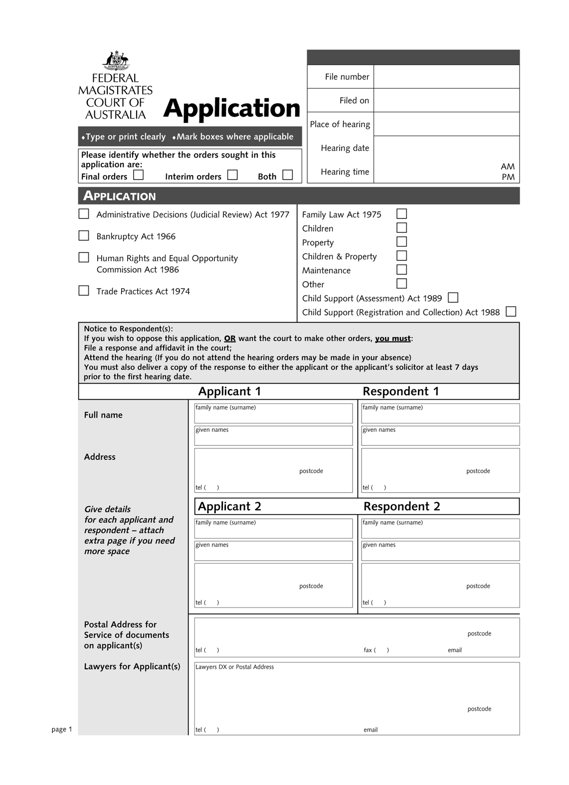
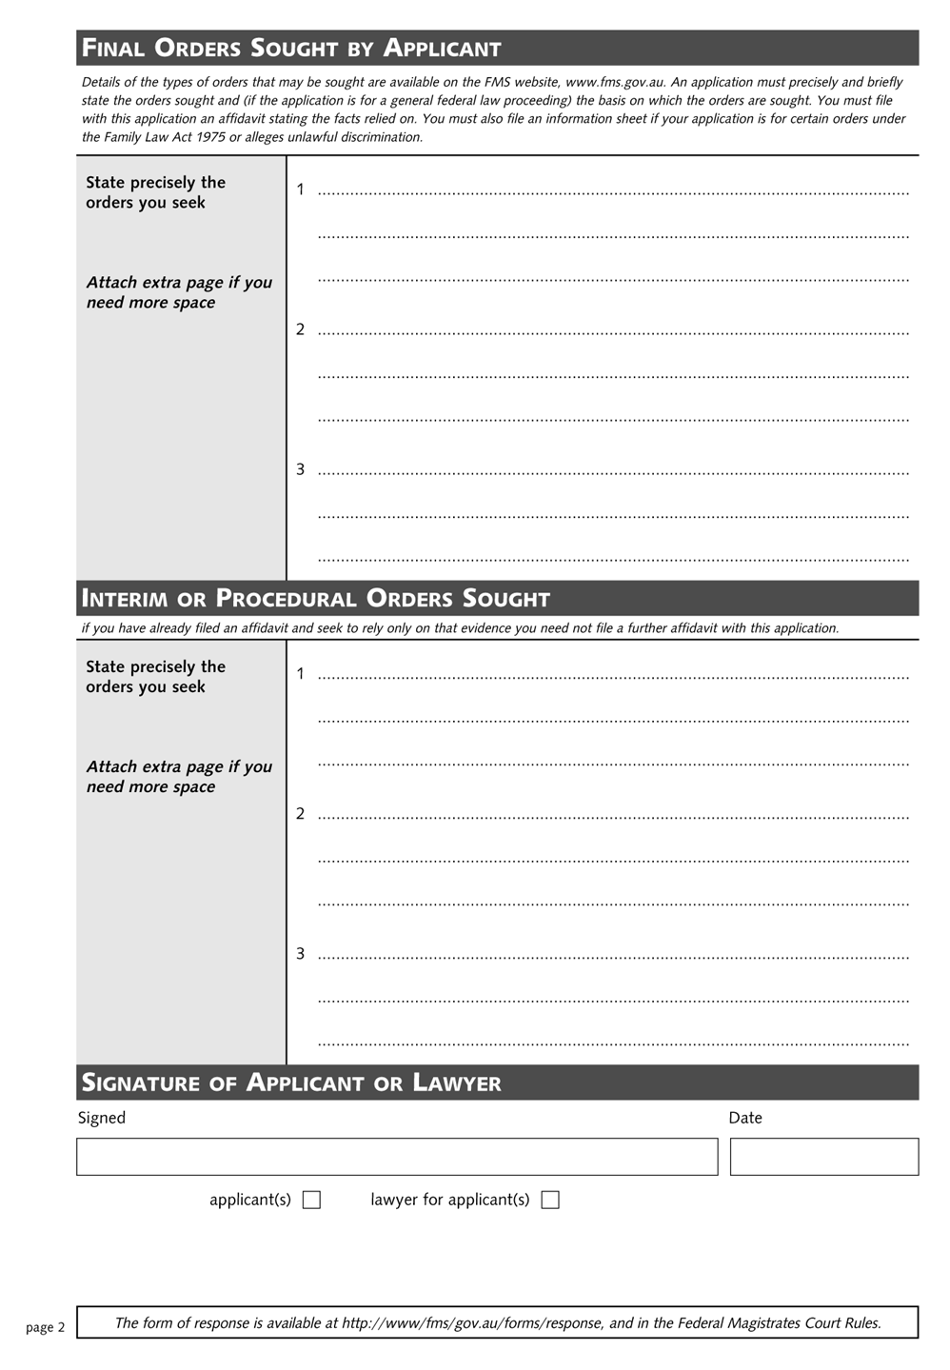
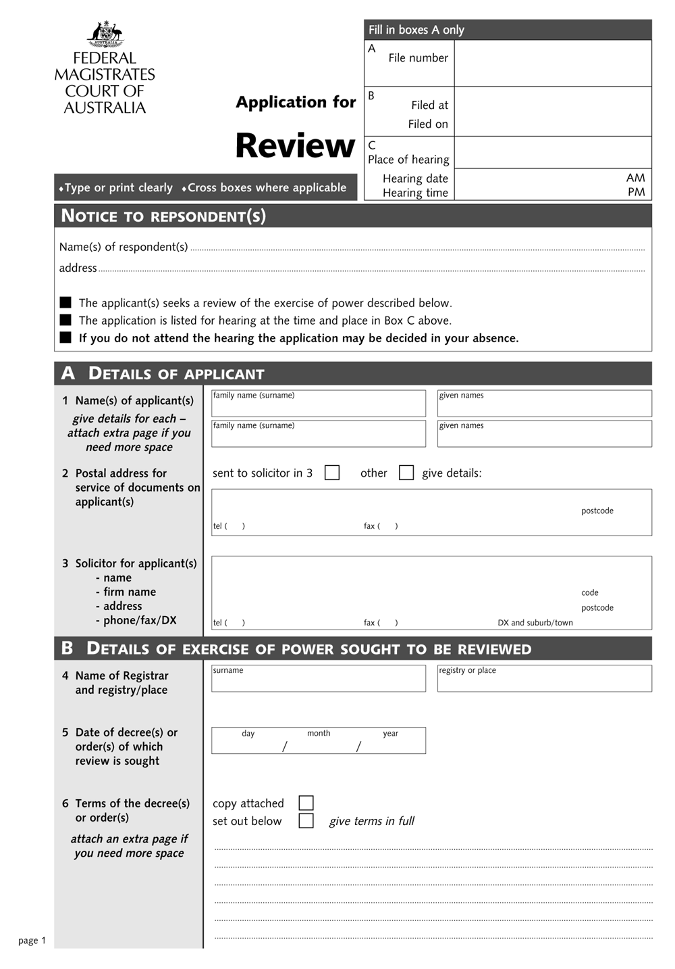
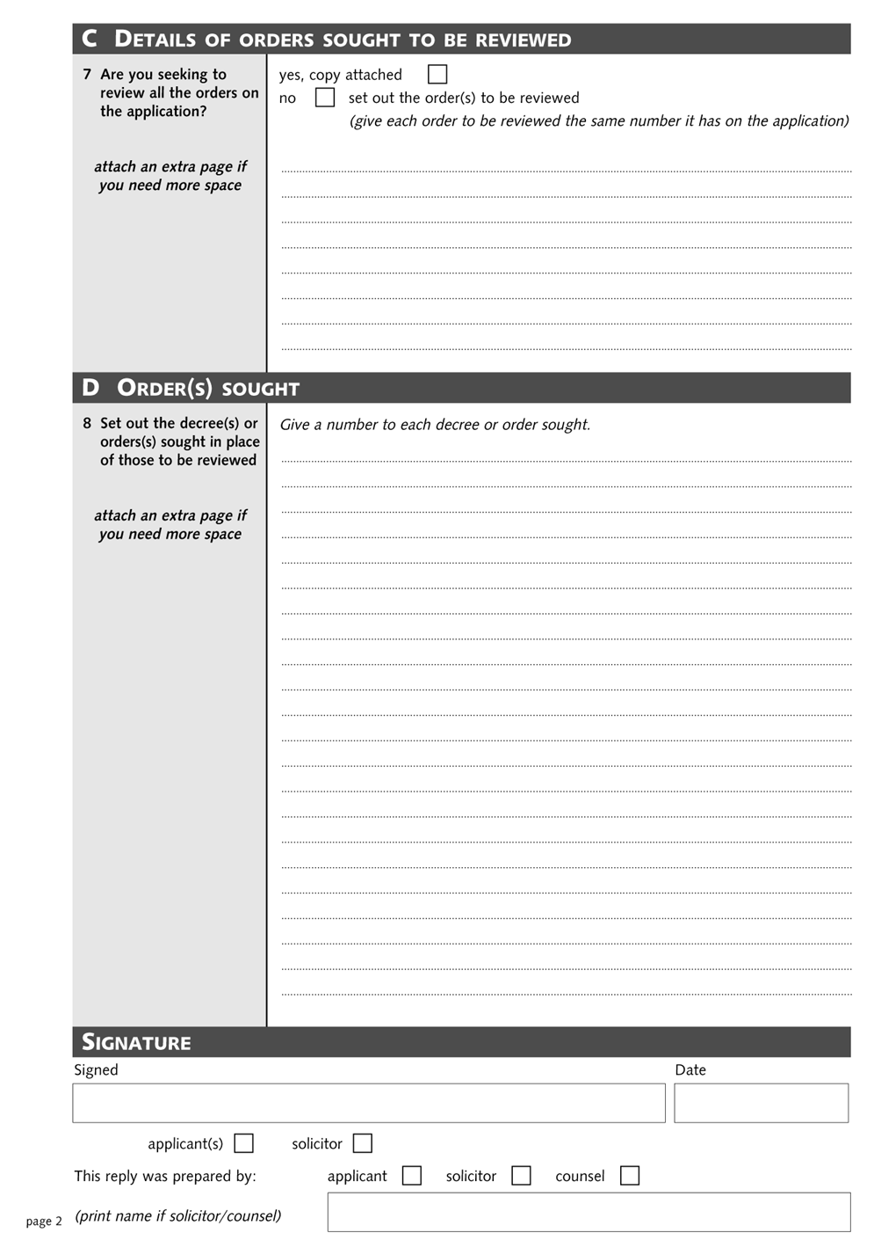
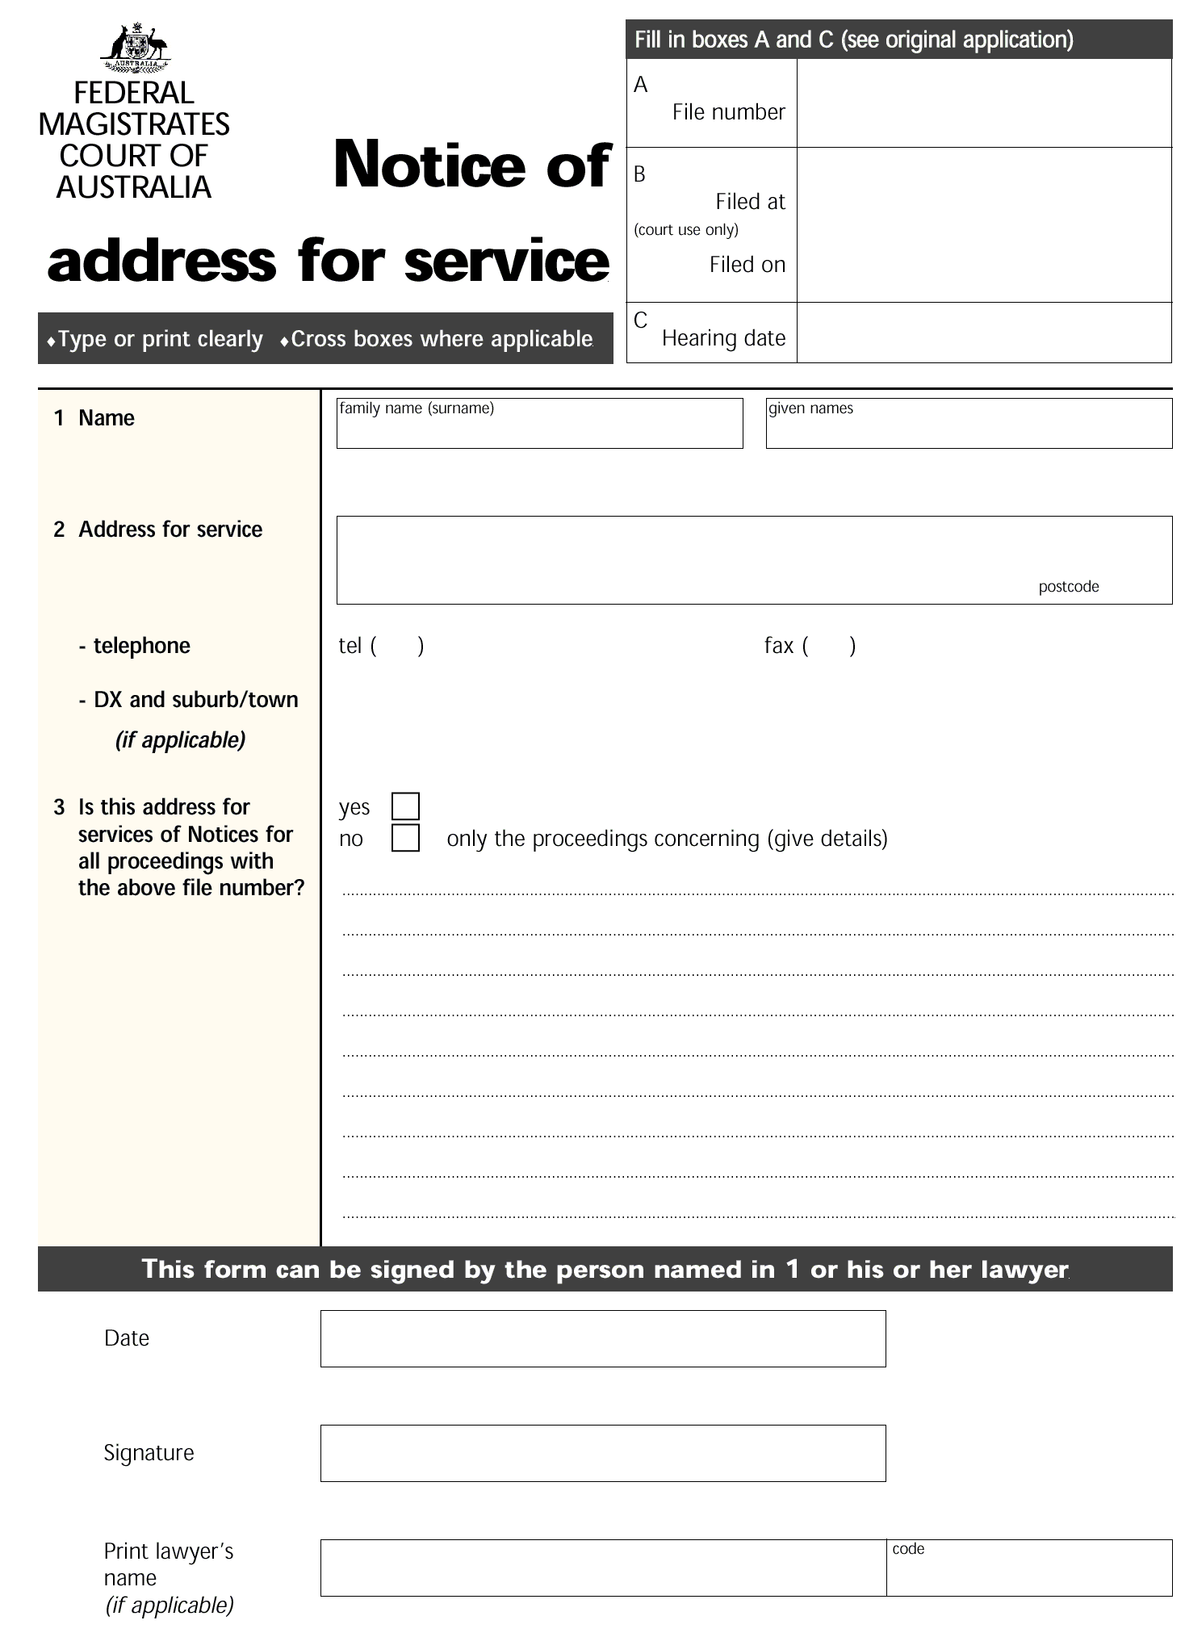
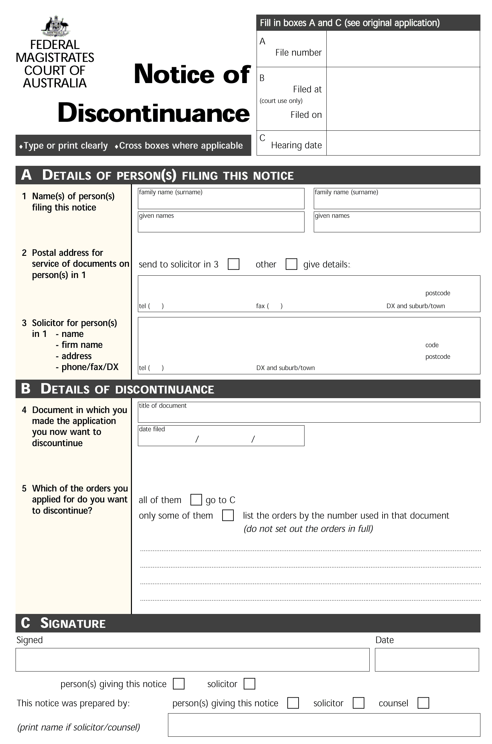
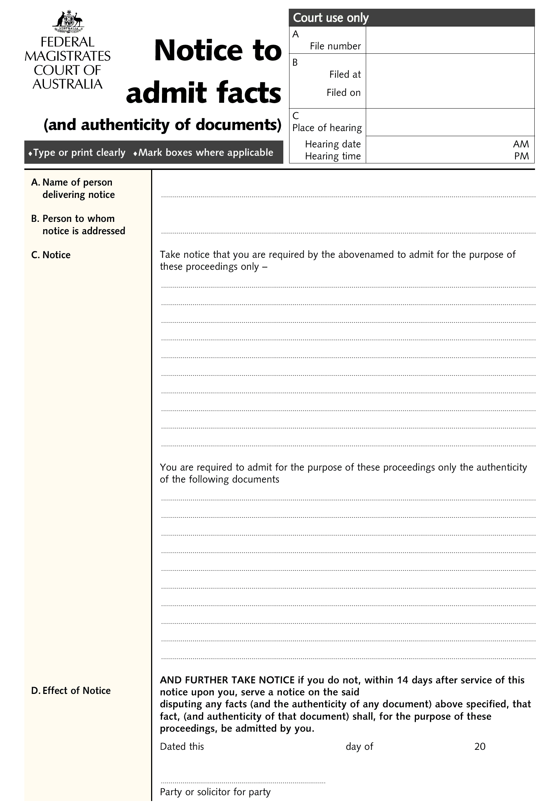
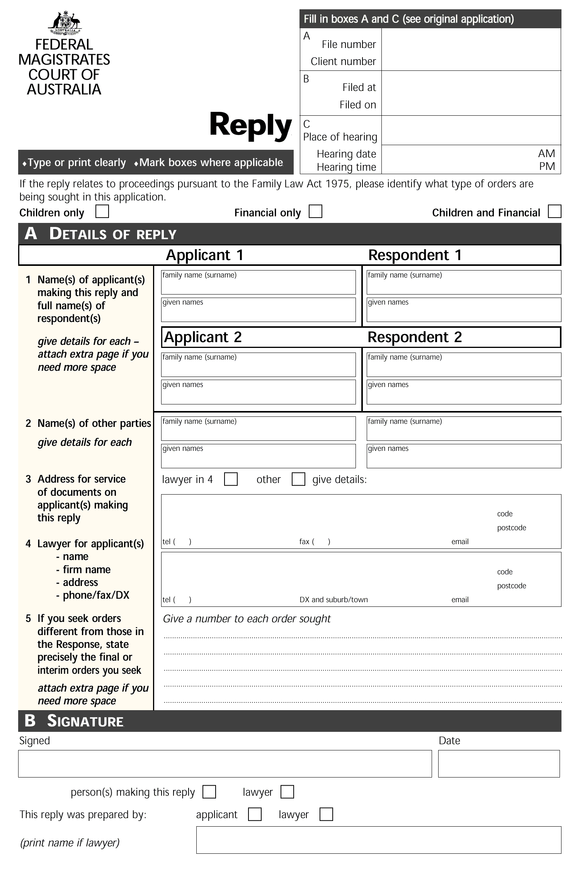
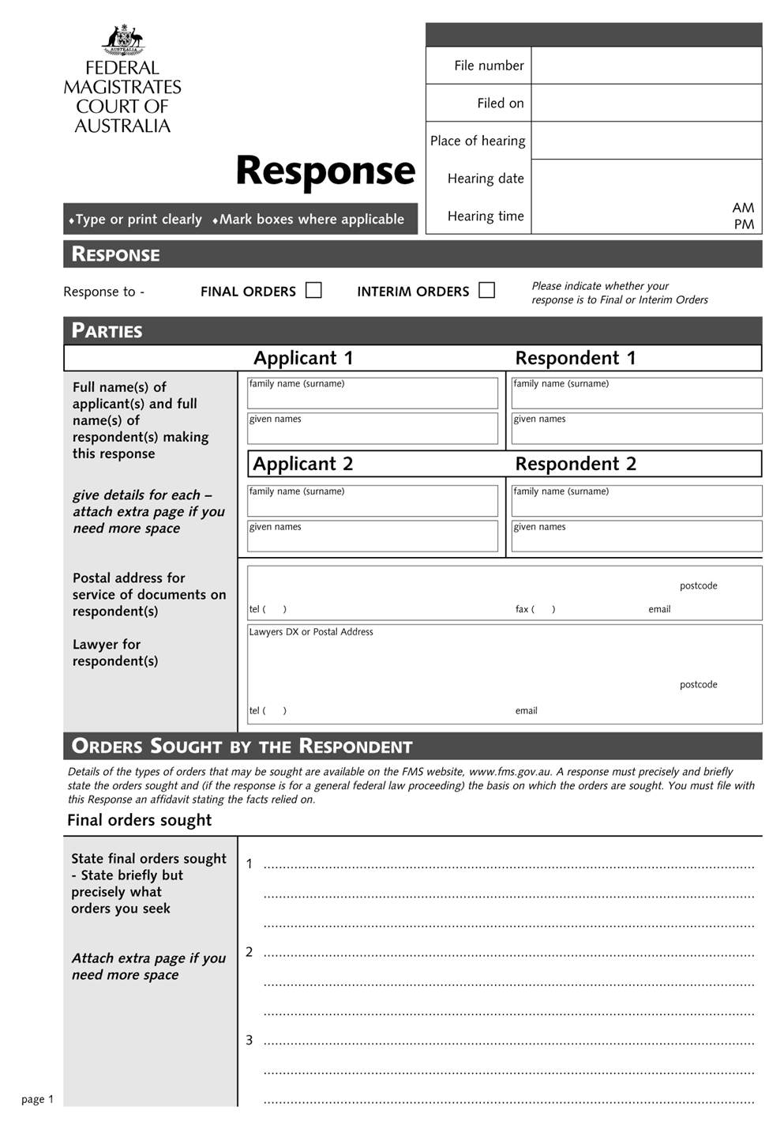
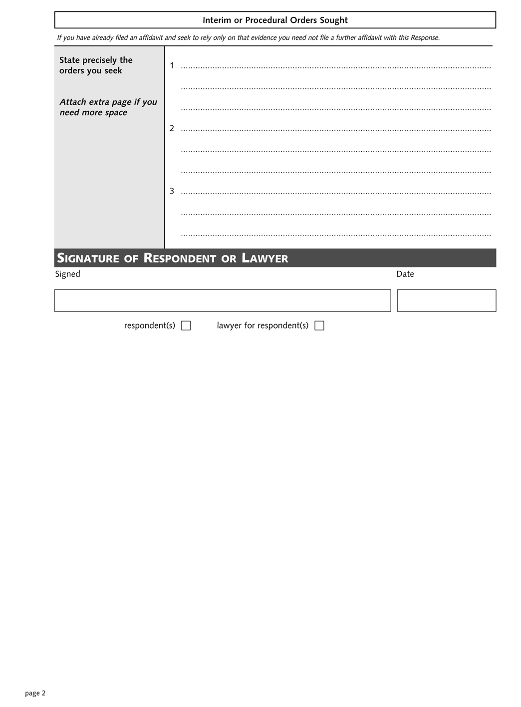
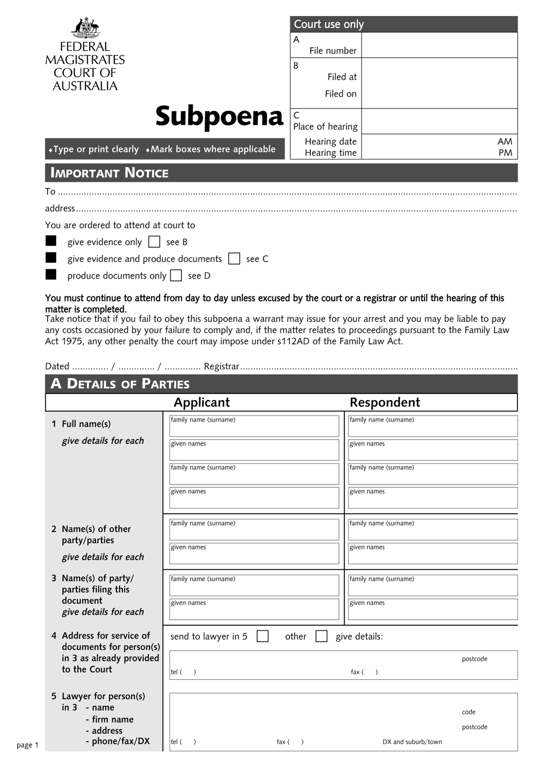
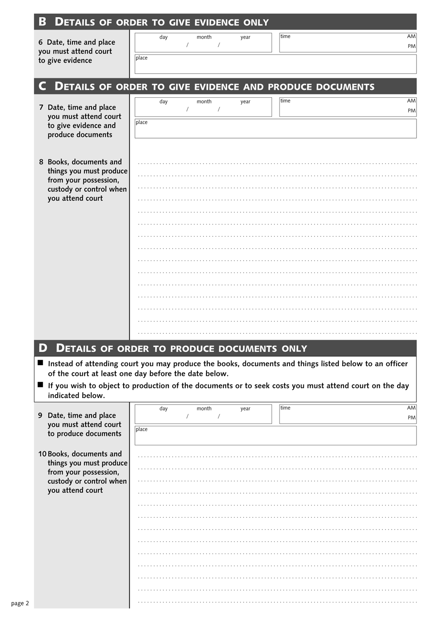

Part 2 Dissolution of marriage
Form 4 Application for divorce
(rule 25.01)
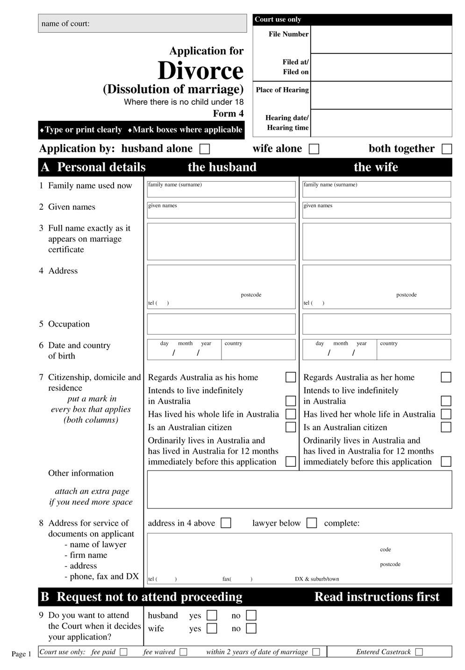

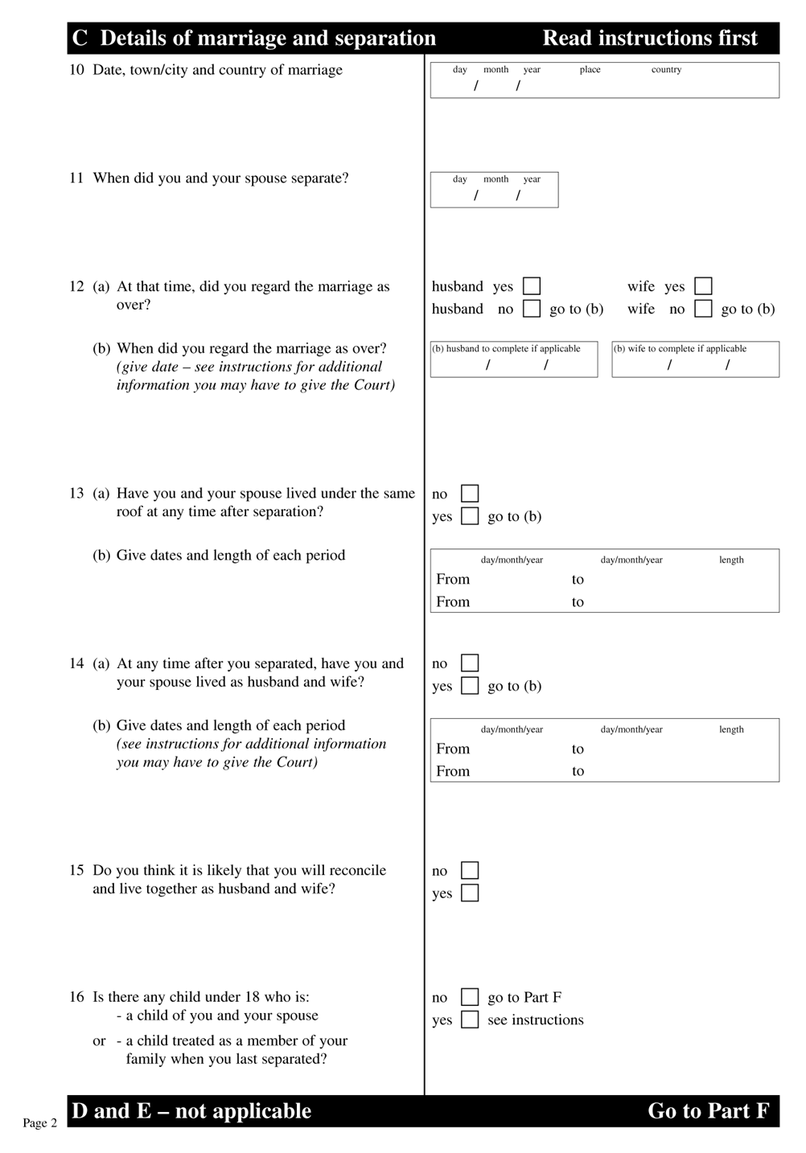
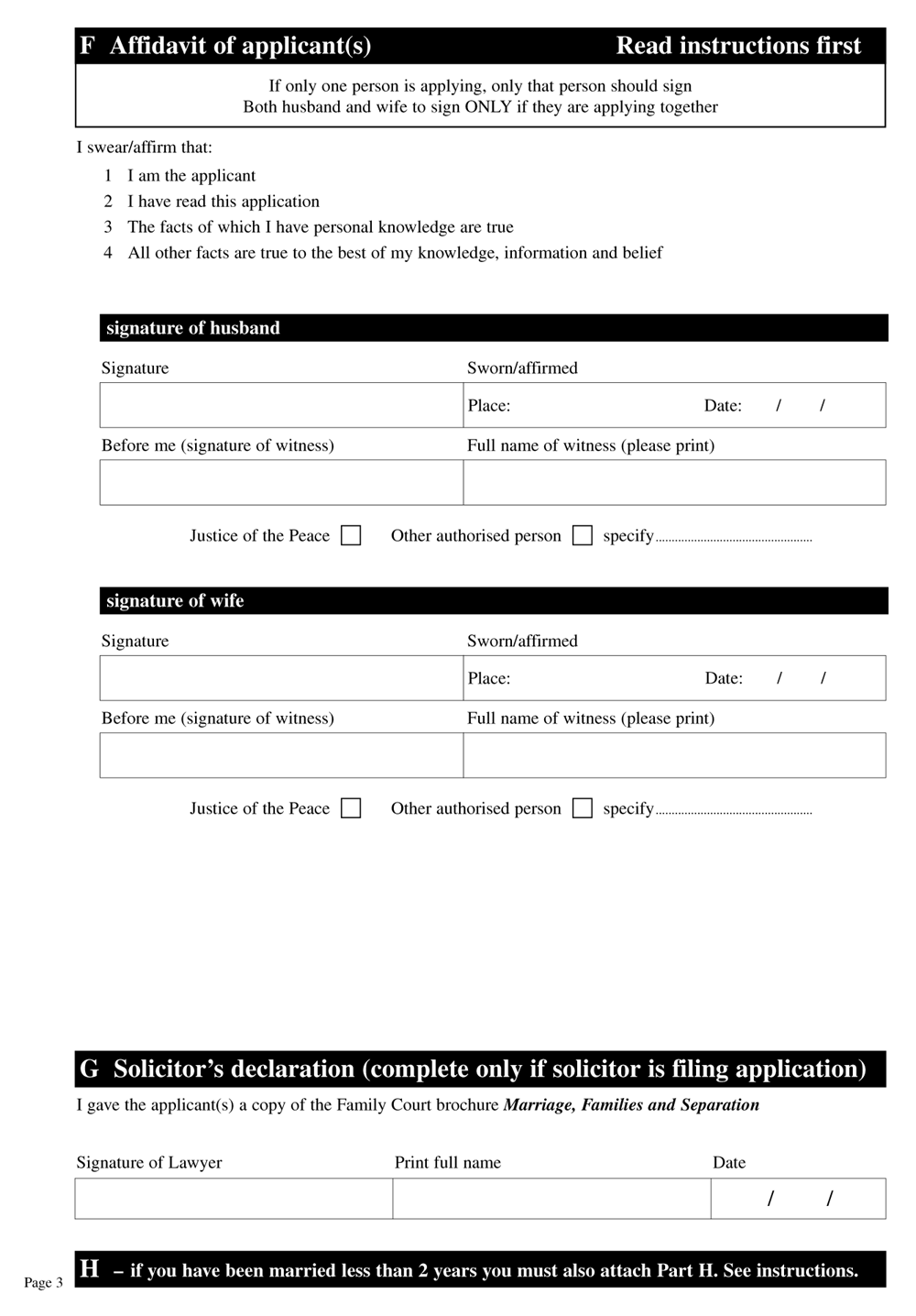
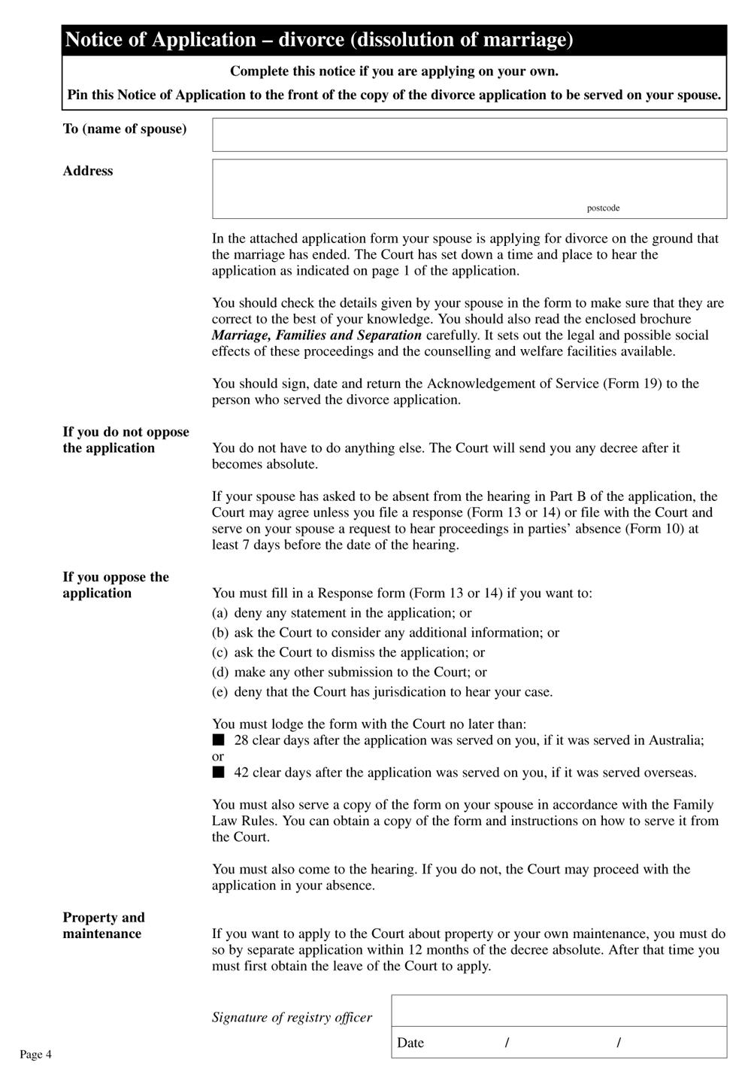
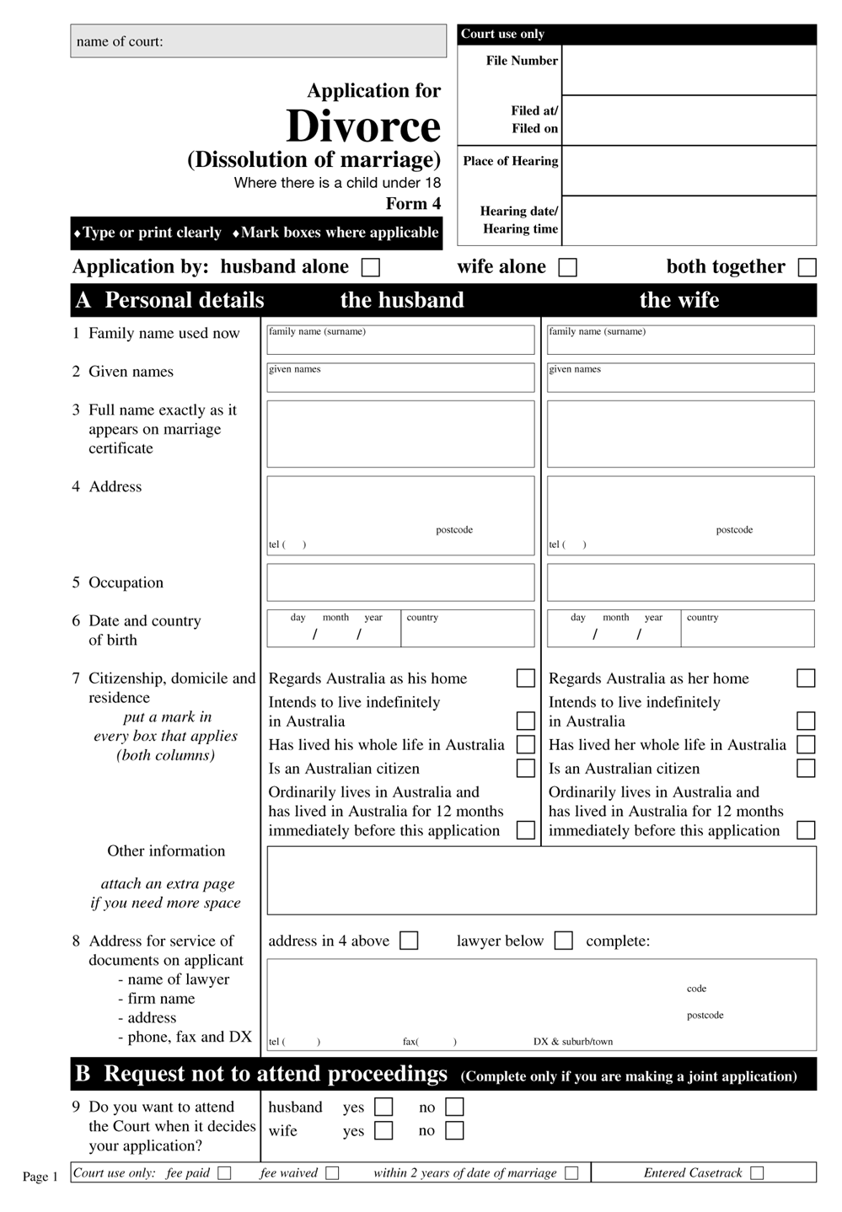
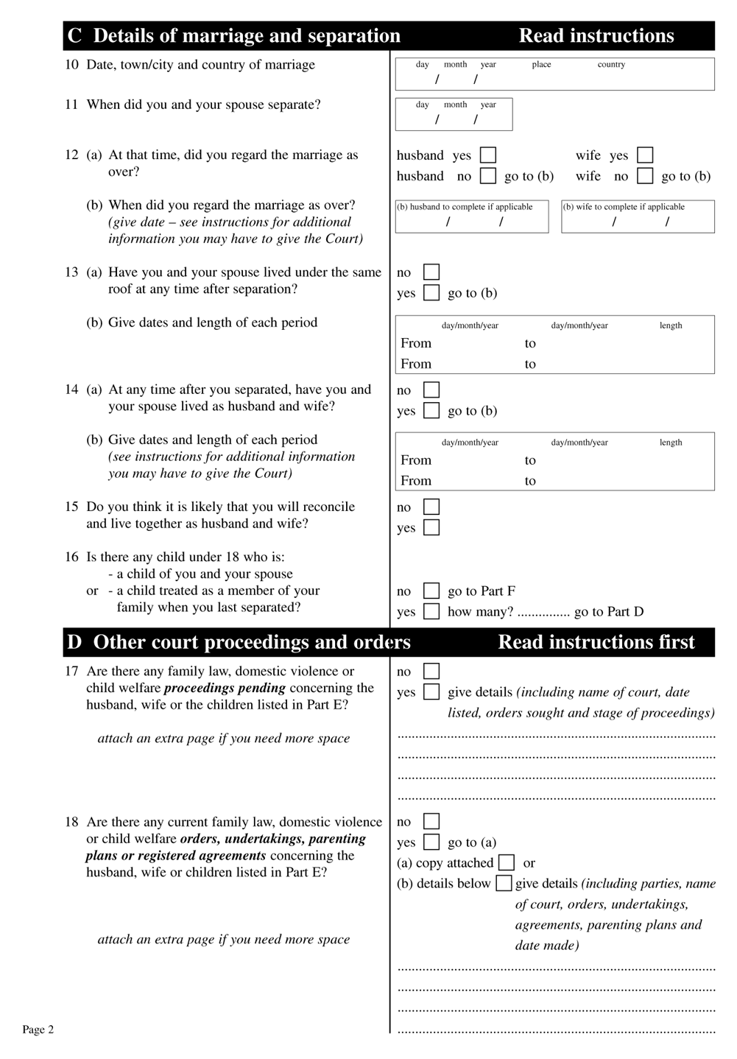
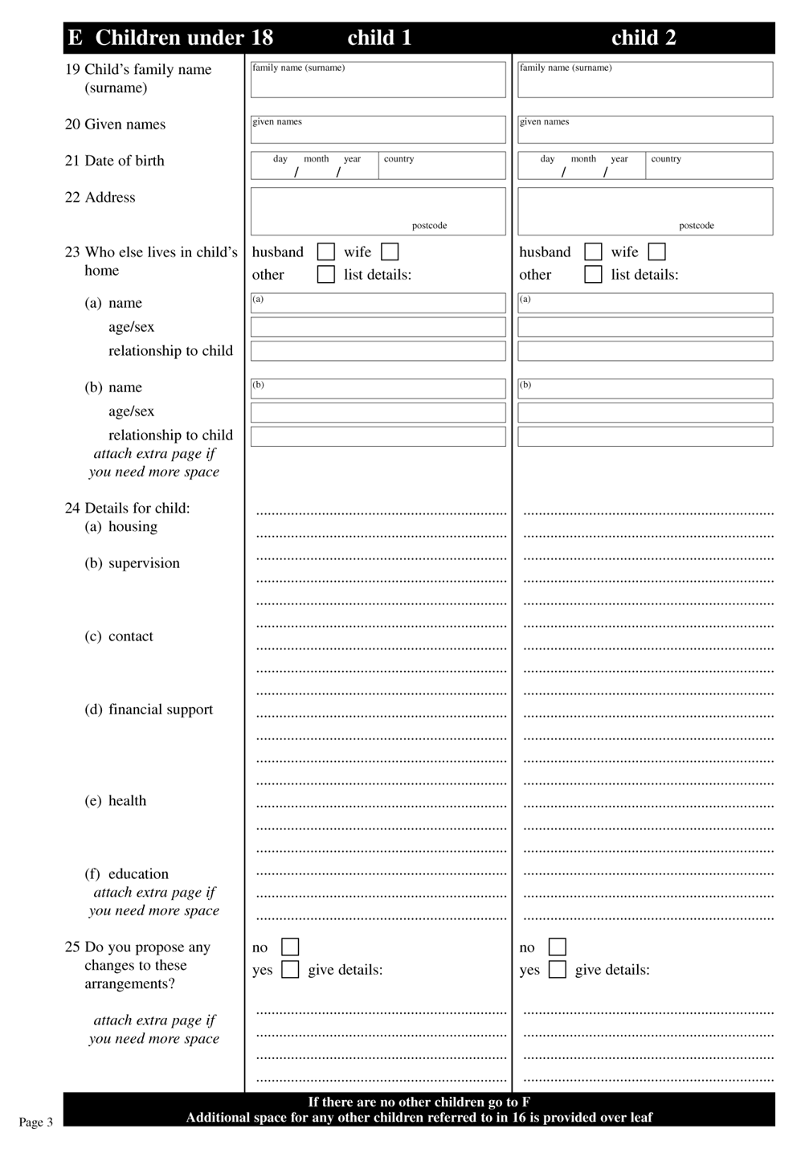
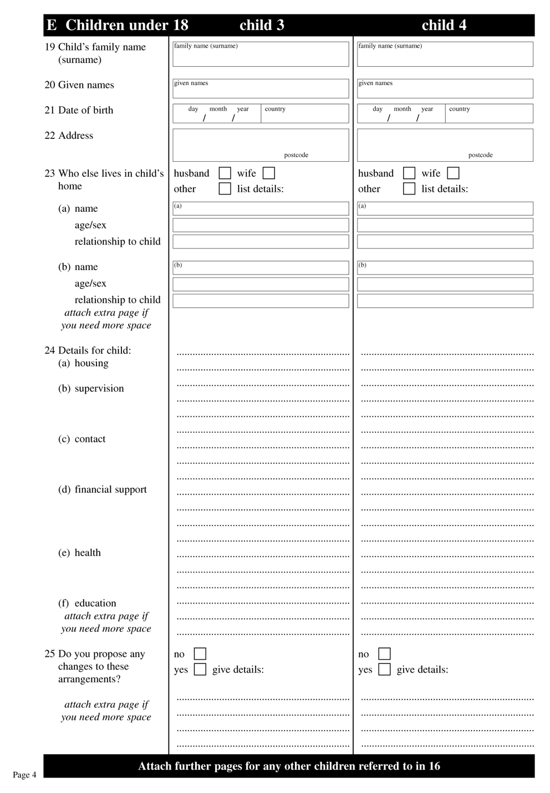
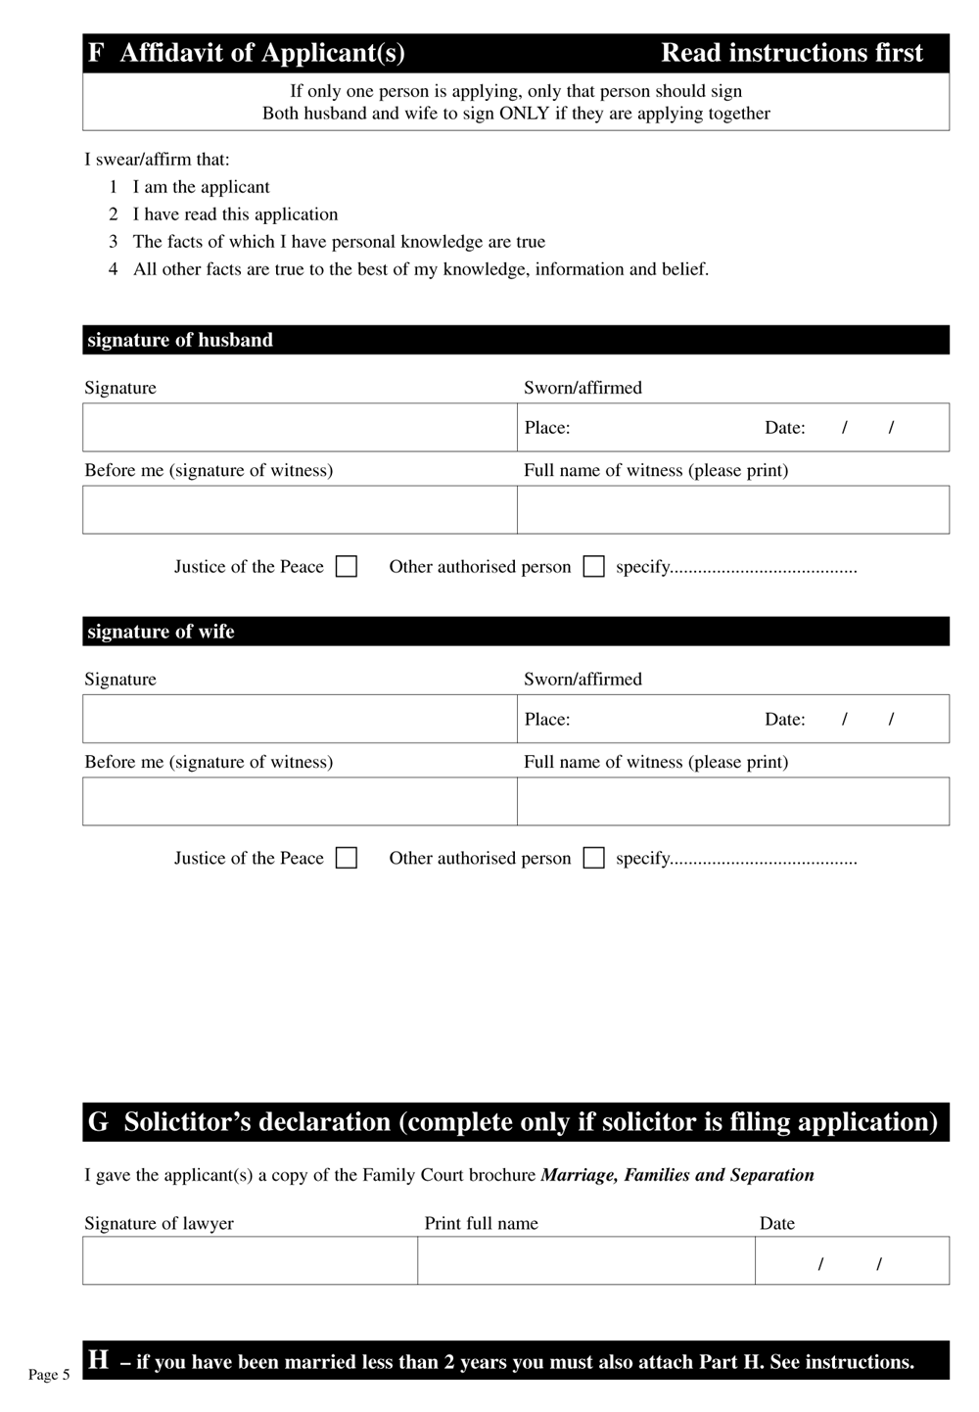
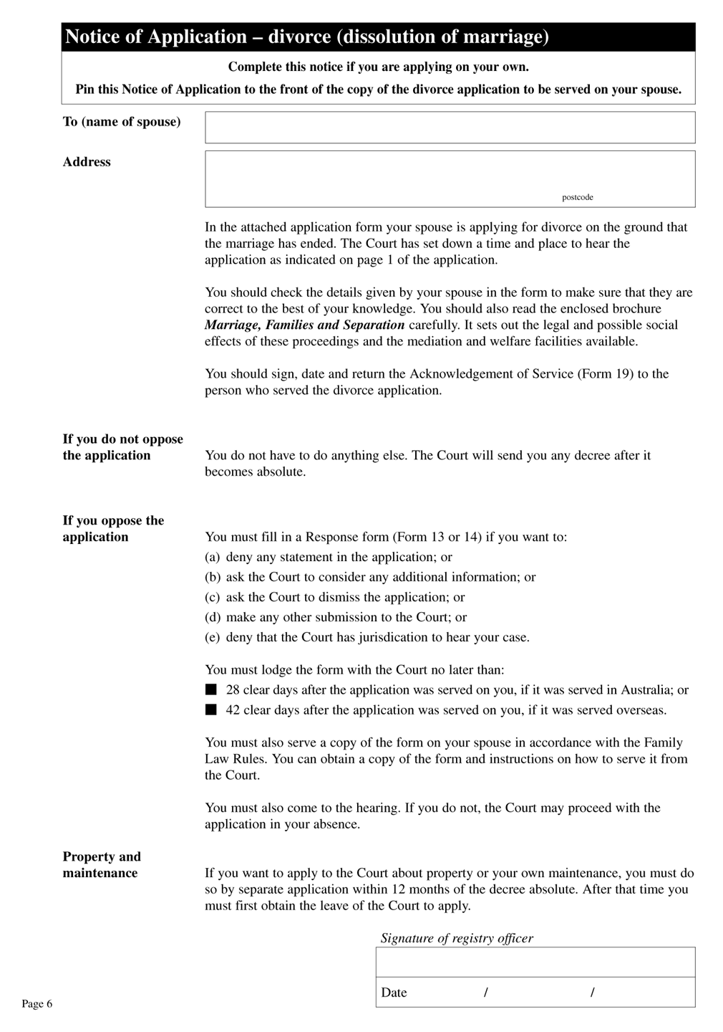
Form 13 Response
(rule 25.07)
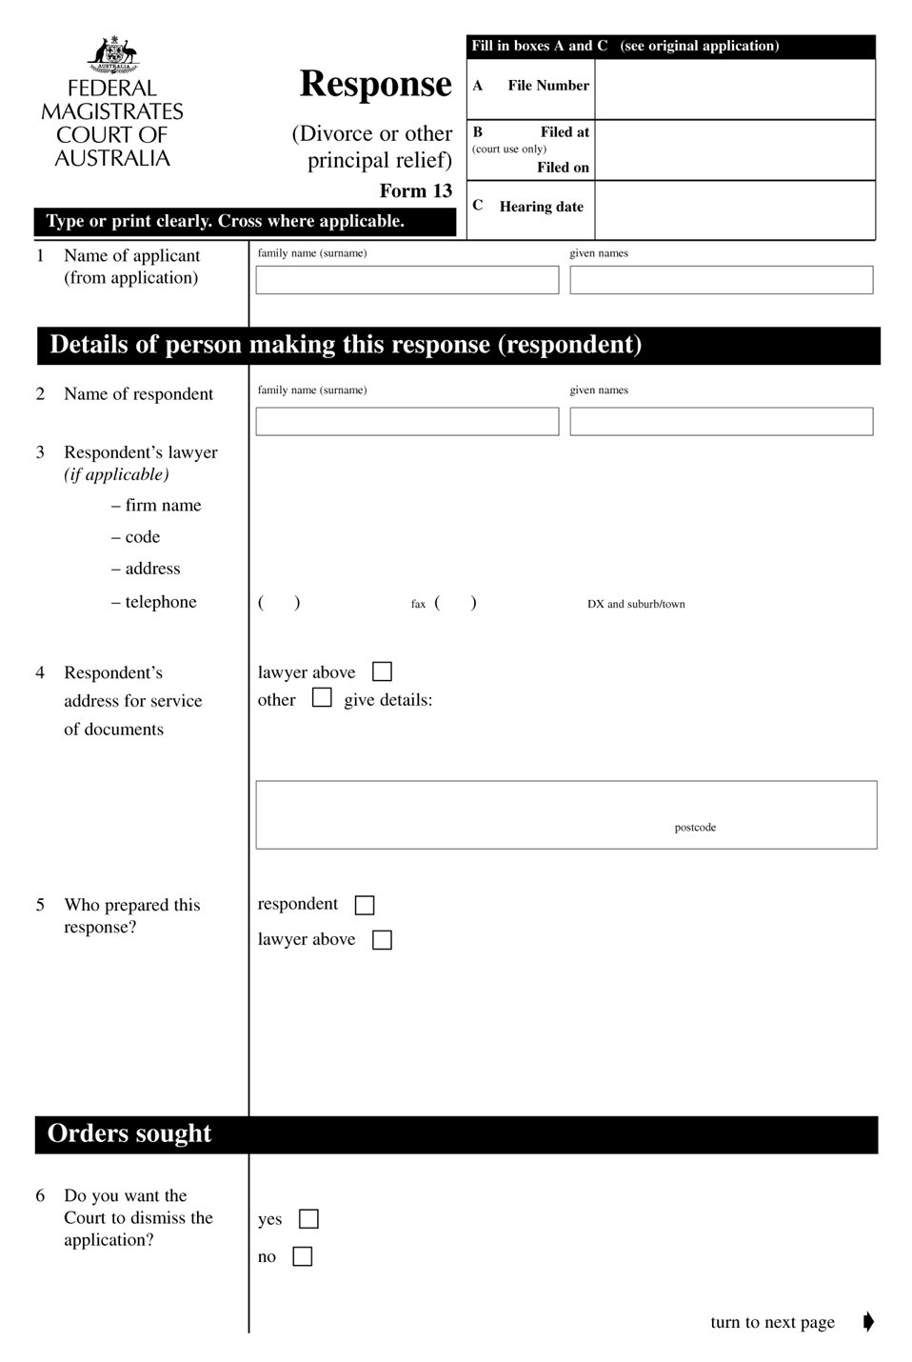

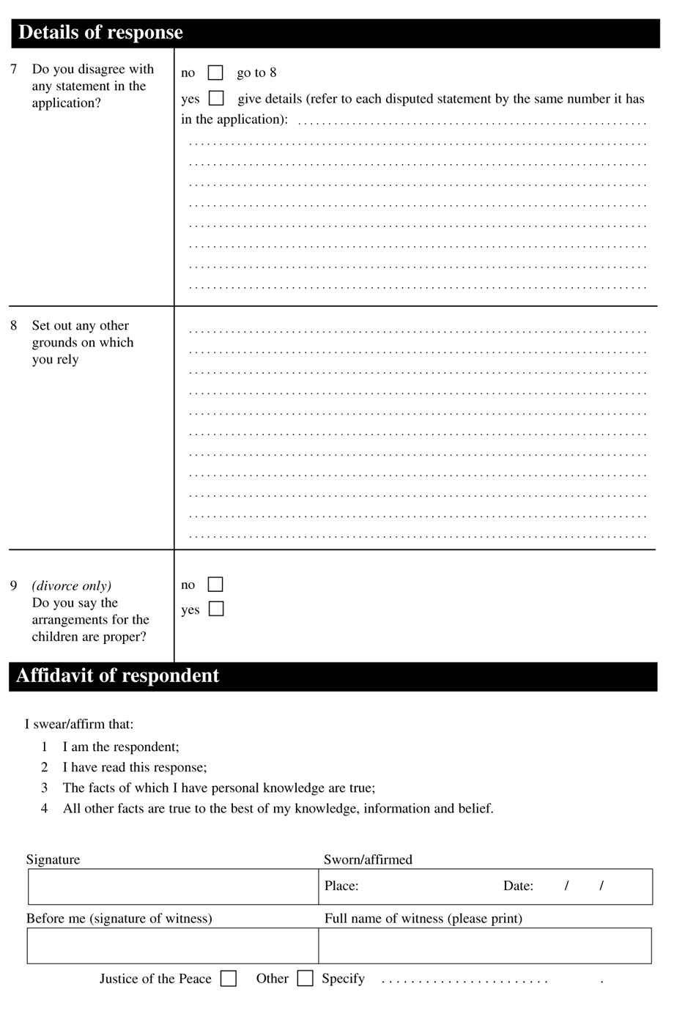
Form 14 Response objecting to jurisdiction
(rule 25.08)
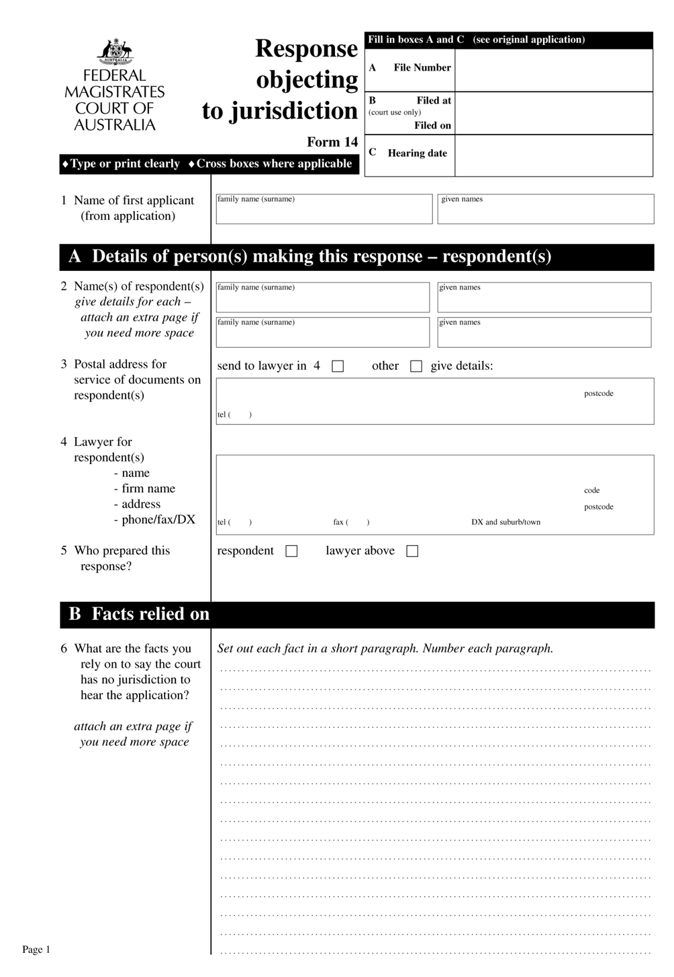

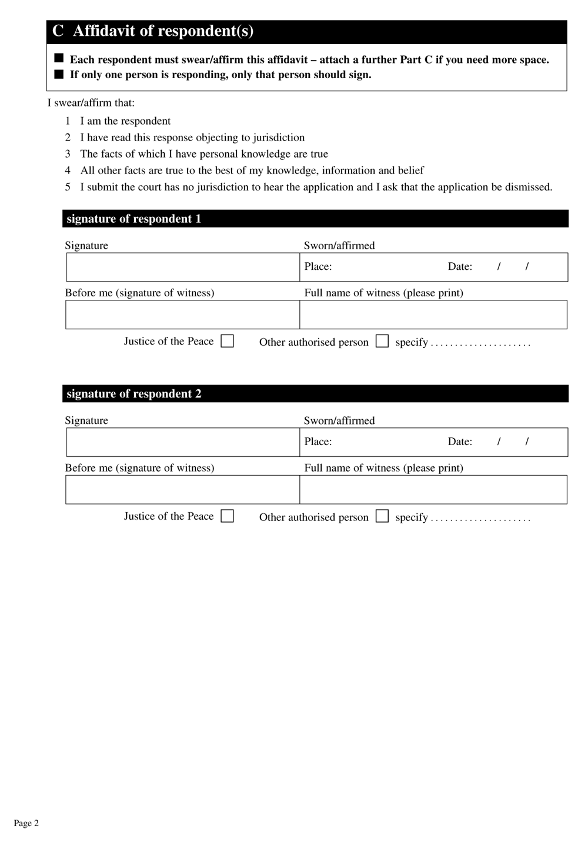

Form 19 Acknowledgment of service
(rule 25.03)
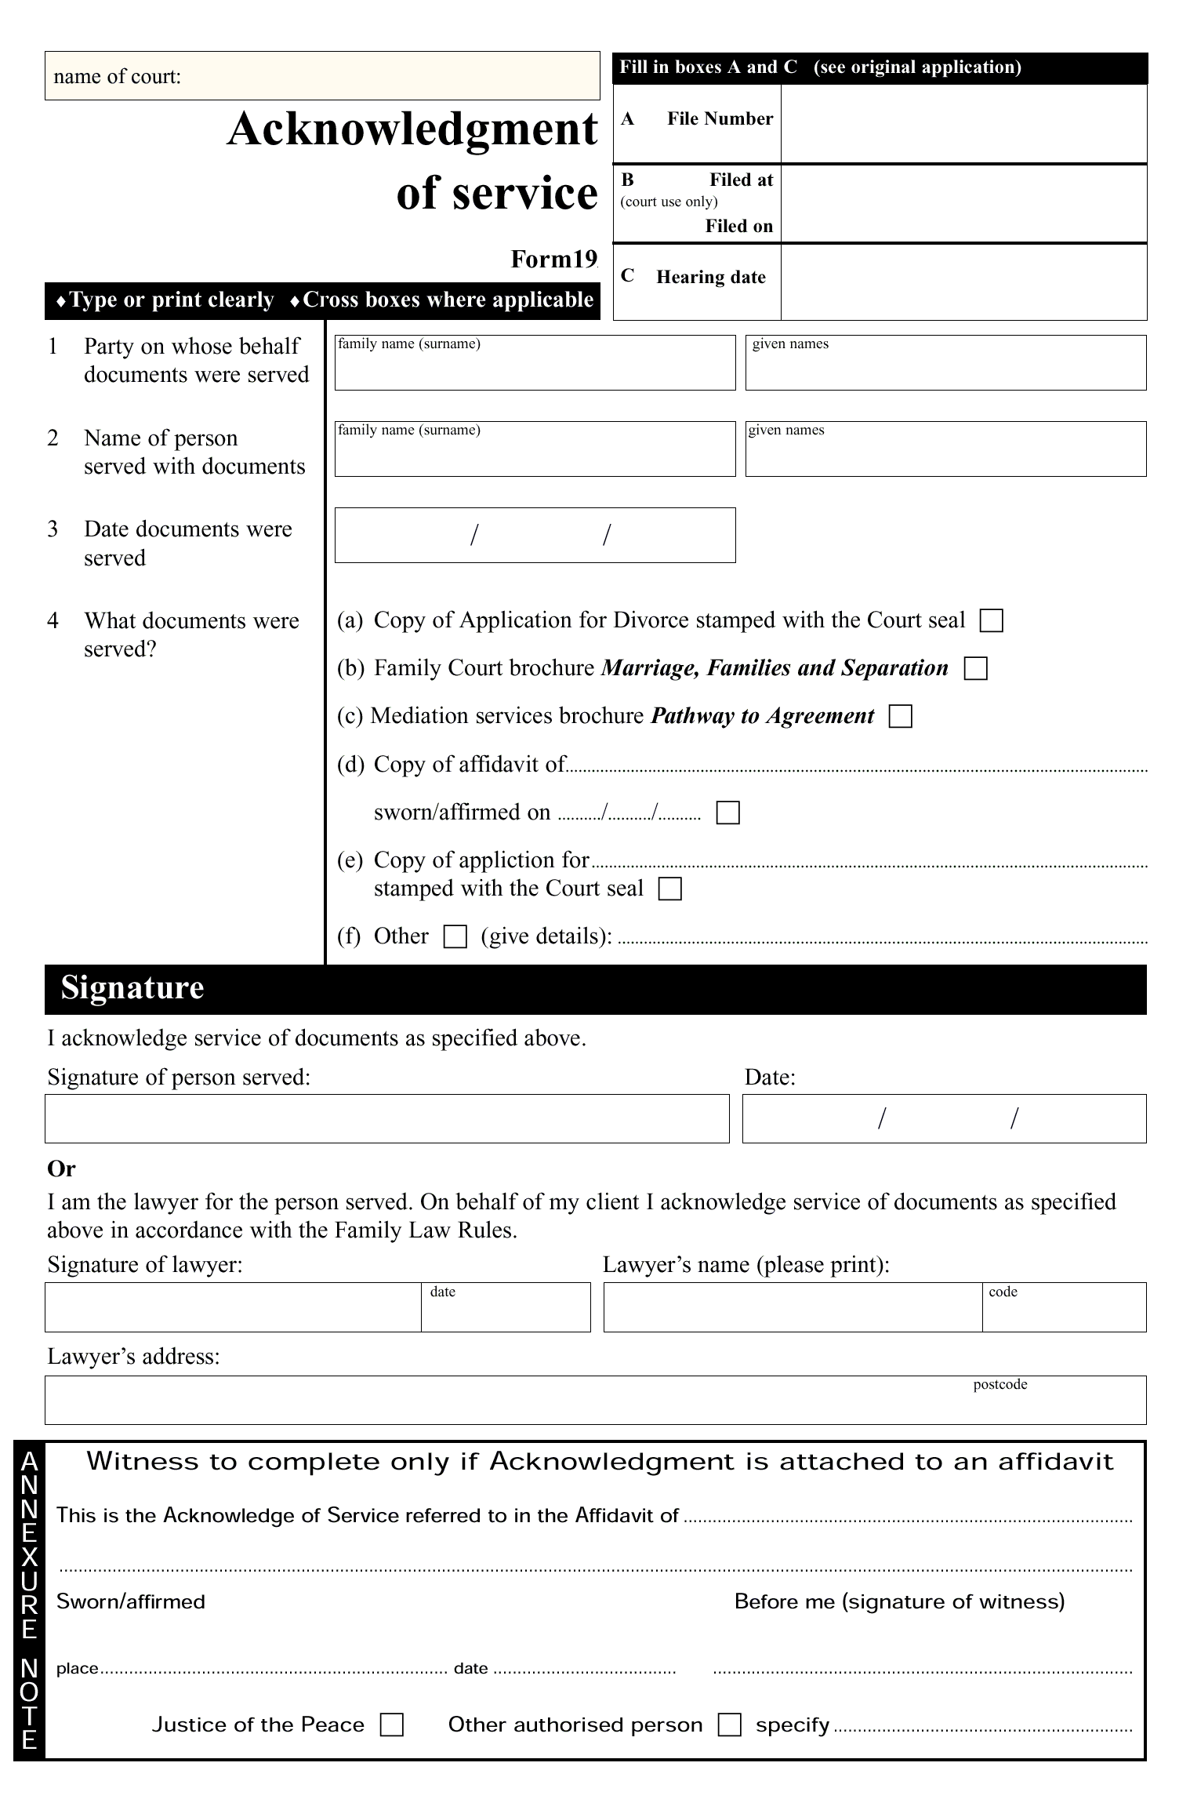

Form 20 Affidavit for service by post (divorce)
(rule 25.05)
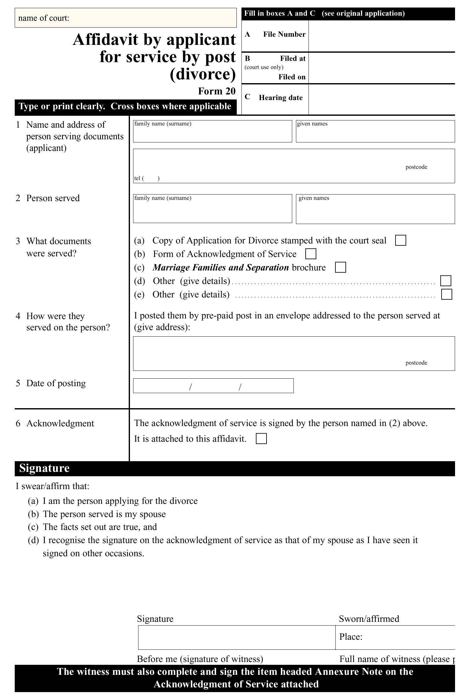

Form 21 Affidavit of service (divorce)
(rule 25.05)
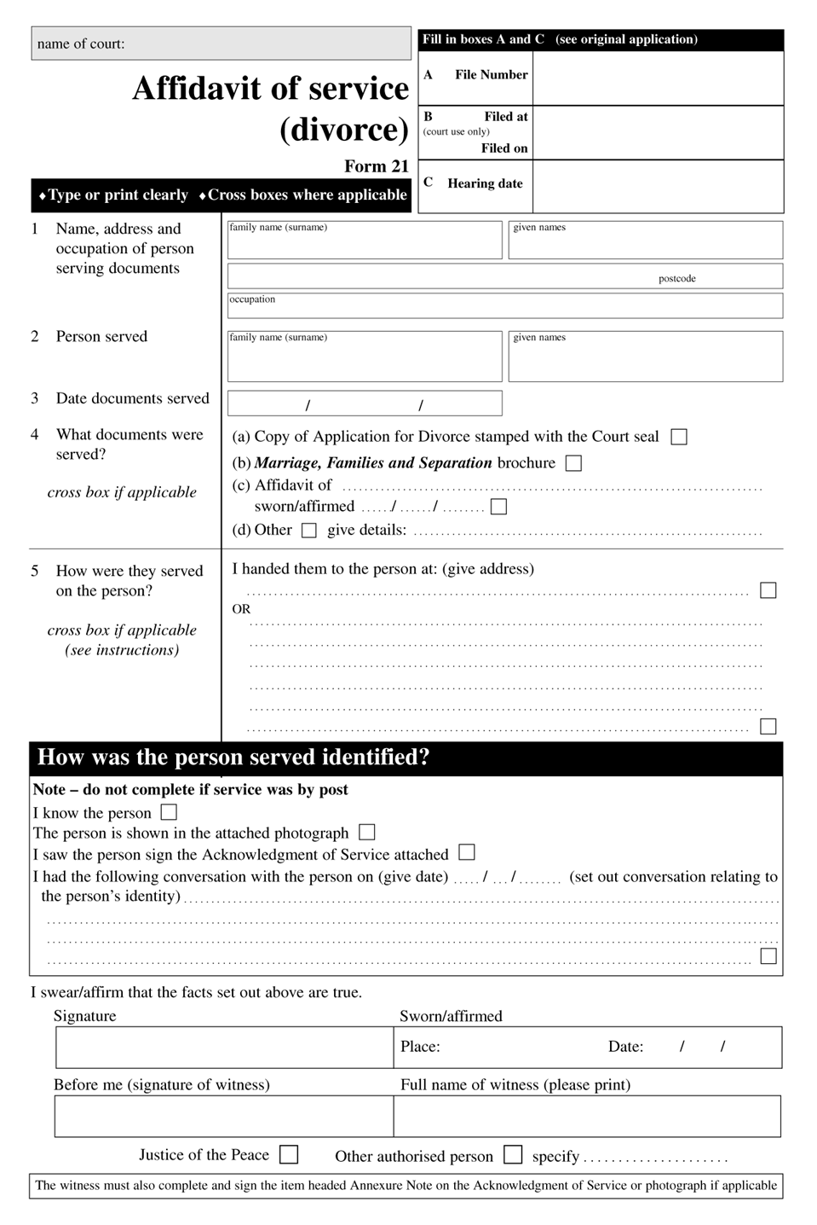
Form 23 Affidavit of proof of signature
(rule 25.06)
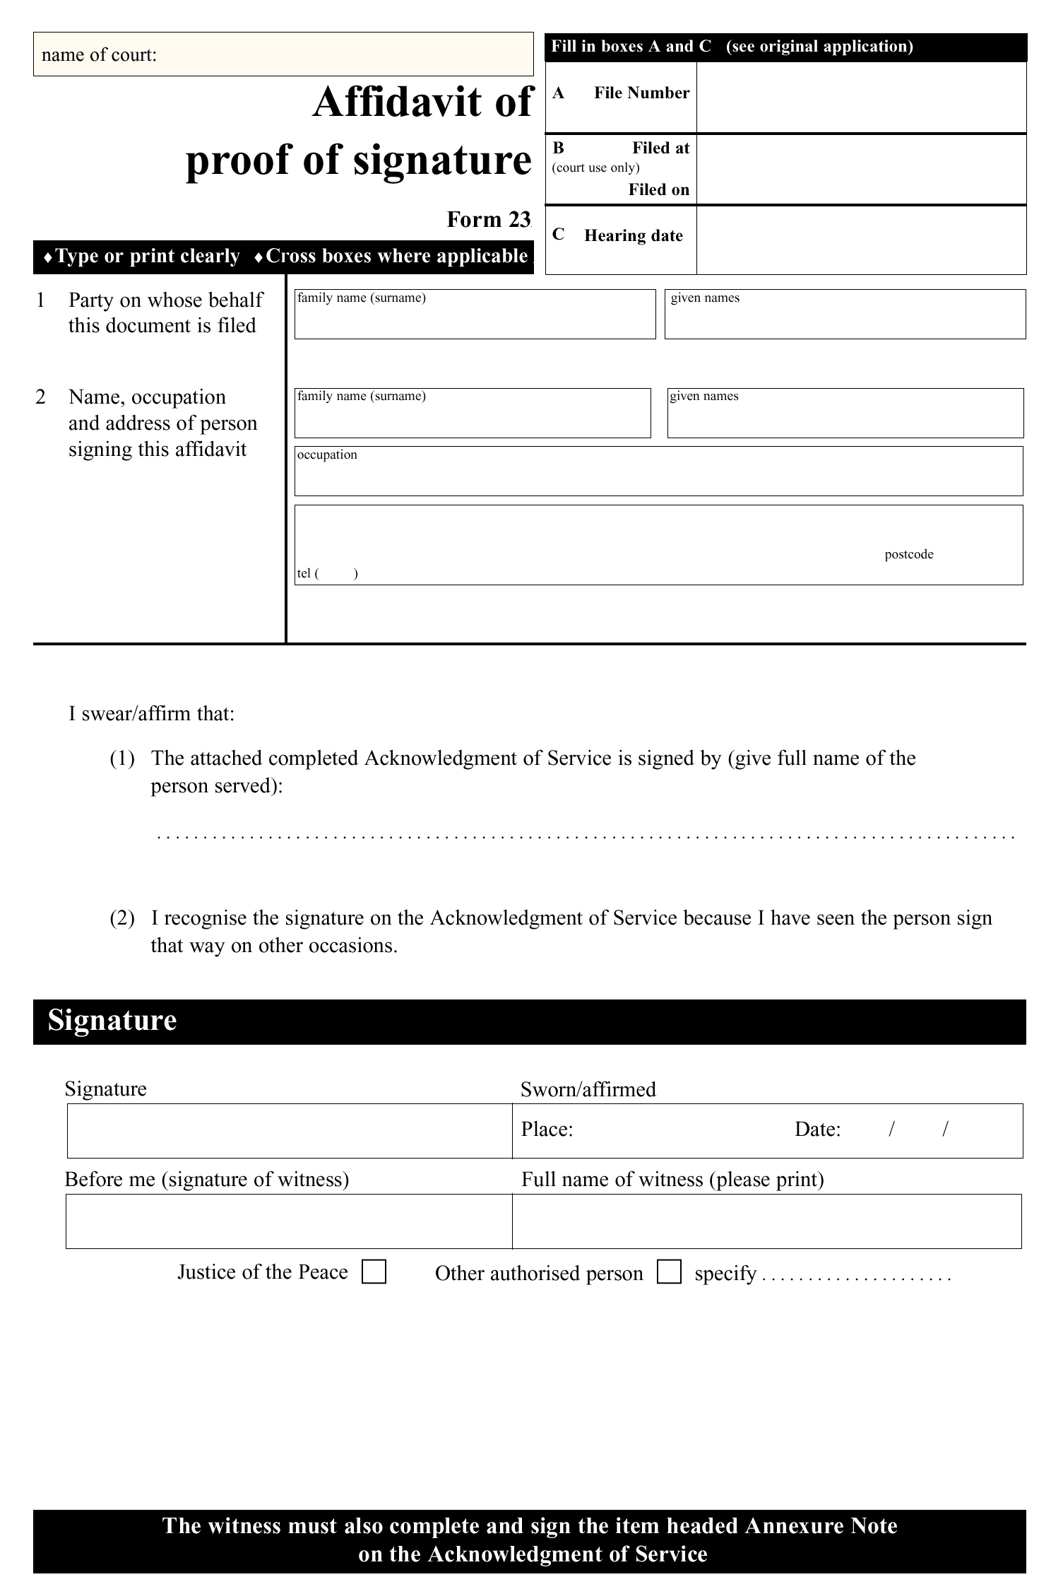

Part 3 Bankruptcy
Form 5 Application (bankruptcy)
(rule 29.03)
(Specify briefly the nature of the subject of the application or cross-claim and the legislative basis of the court’s jurisdiction to hear it and grant the relief sought. Note: This statement does not form part of the application.)
A. DETAILS OF CLAIM
On the grounds stated in the accompanying affidavit or statement of claim, the applicant claims:
1. (Specify in numbered paragraphs all final relief sought.)
2.
3.
B. CLAIM FOR INTERLOCUTORY RELIEF
(Complete this section if you wish to claim interlocutory relief.)
AND the applicant claims by way of interlocutory relief:
1. (Specify in numbered paragraphs all interlocutory relief sought.)
2.
3.
Date:
(signed, applicant or applicant’s lawyer)
C. NOTICE TO RESPONDENT
(Complete this section if there is a respondent.)
TO the respondent of (insert address):
This application has been set down for the time and place stated below. If you or your legal representative do not attend the Court at that time, the application may be dealt with and judgment may be given, or an order made, in your absence. As soon after the time mentioned as the business of the Court will allow, any of the following may happen:
(a) the application may be heard;
(b) directions may be given for the further conduct of the proceeding;
(c) any application for interlocutory relief may be heard.
Before any attendance at Court, you must file an appearance in the Registry.
Time and date for hearing: (to be entered by Registry unless fixed by Court)
Place: (address of Court)
D. ABRIDGMENT OF SERVICE
(Complete this section if the time for service has been abridged.)
The time by which this application is to be served has been abridged by order made on (insert date) to (insert time and date).
Date:
(signed, Registrar)
E. FILING AND SERVICE
This application is filed by (insert name) for (insert name) whose address for service is (insert address).
The applicant’s address is (if the applicant is an individual, specify place of residence or business; if the applicant is a corporation, specify principal place of business).
It is not intended to serve this application on any person.
OR
It is intended to serve this application on each person listed below:
(insert name of each person on whom application is to be served)

Form 15 Appearance
(rule 29.06)
A.B.
of (address) (occupation) appears.
If a person under disability, his or her tutor is: C.D.
(Add other notices if applicable.)
Solicitor: (name)
(address)
telephone: (number)
facsimile: (number)
email address:
Solicitor’s agent: (name)
(address)
telephone: (number)
facsimile: (number)
email address:
Address for service: (the office of his or her lawyer, or as the case may be)
(This notice of appearance may be added to a notice of motion of a person applying to be added as a respondent.)
(If a respondent wishes to enter a conditional appearance insert ‘conditionally’ after ‘appear’.)

Form 149 Notice of intention to oppose application or petition
(rule 29.07)
(Name of opponent), (specify capacity of opponent, eg creditor, trustee), intends to oppose the *application/*petition on the following grounds:
1. } (set out grounds of opposition)
2. }
3. }
An affidavit supporting the grounds of opposition is filed with this notice.
This notice is filed by (name of lawyer for opponent) for (name of opponent).
The opponent’s address for service is: (address for service).
Date:
(signed, opponent or opponent’s lawyer)
* Omit if inapplicable

Form 150 Creditor’s petition
(rule 31.02)
The applicant creditor (name and address of applicant) applies to the Court for a sequestration order under section 43 of the Bankruptcy Act 1966 against the estate of (name, address and occupation of respondent debtor).
1. The respondent debtor owes the applicant creditor the amount of ($ amount) for (statement of reason for and details of the debt).
2. EITHER
The applicant creditor does not hold security over the property of the respondent debtor.
OR
The applicant creditor holds security over the property of the respondent debtor to the value of ($ amount) and consisting of (statement of particulars of security), and:
EITHER
(a) is willing to surrender this security for the benefit of creditors generally if a sequestration order is made against the respondent debtor;
OR
(b) the value of the property is ($ amount), which leaves an unsecured debt of ($ amount).
Note If there is more than 1 applicant creditor, the form may be appropriately amended.
3. At the time when the act of bankruptcy was committed, the respondent debtor:
* was personally present in Australia
* was ordinarily resident in Australia
* had a dwelling house or place of business in Australia
* was carrying on business in Australia either personally or by an agent or manager
* was a member of a firm or partnership carrying on business in Australian by means of partners or agent or manager.
4. The following act of bankruptcy was committed by the respondent debtor within 6 months before the presentation of this petition:
(Give full details of the act of bankruptcy mentioned in section 40 of the Bankruptcy Act 1966 on which you are relying, including details of any judgment on which a bankruptcy notice is founded.)
Date:
(signed, petitioner or lawyer for petitioner)
To: (name of respondent debtor)
(address)
This petition has been set down for hearing by the Court at the time, date and place specified below. If there is no appearance by you or your legal representative at that time, the petition may be dealt with in your absence and a sequestration order made against you.
If you wish to appear at the hearing, you must file and serve a notice of appearance.
If you wish to appear at the hearing and oppose this petition, you must:
(a) enter an appearance and file a notice of intention to oppose the petition, in accordance with Form 149, and an affidavit supporting the grounds; and
(b) serve a copy of each document on the creditor at the address for service stated below not less than 3 days before the date for the hearing of this petition stated below; and
(c) attend at the Court on the date for the hearing stated below.
Time and date for hearing: (to be entered by Registry)
Place: (address of Court)
Date:
(signed, Registrar)
This petition is filed by (name of lawyer for petitioner) for (name of petitioner).
The petitioner’s address for service is: (address for service).
* Omit if inapplicable

Form 151 Summons to attend examination
(rules 31.07, 33.04, 33.11)
TO: (name and address of person summoned)
1. You are required to attend before *the Court/*a Registrar/*a magistrate at the time, date and place stated below to be examined on oath under *section 50/*section 81 of the Bankruptcy Act 1966 and to give evidence in relation to the examinable affairs of (name of bankrupt or debtor).
* Omit if inapplicable
2. You are also required to bring the following books with you and produce them at the examination:
(list books required)
Time and date for examination: (to be inserted by Registry)
Place: (address of Court)
Date:
(signed, Registrar)
This summons was issued on the application of (name of applicant), (specify the capacity of the applicant under subsection 81 (1) of the Bankruptcy Act 1966, eg creditor, trustee), whose address for service is (address).
Note 1 Section 5 of the Bankruptcy Act 1966 defines examinable affairs, in relation to a person, to mean:
(a) the person’s dealings, transactions, property and affairs; and
(b) the financial affairs of an associated entity of the person, in so far as they are, or appear to be, relevant to the bankrupt or to any of his or her conduct, dealings, transactions, property and affairs.
(Use the following note for a summons addressed to the bankrupt. Otherwise omit it.)
Note 2 If you do not comply with this summons, a warrant for your apprehension (arrest) may be issued under section 264B of the Bankruptcy Act 1966.
(Use the following notes for a summons addressed to a person who is not the bankrupt. Otherwise omit them.)
Note 2 If you do not comply with this summons, a warrant for your apprehension (arrest) may be issued under section 264B of the Bankruptcy Act 1966. However, a warrant will not be issued if you were not given a reasonable amount for expenses.
Note 3 You may apply to have this summons discharged by filing a notice of motion and affidavit.

Form 152 Sequestration order
(rule 31.08)
FEDERAL MAGISTRATE/REGISTRAR:
DATE OF ORDER:
WHERE MADE:
THE COURT ORDERS THAT:
1. A sequestration order be made against the estate of (name of debtor).
2. The applicant creditor’s costs be taxed and paid from the estate of the respondent debtor in accordance with the Bankruptcy Act 1966.
The Court notes that the date of the act of bankruptcy is (date).
Date entered:

Form 153 Referral of debtor’s petition to the Court
(rules 32.02, 32.03)
The debtor (name of debtor) has presented a debtor’s petition to the Official Receiver.
Creditor’s petition No. (insert number) of (insert year) is pending against a number of debtors or a partnership and includes this debtor.
A copy of the debtor’s petition and statement of affairs is filed with this referral.
The Court is asked to give a direction to accept or reject the petition.
Date:
(signed, Official Receiver)
Official Receiver
NOTICE TO OFFICIAL RECEIVER, DEBTORS AND APPLICANT CREDITOR:
This referral has been set down for hearing by the Court at:
Time and date: (to be entered by Registry)
Place: (address of Court)
Date:
(signed, Registrar)

Form 154 Application to Registrar for issue of summons under section 81 of the Bankruptcy Act 1966
(rules 33.03, 33.08)
On the grounds set out in the accompanying affidavit, the applicant requests the Registrar to issue a summons under section 81 of the Bankruptcy Act 1966 in accordance with the accompanying draft summons(es) to the following:
A. Relevant person(s):
*to give evidence:
OR
*to give evidence and produce documents:
(list and give details of name and address of each relevant person)
AND/OR
B. Examinable persons:
*to give evidence:
OR
*to give evidence and produce documents:
(list and give details of name and address of each examinable person)
Date:
(signed, applicant or applicant’s lawyer)
* Omit if inapplicable

Form 155 Notice of annulment application
(rule 35.03)
TAKE NOTICE that on (date and time) at (place), (name of debtor or person administering estate of deceased debtor) will be applying for the annulment of the bankruptcy.
If a creditor wishes to take part in the hearing, the creditor must file and serve a notice of appearance at least 3 days before the hearing date stated above.
This notice is given by (name of applicant and applicant’s lawyer) who may be contacted at (address, telephone and facsimile numbers).

Form 156 Notice of hearing
(rules 37.03, 38.05)
An application for (state nature of application, including any application for sequestration order) has been made to the Court by (name of applicant), (state the capacity of the applicant, eg creditor, debtor or trustee, and relevant section of the Bankruptcy Act 1966).
The application is to be heard at:
Time and date: (to be inserted by Registry)
Place: (address of court)
Copies of the application and affidavits in support are available from the applicant at the address stated below.
If you wish to take part in the proceeding, a notice of appearance must be filed and served 3 days before the hearing.
The applicant (or applicant’s lawyer) can be contacted at (address, telephone and facsimile numbers).

Form 157 Creditor’s petition under section 244 of the Bankruptcy Act 1966 for the administration of a deceased person’s estate
(rule 39.01)
The applicant creditor (name and address of creditor) applies to the Court for an order of administration in bankruptcy of the estate of the late (name of deceased debtor) who died on (date of death).
1. The estate of the deceased debtor owes the applicant creditor the amount of ($ amount) for (statement of reason for the debt). This debt is a liquidated sum payable immediately or at a certain future time.
2. EITHER
The applicant creditor does not hold security over the property of the deceased debtor.
OR
The applicant creditor holds security over the property of the deceased debtor to the value of ($ amount) and consisting of (statement of particulars of security), and
EITHER
(a) is willing to surrender this security for the benefit of creditors generally if a sequestration order for administration of the estate in bankruptcy in made;
OR
(b) the value of the property is ($ amount), which leaves an unsecured debt of ($ amount).
Note If there is more than 1 creditor, this form may be appropriately amended.
3. At the time of the debtor’s death, the debtor:
* was personally present in Australia
* was ordinarily resident in Australia
* had a dwelling house or place of business in Australia
* was carrying on business in Australia either personally or by an agent or manager
* was a member of a firm or partnership carrying on business in Australia by means of partners or agent or manager.
4. (Also state any details of the status of any authorisation to administer the deceased person’s estate.)
Date:
(signed, petitioner or lawyer for petitioner)
TO: (legal personal representative of the deceased debtor or other person as directed by the Court under subsection 244 (9) of the Bankruptcy Act 1966)
(address)
This petition has been set down for hearing by the Court at the time and place stated below. If there is no appearance by you or your legal representative at that time, the petition may be dealt with in your absence and a sequestration order made against the estate of the deceased debtor.
If you wish to appear at the hearing, you must file and serve a notice of appearance.
If you wish to appear at the hearing and oppose this petition, you must:
(a) enter an appearance and file a notice of intention to oppose the petition, in accordance with Form 149, and an affidavit supporting the grounds; and
(b) serve a copy of each document on the creditor at the address for service stated below not less than 3 days before the date for the hearing of this petition stated below; and
(c) attend at the Court on the date for the hearing stated below.
Time and date for hearing: (to be entered by Registry)
Place: (address of Court)
Date:
(signed, Registrar)
This petition is filed by *(name of petitioner)/*(lawyer for the petitioner) on behalf of (name of petitioner).
The petitioner’s address for service is: (address for service).
* Omit if inapplicable

Form 158 Petition under section 247 of the Bankruptcy Act 1966 by person administering estate of a deceased person
(rule 39.04)
The applicant, (name and address of administrator), applies to the Court for an order of administration in bankruptcy of the estate of the late (name of the deceased person) who died on (date of death).
1. The applicant is the administrator of the deceased debtor’s estate.
2. The affairs of the deceased debtor and of my administration of the estate are set out in the documents accompanying this petition. To the best of my belief, it is a true and complete statement.
Note: If there is more than 1 administrator, the form may be appropriately amended.
3. At the time of the debtor’s death, the debtor:
* was personally present in Australia
* was ordinarily resident in Australia
* had a dwelling house or place of business in Australia
* was carrying on business in Australia either personally or by an agent or manager
* was a member of a firm or partnership carrying on business in Australia by means of partners or agent or manager.
Date:
(signed, petitioner)
Before:
(signature, name, address and occupation of witness)
This petition has been set down for hearing by the Court at the time, date and place specified below.
Time and date for hearing: (to be entered by Registry)
Place: (address of Court)
Date:
(signed, Registrar)
This petition is filed by (name of lawyer for petitioner) for (name of petitioner).
The petitioner’s address for service: (address for service).
* Omit if inapplicable

Form 159 Warrant for the arrest of a bankrupt
(rule 40.01)
TO: (name of officer), a *member/*special member of the Australian Federal Police and to all other members and special members of the Australian Federal Police and to all constables of police throughout the Commonwealth and to the Governor or Keeper of Her Majesty’s Gaol at (place) and to the Governor or Keeper of any of Her Majesty’s Gaols within the Commonwealth.
BECAUSE of evidence taken on oath, the Court has reason to believe that (name of debtor or bankrupt), against whom a bankruptcy notice has been issued, has absconded with a view to avoiding payment of *his/*her debts (or otherwise as the case may be in accordance with the wording of section 78 of the Bankruptcy Act 1966).
THIS warrant therefore requires and authorises you, (name of officer), and all other constables to whom this warrant is addressed, to take (name of debtor or bankrupt) and to deliver *him/*her to the Governor or Keeper of Her Majesty’s Gaol at (place), and you the Governor or Keeper are to receive (name of debtor or bankrupt) and keep *him/*her safely in the gaol and in your custody until the Court otherwise orders.
THIS warrant also requires and authorises you, (name of officer), and all other constables to whom this warrant is addressed, to seize any property, books, documents, papers and writings in the possession of the *debtor/*bankrupt, and to deliver them into the custody of (full name and address of person named in Court’s order) to be kept by that person until the Court makes an order for their disposal.
Dated:
(signed, Registrar)
* Omit if inapplicable

Form 160 Warrant for apprehension under section 264B of the Bankruptcy Act 1966
(rule 40.02)
TO: (name of officer), a *member/*special member of the Australian Federal Police and to all other members and special members of the Australian Federal Police and to all constables of police throughout the Commonwealth and to the Governor or Keeper of Her Majesty’s Gaol at (place), and to the Governor or Keeper of any of Her Majesty’s Gaols within the Commonwealth.
BY summons dated (insert date), and directed to (full name and address of person named in summons), (person named in summons) was required to appear personally before *the Court/*a Registrar/*a Magistrate at (insert time) at (insert address at which examination or other proceeding was to have been held), AND which summons was, as has been proved on oath, served on (name of person) on (insert date).
‡AND a reasonable amount was tendered to (name of person) for expenses, AND, without reasonable excuse, the person failed to appear as required by the summons.
THIS warrant therefore requires and authorises you, (name of officer), and all other constables to whom this warrant is addressed, to take (name of person) and bring *him/*her up for examination.
THIS warrant also requires and authorises you, if (name of person) cannot immediately be brought before *the Court/*a Registrar/*a Magistrate, to deliver *him/*her to the Governor or Keeper of Her Majesty’s Gaol at (place) and you the Governor or Keeper are to receive (name of person) and keep *him/*her safely in the gaol and in your custody until *the Court/*a Registrar/*a Magistrate otherwise orders, and you are to produce *him/*her before *the Court/*a Registrar/*a Magistrate as *the Court/*a Registrar/*a Magistrate directs.
THIS warrant also informs you, (name of officer), and all other constables to whom this warrant is addressed, that subsection 264B (4) of the Bankruptcy Act 1966 empowers you to break and enter any place or building for the purpose of executing this warrant.
Dated:
(signed, Registrar)
* Omit if inapplicable
‡ Omit if the summons is to a relevant person under section 81 of the Bankruptcy Act 1966

Schedule 3 Family Law Rules and Federal Court Rules applied
(rule 1.05)
Part 1 Family Law Rules
• Order 5, rules 2, 4 and 5
• Order 23A
• Order 23B
• Order 25
• Order 26
• Order 28, Division 2
• Order 29
• Order 31, rules 1 to 7
• Order 31B
• Order 33
• Order 34
• Order 35
• Order 36
• Order 39.
Part 2 Federal Court Rules
• Order 8
• Order 23 (except rules 14 and 15)
• Order 27, rule 4
• Order 35
• Order 37
• Order 63.

Dictionary
(rule 1.04)

Act means the Federal Magistrates Act 1999.
address for service, for a party means the address for service given by the party in accordance with rule 6.01.
Administrative Appeals Tribunal Act means the Administrative Appeals Tribunal Act 1975.
Administrative Decisions (Judicial Review) Act means the Administrative Decisions (Judicial Review) Act 1977.
answers to specific questions includes interrogatories.
appropriate registry, for a proceeding, means the registry in which the application starting the proceeding is filed or, if the proceeding is transferred to another registry, that registry.
Assessment Act means the Child Support (Assessment) Act 1989.
authorised Registrar, in relation to a provision of these Rules, means a Registrar authorised in writing by the Chief Executive Officer to exercise the powers or perform the functions of an authorised Registrar under that provision.
Bankruptcy Act means the Bankruptcy Act 1966.
child representative means a child representative approved under section 68L of the Family Law Act.
corporation includes any artificial person other than an organisation.
Court means the Federal Magistrates Court.
discontinuance, in relation to a proceeding, includes withdrawal from the proceeding.
discovery means an obligation to disclose.
Family Law Act means the Family Law Act 1975.
family law proceeding means a proceeding under the Assessment Act or the Registration Act.
Family Law Rules means the Family Law Rules 1984 made under the Family Law Act 1975.
Federal Court Rules means the Federal Court Rules made under the Federal Court of Australia Act 1976.
financial matter includes a proceeding under section 79 or 79A of the Family Law Act.
general federal law proceeding means a proceeding other than a family law proceeding.
Human Rights Act means the Human Rights and Equal Opportunity Commission Act 1986.
information sheet means the relevant information sheet approved by an authorised Registrar.
lawyer means a legal practitioner who is entitled to practise in the Court.
marriage certificate means:
(a) a certificate of marriage or a certified copy of the certificate; or
(b) a certified copy of:
(i) the entry of a marriage in a Register of Marriages; or
(ii) an extract of the entry of a marriage.
minor means a person under the age of 18 years.
party means an applicant, respondent or other person included as a party to a proceeding.
Registration Act means the Child Support (Registration and Collection) Act 1988.
Regulations means the Federal Magistrates Regulations 2000.
service by hand means personal service.
the Court or a Federal Magistrate includes a Federal Magistrate sitting in Chambers.
Tribunal means the Administrative Appeals Tribunal.
Note
1. Notified in the Commonwealth of Australia Gazette on 13 July 2001.

