Federal Magistrates Court Amendment Rules 2003 (No. 1)¹
Statutory Rules 2003 No. 272²
We, Federal Magistrates, make the following Rules of Court under the Federal Magistrates Act 1999.
Dated 24 October 2003
BRYANT CFM
BARNES FM
BAUMANN FM
BREWSTER FM
BROWN FM
COKER FM
CONNOLLY FM
DONALD FM
DRIVER FM
HARTNETT FM
McINNIS FM
MEAD FM
PHIPPS FM
RAPHAEL FM

ROBERTS FM
RYAN FM
SCARLETT FM
Federal Magistrates
PETER MAY
Chief Executive Officer
1 Name of Rules
These Rules are the Federal Magistrates Court Amendment Rules 2003 (No. 1).
2 Commencement
These Rules commence on 3 November 2003.
3 Amendment of Federal Magistrates Court Rules 2001
Schedule 1 amends the Federal Magistrates Court Rules 2001.
4 Transitional — approval for Registrars to exercise delegated powers
(1) An existing approval to exercise a power mentioned in subrule 1.4 (1), (2) or (3) of the repealed Rules is taken to be an approval under subrule 20.00A (2) of the principal Rules to exercise that power.
(2) In this rule:
existing approval means an approval under the repealed Rules that is in force immediately before the commencement of these Rules.
principal Rules means the Federal Magistrates Court Rules 2001, as amended by these Rules.
repealed Rules means the Federal Magistrates Court (Delegation to Registrars) Rules 2000, as in force immediately before the commencement of these Rules.
Note The Federal Magistrates Court (Delegation to Registrars) Rules 2000 were repealed on 3 November 2003.

Schedule 1 Amendments
(rule 3)

[1] Subrule 2.06 (2)
omit
Part 20.
insert
Division 20.2.
[2] Rule 5.03
omit
Unless
insert
(1) Unless
[3] Rule 5.03
insert
(2) Paragraph (1) (d) does not apply to an application for an interim injunction under section 46PP of the Human Rights Act.
[4] Rule 13.03, heading
substitute
13.03 Default in taking required step etc
[5] Subrule 13.03 (4)
omit
[6] After rule 13.03
insert in Division 13.1
13.03A Default of appearance of a party
If a party to a proceeding is absent from a hearing (other than the first court date), the Court may do any of the following:
(a) adjourn the hearing to a specific date or generally;
(b) order that there is not to be any hearing unless:
(i) the proceeding is again set down for hearing; or
(ii) any other steps that the Court directs are taken;
(c) if the party absent is an applicant or a respondent who has made a cross-claim — dismiss the application or the cross-claim;
(d) proceed with the hearing generally or in relation to any claim for relief in the proceeding.
Note For default of appearance at the first court date, see subrule 10.01 (2).
13.03B Default of appearance of both parties
If no party to a proceeding appears at a hearing (other than the first court date), the Court may:
(a) adjourn the hearing to a specific date or generally; or
(b) stay the proceeding; or
(c) dismiss the proceeding generally or in relation to any claim for relief in the proceeding.
Note For default of appearance at the first court date, see subrule 10.01 (2).
13.03C Court’s powers in relation to contempt etc not affected
Nothing in rule 13.03, 13.03A or 13.03B is intended to limit the Court’s powers in relation to contempt or sanctions for failure to comply with an order.
[7] Rule 13.06
omit
[8] Rule 13.07, heading
substitute
13.07 Disposal by summary judgment
[9] Rule 13.10
substitute
13.10 Disposal by summary dismissal
The Court may order that a proceeding be stayed, or dismissed generally or in relation to any claim for relief in the proceeding, if it appears to the Court that:
(a) no reasonable cause of action is disclosed in relation to the proceeding or claim for relief; or
(b) the proceeding or claim for relief is frivolous or vexatious; or
(c) the proceeding or claim for relief is an abuse of the process of the Court.
Note For additional powers of the Court in relation to family law proceedings that are frivolous or vexatious, see section 118 of the Family Law Act.
[10] Subrule 13.11 (6), at the foot
insert
Note Under section 118 of the Family Law Act, if the Court is satisfied that a family law proceeding is frivolous or vexatious, the Court may, on the application of a party, order that the person who instituted the proceeding must not, without the leave of a court having jurisdiction under that Act, institute a proceeding under that Act of the kind or kinds specified in the order.
[11] Before rule 15.07
insert in Division 15.2
15.06A Definition
In this Division:
expert, in relation to a question, means a person (other than a family and child counsellor or a welfare officer) who has specialised knowledge about matters relevant to the question based on that person’s training, study or experience.
[12] Subrule 15.09 (3)
omit
[13] Part 20, heading
substitute
Part 20 Registrars’ powers
[14] Before rule 20.01
insert
Division 20.1 Delegation of powers to Registrars
20.00A Delegation of powers to Registrars
(1) For subsection 103 (1) of the Act, the following powers are delegated to each Registrar:
(a) the powers mentioned in subsection 102 (2) of the Act;
(b) the following powers of the Court under the Family Law Act:
(i) the power to make a decree of dissolution of marriage in undefended proceedings;
(ii) the powers under subsection 55 (2) and section 55A of that Act to make an order, or a declaration, in relation to a decree of dissolution of marriage;
(c) a power of the Court under a provision of the Bankruptcy Act mentioned in Schedule 4.
(2) A power delegated by subrule (1) may be exercised only by a Registrar who is approved, or is in a class of Registrars who are approved, by the Chief Federal Magistrate for the exercise of the power.
Division 20.2 Review of exercise of Registrars’ powers
[15] Paragraphs 20.01 (1) (a) and (b)
substitute
(a) for the exercise of a power of the Court under a provision of the Bankruptcy Act mentioned in Schedule 4 — 21 days; and
(b) for the exercise of a power of the Court under the Family Law Act mentioned in paragraph 20.00A (1) (b) — 28 days; and
[16] Subrule 21.09 (3), note
substitute
Note For any dispute between a lawyer and a client about the fees charged by the lawyer, see the State or Territory legislation governing the legal profession in the State or Territory where the lawyer practises.
[17] Subrule 21.11 (1)
omit
[18] Rule 21.16
omit
Part 1 of
[19] Rule 24.02
substitute
24.01A Interpretation
(1) In this Part:
superannuation information form has the same meaning as in the Family Law Rules.
(2) An expression used in this Part and in Part VIIIB of the Family Law Act has the same meaning in this Part as it has in the Family Law Act.
Note The following expressions are defined in Part VIIIB of the Family Law Act:
• eligible superannuation plan
• flagging order
• payment split
• splitting order
• superannuation interest.
24.02 Financial statement
(1) An applicant, or a respondent who files a response, must file and serve with the application or response:
(a) a financial statement in accordance with the form prescribed for that purpose under the Family Law Rules; or
(b) an affidavit of financial circumstances.
(2) If an applicant, or a respondent who files a response, is seeking an order for property settlement and has a superannuation interest, he or she must attach to the financial statement or affidavit a completed superannuation information form in relation to the interest.
(3) However, an applicant or respondent need not comply with subrule (2) if, when the statement or affidavit is filed:
(a) the person has, in accordance with section 90MZB of the Family Law Act, made an application to the trustee of the eligible superannuation plan in which the superannuation interest is held for information about the interest; and
(b) the trustee has not provided the information.
(4) An applicant or respondent to whom subrule (3) applies must file and serve a completed superannuation information form within 7 days after receiving the information from the trustee.
[20] Paragraph 24.03 (1) (a)
omit
personal property and
insert
personal property, superannuation and
[21] Paragraph 24.04 (1) (c)
substitute
(c) if the party is a member of a superannuation plan:
(i) if not already filed or exchanged — the completed superannuation information form for any superannuation interest of the party; and
(ii) for a self-managed superannuation fund — the trust deed and copies of the 3 most recent financial statements for the fund;
[22] After rule 24.06
insert
24.07 Service of application or order for superannuation interest
(1) This rule applies if, in an application, response or reply, a person:
(a) seeks a flagging order or splitting order in relation to a superannuation interest under Part VIIIB of the Family Law Act; or
(b) applies under section 79A of that Act for an order to set aside an earlier order made in relation to a superannuation interest.
(2) The person must, immediately after filing the application, response or reply, serve a sealed copy of that document on the trustee of the eligible superannuation plan in which the interest is held.
(3) If the court makes a flagging order or splitting order or any other order in relation to the superannuation interest, the applicant must serve a copy of it on the trustee of the eligible superannuation plan in which the interest is held.
[23] Rule 25.12
omit
[24] After subrule 31.02 (2)
insert
(3) The petition must not be attached to the affidavit mentioned in paragraph (2) (b).
[25] Paragraph 43.04 (1) (a)
substitute
(a) file a notice of cross-appeal; and
[26] Schedule 1, heading, except the note
substitute
Schedule 1 Costs
(rules 21.10 and 21.16)
[27] Schedule 1, Part 1, heading
omit
[28] Schedule 1, Part 1, column 1, Stage 1A
after
interim orders
insert
(other than procedural orders)
[29] Schedule 1, Part 2
omit
[30] Schedule 2, Part 1, Application
substitute
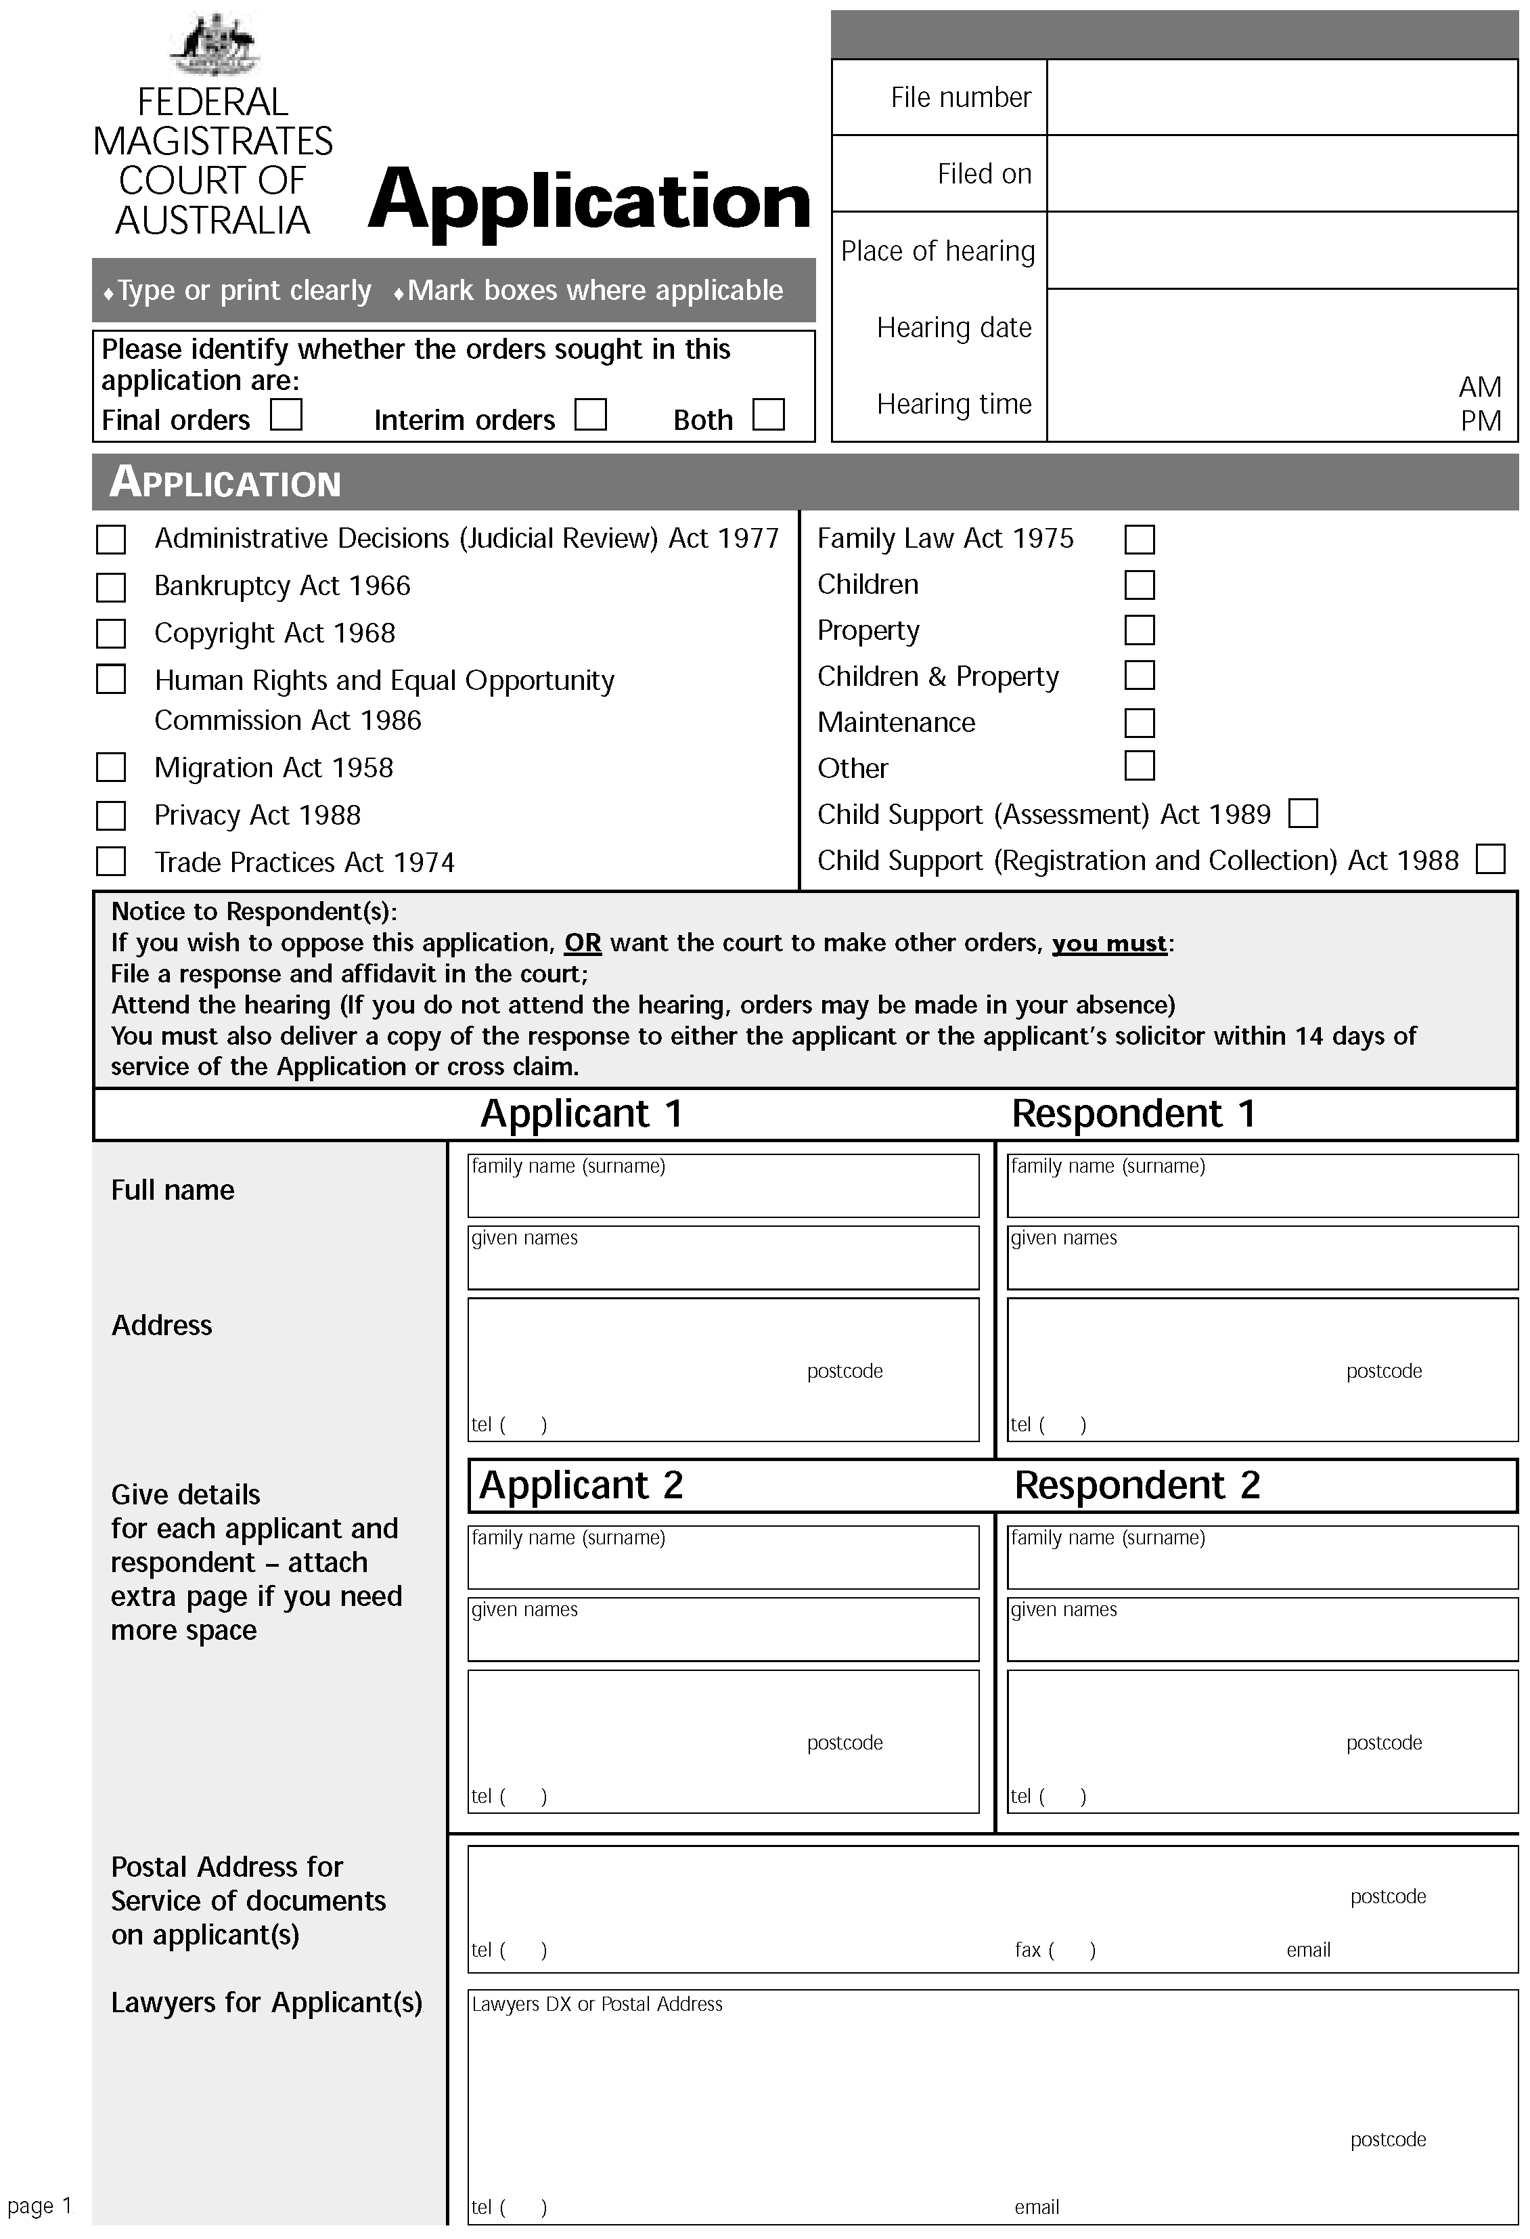
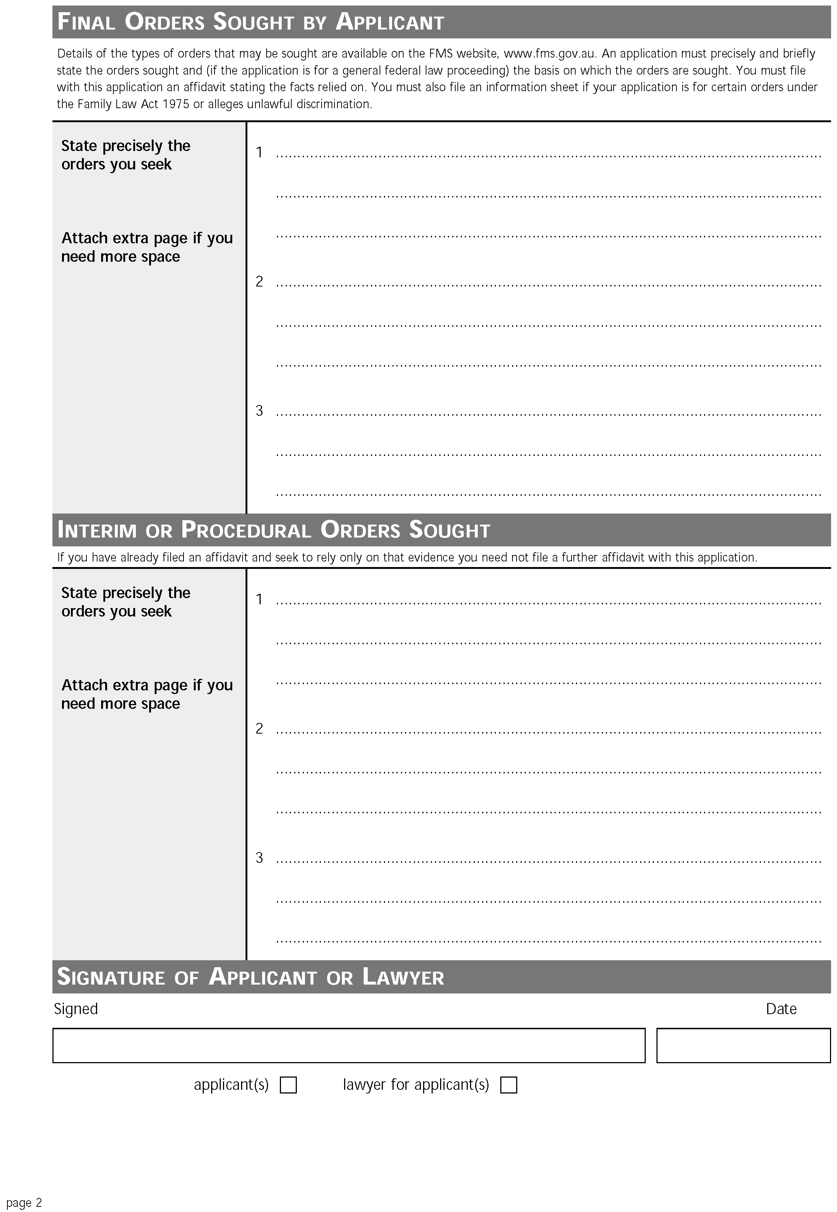
[31] Schedule 2, Part 3, Form 150, at the foot
insert
Note A creditor is required to give a copy of this petition to the Official Receiver within 3 working days of presentation: see subregulation 4.05 (1) of the Bankruptcy Regulations 1996.
[32] Schedule 2, Part 3, Form 152
omit
Date entered:
insert
Date that entry is stamped:
[33] Schedule 3, Part 1, after first dot point
insert
• Order 8, rule 13A
[34] Schedule 3, Part 2, after fifth dot point
insert
• Order 54B
• Order 58, Part III, Division 2
[35] After Schedule 3
insert
Schedule 4 Powers of the Court that may be exercised by a Registrar (Bankruptcy Act)
(paragraph 20.00A (1) (c))

Item | Provision of the  Bankruptcy Act | Description  (for information only)
1 | subsection 30 (1) (only for an application to set aside a bankruptcy notice) | Power to set aside a bankruptcy notice
2 | section 33 | Adjournment, amendment of process and extension and abridgment of time
3 | paragraph 40 (1) (g) | Power to grant leave to serve a bankruptcy notice outside Australia
4 | subsection 41 (6A) | Extension of time for compliance with a bankruptcy notice
5 | subsection 43 (1) | Power to make a sequestration order
6 | subsection 46 (2) | Power to make a sequestration order against 2 or more debtors
7 | subsection 47 (2) | Power to give leave to withdraw a creditor’s petition after presentation
8 | section 49 | Power to permit the substitution of another creditor as petitioner
9 | subsection 52 (1) | Power to make a sequestration order against the estate of a debtor
10 | subsection 52 (2) | Power to dismiss a creditor’s petition
11 | subsection 52 (3) | Power to stay all proceedings under a sequestration order for a period not exceeding 21 days
12 | subsection 52 (5) | Power to extend a period at the expiration of which a creditor’s petition lapses
13 | section 81 | Powers in relation to examinations
14 | section 206 | Power to adjourn a creditor’s petition if creditors have passed a resolution for a deed and to subsequently dismiss the petition
15 | subsection 244 (9) | Power to direct service of a creditor’s petition on person under Part XI
16 | subsection 244 (10) | Power to dispense with service of a creditor’s petition under Part XI
17 | subsection 244 (11) | Power to make an order for the administration of an estate under Part XI
18 | subsection 244 (12) | Power to dismiss a creditor’s petition under Part XI
19 | subsection 244 (13) | Power to give leave to present petition under Part XI
20 | subsection 247 (1A) | Power to make an order for the administration of the estate of a deceased person on the petition of a person administering the estate
21 | section 264B | Power to issue a warrant
22 | subsection 309 (2) | Power to order substituted service
Notes
1. These Regulations amend Statutory Rules 2001 No. 195, as amended by 2002 No. 80.
2. Notified in the Commonwealth of Australia Gazette on 31 October 2003.

