Civil Aviation Amendment Order
(No. R2) 2004

I, WILLIAM BRUCE BYRON, Director of Aviation Safety, on behalf of CASA, issue the following Civil Aviation Order under subregulation 92 (2) of the Civil Aviation Regulations 1988.

[Signed Bruce Byron]

Bruce Byron
Director of Aviation Safety and
Chief Executive Officer

2 December 2004

__________________

1 Name of Order
This Order is the Civil Aviation Amendment Order (No. R2) 2004.
2 Commencement
This Order commences on gazettal.
3 Replacement of section 20.3 of the Civil Aviation Orders
Section 20.3 of the Civil Aviation Orders is omitted and a new section substituted as set out in Schedule 1.
Schedule 1 Substitution of section 20.3 of the Civil Aviation Orders

SECTION 20.3 AIR SERVICE OPERATIONS

MARSHALLING AND PARKING OF AIRCRAFT
1 APPLICATION
1.1 This section applies to all aircraft operating at aerodromes established under the Air Navigation Regulations 1947, aerodromes licensed or authorised under the Civil Aviation Regulations 1988, and Department of Defence aerodromes in respect of which an arrangement under section 20 of the Civil Aviation Act 1988 is in force.
2 RESPONSIBILITY FOR MARSHALLING AND PARKING AIRCRAFT
2.1 An operator is responsible for marshalling and parking of the operator’s aircraft on an aerodrome.
2.2 An operator must ensure that any person designated for marshalling and parking duties uses the standard hand signals set out in Appendix I.
3 PARKING AREAS
3.1 The aerodrome licence-holder or proprietor, as the case requires, is responsible for designating parking areas on an aerodrome.
3.2 A person must not park an aircraft outside the areas designated in accordance with subparagraph 3.1 without permission of the aerodrome licence-holder or proprietor, as the case may be.
4 STANDARD HAND SIGNALS
4.1 The hand signals set out in Appendix I have the meanings indicated in that Appendix.
4.2 These signals are to be given as required by persons involved in the parking of aircraft.
4.3 Pilots in command of aircraft are to comply with all signals so given except where a pilot in command of an aircraft considers that to do so would jeopardise the safety of the aircraft or of its passengers or of persons or property on the ground.

APPENDIX I

STANDARD HAND SIGNALS TO BE USED BY GROUND PERSONNEL
MARSHALLING AIRCRAFT

Note 1: These signals are designed for use by the signalman, using lights where necessary, to facilitate observation by the pilot, and facing the aircraft in a position:
(a) for fixed wing aircraft — forward of the left wing tip within view of the pilot; and
(b) for helicopters — where the signalman can best be seen by the pilot.
Note 2: The meaning of the relevant signals remains the same if bats, illuminated wands or torchlights are held.
Note 3: The aircraft engines are numbered, for the signalman facing the aircraft, from right to left (i.e. No. 1 engine being the port outer engine).
1. To proceed under further guidance by signalman
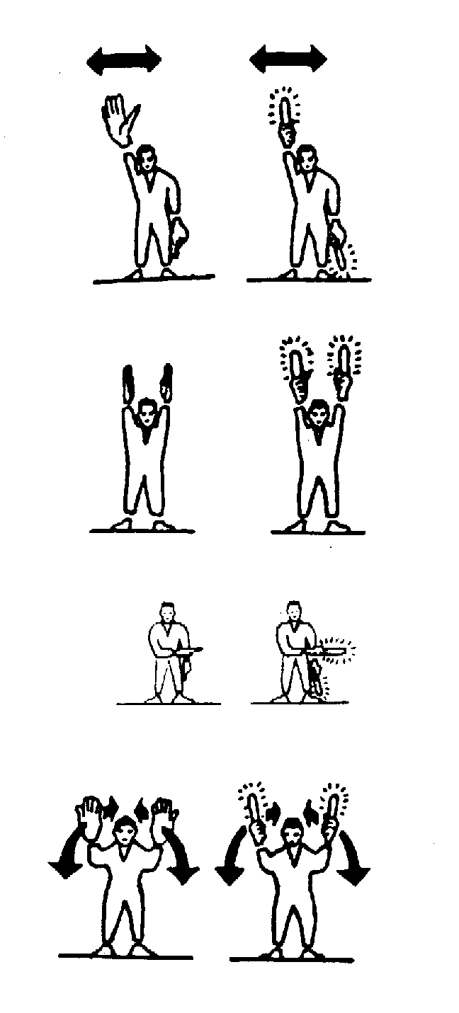
Signalman directs pilot if traffic conditions on aerodrome require this action.

2. This bay
Arms above head in vertical position with palms facing inward.

3. Proceed to next signalman
Right or left arm down, other arm moved across the body and extended to indicate the direction of the next signalman.

4. Move ahead
Arms a little aside, palms facing backward and repeatedly moved upward-backward from shoulder height.

5. (a) Turn to your left
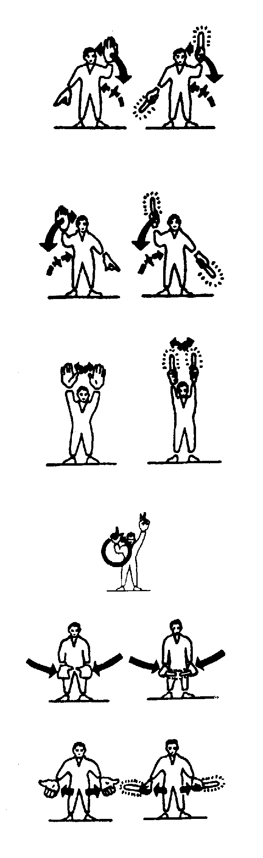
Right arm downward, left arm repeatedly moved upward-backward. Speed of arm movement indicates rate of turn.

(b) Turn to your right
Left arm downward, right arm repeatedly moved upward-backward. Speed of arm movement indicates rate of turn.

6. Stop
Arms repeatedly crossed above head (the rapidity of the arm movement should be related to the urgency of the stop, i.e. the faster the movement the quicker the stop).
7. Start engine
Left hand overhead with appropriate number of fingers extended to indicate the number of the engine to be started, and circular motion of the right hand at head level.
8. (a) Insert chocks
Arms down palms facing inwards, swing arms from extended position inwards.
(b) Chocks away
Arms down palms facing outwards, swing arms outwards.
9. Cut engines
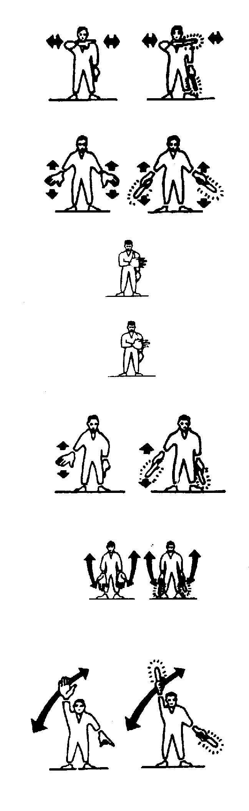
Either arm and hand level with the shoulder, hand across throat, palm downward. The hand is moved sideways with the arm remaining bent.
10. Slow down
Arms down with palms toward ground, then moved up and down several times.

11. (a) Engage brakes
Raise arm and hand, with fingers extended, horizontally in front of body, then clench fist.
(b) Release brakes
Raise arm, with fist clenched, horizontally in front of body, then extend fingers.
12. Slow down engine(s) on indicated side
Arms down with palms toward ground, then either right or left hand waved up and down indicating that the left or right side engine(s) respectively should be slowed down.
13. Move back
Arms by sides, palms facing forward, swept forward and upward repeatedly to shoulder height.

14. Turns while backing
For tail to starboard: point left arm down, and right arm brought from overhead, vertical position to horizontal forward position, repeating right arm movement.
For tail to port: point right arm down, and left arm brought from overhead, vertical position to horizontal forward position, repeating left arm movement.
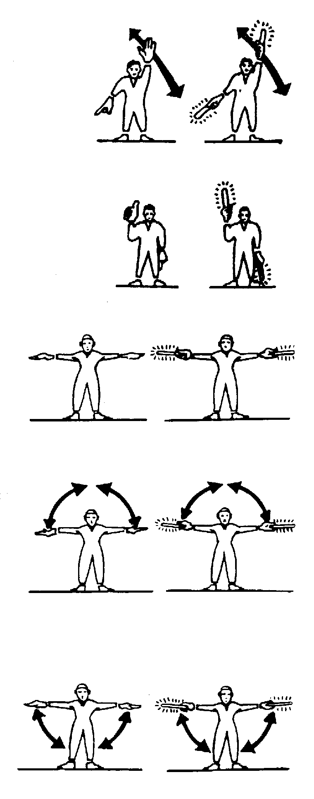

15. All clear
Right arm raised at elbow with thumb erect.

16. Hover
Arms extended horizontally sideways.

17. Move upwards
Arms extended horizontally to the side beckoning upwards, with palms turned up. Speed of movement indicates rate of ascent.

18. Move downwards
Arms extended horizontally to the side beckoning downwards, with palms turned down. Speed of movement indicates rate of descent.

19. Move horizontally
Appropriate arm extended horizontally sideways in direction of movement and other arm moved in front of body in same direction, in a repeating movement.
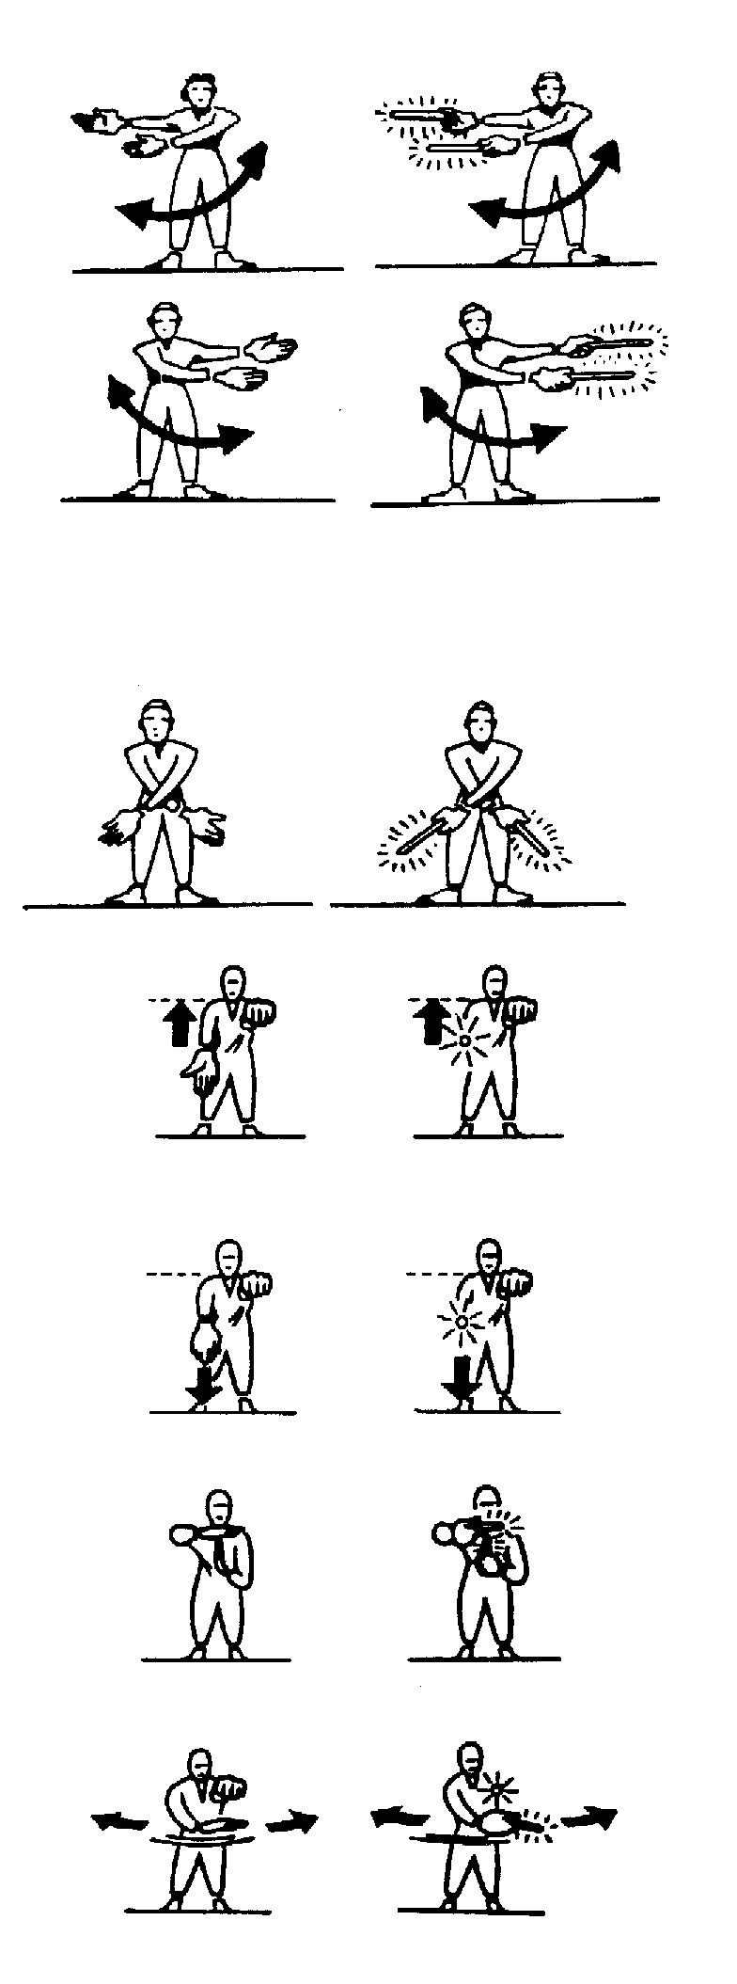

20. Land
Arms crossed and extended downwards in front of the body.
21. Winch up
Left arm horizontal in front of body, fist clenched, right hand with palm turned upwards making upwards motions.
22. Winch down
Left arm horizontal in front of body, fist clenched, right hand with palm turned downwards making downward motions.
23. Your load has not released
Right arm held across chest, palm facing down. Left hand pointing up to form ‘T’.
24. Release sling load —
release winch load
Left arm extended forward horizontally, fist clenched, right hand making horizontal slicing movement below the left fist, palm downward.

