Commonwealth of Australia
Radiocommunications Act 1992
900 MHz Band Plan (Variation)¹
I, anthony john shaw, Acting Spectrum Manager, acting on behalf of the Spectrum Management Agency, make the following Variation under subsection 34 (1) of the Radiocommunications Act 1992.
Dated 26 June 1997.

A J Shaw
Acting Spectrum Manager
____________
1. Amendment
1.1 The 900 MHz Band Plan² is varied as set out in this Variation.
[Note: This variation commences on gazettal: see Acts Intepretation Act 1901, ss. 46A and 48.]
2. Schedule, Table 2 (Secondary services in the 820 - 960 MHz band)
2.1 Schedule, Table 2, item 6:
Omit the item, substitute:
“6 | 890 - 915 | Radiolocation, see Note 3  Fixed Service, see Note 5 | Australia Wide  Australia Wide”.
2.2 Schedule, Table 2, item 8:
Omit the item, substitute:
“8 | 928 - 935 | Radiolocation, see Note 3 | Australia Wide
9 | 935 - 942 | Radiolocation, see Note 3  Fixed Service, see Note 5 | Australia Wide  Australia Wide
10 | 942 - 960 | Fixed Service, see Note 5 | Australia Wide”.
[Note: The following note should be added after Table 2:
“5. Assignments for these services are normally limited to those operating digital cellular mobile telephone services. They will be made within the same bandwidth as the particular operator’s digital cellular mobile telephone service.”.]

3. Schedule, Figure 1 (900 MHz Band Plan Diagram)
3.1 Omit Figure 1, substitute:
figure 1: 900 mhz band plan diagram
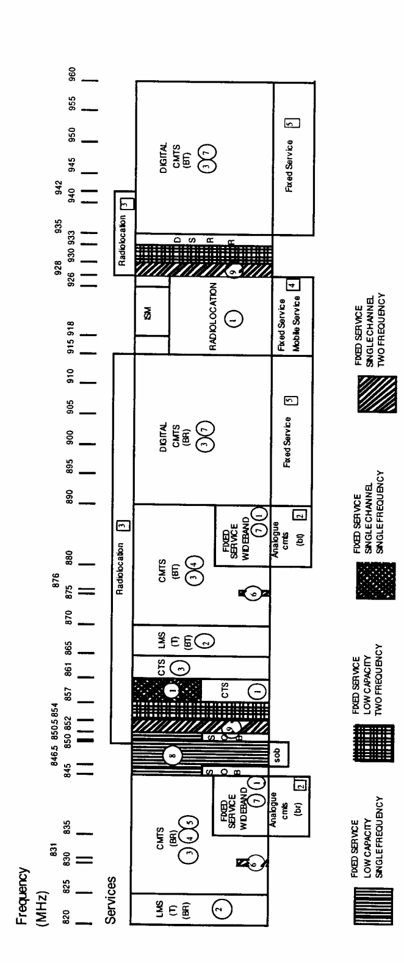
Notes:
1. Acronyms have the following meanings:
acronym | meaning
BR | base receive
BT | base transmit
CMTS | cellular mobile telephone service
CTS | cordless telephone service
DSRR | digital short range radio
ISM | industrial, scientific and medical applications
LMS(T) | land mobile service (trunked)
SOB | sound outside broadcast link
2. Services printed in capital letters are primary services, see Table 1.
3. Services printed in lower case are secondary services, see Table 2.
4. For circled notes, see Table 1.
5. For boxed notes, see Table 2.

NOTES
1. Notified in the Commonwealth of Australia Gazette on 1997.
2. Statutory Rules 1992 No. 47 as amended by Statutory Rules 1993 No. 39. The 900 MHz Band Plan was made by the Parliamentary Secretary to the Minister of State for Transport and Communications under section 19 of the Radiocommunications Act 1983. It was continued in force by section 4 of the Radiocommunications (Transitional Provisions and Consequential Amendments) Act 1992 as if it were a frequency band plan made under section 32 of the Radiocommunications Act 1992.

