VHF Mid Band Frequency Band Plan (70 to 87.5 MHz) 1991
as amended
made under subsection 32 (1) of the
Radiocommunications Act 1992
This compilation was prepared on 20 June 2005
taking into account amendments up to VHF Mid Band Frequency Band Plan
(70 to 87.5 MHz) Plan Variation 1999 (No. 1)
[Note: Section 4 of the Radiocommunications (Transitional Provisions and Consequential Amendments) Act 1992 (Act No. 167, 1992) provides that an instrument in force under the old Act (the Radiocommunications Act 1983) remains in force as if the instrument were made under the new Act (the Radiocommunications Act 1992)]
Prepared by the Office of Legislative Drafting and Publishing,
Attorney-General’s Department, Canberra
Contents
1 Name of plan [see Note 1] 3
2 General 3
3 Definitions 3
6 General purposes for band segments 4
7 Channelling arrangements for band segments 5
8 Status of allocations 5
9 Exemption from compliance with clause 6 or 7 — existing services 5
9A Exemption from compliance with clause 7 — new services 6
10 Table 2: Service allocations 6
11 Table 3: Channelling arrangements 8
12 Figure 1: VHF Mid Band Plan Diagram 9
13 High Spectrum Demand areas 10
14 Table 4: High Spectrum Demand contour centre coordinates and radii 10
15 Figure 2: Diagram of High Spectrum Demand areas 11
Notes 12

1 Name of plan [see Note 1]
This plan is the VHF Mid Band Frequency Band Plan (70 to 87.5 MHz) 1991.
2 General
The following notes describe the intention of this plan and outline the approach adopted for its implementation.
[General Note: This general note and other notes in square brackets are intended to provide guidance in the operation of the Band Plan and are not intended to be part of the Band Plan.
(1) This plan provides for the expansion of existing services and the introduction of new types of services.
(2) The principal changes to the VHF Mid Band provide for:
(a) predominant use of the band for land mobile services; and
(b) a band structure which accommodates predominantly two frequency systems to facilitate more efficient use of radiocommunications sites; and
(c) the existing 30 kHz channelling to be replaced by a more spectrum efficient 12.5 kHz channelling to increase the short and medium term productivity of the band; and
(d) flexibility to accommodate services which provide more efficient use of the spectrum.
(3) This plan commences on gazettal.]
3 Definitions
(1) Unless the contrary intention appears, a word or expression used in this plan and in the spectrum plan has the same meaning in this plan as it has in the spectrum plan (even if the word or expression is also defined in the Radiocommunications (Definitions) Determination 1993 (No. 2)).
Note For the definitions of other expressions used in this plan, see the Radiocommunications Act 1992, the Radiocommunications (Definitions) Determination 1993 (No. 2) and the Radiocommunications Regulations 1993.
(2) In this plan, unless the contrary intention appears:
Act means the Radiocommunications Act 1992.
allocation means the purpose for which a segment may be used.
allowed area means the geographic area in which services specified in this plan may be operated.
authorised means authorised by the ACA.
bandwidth means the frequency difference between the upper frequency limit and the lower frequency limit of a sub-band.
base receive means a segment which may be used at a base station for reception only.
base transmit means a segment which may be used at a base station for transmission only.
channel means a sub-band in a segment, with a specified centre frequency.
channelling refers to the frequency separation between 2 consecutive channel centre frequencies in the same segment.
HSD area has the meaning it is given in clause 13.
miscellaneous service means a mobile service, or a fixed service, that uses unconventional or innovative radiocommunications technologies.
narrowband area service means a service provided by a narrowband area service station.
non-HSD area means an area outside an HSD area.
primary service has the same meaning as in the spectrum plan.
secondary service has the same meaning as in the spectrum plan.
segment is a sub-band of the VHF Mid Band, represented by a letter in the range ‘A’ to ‘Q’, as indicated in Column 2 of an item in Table 2 or 3, to which the frequency range in Column 3 of Table 2 corresponds.
single frequency means a mode of operation in which transmissions can be made between 2 stations in either one or both directions, but not simultaneously in both directions, and for which only one channel is used.
sub-band means any part of the VHF Mid Band.
transmit/receive split means the frequency separation between the transmit channel centre frequency and receive channel centre frequency of a station in a two frequency service.
two frequency means a mode of operation in which transmissions can be made between 2 stations and in which 2 channels are used.
VHF Mid Band is the range of frequencies from 70 MHz (exclusive) to 87.5 MHz (inclusive).
6 General purposes for band segments
Subject to clause 9 and the spectrum plan, the VHF Mid Band, represented diagrammatically in Figure 1, may only be used for a service:
(a) which transmits or receives signals in a channel in the range specified in Column 3 of an item in Table 2, to which range the segment in Column 2 corresponds; and
(b) whose purpose accords with the allocation specified in Column 4 of that item; and
(c) in a geographic area specified in Column 5 of that item.
7 Channelling arrangements for band segments
(1) Subject to clause 9 and subclause 7 (3) and the spectrum plan, the VHF Mid Band may only be used for a service which operates:
(a) within a channel whose centre frequency is determined by the formula specified in Column 3 of an item in Table 3, where the values of ‘n’ in the formula are specified in Column 4 of that item; and
(b) within a channel bandwidth as specified in Column 5 of that item.
(2) The transmit/receive split in the VHF Mid Band is 2.5 MHz.
(3) Channelling arrangements other than those specified by subclauses 7 (1) and 7 (2) may be authorised where such arrangements provide for more efficient use of the spectrum, as compared to the channelling arrangements specified for that segment.
[Note In determining the spectrum efficiency of a service, without limiting the range of matters which may be taken into account, the following matters may be considered:
(a) occupied bandwidth;
(b) adjacent channel performance;
(c) the distance from the transmitter that the channel may be used again without causing harmful interference;
(d) the impact that introduction of the service will have upon existing services.]
8 Status of allocations
Unless the contrary intention appears, a service which is operated according to clauses 6 and 7 is a primary service.
9 Exemption from compliance with clause 6 or 7 — existing services
(1) An existing service may use frequencies in the VHF Mid Band, on a secondary basis, to supply a service that does not comply with either clause 6 or 7.
(2) For subclause (1), an existing service is a service for the operation of which a licence:
(a) was, or is taken to have been, in force on 30 June 1998; and
(b) has continued, or is taken to have continued, in force after that date.
(3) For this clause:
(a) a licence is taken to have been in force on 30 June 1998 if the operation of the service became unlicensed between 2 May 1998 and 30 June 1998 and was unlicensed for not more than 60 consecutive days; and
(b) a licence is taken to have continued in force after 30 June 1998 if the operation of the service has been unlicensed for not more than 60 consecutive days.
9A Exemption from compliance with clause 7 — new services
(1) A new service may use frequencies in the VHF Mid Band, on a secondary basis, in a non-HSD area, to supply a service that does not comply with clause 7.
(2) For subclause (1), a new service is a service for which a licence was not in force, or taken to have been in force for clause 9, on 30 June 1998.
10 Table 2: Service allocations (See Note 1)
Table 2
Column 1 | Column 2 | Column 3 | Column 4 | Column 5
Item | Segment | Segment limits (MHz) (Lower limit exclusive, upper limit inclusive) | Allocation | Allowed Areas
1 | A | 70.00000 to 70.24375 | Miscellaneous Service (See note 5) | Australia Wide
2 | B | 70.24375 to 72.29375 | Land Mobile Service (two frequency, base transmit) | Australia Wide
3 | C | 72.29375 to 72.74375 | Land Mobile Service (single frequency) | Australia Wide
4 | D | 72.74375 to 74.80000 | Land Mobile Service (two frequency, base receive) | Australia Wide
5 | E | 74.80000 to 75.20000 | Aeronautical Radionavigation Service (See note 2) | Australia Wide
6 | F | 75.20000 to 77.29375 | Land Mobile Service (single frequency) | Australia Wide
7 | G | 77.29375 to 77.49375 | Miscellaneous Service (See note 5) | Australia Wide
8 | H | 77.49375 to 79.80625 | Land Mobile Service (two frequency, base transmit) | Australia Wide
9 | I | 79.80625 to 79.99375 | Land Mobile Service (single frequency) | Australia Wide
10 | J | 79.99375 to 82.30625 | Land Mobile Service (two frequency, base receive) | Australia Wide
11 | K | 82.30625 to 82.49375 | Land Mobile Service (single frequency) | Australia Wide
12 | L | 82.49375 to 83.74375 | Land Mobile Service (two frequency, base receive) | Australia Wide
13 | M | 83.74375 to 84.69375 | Land Mobile Service (two frequency, base receive) OR (single frequency)  (See note 3) | Australia Wide
14 | N | 84.69375 to 84.99375 | Miscellaneous Service (See note 5) | Australia Wide
15 | O | 84.99375 to 86.24375 | Land Mobile Service (two frequency, base transmit) (See note 4) | Australia Wide
16 | P | 86.24375 to 87.19375 | Land Mobile Service (two frequency, base transmit) OR (single frequency)  (See notes 3 and 4) | Australia Wide
17 | Q | 87.19375 to 87.50000 | Miscellaneous Service  (See notes 4 and 5) | Australia Wide
Note 1 The Department of Defence and the Australian Defence Force are allowed secondary use of the 70 MHz to 87.5 MHz band for the purpose of tactical land mobile communications.
Note 2 The operation of aeronautical marker beacons within the aeronautical radionavigation service is subject to the provisions of Annex 10 to the Convention on International Civil Aviation and the Standards and Recommended Practices of the International Civil Aviation Organisation.
Note 3 Land mobile segments referenced by this note may be used in a single frequency mode or a two frequency mode in non-HSD areas of any State or Territory. In HSD areas of any State or Territory, either single or two frequency modes may be used, but not both. The mode of operation for these segments in HSD areas may be determined by the ACA, based upon relative demand for these modes of operation in each State and Territory.
Note 4 Subject to the Band II Television Clearance Programme, the 85 MHz to 87.5 MHz Band may be used for broadcasting services as primary services. The band may be used for other services, as indicated in Table 2, as secondary services.
Note 5 Segments A, G, N and Q are predominantly allocated to miscellaneous services. However, they may also be used for narrowband area services.
11 Table 3: Channelling arrangements (See Note 1)
Table 3
Column 1 | Column 2 | Column 3 | Column 4 | Column 5
Item | Segment | Channel centre frequencies formula (MHz) | Range of integer values for the variable ‘n’ (inclusive) | Channel bandwidth (kHz)
1 | A | 70.0000 + (n x (0.0125)) (See note 2) | 1 to 19 | 12.5  (See note 2)
2 | B | 70.2375 + (n x (0.0125)) | 1 to 164 | 12.5
3 | C | 72.2875 + (n x (0.0125)) | 1 to 36 | 12.5
4 | D | 72.7375 + (n x (0.0125)) | 1 to 164 | 12.5
5 | E | See note 3 | See note 3 | See note 3
6 | F | 75.2000 + (n x (0.0125)) | 1 to 167 | 12.5
7 | G | 77.2875 + (n x (0.0125))  (See note 2) | 1 to 16 | 12.5  (See note 2)
8 | H | 77.4875 + (n x (0.0125)) | 1 to 185 | 12.5
9 | I | 79.8000 + (n x (0.0125)) | 1 to 15 | 12.5
10 | J | 79.9875 + (n x (0.0125)) | 1 to 185 | 12.5
11 | K | 82.3000 + (n x (0.0125)) | 1 to 15 | 12.5
12 | L | 82.4875 + (n x (0.0125)) | 1 to 100 | 12.5
13 | M | 83.7375 + (n x (0.0125)) | 1 to 76 | 12.5
14 | N | 84.6875 + (n x (0.0125)) (See note 2) | 1 to 24 | 12.5  (See note 2)
15 | O | 84.9875 + (n x (0.0125)) (See note 4) | 1 to 100 | 12.5  (See note 4)
16 | P | 86.2375 + (n x (0.0125)) (See note 4) | 1 to 76 | 12.5  (See note 4)
17 | Q | 87.1875 + (n x (0.0125)) (See notes 2 and 4) | 1 to 24 | 12.5 (See notes 2 and 4)
Note 1 The Department of Defence and the Australian Defence Force may operate with channelling arrangements other than those specified in Table 3.
Note 2 The channelling arrangements are for miscellaneous services only, and are nominal. Any user of a miscellaneous service may be authorised to operate with a channel centre frequency and channel bandwidth other than that specified. The channelling arrangements for narrowband area services are not defined.
Note 3 The operation of aeronautical marker beacons within the aeronautical radionavigation service is subject to the provisions of Annex 10 to the Convention on International Civil Aviation and the Standards and Recommended Practices of the International Civil Aviation Organisation.
Note 4 Broadcasting services may operate with channelling arrangements other than those specified in Table 3.
12 Figure 1: VHF Mid Band Plan Diagram
Figure 1
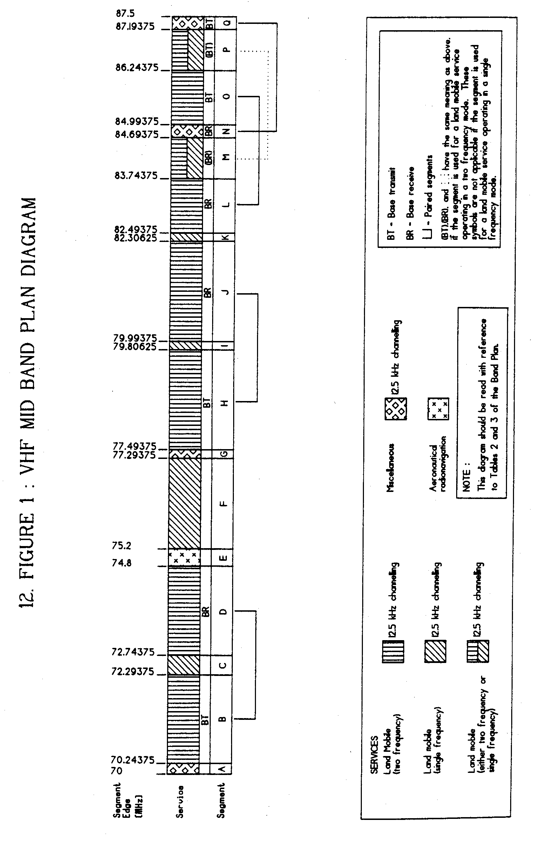

13 High Spectrum Demand areas
(1) A High Spectrum Demand (HSD) area is the area on or within a circular contour drawn with a radius specified in Column 5 of an item in Table 4, centred on a point specified as an Australian Map Grid coordinate in Column 4 of that item.
(2) The centre point is nominally described by reference to a nearby town, specified in Column 3, situated in a State specified in Column 2 of that item.
(3) Where adjacent areas overlap, an HSD area then becomes the combination of those adjacent areas.
(4) Diagrammatic representations of the HSD areas are set out in Figure 2.
14 Table 4: High Spectrum Demand contour centre coordinates and radii
Table 4
Column 1 | Column 2 | Column 3 | Column 4 | Column 5
Item | State | Town | Coordinate (Easting, Northing, Zone) | Radius
1 | New South Wales | Newcastle | 384722 6355447 56 | 50 km
2 | New South Wales | Sydney | 335103 6249367 56 | 60 km
3 | New South Wales | Penrith | 279726 6267448 56 | 35 km
4 | New South Wales | Wollongong | 301116 6177146 56 | 35 km
5 | Queensland | Maroochydore | 509952 7052315 56 | 35 km
6 | Queensland | Brisbane | 501674 6961834 56 | 55 km
7 | Queensland | Surfers Paradise | 542065 6902340 56 | 35 km
8 | Victoria | Melbourne | 320605 5812740 55 | 50 km
9 | Victoria | Mornington | 328000 5768000 55 | 50 km
10 | Victoria | Geelong | 268300 5774265 55 | 20 km
11 | Western Australia | Perth | 391314 6464517 50 | 50 km
15 Figure 2: Diagram of High Spectrum Demand areas
Figure 2
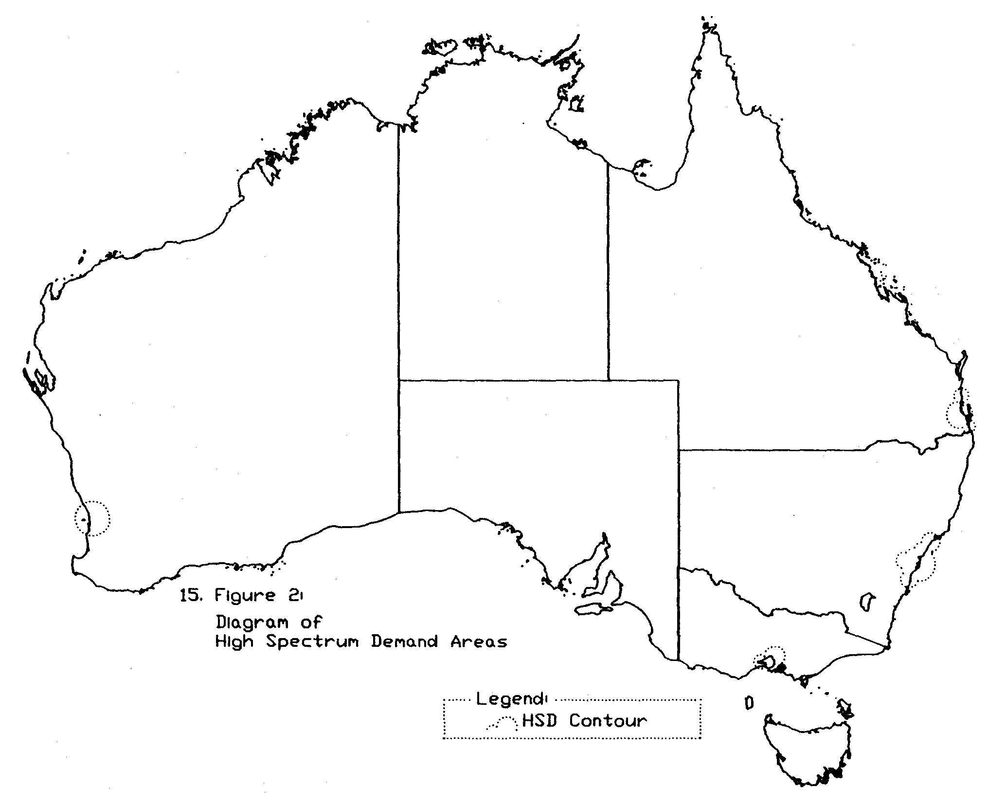

Notes to the
Note 1
The VHF Mid Band Frequency Band Plan (70 to 87.5 MHz) 1991 (in force under subsection 32 (1) of the Radiocommunications Act 1992) as shown in this compilation is amended as indicated in the Tables below.
Table of Instruments
Title |  | Date of notification  in Gazette |  | Date of  commencement |  | Application, saving or  transitional provisions
VHF Mid Band Frequency Band Plan (70 to 87.5 MHz)  SR 1991 No. 355 | 27 Nov 1991  (see Gazette 1991, No. S326) |  | 27 Nov 1991
VHF Mid Band Frequency Band Plan (70 to 87.5 MHz) (Amendment)\  SR 1993 No. 37 | 12 Mar 1993  (see Gazette 1993, No. S83) |  | 12 Mar 1993 |  | —
VHF Mid Band Frequency Band Plan (70 to 87.5 MHz) (Variation) | 26 June 1996  (see Gazette 1996, No. S226) |  | 26 June 1996 |  | —
VHF Mid Band Frequency Band Plan (70 to 87.5 MHz) (Variation) 1998 | 24 June 1998  (see Gazette 1998, No. GN25) |  | 1 July 1998 |  | —
VHF Mid Band Frequency Band Plan (70 to 87.5 MHz) Plan Variation 1999 (No. 1) | 7 July 1999  (see Gazette 1999, No. GN27) |  | 7 July 1999 |  | —
Table of Amendments
ad. = added or inserted am. = amended rep. = repealed rs. = repealed and substituted
Provision affected |  | How affected
C. 1 | rs. 1999 No. 1
C. 2 | am. 1999 No. 1
General note to c. 2 | am. 1993 No. 37
Note 1 to c. 2 | am. 1999 No. 1
Note 3 to c. 2 | rs. 1999 No. 1
Note 4 to c. 2 | am. 1996 No. 1
 | rep. 1998 No. 1
Notes 5–7 to c. 2 | rep. 1998 No. 1
Note 8 to c. 2 | am. 1996 No. 1
 | rep. 1998 No. 1
Note 9 to c. 2 | rep. 1998 No. 1
Heading to c. 3 | rs. 1999 No. 1
C. 3 | am. 1996 No. 1; 1998 No. 1; 1999 No. 1
C. 4 | rep. 1998 No. 1
C. 5 | rep. 1998 No. 1
C. 6 | am. 1996 No. 1; 1999 No. 1
C. 7 | am. 1996 No. 1; 1999 No. 1
C. 9 | am. 1996 No. 1
 | rs. 1998 No. 1
C. 9A | ad. 1996 No. 1
 | rs. 1998 No. 1
C. 10 | am. 1999 No. 1
Note 3 to c. 10 | am. 1996 No. 1; 1998 No. 1
Note 5 to c. 10 | ad. 1999 No. 1
Note 2 to c. 11 | am. 1999 No. 1

