Statutory Rules 1991 No. 354
____________________

VHF High Band Frequency Band Plan
(148 to 174 MHz)

TABLE OF PROVISIONS
Clause
1. Citation
2. General
3. Interpretation
4. Conversion dates
5. Table 1: Conversion date in High Spectrum Demand areas of States
6. General purposes for band segments
7. Channelling arrangements for band segments
8. Status of allocations
9. Exemption from compliance with clauses 6 and 7
10. Table 2: Service allocations
11. Table 3: Channelling arrangements
12. Figure 1: VHF High Band Plan diagram
13. High Spectrum Demand and Rural areas
14. Table 4: High Spectrum Demand contour centre coordinates and radii
15. Figure 2: Diagram of High Spectrum Demand and Rural areas

Statutory Rules 1991 No. 3541
____________________

VHF High Band Frequency Band Plan
(148 to 174 MHz)

I, WARREN EDWARD SNOWDON, Parliamentary Secretary to the Minister of State for Transport and Communications acting for and on behalf of the Minister of State for Transport and Communications, make the following band plan, under section 19 of the Radiocommunications Act 1983.

Dated 14 November 1991.

WARREN SNOWDON
Parliamentary Secretary to the
Minister of State for Transport and Communications
for and on behalf of the
Minister of State for Transport and Communications

Citation
1. This Band Plan for the 148 to 174 MHz band may be cited as the VHF High Band Frequency Band Plan (148 to 174 MHz).

General
2. The following notes describe the intention of the VHF High Band Frequency Band Plan (148 to 174 MHz) and outline the approach adopted for its implementation.

[GENERAL NOTE:
(1) The VHF High Band Frequency Band Plan (148 to 174 MHz) provides for the expansion of existing services and the introduction of new types of services.

(2) The principal changes to the VHF High Band provide for:
(a) predominant use of the band for land mobile services; and
(b) a band structure which accommodates predominantly two frequency systems to facilitate more efficient use of radiocommunications sites; and
(c) the introduction of land mobile services (trunked) and amplitude companded single sideband services to increase the long term productivity of the band; and
(d) the existing 30 kHz channelling to be replaced by a more spectrum efficient 12.5 kHz channelling to increase the short and medium term productivity of the band; and
(e) flexibility to accommodate services which provide more efficient use of the spectrum.

(3) The VHF High Band Plan will come into effect on the date of notification of the Band Plan in the Commonwealth Gazette.

(4) Each Regional Office of the Department will develop and manage the detailed programme for conversion of services in their region.

(5) Conversion of services will generally require modification or replacement of existing equipment and a change in operating frequency.

(6) To permit time for conversion to the new arrangements, conversion time frames have been provided and are specified in clause 4 for High Spectrum Demand (HSD) areas of each Region.

(7) No conversion deadline is specified for non-HSD areas.

(8) To ensure completion of the programme for conversion by the dates specified, individual users will be required by the relevant Regional Office to convert their service earlier than the relevant State conversion date.

(9) The cost impact of the conversion and possible disruption to user operations will be minimised by:
(a) focusing the implementation programme upon HSD areas and only converting services in non-HSD areas as necessitated by spectrum demand; and
(b) generally converting small services ahead of large services; and
(c) implementing conversion in periods when operational demands upon the user's communications system are lowest; and
(d) a progressive and systematic clearance and conversion on an area by area and channel by channel basis.]

Interpretation
3. (1) Unless the contrary intention appears, if any expression used in this Band Plan is defined in the Radiocommunications Act 1983, the Radiocommunications—Australian Spectrum Plan, or the Radiocommunications (Licensing and General) Regulations, that expression has the same meaning in this Band Plan as in that Act, that Spectrum Plan, or those Regulations, as the case requires.

(2) In this Band Plan, unless the contrary intention appears:
“allocation” means the purpose for which a segment may be used;
“allowed area” means the geographic area in which services specified in this Band Plan may be operated;
“Band Plan” means the VHF High Band Plan;
“bandwidth” means the frequency difference between the upper frequency limit and the lower frequency limit of a sub-band;
“base receive” means a segment which may be used at a base station for reception only;
“base transmit” means a segment which may be used at a base station for transmission only;
“channel” means a sub-band in a segment, with a specified centre frequency;
“channelling” refers to the frequency separation between 2 consecutive channel centre frequencies in the same segment;
“conversion date” means the date by which all users in HSD areas of each State are required to have completed conversion of their service to the VHF High Band Plan.
[NOTE: No conversion deadline is set for users to convert their service in non-HSD areas.]
“HSD area” has the meaning it is given in clause 13;
“interior paging talkback channel” means a channel in a land mobile service (single frequency) which is used in conjunction with an interior paging service, but which may not be used for transmissions between ambulatory stations on land;
“land mobile service” means a radiocommunications service between ambulatory stations on land and:
(a) land stations; or
(b) other ambulatory stations on land;
“miscellaneous service” means a land mobile service or a fixed service, the provision for which is intended to support the development of unconventional and innovative radiocommunication technologies, but is not intended to accommodate services whose purpose can be met by other allocations within the Band Plan;
“non-HSD area” means an area outside (or on the rural area side of) an HSD area;
“non-rural area” means an area outside (or on the HSD area side of) a rural area;
“paging service” means an exterior or interior paging service;
“primary service” has the same meaning as in Part 3 of the Radiocommunications—Australian Spectrum Plan;
“Regional Office” means a State or Territory Office of the Department;
“rural area” has the meaning it is given in in clause 13;
“secondary service” has the same meaning as in Part 3 of the Radiocommunications—Australian Spectrum Plan;
“segment” is a sub-band of the VHF High Band, represented by a letter in the range ‘A’ to ‘W’, as indicated in Column 2 of an item in Table 2 or 3, to which the frequency range in Column 3 of Table 2 corresponds;
“single frequency” means a mode of operation in which transmissions can be made between 2 stations in either one or both directions, but not simultaneously in both directions, and for which only one channel is used;
“sub-band” means any part of the VHF High Band;
“transmit/receive split” means the frequency separation between the transmit channel centre frequency and receive channel centre frequency of a station in a two frequency service;
“trunked” means a mode of operation in which base stations are used for communicating with mobile stations and in which a number of users share the use of 2 or more channels selected automatically by the base station;
“two frequency” means a mode of operation in which transmissions can be made between 2 stations and in which 2 channels are used;
“VHF High Band” is the range of frequencies from 148 MHz (exclusive) to 174 MHz (inclusive).

(3) Wherever in this Band Plan “authorised” is used, this refers to an authorisation given by the Secretary of the Department, or by an officer of the Department authorised in writing by the Secretary, for the relevant purpose.

Conversion Dates
4. (1) Implementation of conversion to the VHF High Band Frequency Band Plan (148 to 174 MHz) commences on the date of notification of the making of the Band Plan in the Gazette.

(2) The conversion date for HSD areas of a State, specified in Column 2 of an item in Table 1, is the date specified in Column 3 of that item.
[NOTE: There are no HSD areas in Tasmania, the Northern Territory, the Australian Capital Territory or any other territory of Australia.]

Table 1
5. TABLE 1: CONVERSION DATE IN HIGH SPECTRUM DEMAND AREAS OF STATES

Column 1 | Column 2 | Column 3
Item | State | Date
1 | New South Wales | 1 July 1996
2 | Queensland | 1 July 1998
3 | South Australia | 1 July 1998
4 | Victoria | 1 July 1998
5 | Western Australia | 1 July 1998

General Purposes for Band Segments
6. Subject to clause 9 of this Band Plan and Part 4 of the Radiocommunications—Australian Spectrum Plan, the VHF High Band, represented diagrammatically in Figure 1, may only be used for a service:
(a) which transmits or receives signals in a channel in the range specified in Column 3 of an item in Table 2, to which range the segment in Column 2 corresponds; and
(b) whose purpose accords with the allocation specified in Column 4 of that item; and
(c) in a geographic area specified in Column 5 of that item.

Channelling Arrangements for Band Segments
7. (1) Subject to clause 9 and subclause 7 (3) of this Band Plan and Part 4 of the Radiocommunications—Australian Spectrum Plan, the VHF High Band may only be used for a service which operates:
(a) within a channel whose centre frequency is determined by the formula specified in Column 3 of an item in Table 3, where the values of "n" in the formula are specified in Column 4 of that item; and
(b) within a channel bandwidth as specified in Column 5 of that item.

(2) The transmit/receive split in the VHF High Band is 4.6 MHz.

(3) Channelling arrangements other than those specified by subclauses 7 (1) and 7 (2) may be authorised where such arrangements provide for more efficient use of the spectrum, as compared to the channelling arrangements specified for that segment.

[NOTE: In determining the spectrum efficiency of a service, without limiting the range of matters which may be taken into account, the following matters may be considered:
(a) occupied bandwidth;
(b) adjacent channel performance;
(c) the distance from the transmitter that the channel may be used again without causing harmful interference;
(d) the impact that introduction of the service will have upon existing services.]

Status of Allocations
8. Unless the contrary intention appears, a service which is operated according to clauses 6 and 7 is a primary service.

Exemption From Compliance With Clauses 6 and 7
9. (1) In non-HSD areas of any State or Territory, a service currently operating with technical or operational characteristics other than those specified by clauses 6 and 7 may continue to operate as a secondary service.

(2) In non-HSD areas of any State or Territory, a new service which would be operated with technical and operational characteristics as prescribed in clause 6, but would not be operated in accordance with clause 7, may be authorised only as a secondary service.

(3) Any segment of the Band Plan may be authorised to be used, up to the relevant conversion date, for purposes or with technical or operational characteristics other than those specified in the Band Plan for that segment on a transitional basis to facilitate implementation of the Band Plan.

Table 2
10. TABLE 2: SERVICE ALLOCATIONS

Column 1 | Column 2 | Column 3 | Column 4 | Column5
Item | Segment | Segment Limits (MHz) | Allocation | Allowed Areas
 |  | (Lower limit exclusive, upper limit inclusive)
1 | A | 148.00000 to 149.25000 | Paging Service (See note 1) | Australia Wide
2 | B | 149.25000 to 149.75625 | Land Mobile Service (two frequency, base transmit) | Australia Wide
3 | C | 149.75625 to 149.90000 | Land Mobile Service (single frequency) (See note 2) | Australia Wide
4 | D | 149.90000 to 150.05000 | Radionavigation Satellite Service | Australia Wide
5 | E | 150.05000 to 151.39375 | Land Mobile Service (two frequency, base transmit) | Australia Wide
6 | E | 150.05000 to 151.39375 | Fixed Service (two frequency) | Rural Areas (See note 3)
7 | F | 151.39375 to 152.49375 | Miscellaneous Service | Australia Wide
8 | G | 152.49375 to 153.85000 | Land Mobile Service (single frequency) (See note 4) | Australia Wide
9 | H | 153.85000 to 154.35625 | Land Mobile Service (two frequency, base receive) | Australia Wide

Column 1 | Column 2 | Column 3 | Column 4 | Column5
Item | Segment | Segment Limits (MHz) | Allocation | Allowed Areas
 |  | (Lower limit exclusive, upper limit inclusive)
10 | I | 154.35625 to 154.65625 | Land Mobile Service (single frequency) | Australia Wide
11 | J | 154.65625 to 156.00000 | Land Mobile Service (two frequency, base receive) | Australia Wide
12 | J | 154.65625 to 156.00000 | Fixed Service (two frequency) | Rural Areas (See note 3)
13 | K | 156.00000 to 157.45000 | Maritime Mobile Service (See note 5) | Australia Wide
14 | L | 157.45000 to 158.29375 | Land Mobile Service (two frequency, base receive) OR (single frequency) (See note 6) | Australia Wide
15 | M | 158.29375 to 160.60000 | Land Mobile Service (two frequency, base receive) | Australia Wide
16 | N | 160.60000 to 160.97500 | Maritime Mobile Service (See note 5) | Australia Wide
17 | O | 160.97500 to 161.47500 | Land Mobile Service (single frequency) | Australia Wide
18 | P | 161.47500 to 162.05000 | Maritime Mobile Service (See note 5) | Australia Wide
19 | Q | 162.05000 to 162.89375 | Land Mobile Service (two frequency, base transmit) OR (single frequency) (See note 6) | Australia Wide
20 | R | 162.89375 to 165.19375 | Land Mobile Service (two frequency, base transmit) | Australia Wide
21 | S | 165.19375 to 168.19375 | Land Mobile Service (trunked, base transmit) (See note 7) | Australia Wide
22 | T | 168.19375 to 169.79375 | Land Mobile Service (single frequency) | Australia Wide

Column 1 | Column 2 | Column 3 | Column 4 | Column5
Item | Segment | Segment Limits (MHz) | Allocation | Allowed Areas
 |  | (Lower limit exclusive, upper limit inclusive)
23 | U | 169.79375 to 172.79375 | Land Mobile Service (trunked, base receive)  (See note 7) | Australia Wide
24 | V | 172.79375 to 173.29375 | Land Mobile Service (single frequency) | Australia Wide
25 | W | 173.29375 to 174.00000 | Miscellaneous Service | Australia Wide

Notes:
1. Segment A is allocated to exterior paging services as primary services and to interior paging services as secondary services, except for the channels with centre frequencies 148.3375 MHz and 149.1875 MHz which are allocated only to interior paging services as primary services.

2. An exterior paging service may be authorised to operate as a primary service in a channel with centre frequency 149.7875, 149.8375 or 149.8875 MHz. An interior paging service may be authorised to operate as a secondary service in a channel with centre frequency 149.7875, 149.8375 or 149.8875 MHz.

3. Fixed services (two frequency) may be operated in non-rural areas on a secondary basis.

4. The frequency 153.8 MHz may be used as the centre frequency for an interior paging talkback channel.

5. The operation of maritime mobile services is subject to the provisions of Appendix 18 of the International Telecommunications Union Radio Regulations.

6. Land mobile segments referenced by this note may be used in a single frequency mode or a two frequency mode in non-HSD areas of any State or Territory. In HSD areas of any State or Territory, either single frequency or two frequency modes may be used, but not both. The mode of operation for these segments in HSD areas may be determined by the Secretary, or by an officer of the Department authorised in writing by the Secretary, based upon relative demand for these modes of operation in each State and Territory.

7. Segments referenced by this note may be authorised for use by users of:
(a) other land mobile services that make equivalent or more efficient use of the spectrum, as compared to the designated service allocation; or
(b) land mobile services (two frequency), if such services are used in conjunction with a land mobile service (trunked).

Table 3
11. TABLE 3: CHANNELLING ARRANGEMENTS

Column 1 | Column 2 | Column 3 | Column 4 | Column 5
Item | Segment | Channel centre frequencies formula (MHz) | Range of integer values for the variable ‘n’ (inclusive) | Channel bandwidth (kHz)
1 | A | 147.9875 + (n x (0.025)) | 1 to 50 | 25
2 | B | 149.2500 + (n x (0.00625)) | 1 to 80 | 6.25
3 | C | 149.7500 + (n x (0.0125)) (See note 1) | 1 to 11 | 12.5  (See note 1)
4 | D | See note 2 | See note 2 | See note 2
5 | E | 150.0500 + (n x (0.0125)) | 1 to 107 | 12.5
6 | F | 151.3875 + (n x (0.0125)) (See note 3) | 1 to 88 | 12.5  (See note 3)
7 | G | 152.4875 + (n x (0.0125)) | 1 to 108 | 12.5  (See note 4)
8 | H | 153.8500 + (n x (0.00625)) | 1 to 80 | 6.25
9 | I | 154.3500 + (n x (0.0125))  (See note 5) | 1 to 23 | 12.5  (See note 5)
10 | J | 154.6500 + (n x (0.0125)) | 1 to 107 | 12.5
11 | K | See note 6 | See note 6 | See note 6
12 | L | 157.4500 + (n x (0.0125)) | 1 to 67 | 12.5
13 | M | 158.2875 + (n x (0.0125)) | 1 to 184 | 12.5
14 | N | See note 6 | See note 6 | See note 6
15 | O | 160.9750 + (n x (0.0125)) | 1 to 39 | 12.5
16 | P | See note 6 | See note 6 | See note 6
17 | Q | 162.0500 + (n x (0.0125)) | 1 to 67 | 12.5
18 | R | 162.8875 + (n x (0.0125)) | 1 to 184 | 12.5
19 | S | 165.1875 + (n x (0.0125)) | 1 to 240 | 12.5
20 | T | 168.1875 + (n x (0.0125)) | 1 to 128 | 12.5
21 | U | 169.7875 + (n x (0.0125)) | 1 to 240 | 12.5
22 | V | 172.7875 + (n x (0.0125)) | 1 to 40 | 12.5
23 | W | 173.2875 + (n x (0.0125))  (See note 3) | 1 to 56 | 12.5  (See note 3)

Notes:
1. Paging services may be operated with a channel bandwidth of 25 kHz on the channel centre frequencies 149.7875, 149.8375 and 149.8875 MHz in this segment.

2. The channelling arrangements for the radionavigation satellite service are not defined.

3. The channelling arrangements specified for miscellaneous services are nominal only. Any user of a miscellaneous service may be authorised to operate with a channel centre frequency and channel bandwidth other than that specified.

4. The interior paging talkback channel, with channel centre frequency 153.8 MHz, has a bandwidth of 25 kHz.

5. Any user of a land mobile service (single frequency) may be authorised to operate their service with a channel bandwidth of 25 kHz and a channel centre frequency other than that specified in this segment, if their service is used in conjunction with a maritime mobile service.

6. The operation of maritime mobile services is subject to the provisions of Appendix 18 of the International Telecommunications Union Radio Regulations.

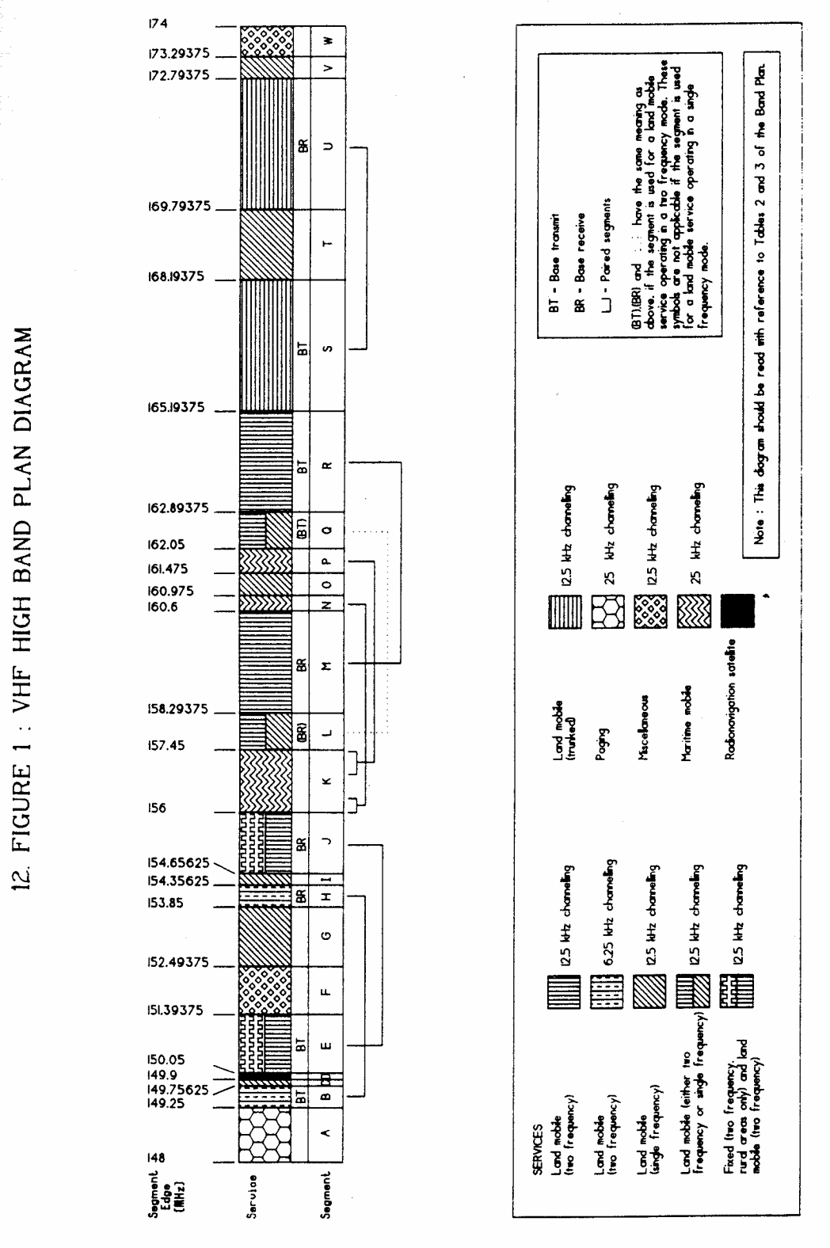
12. FIGURE 1: VHF HIGH BAND PLAN DIAGRAM
FIGURE 1 : VHF HIGH BAND PLAN DIAGRAM

High Spectrum Demand And Rural Areas
13. (1) A High Spectrum Demand (HSD) area is the area on or within a circular contour drawn with a radius specified in Column 5 of an item in Table 4, centred on a point specified as an Australian Map Grid coordinate in Column 4 of that item.

(2) The centre point is nominally described by reference to a nearby town, specified in Column 3, situated in a State specified in Column 2 of that item.

(3) Where adjacent areas overlap, an HSD area then becomes the combination of those adjacent areas.

(4) The Rural area is defined by a contour which lies 100 km outside the HSD areas and encloses the HSD areas.

(5) Diagrammatic representations of the HSD and Rural areas are set out in Figure 2.

Table 4
14. TABLE 4: HIGH SPECTRUM DEMAND CONTOUR CENTRE COORDINATES AND RADII

Column 1 | Column 2 | Column 3 | Column 4 | Column 5
Item | State | Town | Coordinate (Easting, Northing, Zone) | Radius
1 | New South Wales | Newcastle | 384722 6355447 56 | 50 km
2 | New South Wales | Sydney | 335103 6249367 56 | 60 km
3 | New South Wales | Penrith | 279726 6267448 56 | 35 km
4 | New South Wales | Wollongong | 301116 6177146 56 | 35 km
5 | Queensland | Maroochydore | 509952 7052315 56 | 35 km
6 | Queensland | Brisbane | 501674 6961834 56 | 55 km
7 | Queensland | Surfers Paradise | 542065 6902340 56 | 35 km
8 | South Australia | Adelaide | 280600 6132250 54 | 40 km
9 | Victoria | Melbourne | 320605 5812740 55 | 50 km
10 | Victoria | Mornington | 328000 5768000 55 | 50 km
11 | Victoria | Geelong | 268300 5774265 55 | 20 km
12 | Western Australia | Perth | 391314 6464517 50 | 50 km
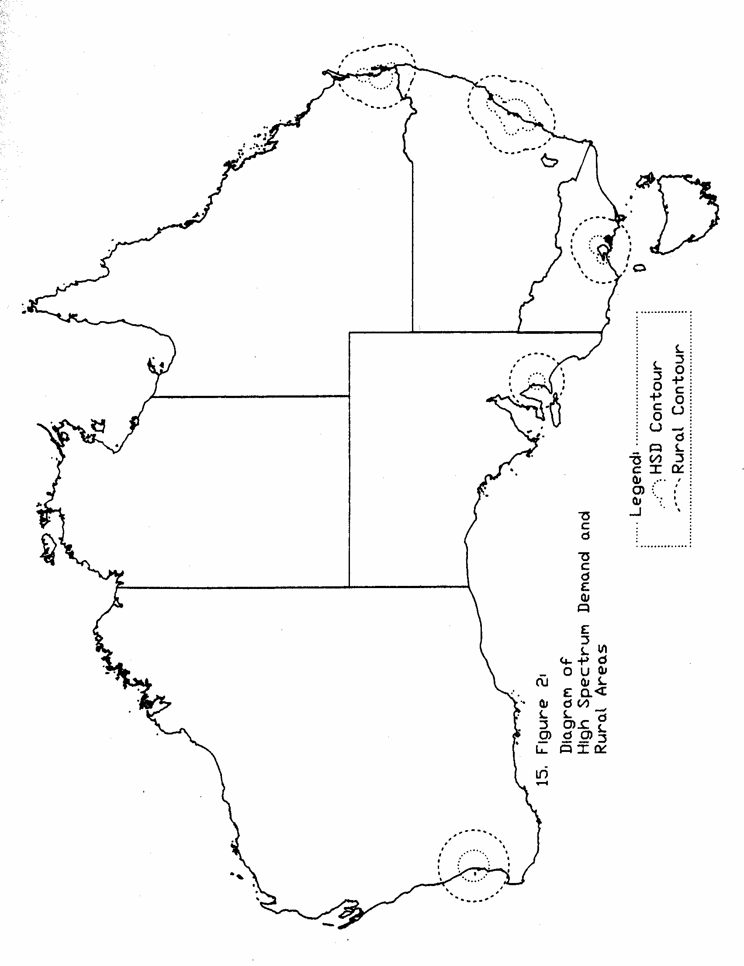
NOTE
1. Notified in the Commonwealth of Australia Gazette on 27 November 1991.

